Electrical Note July 2024
Access Canberra Electrical Inspections team provide this guidance note to electricians in the ACT on some emerging issues affecting the electrical industry.

Contents:
- Licence Endorsement for electricians installing PV and Battery systems.
- Recall – Thermofilm Australia Pty Ltd
- Changes to the installation of Point of Entry Boxes (POE)
- Prevention of the Spread of Fire from a Switchboard
- Idle Electrical Installations
- Clearances for Battery Energy Storage System (BESS) installations
- PV Safety item – Array Cabling
- More Information
- Email Address and Contact Information
- Advice, Defect Notice Reviews, Extension of time
- Contact Us

Licence Endorsement for electricians installing PV and Battery systems.
 | There has been a change to electrical licensing legislation that requires, all electricians working on Photovoltaic (PV) and Battery installations, to have a specific endorsement added to their licence before they undertake this type of electrical work. These systems are being referred to as Distributed Energy Resources (DER) to align with the National Construction Code, National Electricity Rules, and relevant standards. This new licensing requirement is effective from 11 September 2024 and applications for endorsement are available at this link: Application for Electrical Licence Endorsements (act.gov.au)  Regulatory obligations  The changes will require all unrestricted electricians, from 11 September 2024, who want to begin or continue working on certain prescribed DER to apply for and obtain an endorsement on their existing Electrical licence. The types of DER that are prescribed include:  - installation of photovoltaic panels,  - installation of grid-connected inverters as part of a photovoltaic system, and  - installation of grid connected batteries.  With the legislation coming into force from 11 September 2024, we would require your application to be submitted by 16 August 2024 to allow for processing time of the application.  Timing  11 March 2024 – applications opened for unrestricted electricians to start applying for the endorsement. Applications can be made at: Application for Electrical Licence Endorsements (act.gov.au)  16 August 2024 - the last date that you can submit your application and have your endorsement application processed in time to meet the start date of the new licensing requirement.  11 September 2024 – all electricians doing DER work will need an endorsement on their ACT Unrestricted Electrical licence and it will be an offence for electricians to carry out work on grid connected PV and battery installations without the required endorsement.  How to apply  Application for Electrical Licence Endorsements (act.gov.au)  - For electricians currently with equivalent accreditation with the Clean Energy Council (CEC), or Solar Accreditation Australia (SAA), it will be sufficient to provide evidence of a current accreditation with the application.  - For electricians not currently accredited with the CEC or SAA, evidence of completion of specific units of competency will need to be provided. The required units of competency are available in the Construction Occupations (Licensing) (Qualifications) Declaration 2024 (No 2) | HTML view (act.gov.au) in the Electrical section.  Cost  The cost for an endorsement is currently $72.15 (2024-25 financial year).  - There is no annual fee for endorsements as it is a one-off fee on application.  If applying for more than one type of endorsement, the application fee covers all types of endorsement if they are applied for at the same time.  Further information  For information on applying for the endorsement and licensing related matters, please email the licensing team at cwpl@act.gov.au  Note:  On behalf of the Clean Energy Regulator (Commonwealth), Solar Accreditation Australia (SAA) is taking over the accreditation of solar installers from the CEC, visit their website at: Home - Solar Accreditation Australia (saaustralia.com.au).  SAA accreditation is part of Clean Energy Regulator (Commonwealth) requirements and not Access Canberra. Visit the CER for further information on this requirement. Supporting Australia to reduce, offset and track our emissions | Clean Energy Regulator (cer.gov.au)
Back to Contents

Recall – Thermofilm Australia Pty Ltd
    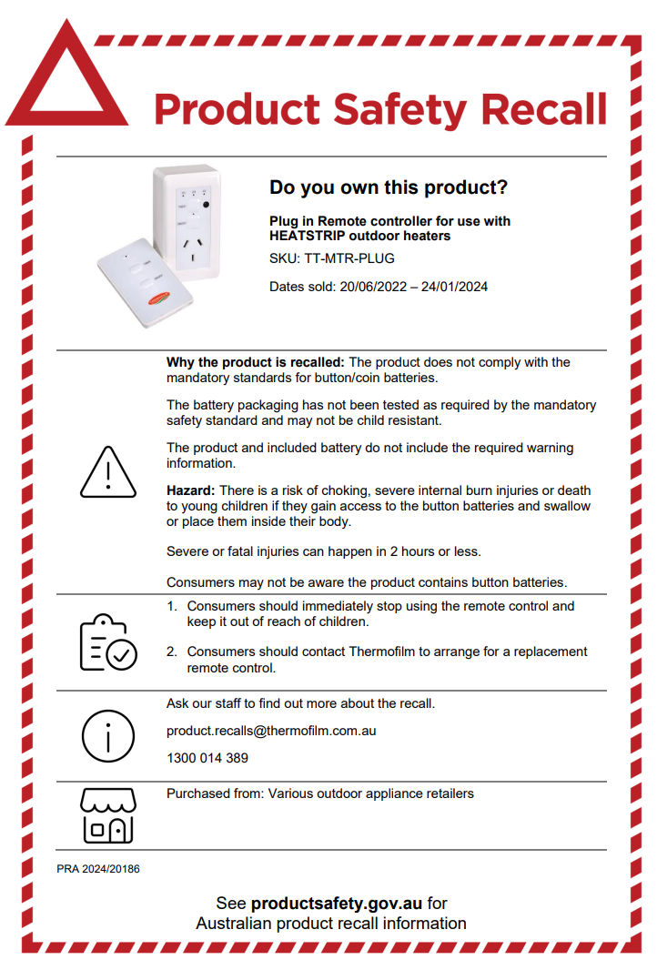  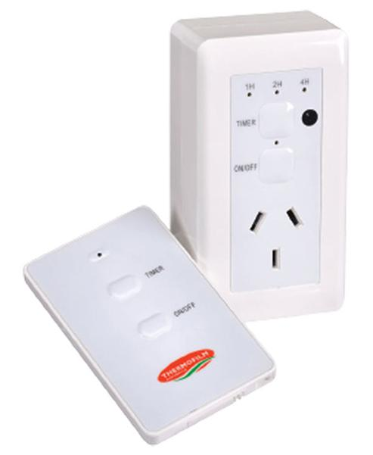 | Thermofilm Australia Pty Ltd — Plug in Remote controller for use with HEATSTRIP outdoor heaters.  Product description  A plug-in control unit with remote.  Compatible with all HEATSTRIP outdoor heaters.  The button battery for the remote does not come installed and is supplied separately in a bag.  Model number: TT-MTR-PLUG  What are the defects?  The product does not comply with the mandatory standards for button/coin batteries.  The battery packaging has not been tested as required by the mandatory safety standard and may not be child resistant.  The product and included battery do not include the required warning information.  What are the hazards?  There is a risk of choking, severe internal burn injuries or death to young children if they gain access to the button batteries and swallow or place them inside their body.  Severe or fatal injuries can happen in 2 hours or less.  Consumers may not be aware the product contains button batteries.  What should consumers do?  Consumers should immediately stop using the remote control and keep it out of reach of children.  Consumers should contact Thermofilm to arrange for a replacement remote control.  For more information, consumers should contact Thermofilm by phone on 1300 014 389 or via email at product.recalls@thermofilm.com.au  Additional Information  Supplier:  Thermofilm Australia Pty Ltd  https://heatstrip.com.au/  Traders who sold this product: Nationally  Dates available for sale:  22 Jun 2022 - 24 Jan 2024  ACCC Notice: Thermofilm Australia Pty Ltd — Plug in Remote controller for use with HEATSTRIP outdoor heaters | Product Safety Australia  Recall Notice:  Recall Advertisement - 5 June 2024_4.pdf (productsafety.gov.au)
Back to Contents

Changes to the installation of Point of Entry Boxes (POE)
  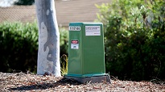  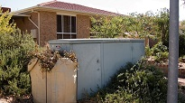   | From July 2024, Evoenergy will no longer be installing Point of Entry (POE) boxes.  This decision follows engagement with the Australian Energy Regulator (AER) for our five-year electricity network plan for the 2024-2029 period.  Key changes:  - Point of Entry installations for all basic connections are now the responsibility of customers and their contracted builder or electrician.  - This change aligns POE box installation requirements with those for Point of Attachment (POA) and meter box installations for basic connections, as well as POE boxes on larger projects.  - Evoenergy has developed a standard that will be required for these installations. Attached are a copy of the updated standard drawings, which are also available on the Evoenergy website.  Evoenergy is also engaging with electrical wholesalers across the region to ensure they are aware of the changes and have copies of the standards.  These changes may impact your operations and planning. Ensure you review these changes and reach out to Evoenergy should you have any questions or require clarification at communications@evoenergy.com.au.  Drawings and additional information are available from the Evoenergy web site at this link: Drawings and Standards (evoenergy.com.au)  Working near the network  Electrical workers are reminded to refresh themselves on the requirements for working near Evoenergy network infrastructure, safe approach distances and the requirements to be accredited with Evoenergy.  By being authorised and accredited with Evoenergy, licensed electricians in the ACT can:  - install and/or remove service fuses at the network boundary for single premises, and/or  - terminate consumer mains cables at the network boundary of single premise installations, and/or  - apply for an Evoenergy key to access metering or isolation locations in multi tenancy installations.  More information is available on the Evoenergy Safety website at this link: Network safety (evoenergy.com.au)
Back to Contents

Prevention of the Spread of Fire from a Switchboard
    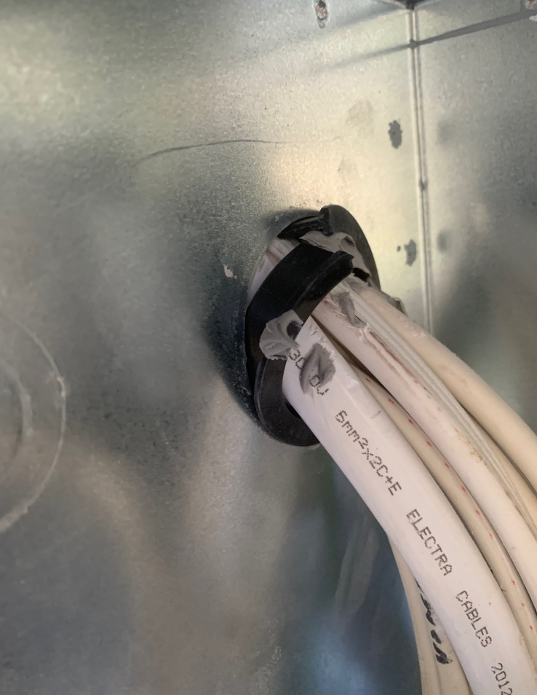 | Did you know that one of the most frequently discovered defect items found in electrical installations by Access Canberra’s Electrical Inspections Team is also one of the most fundamental electrical safety requirements?  AS/NZS 3000 Clause 2.10.7 ‘Fire-protective measures’ requires that: “Where a switchboard is enclosed in a case or surround, any wiring systems entering the switchboard enclosure shall pass through openings that provide a close fit”.  Further guidance is provided, where the standard notes that an opening with less than 5 mm diameter of free space is defined to be a close fit, and that any opening of 5 mm diameter or greater is required to be sealed with a fire-retardant sealant.  Generally, fire sealing involves applying a fire tested intumescent acrylic fire-rated sealant to seal any gaps or openings in the meter box or switchboard enclosure. These materials are designed to expand and form a fire-resistant barrier when exposed to heat or flames, preventing the fire from spreading beyond the enclosed area.  To be effective however, these products must be installed properly and in accordance with the manufacturer’s instructions, and this is where Access Canberra is finding many electricians are not compliant.  Fire sealant is often found to have been applied in a haphazard manner or in insufficient enough quantities to be effective in achieving its intended purpose. In many instances fire sealant is applied that forms a good bond between the wiring entering the switchboard and the surrounding bush, only to be undone when subsequent movement of the switchboard wiring terminating on the hinged panel, results in un-secured bushes being pulled out of the opening, exposing cables to damage from sharp edges and nullifying the fire seal.  Compliance with AS/NZS 3000 Clause 2.10.7 ‘Fire-protective measures’ will be an area of increased focus for the electrical inspections team in the second half of 2024.
Back to Contents

Idle Electrical Installations
On 11 March 2024 an amendment to the Electricity Safety Act 1971 come into effect that covers Idle Installations.

An Idle Installation is an electrical installation that has been disconnected from the electricity network for a time greater than six (6) months, either:
- Physically. For example: by turning the main switch off, removing service fuses.
- Remotely. For example: by devices such as Smart Meters turning off power to the installation.

A licensed electrician is required to re-test an installation that has been idle for over six (6) months and submit a NEW Certificate of Electrical Safety (CES) within 14 days of testing. It is important that the electrician makes a booking request for an electrical inspector by calling the electrical bookings team on (02) 62077775 or by email to Electrical.Inspections@act.gov.au

Completing the Certificate of Electrical Safety (CES) Form
All idle installation CES forms must be lodged as new work as shown in the following example.
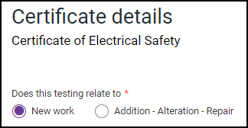
When new work is selected a dialog box will open for a new installation type, select Idle Installation.

Choosing the Idle Installation option will set the cost of the CES form to the same fee as for additions & alterations, which is currently $32.87 and help the inspections team to locate the job when it needs to be booked.

In the Electrical installation details dialog box select Idle Installation as shown in the following example.

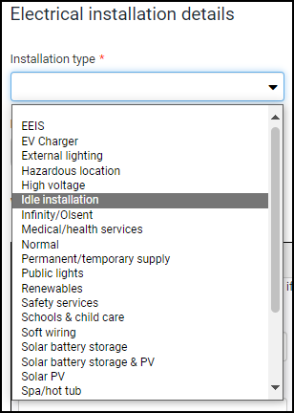
Access Canberra is assisting the electrical industry in getting Idle Installations inspected and connected to the electricity network as soon as practical, so have set a special priority for booking an electrical inspector for this work. Once the CES form is completed, you must call the electrical inspections bookings team (02 6207 7775) and request to book an idle installation inspection. Where possible, the team will assist you with a booking for the following business day (if urgency is required), or you can book a date that suits site access best.

Important - Please note:
- The electrician is to book and arrange site access for the electrical inspector.

- The electrical installation cannot be reconnected to the electricity network until an electrical inspector has inspected the installation and authorised its reconnection.

Further information
Please contact the electrical team on 02 6207 7775 or Electrical.Inspections@act.gov.au
Back to Contents

Clearances for Battery Energy Storage System (BESS) installations.
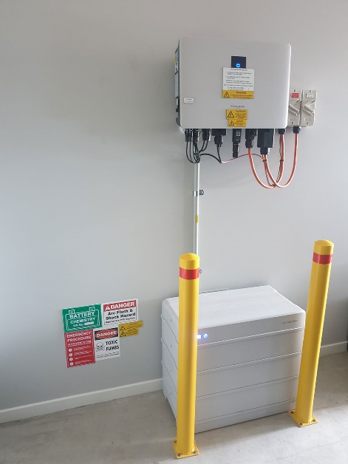  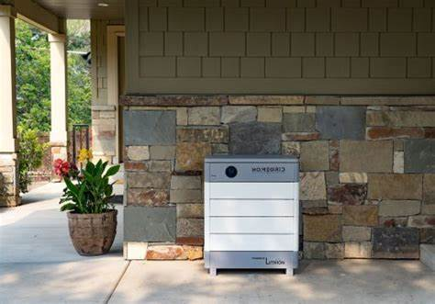  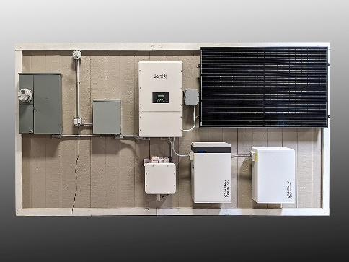 | The Access Canberra Electrical Inspections team would like to make industry aware of some of the requirements for clearances around Battery Energy Storage System (BESS) installations which are detailed in AS/NZS 5139:2019.  AS/NZS 5139:2019 Clause 4.2.4.2 states –  Where the pre-assembled integrated BESS is located on the wall, or mounted on the floor within 300 mm of the wall or structure separating it from the habitable room, the barrier shall extend —  (i) 600 mm beyond the vertical sides of the BESS,  (ii) 900 mm above the BESS, and  (iii) to the extent of the bottom of the BESS.  Where the top of the pre-assembled integrated BESS is within 900 mm of the ceiling or structure above the BESS, the ceiling or structure surface shall be suitably non-combustible for an area of 600 mm past the extremities of the BESS.  Please note:  When reading further onto Clause 4.2.5, that the 600mm clearance in 4.2.4.2 (i) becomes 900mm when considering the access panels which allow access to the 230V a.c connections.  AS/NZS 5139:2019 Clause 4.2.5  The pre-assembled integrated BESS minimum unimpeded access on the working side of a system shall be no less than 600 mm or the clearance specified by the manufacturer, whichever is greater. Where access panels allow access to 230 V a.c. connections, the minimum clearance shall be 900 mm.  Please ensure the requirements of AS/NZS 5139:2019 clauses 4.2.4.2 and especially 4.2.5 are met when installing a BESS.  Compliance with AS/NZS 5139:2019 Clause 4.2.5  will be an area of increased focus for the electrical inspections team in the second half of 2024.
Back to Contents

PV Safety item – Array Cabling
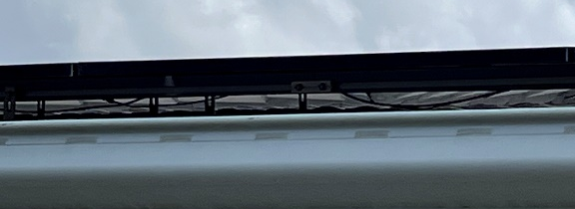  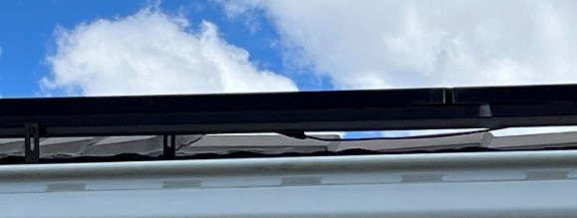  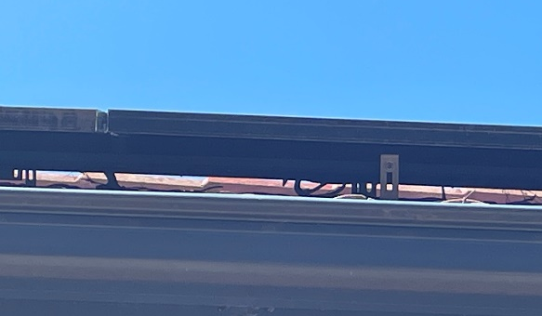  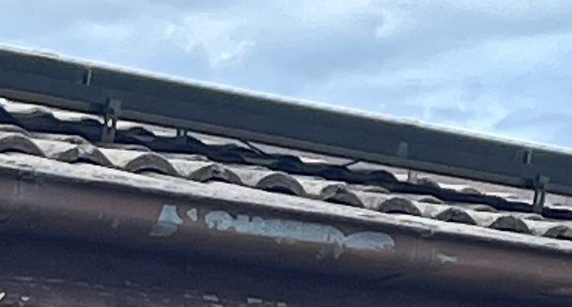 | The Access Canberra Electrical Inspections team have noticed trends of non-compliant issues within the renewable energy sector of the ACT electrical industry.  A particular issue is photovoltaic (PV) array cabling being insufficiently fixed in position, resulting in DC cabling becoming in contact with the roof structure or drooping down under the array.  AS/NZS 5033 – PV Arrays – Clause 4.4.3.1 states:  Cables shall be installed so that they—  (c) do not lie on roofs or floors without an enclosure or conduit…  (e) are supported so they do not suffer fatigue due to wind/snow affects...  In considering the requirements of the standard it is easier to understand the reasoning behind the clause:  - Contact between the array cabling and the roof structure will cause an abrasive effect between the two elements and may cause for the insulation of the array cabling to become compromised.  - This may present a shock or fire risk to person or property.  - Similar issues may be presented if array cabling is insufficiently restrained as wind, snow or fauna could cause the cabling to become in contact with the roof over time.  - A reminder that the installation must be installed to a quality to last the lifespan of the installation. It is reasonable to expect a solar installation to last 20+ years and the wiring supports should be installed in a manner to achieve compliance for at least this time frame.  Access Canberra Electrical Inspections Team have been targeting this compliance issue to educate the electrical industry of the issues and dangers.  Non-compliance with AS/NZS 5033 – PV Arrays – Clause 4.4.3.1 may result in demerit points being applied to your electrical licence.
Back to Contents

More Information
 | The Access Canberra electrical inspections team have published Frequently Asked Questions (FAQ) and fact sheets on several subjects that are either a concern for compliance, or where the electrical industry can benefit from our assistance.  The FAQs can be found on our web site at: Electrician notes - Access Canberra (act.gov.au)  If you think additional content is required, send us an email.  The FAQs will be updated as new questions come in and Australian Standards are updated.
Back to Contents

Email Address and Contact Information
   | All licensed construction professionals in the ACT are required to keep their details up-to-date, and to notify Access Canberra within seven (7) days of any change. Use this link to access the change of address form.  Not only do we use your email address to keep you up to date with emerging issues affecting the electrical industry, the  - Licensing team need it to send out your licence reminders.  - Electrical inspections team need it to send out inspections reminders and results.  Where you use a work email address, consider to also use a personal email address, for those times you are on leave or change employers and we need to let you know of an important issue.  Did you know Access Canberra provides a list of construction professionals on their website? Visit Choosing a tradesperson - Access Canberra (act.gov.au)  https://www.accesscanberra.act.gov.au/consumer-rights/choosing-a-tradesperson
Back to Contents

Advice, Defect Notice Reviews, Extension of time
 | Advice  Electricians requiring advice on Wiring Rules interpretations should check out our FAQ page Electrician notes - Access Canberra (act.gov.au) and should additional information be required they can contact the electrical inspections team by email at Electrical.Inspections@act.gov.au.  To aid in providing consistent advice to the electrical industry, only the electrical inspections team manager will respond to your enquiry. If you pose a question on site to an electrical inspector, this must not be considered as binding advice but as the personal opinion of that inspector.  Defect Notice Questions & Review  If you receive a Defect Notice from an electrical inspector and have questions relating to it, we have the following process for reviewing it.  - Call the inspector who issued the defect notice, their mobile number will be on the notice. Discuss your questions or concerns to see if a resolution is possible. If it is not possible to come to a consensus, ask for their team manager’s contact details.  - Call the team manager and discuss your concerns.  - Should the team manager not be able to come to a consensus view then send an email to: The Director of Electrical Inspections at Electrical.Inspections@act.gov.au with your concerns and request a review.  Extension of time  If you require an extension of time to make repairs the Defect Notice has identified, please email the Electrical team with your request as soon as possible and before you receive the Final Notice. Electrical.Inspections@act.gov.au
Back to Contents

Contact Us
 | Access Canberra Electrical Inspections Team  Phone: 02 6207 7775 (8:30am to 4:30pm) Business Days  Email: Electrical.Inspections@act.gov.au  Web: https://www.accesscanberra.act.gov.au
Previous electrical notices are available at: Electrician notes - Access Canberra (act.gov.au)
https://www.accesscanberra.act.gov.au/business-and-work/building-and-construction/electrician-notes

Back to Contents

