Electrical Note March 2024
Access Canberra Electrical Inspections team provide this guidance note to electricians in the ACT on some emerging issues affecting the electrical industry.

Contents:
- Change to Electricity Safety Act 1971 – Idle Electrical Installations
- Recall – SunTank hybrid inverter JKS-5HLVS-ABI
- Recall – Growatt solar power inverters
- Endorsement for electricians installing PV and Battery systems
- Cascading RCDs
- Festivals and Major Events
- PV Safety item – Array Cabling
- SRES installer and designer accreditation scheme update
- More Information
- Email Address and Contact Information
- Advice, Defect Notice Reviews, Extension of time
- Contact Us

Change to Electricity Safety Act 1971 – Idle Electrical Installations
  Electricity Safety Act 1971 | On 11 March 2024 some minor amendments to the Electricity Safety Act 1971 come into effect. A change that all electricians and electrical contractors need to be aware of, is in relation to the reconnection of idle installations to the electricity network.  This change is for electrical installations that have been disconnect from the electricity network for a time greater than six (6) months, either;  - Physically. For example: by turning the main switch off.  - Remotely. For example: by devices such as Smart Meters turning off power to the installation.  From 11 March 2024 a licensed electrician will need to re-test an installation that has been idle for over six (6) months and submit a NEW Certificate of Electrical Safety (CES) within 14 days of testing. It is important the electrician select the NEW category of the CES form and then make a booking request for an electrical inspector by calling the electrical bookings team on (02) 62077775 or by email to Electrical.Inspections@act.gov.au  Important - Please note:  The electrical installation cannot be reconnected to the electricity network until an electrical inspector has inspected the installation and authorised its reconnection.
Back to Contents

Recall – SunTank Hybrid Inverter JKS-5HLVS-ABI
    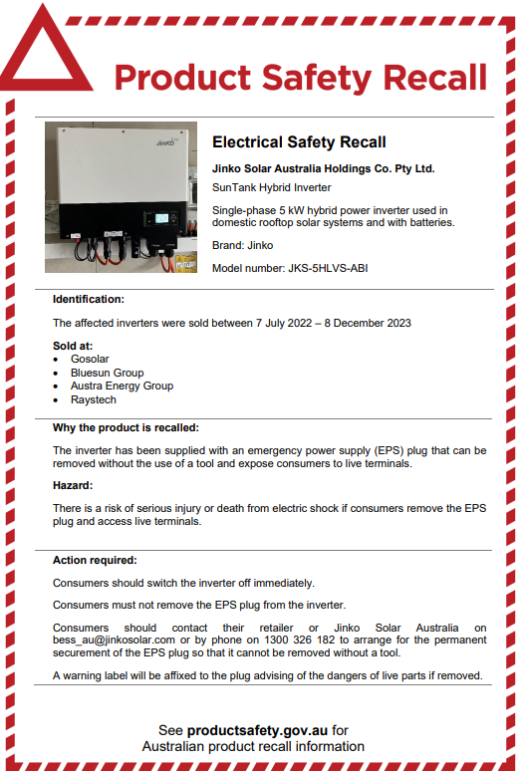 | Jinko Solar Australia Holdings Co. Pty Ltd. — SunTank hybrid inverter JKS-5HLVS-ABI  Product description  Single-phase 5 kW hybrid power inverter used in domestic rooftop solar systems and with batteries.  Brand: Jinko  Model number: JKS-5HLVS-ABI  What are the defects?  The inverter has been supplied with an emergency power supply (EPS) plug that can be removed without the use of a tool and expose consumers to live terminals.  What are the hazards?  There is a risk of serious injury or death from electric shock if consumers remove the EPS plug and access live terminals.  What should consumers do?  Consumers should switch the inverter off immediately.  Consumers must not remove the EPS plug from the inverter.  Consumers should contact their retailer or Jinko Solar Australia on bess_au@jinkosolar.com or by phone on 1300 326 182 to arrange for the permanent securement of the EPS plug so that it cannot be removed without a tool.  A warning label will be affixed to the plug advising of the dangers of live parts if removed.  Additional Information  Supplier:  Jinko Solar Australia Holdings Co. Pty Ltd  http://jinkosolarenergystorage.com.au/  Traders who sold this product:  • Gosolar • Bluesun Group • Austra Energy Group  • Raystech  Dates available for sale:  7 Jul 2022 - 8 Dec 2023  ACCC Notice: Jinko Solar Australia Holdings Co. Pty Ltd. — SunTank hybrid inverter JKS-5HLVS-ABI | Product Safety Australia  Recall Notice:  Recall advertisement - 11 January 2024.pdf (productsafety.gov.au)
Back to Contents

Recall – Growatt Solar Power Inverters
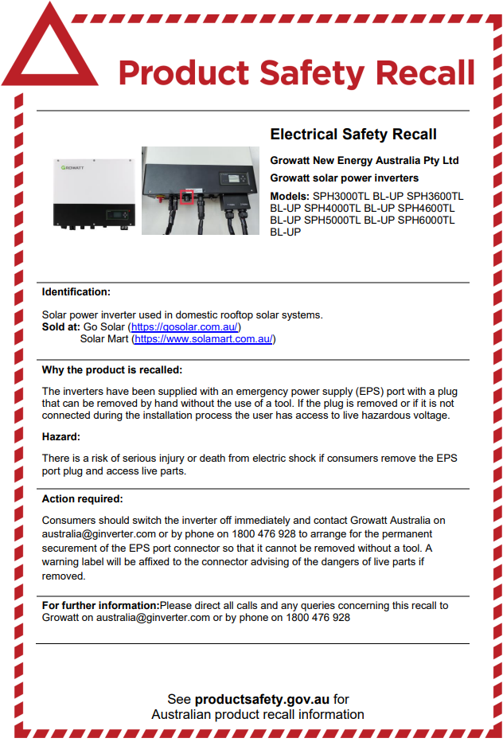 | Growatt New Energy Australia Pty Ltd — solar power inverters.  Product description  Growatt New Energy Australia Pty Ltd Growatt solar power inverters Models: SPH3000TL BL-UP SPH3600TL BL-UP SPH4000TL BL-UP SPH4600TL BL-UP SPH5000TL BL-UP SPH6000TL BL-UP  What are the defects?  The inverters have been supplied with an emergency power supply (EPS) port with a plug that can be removed by hand without the use of a tool. If the plug is removed or if it is not connected during the installation process the user has access to live hazardous voltage.  What are the hazards?  There is a risk of serious injury or death from electric shock if consumers remove the EPS port plug and access live parts.  What should consumers do?  Consumers should switch the inverter off immediately and contact Growatt Australia on australia@ginverter.com or by phone on 1800 476 928 to arrange for the permanent securement of the EPS port connector so that it cannot be removed without a tool. A warning label will be affixed to the connector advising of the dangers of live parts if removed.  Additional Information  Supplier: Growatt New Energy Australia Pty Ltd  Traders who sold this product:  Go Solar and Solar Mart  Dates available for sale  1 Jul 2022 - 31 Oct 2023  ACCC Notice:  Growatt New Energy Australia Pty Ltd — solar power inverters models: SPH3000TL BL-UP SPH3600TL BL-UP SPH4000TL BL-UP SPH4600TL BL-UP SPH5000TL BL-UP SPH6000TL BL-UP | Product Safety Australia  Recall Notice:  Recall advertisement - 17 November 2023_0.pdf (productsafety.gov.au)
Back to Contents

Endorsement for electricians installing PV and Battery systems
There has been a change to electrical licensing legislation that requires, all electricians working on Photovoltaic (PV) and Battery installations, to have a specific endorsement added to their licence before they undertake this type of electrical work. These systems are being referred to as Distributed Energy Resources (DER) to align with the National Construction Code, National Electricity Rules, and relevant standards. This new licensing requirement is effective from 11 September 2024 and applications open from 11 March 2024.

Regulatory obligations
The changes will require all unrestricted electricians, from 11 September 2024, who want to begin or continue working on certain prescribed DER to apply for and obtain an endorsement on their existing (Electrical) COLA licence. The types of DER that will be prescribed include:
- installation of photovoltaic panels;
- installation of grid-connected inverters as part of a photovoltaic system; and
- installation of grid connected batteries.

The transitional arrangements of applications for endorsement starting 11 March 2024 and the legislation coming into force from 11 September 2024, will allow unrestricted electricians and electrical contractors to continue to install DER for this 6-month grace period. This should give electricians enough time to make an application to Access Canberra for an endorsement.

Timing
From 11 March 2024 – applications will be open for unrestricted electricians to start applying for the endorsement. Applications can be made at: https://www.planning.act.gov.au/professionals/regulation-and-responsibilities/construction-licences
From 11 September 2024 – all electricians doing this work will need an endorsement and it will be an offence for electricians to carry out work on grid connected PV and battery installations without the required endorsement.

How to apply
https://www.planning.act.gov.au/professionals/regulation-and-responsibilities/construction-licences

- For electricians currently accredited with the Clean Energy Council (CEC), it will be sufficient to provide evidence of a current accreditation with the application.
- For electricians not currently accredited with the CEC, evidence of completion of specific units of competency will need to be provided. The required units of competency will be available in the Construction Occupations (Licensing) (Qualifications) Declaration (2024) when published at Construction Occupations (Licensing) Act 2004 | Acts

Cost
The cost for an endorsement is currently $72.15 (2023-24 financial year).
The endorsement cost is a one-off and remains on the licence indefinitely. If applying for more than one type of endorsement, the $72.15 fee covers all types of endorsement if they are applied for at the same time.

Further information
For information on applying for the endorsement and licensing and related matters, please email the licensing team at cwpl@act.gov.au
Back to Contents

Cascading RCDs
  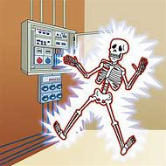 | The Access Canberra Electrical Inspections team have encountered several installations which have had an RCD installed protecting a submain which supplies distribution boards containing subcircuits with RCD protection.  The arrangement for RCD installation is designed to minimise the impact of the operation of a single RCD. As such RCDs cannot be installed on a submain under the following conditions,  - If the installation has more than one lighting circuit or,  - If the installation has more than three final subcircuits  AS/NZS 3000:2018 clause 2.6.2.4 states  - Arrangement  Where additional protection of final subcircuits is required, in accordance with Clause 2.6.3, the final subcircuits shall be arranged as follows:  (a) In all electrical installations where—  - the number of RCDs installed exceeds one; and  - more than one lighting circuit is installed, lighting circuits shall be distributed between RCDs.  (b) In residential installations—  - not more than three final subcircuits shall be protected by any one RCD; and  - where there is more than one final subcircuit, a minimum of two RCDs shall be installed.  NOTE: These arrangements are intended to minimize the impact of the operation of a single RCD.  Electricians must ensure they follow the requirements of AS/NZS 3000:2018 clause 2.6.2.4 to ensure compliance is met and to avoid nuisance tripping of the installation.
Back to Contents

Festivals and Major Events
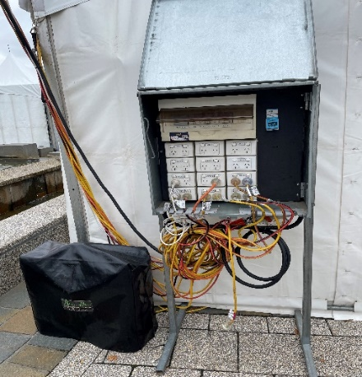 | The Access Canberra Electrical Inspections team, work in collaboration with the Access Canberra Events team, to attend Canberra’s festivals for the purpose of a pre-safety inspection and familiarisation of the event.  Electrical licensees are required to submit a Certificate of Electrical Safety with Access Canberra for event electrical work, which typically includes generators, switchboards, and associated event cabling.  There is a recently revised electrical Standard for festivals, Electrical Installations – Shows, carnivals and events AS/NZS 3002:2021 which supersedes the 2008 version and differs in several areas. One change was to have the standard format set out similar to AS/NZS 3000.  Compliance is required to the revised AS/NZS 3002:2021 which has additional requirements for festivals. The Shows, carnivals and events Standard works in conjunction with other relevant Standards and typically the Licensee will need to be familiar with AS/NZS 3000:2018, AS/NZS 3001:2022, AS/NZS 5033:2021 and AS/NZS 3010:2017 when delivering an electrically compliant event.  Some key points for festival electrical work.  - Type AC RCDs shall not be installed.  - RCDs shall be of a type that operate in all live conductors (active and neutral).  - Where the switchboard is provided with socket outlets, means to prevent strain on flexible cords shall be provided such as an insulated tie bar. The switchboard shall also have a legible sign e.g., “KEEP CLOSED – RUN ALL LEADS THROUGH BOTTOM”  - All connection facilities, unless under appropriate cover, shall have a minimum protection of IP23.  - Transportable generator sets shall comply with the principles of AS/NZS 3010.  - Generators can provide electrical power via an approved RCD to multiple items of electrical equipment.  - All event lighting shall be located to be adequately protected against damage that might reasonably be expected.  - Certificate/s of Electrical Safety (CES) are required to be submitted to Access Canberra for festival electrical work after testing.  The Access Canberra Electrical Inspections team are available to assist with electrical enquiries and regularly meets the electrical community festival sites. Contact us for additional information.
Back to Contents

PV Safety item – Array Cabling
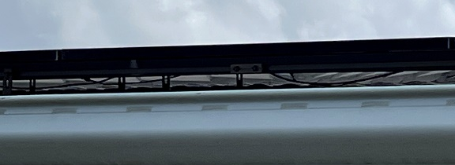  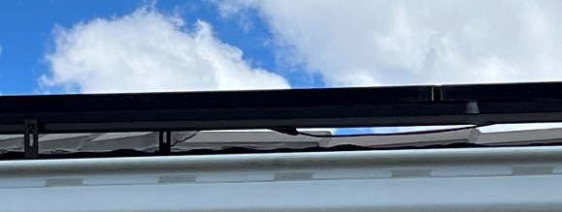  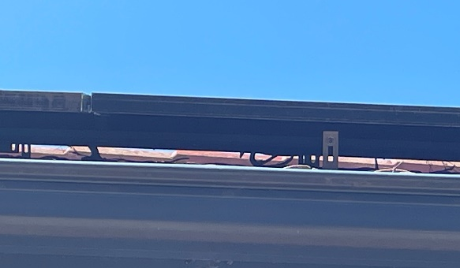  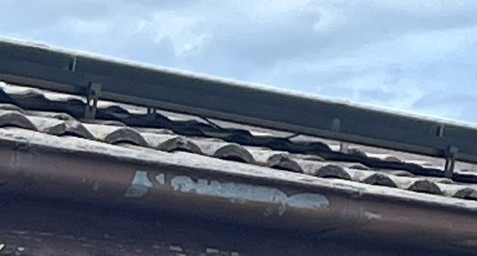 | The Access Canberra Electrical Inspections team have noticed trends of non-compliant issues within the renewable energy sector of the ACT electrical industry.  A particular issue is photovoltaic (PV) array cabling being insufficiently fixed in position, resulting in DC cabling becoming in contact with the roof structure or drooping down under the array.  AS/NZS 5033 – PV Arrays – Clause 4.4.3.1 states:  Cables shall be installed so that they—  (c) do not lie on roofs or floors without an enclosure or conduit…  (e) are supported so they do not suffer fatigue due to wind/snow affects...  In considering the requirements of the standard it is easier to understand the reasoning behind the clause:  - Contact between the array cabling and the roof structure will cause an abrasive effect between the two elements and may cause for the insulation of the array cabling to become compromised.  - This may present a shock or fire risk to person or property.  - Similar issues may be presented if array cabling is insufficiently restrained as wind, snow or fauna could cause the cabling to become in contact with the roof over time.  - A reminder that the installation must be installed to a quality to last the lifespan of the installation. It is reasonable for a customer to expect a solar installation to last 20+ years and so should the wiring supports.  Access Canberra Electrical Inspections Team has been targeting this compliance issue to educate the electrical industry of the issues and dangers.
Back to Contents

SRES installer and designer accreditation scheme update

Transfer to the new accreditation scheme operator (cleanenergyregulator.gov.au)

The Clean Energy Regulator (CER) expects to announce the new Small-scale Renewable Energy Scheme (SRES) installer and designer accreditation scheme operator (ASO) in late February 2024.
Accredited persons must transfer to the new ASO within 3 months of the CER’s announcement to maintain their accreditation and small-scale technology certificate (STC) eligibility. The Clean Energy Council (CEC) will cease their accreditation services when CER’s decision is announced.
Find out how to transfer and maintain your accreditation on CER’s new installer and designer ASO webpage.
Important information for accredited persons:
- A new accreditation number will be issued after successfully transferring to the new ASO.
  - The new accreditation number will be used to claim STCs for installations from the date of the transfer.
  - The CEC accreditation number will be used to claim STCs for installations that were completed before transferring to the new ASO.
- Accreditation periods will move from annual to triennial. Fees will be between $650-$800 for 3 years of accreditation. You will still be required to maintain 100 continuous professional development points annually to maintain your accreditation.
- The new ASO’s website will go live on the day of CER’s announcement. Accredited persons can then apply to transfer their accreditation directly via the website.
- Further details will be provided in February when the new ASO is announced. Please bookmark CER’s new installer and designer ASO webpage for easy reference and subscribe to our email list.
It is an accredited person’s responsibility to ensure they meet SRES eligibility requirements. The CER closely monitors all installation dates for STC applications and will be working closely with the new ASO to ensure persons are appropriately accredited at the time of design and installation of a small generation unit. It is important to remember that the provision of false and/or misleading information is an offence under the Renewable Energy (Electricity) Act 2000.
The CER continues to work closely with the CEC and new ASO to ensure a smooth transition process.
For more information, please email us at cer-sresreforms@cer.gov.au or call our Contact Centre team on 1300 553 542.

Back to Contents

More Information
 | The Access Canberra electrical inspections team have published Frequently Asked Questions (FAQ) and fact sheets on several subjects that are either a concern for compliance, or where the electrical industry can benefit from our assistance.  The FAQs can be found on our web site at: Electrician notes - Access Canberra (act.gov.au)  If you think additional content is required, send us an email.  The FAQs will be updated as new questions come in and Australian Standards are updated.
Back to Contents

Email Address and Contact Information
   | All licensed construction professionals in the ACT are required to keep their details up-to-date, and to notify Access Canberra within seven (7) days of any change. Use this link to access the change of address form.  Not only do we use your email address to keep you up to date with emerging issues affecting the electrical industry, the  - Licensing team need it to send out your licence reminders.  - Electrical inspections team need it to send out inspections reminders and results.  Where you use a work email address, consider to also use a personal email address, for those times you are on leave or change employers and we need to let you know of an important issue.  Did you know Access Canberra provides a list of construction professionals on their website? Visit Choosing a tradesperson - Access Canberra (act.gov.au)  https://www.accesscanberra.act.gov.au/consumer-rights/choosing-a-tradesperson
Back to Contents

Advice, Defect Notice Reviews, Extension of time
 | Advice  Electricians requiring advice on Wiring Rules interpretations should check out our FAQ page Electrician notes - Access Canberra (act.gov.au) and should additional information be required they can contact the electrical inspections team by email at Electrical.Inspections@act.gov.au.  To aid in providing consistent advice to the electrical industry, only the electrical inspections team manager will respond to your enquiry. If you pose a question on site to an electrical inspector, this must not be considered as binding advice but as the personal opinion of that inspector.  Defect Notice Questions & Review  If you receive a Defect Notice from an electrical inspector and have questions relating to it, we have the following process for reviewing it.  - Call the inspector who issued the defect notice, their mobile number will be on the notice. Discuss your questions or concerns to see if a resolution is possible. If it is not possible to come to a consensus, ask for their team manager’s contact details.  - Call the team manager and discuss your concerns.  - Should the team manager not be able to come to a consensus view then send an email to: The Director of Electrical Inspections at Electrical.Inspections@act.gov.au with your concerns and request a review.  Extension of time  If you require an extension of time to make repairs the Defect Notice has identified, please email the Electrical team at with your request as soon as possible and before you receive the Final Notice. Electrical.Inspections@act.gov.au
Back to Contents

Contact Us
 | Access Canberra Electrical Inspections Team  Phone: 02 6207 7775 (8:30am to 4:30pm) Business Days  Email: Electrical.Inspections@act.gov.au  Web: https://www.accesscanberra.act.gov.au
Previous electrical notices are available at: Electrician notes - Access Canberra (act.gov.au)
https://www.accesscanberra.act.gov.au/business-and-work/building-and-construction/electrician-notes

Back to Contents

