VEHICLE SAFETY STANDARDS


Access Canberra Framework

Part of Accountability Commitment series
Jan 2020

Chief Minister, Treasury and Economic Development Directorate - CMTEDD Access Canberra
P: 13 22 81
W: website - https://www.accesscanberra.act.gov.au/app/home Published June 2020
IMPORTANT NOTE: This information is for guidance only.

CONTENTS

Introduction 4
Purpose 4
Key principles 4
Operational objectives 4
Legislative framework 5
Compliance model 5
Engage, Educate, Enforce 5
Approach to enforcement 5
Education 6
Compliance monitoring 6
Proactive activities 6
Reactive activities 6
Determining appropriate enforcement responses 7
Enforcement options 7
Powers held by Authorised Vehicle Inspectors 7
Review of Defects and Infringements 8
Appendix 1: relevant legislation 9
Appendix 2: offences 10

INTRODUCTION

Purpose
The purpose of this framework is to set out the objectives and general principles for compliance and enforcement activities undertaken by the Access Canberra Vehicle Safety Standards Unit.
This framework outlines the risk-based approach to compliance with relevant legislation in the ACT and is intended to be a useful and transparent guide.

Key principles
Please refer to the Access Canberra Accountability Commitment as this sets out the principles that inform the decisions and regulatory action of Access Canberra. The Accountability Commitment is available online from www.accesscanberra.act.gov.au.
Risk-based – Access Canberra will apply a risk-based compliance approach to ensure resources are targeted to where the risks of harm, unsafe practices or misconduct are the greatest, thereby strengthening its capacity to take action where the community, workers and the environment are most at risk.

...risk-based compliance approach...

Operational objectives
Operational objectives central to the role of Vehicle Safety Standards Operations:
Safety – Many instances of defective vehicle use within the ACT pose significant safety risks to the community. We aim to actively enforce the road rules and vehicle safety standards throughout the ACT to provide a positive outcome for the community.
Compliance- All vehicles using the ACT road network must comply with all registration conditions and have a valid compulsory third party insurance. We will conduct regular audit inspections to monitor the compliance levels of authorised inspectors in the authorised examiner scheme and motor traders program.
Community Education and Engagement- We will respond to requests for advice and proactively make contact with businesses and the public to inform them of their obligations. We will engage specific industry through education campaigns to promote and explain regulatory requirements.

safety
compliance
community education
and engagement
The relationship between our Strategic Objectives

Legislative framework
The Australian Capital Territory introduced the Road Transport (Vehicle Registration) Act 1999 to provide for the registration of vehicles and related matters as part of the system for nationally consistent road transport law.
The object of this Act is to provide for a vehicle registration system in the ACT that is consistent with agreements scheduled in the National Road Transport Commission Act 1991 and part of the uniform national road transport legislation envisaged by that Act. It will also improve road safety and transport efficiency.
The Road Transport (Vehicle Registration) Regulation 2000 contains laws to implement and administer the Road Transport (Vehicle Registration) Act 1999.

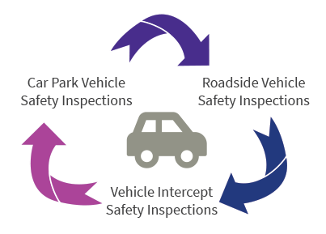
Vehicle Inspections conducted in the ACT

Compliance model

Engage, Educate, Enforce
Engage, educate and enforce are the three fundamental steps used by Access Canberra. Compliance is encouraged through education but escalating enforcement action will be applied to those whose conduct will, or is likely to, cause harm, or those who demonstrate a disregard for the law.
Engage means ensuring there is a positive working relationship with stakeholders and members of the public.

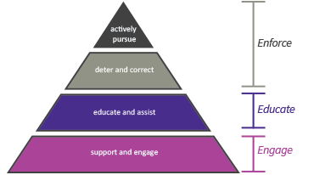
Regulatory response
Educate means taking reasonable steps to ensure people know how to comply. (Information publically available on Access Canberra’s website, media information, staff interaction with the public across the Access Canberra organisation).
Enforce means taking action for non-compliance proportional to the harm caused by the conduct (Warnings, Defect notices or Infringement Notices).

Approach to enforcement
Access Canberra operates on a risk-based compliance model and aims to adopt the right regulatory response for the right situation.
The risk-based compliance approach enables the targeting of resources to those areas where they are most needed and will be most effective. This approach involves a series of steps to identify and assess risks and to then apply the most appropriate regulatory tool to control the risk.

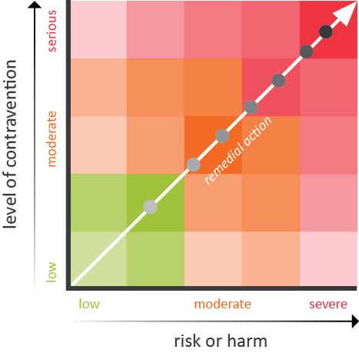
Enforcement response

EDUCATION
Like any regulatory regime, the optimal outcome for Vehicle Safety Standards is voluntary compliance.
Education by vehicle inspector’s plays a key role in maximising compliance by ensuring lack of information is not a contributing factor to non-compliance.
As part of its communication strategy, Access Canberra strives to deliver advice and education to relevant target audiences through a number of activities and tools, including newsletters, editorial/articles for industry publications including factsheets, social media such as Facebook and Twitter, advertising campaigns, web content and features at www.accesscanberra.act.gov.au. The Access Canberra online resources include numerous guides, brochures, factsheets and links to assist people ensure their actions comply with relevant laws.
www.accesscanberra.act.gov.au - Access Canberra online resources

COMPLIANCE MONITORING
Access Canberra compliance activities are aimed at ensuring positive outcomes for industry and the community.
Access Canberra carries out both proactive and reactive activities that are risk-based, with resources allocated based on the level of risk posed to the strategic objectives.
Monitoring compliance and investigating non- compliance is an important component of the compliance framework.

...positive outcomes for industry and the community.

Proactive activities
The majority of monitoring undertaken by Vehicle Safety Standards is proactive, identifying instances of non-compliance by road users throughout the state.
Proactive patrols are conducted by authorised vehicle inspectors at various locations across the ACT to identify unregistered and defective vehicles using the ACT’s road network. These patrols are conducted daily and include carparks, roadsides and vehicle intercepts.
...identifying instances of non- compliance...

Reactive activities
Reactive monitoring relies on members of the public, businesses, or government agencies contacting Access Canberra and Vehicle Safety Standards to report non- compliant vehicles.
The Vehicle Safety Standards team will recall alleged defective vehicles that have been reported with safety defects when the person making the report has provided sufficient evidence and details of the vehicle.
The vehicle will be subjected to a free inspection at the Hume Motor Vehicle Inspection Station where any issues of non-compliance will be recorded and a defective vehicle notice issued.
Vehicle Safety Standards will also liaise with other Government agencies to investigate reports of non- compliance.

...investigate reports of non- compliance.

DETERMINING APPROPRIATE ENFORCEMENT RESPONSES

Enforcement options
The available enforcement options for vehicle Safety Standards include:
Warnings/cautions – these are appropriate only when the level of risk posed by the defect is low. Minor items that do not affect how the vehicle is used in varied conditions and do not affect other road users.
Defect notices- these can be issued by an authorised person as either minor or major notices. A minor defect will be issued when the vehicle had been identified
to have a defective component that fails to meet the vehicle standards requirements. The owner will need to get the vehicle repaired within 14 days and obtain a passed roadworthy inspection from either Hume Motor Vehicle Inspection Station (HMVIS) or an approved inspection station within the Authorised Examiner Scheme (AES) to clear the defect.
A major defect notice will be issued to a vehicle when a potentially serious defect is found, this can be issued with conditions preventing the vehicle from being driven away. The defective items will also need to be rectified and inspected within 14 days.
Infringement notices – An infringement notice can be issued to the operator or driver of a vehicle when a contravention of vehicle standards or road rules is detected. When the operator is present the infringement will usually be given to them at the time of the offence, but if the vehicle is unattended the infringement will be sent to the registered operator.
...available enforcement options...

POWERS HELD BY AUTHORISED VEHICLE INSPECTORS
Please note: The following powers are not an exhaustive list of those held by an authorised vehicle inspector.
Vehicle inspectors are authorised under section 19 of the Road Transport (General) Act 1999 as an authorised person for road transport legislation.
Sections 24 and 53A of the Act authorise vehicle inspectors to issue infringement notices for offences identified under road transport law.
Under section 159 of the Road Transport (Vehicle Registration) Regulation 2000 an authorised person may issue a defective vehicle notice if in their opinion deficiencies with the vehicle may pose a safety risk.
The Road Transport (Vehicle Registration) Act 1999 under sections 25 and 27, gives an authorised person the power to identify and inspect a registrable vehicle on a road or road related area to find out its identity, condition or the status of any registration or permit relating to the vehicle. Section 30 allows the
authorised person to remove and seize numberplates on reasonable grounds.
A Vehicle Inspector cannot, whilst on patrol, withdraw an infringement notice or defective vehicle notice once it has been issued. While carrying out their duties authorised vehicle inspectors must carry photographic identification cards and present them on request.

... identify and inspect a registrable vehicle on a road or road related area to find out its identity, condition or the status of any registration or permit...

REVIEW OF DEFECTS AND INFRINGEMENTS
Any person who receives an infringement is entitled to seek a review. Information on how to transfer, dispute or request a payment plan is available on the Access Canberra website- https://www.accesscanberra.act. gov.au/app/answers/detail/a_id/1271/~/traffic-and- parking-infringements.

web: https://www.accesscanberra.act.gov.au/app/home/transport
Phone: 13 22 81
Contact: Access Canberra, Road Transport Authority PO Box 582, DICKSON ACT 2602
Online: Road Transport Authority Contact Form

...how to request an internal review is provided on the reverse of the defect notice. Internal reviews will be considered by a senior officer who was not involved in the original issuance.

A person has the right of appeal to dispute a defective vehicle notice which they have been issued by an authorised vehicle inspector. The appeal information on how to request an internal review is provided on the reverse of the defect notice. Internal reviews will be considered by a senior officer who was not involved in the original issuance.
If you are dissatisfied
with the outcome...

If you are dissatisfied with the outcome of the internal review, you may contact the Australian Capital Territory Ombudsman-

web: https://www.ombudsman.act.gov.au/ Phone: 1300 362 072
Contact: ACT Ombudsman
GPO Box 442, CANBERRA ACT 2601
Email: ombudsman@ombudsman.gov.au

APPENDIX 1: RELEVANT LEGISLATION
- Road Transport (General) Act 1999
- Road Transport (General) Regulation 2000
- Road Transport (Vehicle Registration) Act 1999
- Road Transport (Vehicle Registration) Regulation 2000
- Road Transport (Offences) Regulation 2005
The ACT Government also periodically issues guidelines, determinations and delegations in the form of Notifiable
Instruments and Disallowable Instruments. To access ACT legislation visit: http://www.legislation.act.gov.au.

APPENDIX 2: OFFENCES
Please note, this list is intended for use as a guide only and is not exhaustive.
Note- Infringement penalties are listed in the Road Transport (Offences) Regulation 2005.

Code | Offence Provision | Infringement description
Light
1 | 17 (1) | use uninsured motor vehicle on road or road related area
2 | 18 (1) | use unregistered/suspended vehicle
10 | 31 (1) | unlicensed driver/rider
12 | 31A | drive when right to drive suspended— driver does not hold ACT licence—  non-payment of infringement notice penalty
56 | 107 (2) | drive unsafely maintained vehicle
57 | 107 (3) | tow unsafely maintained combination vehicle
58 | 107 (4) | operator not maintain vehicle safe to drive
59 | 107 (5) | operator not maintain trailer safe to tow
60 | 108 (2) | drive vehicle without emission control system fitted
499 | 292 (A) | drive/tow vehicle with unsecured load
500 | 292 (B) | drive/tow vehicle with load causing instability
501 | 292 (C) | drive/tow vehicle with overhanging load
502 | 292A (1) | drive/tow vehicle with unrestrained moving load
538 | 303A (1) | use motor vehicle/trailer without adequate precautions to prevent oil/grease dropping onto road
Taxi
451 | 307 (1) | public passenger vehicle driver—not display driver authority card as required
452 | 308 (1) | driver of public passenger vehicle—not produce driver authority card to police officer/authorised person on request.
Note- Heavy Vehicle compliance and enforcement functions will no longer be conducted by the ACT Government from the 1st July 2019. This will be performed by the National Heavy Vehicle Regulator (NHVR) under Heavy Vehicle National Law (HVNL).

Chief Minister, Treasury and Economic Development Directorate
Access Canberra
 Accountability Commitment Framework January 2020

