Electrical Note December 2023
Access Canberra Electrical Inspections team provide this guidance note to electricians in the ACT on some emerging issues affecting the electrical industry.

Contents:
- NEW Codes of Practice coming into effect in November
- Recall – LG Batteries –Updated
- Failed Inspections – Defect Notices – Demerit Points Ceiling insulation – Update
- Cessation of physical Construction Occupational Licencing Cards
- FAQ: Cessation of physical Construction Occupational Licencing Cards
- More Information
- Email Address and Contact Information
- Advice, Defect Notice Reviews, Extension of time
- Contact Us

NEW Codes of Practice coming into effect in November
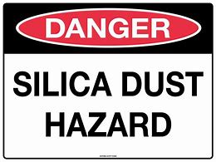  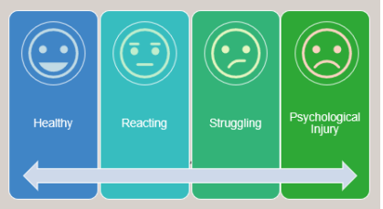 | WorkSafe ACT have advised of two new Codes of Practice coming into effect in November on their web site at this Link.  - (Managing the Risks of Airborne Crystalline Silica (Silica Dust) in the Workplace Code of Practice  - Managing Psychosocial Hazards at Work Code of Practice.  The Code of Practice for managing the risks of silica dust commences on 15 Nov 2023 and supports the WHS regulations introduced in 2022. It aims to provide better protection to ACT workers who modify engineered stone and other materials containing silica.  The Code of Practice for Managing Psychosocial Hazards commences on  27 Nov 2023. This Code aims to provide more information to duty holders about what psychosocial hazards are, how to prevent harm and what control measures can be used in workplaces.  More information is available on the WorkSafe ACT web site.
Back to Contents

Recall – LG Batteries – Updated
    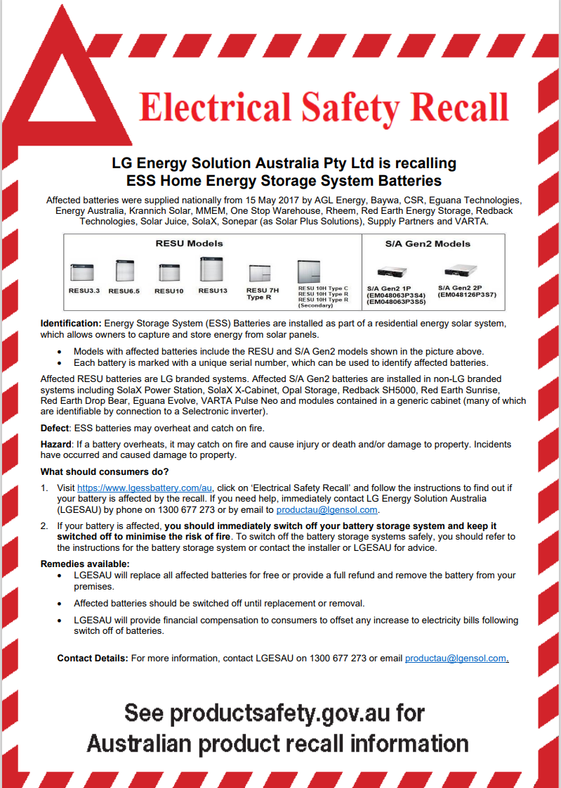 | LG Energy Solution Australia Pty Ltd (formerly LG Chem Australia Pty Ltd) — ESS Home Energy Storage System Batteries  Product description  This safety recall was extended in August 2021 to include additional affected models.  These Energy Storage System (ESS) Home Batteries are installed as part of a residential energy solar system which allows owners to capture and store energy from solar panels. Each ESS Home Battery is marked with a unique serial number, which can be used to identify affected batteries.  Affected models include:  • RESU3.3  • RESU6.5  • RESU10  • RESU13  • RESU7H Type-R  • RESU10H Type-C  • RESU10H Type-R  • RESU10H Type-R (Secondary)  • S/A Gen2 1P (EM048063P3S4)  • S/A Gen2 2P (EM048126P3S7)  • S/A Gen2 1P (EM048063P3S5)  The affected ESS Home Batteries are equipped with cells from all production lots manufactured between 29 March 2017 and 13 September 2018. The affected ESS Home Batteries were supplied to consumers in Australia from 15 May 2017.  Affected RESU batteries are LG branded systems. Affected S/A Gen2 batteries are installed in non-LG branded systems including SolaX Power Station, SolaX X-Cabinet, Opal Storage, Redback SH5000, Red Earth Sunrise, Red Earth Drop Bear, Eguana Evolve, VARTA Pulse Neo and modules contained in a generic cabinet (many of which are identifiable by connection to a Selectronic inverter). Some of these batteries are covered by a related recall by SolaX that can be found at PRA 2022/19420 - SolaX Power Aus Pty Ltd - LG S/A Gen2 ESS Batteries.  Separately, batteries with cells manufactured between 21 January 2016 to 28 March 2017 and 14 September 2018 to 30 June 2019 are also subject to another product safety recall PRA 2022/19550 because of the fire hazards they pose. This recall also requires affected batteries to be switched off until diagnostic software has been installed, with financial compensation for consumers for higher energy bills due to the battery being switched off.  What are the defects?  ESS Batteries may overheat and catch on fire.  What are the hazards?  If a battery overheats, it may catch on fire and cause injury or death and/or damage to property. Incidents have occurred and caused damage to property.  What should consumers do?  1. Visit https://www.lgessbattery.com/au, click on ‘Electrical Safety Recall’ and follow the instructions to find out if your battery is affected by the recall. If you need help, immediately contact LG Energy Solution Australia (LGESAU) by phone on 1300 677 273 or by email to productau@lgensol.com.  2. If your battery is affected, you should immediately switch off your battery storage system and keep it switched off to minimise the risk of fire. To switch off the battery storage systems safely, you should refer to the instructions for the battery storage system or contact the installer or LGESAU for advice.  Additional Information  Supplier:  LG Energy Solution Australia Pty Ltd (formerly LG Chem Australia Pty Ltd)  Traders who sold this product:  AGL Energy, Baywa, CSR, Eguana Technologies, Energy Australia, Krannich Solar, MMEM, One Stop Warehouse, Rheem, Red Earth Energy Storage, Redback Technologies, Solar Juice, SolaX, Sonepar (as Solar Plus Solutions), Supply Partners, VARTA, Various residential solar energy storage system retailers  Dates available for sale:  The affected ESS Home Batteries are equipped with cells from all production lots manufactured between 29 March 2017 and 13 September 2018. The affected ESS Home Batteries were supplied to consumers in Australia from 15 May 2017.  ACCC Notice:  LG Energy Solution Australia Pty Ltd (formerly LG Chem Australia Pty Ltd) — ESS Home Energy Storage System Batteries | Product Safety Australia  Recall Notice:  Recall Advertisement - Updated 29 September 2023.pdf
Back to Contents

Failed Inspections – Defect Notices – Demerit Points
    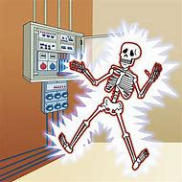   | The Access Canberra Electrical Inspections team have seen an increase in electrical installations that have had major safety issues. In 2022 the inspection fail rate was 2.0% in 2023 it has increased to 3.5%  An area of major concern and focus is the Renewable energy sector, which includes Photovoltaic and Battery systems. The fail rate at the end of June 2023 was 14%, which is 4 times higher than the rest of the electrical industry.  Electricians are advised that the Certificate of Electrical Safety (CES form) is a declaration that the electrician;  - has completed the electrical work,  - has tested the electrical work,  - certifies the electrical work as compliant to the Wiring Rules.  Do not submit the CES form until the abc from above are completed. It is the electrician’s responsibility to test the electrical installation and to ensure it is safe and compliant to the Wiring Rules.  When a major safety issue is identified by the electrical inspector, a Defect Notice will be sent to the electrician, additionally the electrical inspections team managers will conduct a review, which may result in Demerit Points being issued to the electrician.  Some examples for Demerit Points are, (but not limited to)  - Failure, to test an electrical installation and/or issue a CES.  - RCD not installed where required.  - PV panel cables not supported correctly.  - Reverse polarity.  - Cables not terminated at equipment, and  - Direct contact with live parts.  When at 15 Demerit Points in 3 Years, your licence can be cancelled and/or suspended. Even before you reach 15 Demerit points the Registrar can condition your licence, or request training be undertaken.  We would rather work with the electrical industry and help you achieve compliance than issue Demerit Points, so please take care with your testing. AS/NZS 3000:2018 Section 8 and AS/NZS 3017 provide guidance to the testing required to certify an electrical installation.
Back to Contents

Ceiling insulation – Update
The Access Canberra Electrical Inspections team advise electricians, where electrical works are included as a part of ACT Government programs such as the Sustainable Household Scheme (SHS), the Energy Efficiency Scheme and the Residential Tenancies Amendment Regulation 2023 (No1), additional reporting to Access Canberra is required.

An Insulation Installation Electrical Safety Inspection Report (iiESIR) must be completed and submitted with the CES form. Please find link to the iiESIR form here: iiESIR report
Further information regarding the government scheme can be found here:
Ceiling insulation - Climate Choices (act.gov.au)

Updated Information - Main Issues encountered with Inspections
Access Canberra Electrical Inspectors have commenced inspections on installations which have had thermal insulation installed, below is a summary of some of the issues inspectors have come across.
- CES forms are being submitted without the Electrical Safety Inspection Report (iiESIR report)
- Information on the CES is incomplete, we have found owners contact details missing, load details missing. If in doubt, information should be included in comments section or additional attachments, inspectors have reported photos in the attachments would help.
- If no electrical work was carried out, this should be recorded in the comments section.
- Installation type on CES - Insulation should be selected in drop down menu.
  - New options have recently been added.
- Once CES is submitted contact Access Canberra booking Staff to arrange an inspection whilst contact details on CES are current.
- If in doubt put information in comments section of CES form and we will follow up with you.

Electrical Wiring System
An electrician needs to conduct an assessment of any wiring system that is affected by the installation of insulation and complete the required reports.

Attached is a link to a fact sheet with further information regarding thermal ceiling and cavity insulation : Fact Sheet - Thermal roof and cavity insulation.

Certificate of Electrical Safety (CES)
The type of CES form submitted will depend on the work performed:
- Where no electrical work other than the safety inspection has taken place, this would require a REPAIR category CES form.
- Where wiring work has taken place to make the electrical installation compliant due to the insulation activity this would be an ALTERATIONS category CES form

Notes regarding CES forms:
- The replacement of a Halogen downlight with a LED downlight is considered a REPAIR.
- Repairs and Alterations CES forms with attached iiESIR (where required) are to be submitted via the Access Canberra smart-forms portal: Certificate of Electrical Safety (act.gov.au)
- An additional check box in the category of works will be added for the Sustainable Household Scheme (SHS). This box must be checked at time of submission.

Back to Contents

Cessation of physical Construction Occupational Licencing Cards
  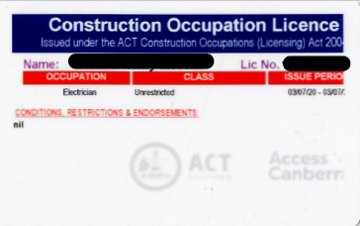  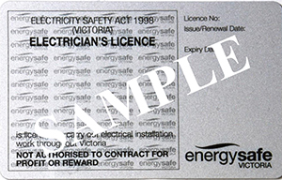    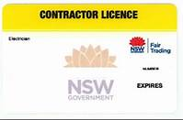 |   From 1 January 2024, Access Canberra will cease printing physical Construction Occupational Licencing Cards.  This change reduces our environmental impact, improves efficiency of licence assessments and empowers the community by making licence information publicly accessible on the Access Canberra website.  What do I need to do?  You are not required to take any action and this change will not impact your ability to carry out your work in the ACT.  Licence cards are no longer required to be carried on construction sites and the Public Registers page is used to verify credentials.  When you next renew your licence, you will be offered an optional PDF certificate in place of a physical card.  We have addressed some questions you might have below. If you have any further questions, please contact cwpl@act.gov.au.  Yours sincerely  Nick Lhuede  Construction Occupations Registrar
Back to Contents

FAQ: Cessation of physical Construction Occupational Licencing Cards
What if I don’t have a smartphone, how will I display my licence?
You can apply for a PDF certificate and print this out.

My card hasn’t expired yet, can I still use it as proof of licencing?
Yes, the licence can still be used until its current expiry as proof of licencing.

Will this impact my ability to apply for Mutual Recognition in other states?
No, you can use a screenshot of your online registration as proof of licencing when applying in other states.

How can I check my licence details?
You can access your licence details on the Public Registers page on the Access Canberra website.

My potential client is requesting proof of licensing and requesting a copy of my licence card, what can I do?
The client can refer to the Public Registers page on the Access Canberra website or can also contact our licencing team to confirm by emailing cwpl@act.gov.au or calling (02) 6207 8096.

How will I know when to renew my licence if I can’t see the expiry date on my licence card?
You can view your details on the Public Registers page on the Access Canberra website. You will also receive a licence renewal reminder via SMS and email.

What do I do if I renew my licence and it isn’t reflected on the Construction Professionals page?
If your details are not on the Public Registers page, contact the licencing team on (02) 6207 8096.

Will I still be required to provide a physical copy of my licence when undertaking site inductions?
No. The organisation can refer to the Public Registers page on the Access Canberra Website.

What security measures are in place to ensure the electronic copy of my licence remains private and will not be accessible or used fraudulently by others?
Only your name, occupation class, the licence number and expiry date are published the register. We do not publish other personal information. If you have concerns someone is using your details fraudulently, report it to the licensing team by emailing cwpl@act.gov.au or by phoning (02) 6207 8096.

Back to Contents

More Information
 | The Access Canberra electrical inspections team have published Frequently Asked Questions (FAQ) and fact sheets on several subjects that are either a concern for compliance, or where the electrical industry can benefit from our assistance.  The FAQs can be found on our web site at: Construction industry information (act.gov.au)  If you think additional content is required, send us an email.  The FAQs will be updated as new questions come in and Australian Standards are updated.
Back to Contents

Email Address and Contact Information
   | All licensed construction professionals in the ACT are required to keep their details up-to-date, and to notify Access Canberra within seven (7) days of any change. Use this link to access the change of address form.  Not only do we use your email address to keep you up to date with emerging issues affecting the electrical industry, the  - Licensing team need it to send out your licence reminders.  - Electrical inspections team need it to send out inspections reminders and results.  Where you use a work email address, consider to also use a personal email address, for those times you are on leave or change employers and we need to let you know of an important issue.  Did you know Access Canberra provides a list of construction professionals on their website? Visit Construction Professionals (act.gov.au)  https://www.accesscanberra.act.gov.au/s/contstruction-professionals
Back to Contents

Advice, Defect Notice Reviews, Extension of time
 | Advice  Electricians requiring advice on Wiring Rules interpretations should check out our FAQ page Construction industry information (act.gov.au) and should additional information be required they can contact the electrical inspections team by email at Electrical.Inspections@act.gov.au.  To aid in providing consistent advice to the electrical industry, only the electrical inspections team manager will respond to your enquiry. If you pose a question on site to an electrical inspector, this must not be considered as binding advice but as the personal opinion of that inspector.  Defect Notice Questions & Review  If you receive a Defect Notice from an electrical inspector and have questions relating to it, we have the following process for reviewing it.  - Call the inspector who issued the defect notice, their mobile number will be on the notice. Discuss your questions or concerns to see if a resolution is possible. If it is not possible to come to a consensus, ask for their team manager’s contact details.  - Call the team manager and discuss your concerns.  - Should the team manager not be able to come to a consensus view then send an email to: The Director of Electrical Inspections at Electrical.Inspections@act.gov.au with your concerns and request a review.  Extension of time  If you require an extension of time to make repairs the Defect Notice has identified, please email the Electrical team at with your request as soon as possible and before you receive the Final Notice. Electrical.Inspections@act.gov.au
Back to Contents

Contact Us
 | Access Canberra Electrical Inspections Team  Phone: 02 6207 7775 (8:30am to 4:30pm) Business Days  Email: Electrical.Inspections@act.gov.au  Web: https://www.accesscanberra.act.gov.au
Previous electrical notices are available at: Construction industry information (act.gov.au)

https://www.accesscanberra.act.gov.au/s/article/construction-industry-information-tab-electrician-notes

Back to Contents

