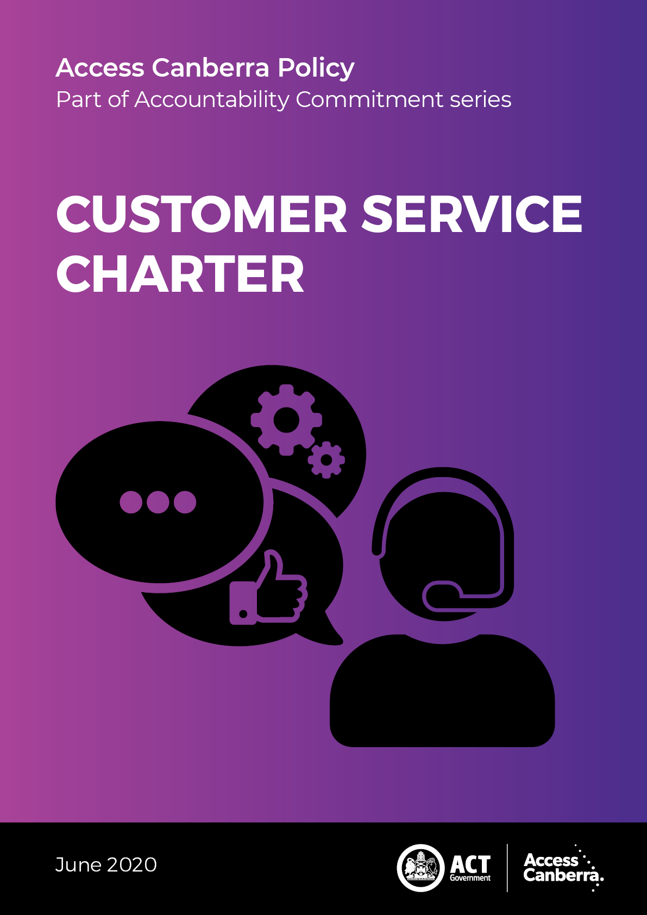

Chief Minister, Treasury and Economic Development Directorate - CMTEDD

Access Canberra

P: 13 22 81

W: <https://www.accesscanberra.act.gov.au/s/>

Published June 2020

IMPORTANT NOTE: This information is for guidance only.

## Forward

### Purpose

The Access Canberra Accountability Commitment explains how Access Canberra will approach its role as both a service provider and a risk-based regulator, including what factors will be considered when dealing with non- compliance.

### Aim

The Accountability Commitment ensures that Access Canberra is approaching its role as a service provider and risk-based regulator in a consistent and transparent way. There are four policies that make up the Accountability Commitment series:

* Customer Service Charter;
* Decision Making Guidelines;
* Regulatory Complaint and Investigation Policy; and
* Compliance and Enforcement Policy.

This Accountability Commitment policy together with frameworks (tailored for different sectors the organisation oversees), is Access Canberra’s adopted approach to compliance and enforcement. Access Canberra will focus its resources where the risks of harm, unsafe practices or misconduct are greatest in the community.

## Content

Forward 3

Purpose 3

Aim 3

Content 4

Introduction 5

SERVICE DELIVERY – PRINCIPLES 6

Principles 6

Service Delivery – COMMITMENT 7

Advice, decisions and actions 7

Conduct 7

WHAT YOU CAN EXPECT FROM US 8

What you can expect from us 8

WHAT WE EXPECT FROM YOU 9

What we expect from you 9

FEEDBACK AND COMPLAINTS 10

Feedback and complaints 10

General feedback 10

MANAGEMENT OF INFORMATION 11

Management of information 11

Responses 11

COMPLAINTS 12

Complaints about our service delivery 12

Complaints about the conduct of our staff 12

REGULATORY MATTERS AND COMPLAINTS 13

Policy and Legislation 13

Regulatory complaints and investigations 13

REGULATORY MATTERS AND COMPLAINTS CONTINUE... 14

COMPLAINTS ABOUT OUR DECISIONS 15

Complaints about our decisions 15

Compliance and enforcement policy and frameworks 16

Compliance and enforcement policy and frameworks 16

## Introduction

Access Canberra is an agency within Chief Minister, Treasury and Economic Development Directorate (CMTEDD). Access Canberra combines the territory’s service centres, shopfronts, contact centre and online services within a single organisation to provide the Canberra community with a highly effective services hub.

It is a one-stop shop for ACT Government customer and regulatory services. We provide an easy, streamlined approach to accessing government information and undertaking a range of transactions with the ACT Government.

Access Canberra is committed to delivering excellent, integrated services for ACT businesses, community groups and individuals seeking service, support, protection and advice from the ACT Government on a range of matters including:

* Building, utilities, land and lease regulation
* Electricity, natural gas, water, sewerage and industry technical regulation
* Environment protection and water regulation
* Fair trading and registration, inspection and regulatory services
* Occupational licensing
* Public health protection and regulation for food permits
* Racing and gambling legislation
* Transport regulation and licensing
* Controlled sports registrations

****

# SERVICE DELIVERY – PRINCIPLES

...understand customer and government needs...

## Principles

***User-centred***– we will understand customer and government needs and create a balanced, seamless end-to-end experience.

***Simplified***– we will ensure services are streamlined, logical, reduce administrative burden on users, and are easy to understand and use.

***Inclusive*** – we will make services accessible to all members of our community, use a ‘digital first approach’ where appropriate and involve users in design.

***Connected***– we will ensure services are effective and joined up, collaborating across service providers, so customers only have to tell their story once.

***Sustainable***– we will continuously improve to provide better services into the future. We welcome suggestions on how we can better serve our customers.

***Supported*** – we will employ staff who are accountable, responsive and skilled to ensure that the customer’s experience with us continues to meet expectations and needs.

person in circle

# Service Delivery – COMMITMENT

...We will be honest, respectful and treat you fairly and we expect the same from you....

## Advice, decisions and actions

* We will help you to access government services, coordinate approvals and keep you up to date if you are waiting on a decision.
* We will give you;
* clear and comprehensive advice;
* make it easy to understand what is needed to use a government service;
* the reasons for our decisions or actions.
* We will educate you about your legal obligations as they apply to your activities, including matters relating to fair trading, safety and environmental protection.

## Conduct

* We will be professional and efficient in our dealings with you.
* We will be honest and respectful
* We will treat you fairly and expect the same from you.
* We will stop interacting with you if you are threatening or behave inappropriately

****

# WHAT YOU CAN EXPECT FROM US

...we will assist you effectively in an inclusive personalised way drawing on a range of supports as needed, including interpreter services and help with accessibility requests…

## What you can expect from us

* We will respond to your enquiries and process your transactions accurately, thoroughly and promptly;
* We will serve you in a professional, courteous and respectful manner;
* We will listen carefully to you to ensure we can assist you.
* We will provide support where needed, including interpreter services and help with any accessibility requests made of us;
* We will act with honesty and integrity;
* We will respect and protect your privacy.
* We will manage your information in a way that protects your personal safety.
* We welcome your comments and feedback so we can continue to improve the quality of our service; we conduct regular customer satisfaction surveys to measure our performance.
* We will make it as convenient as possible for you to contact us and to do business with the ACT Government.

****

# WHAT WE EXPECT FROM YOU

...let us know if you need an interpreter or any assistance in understanding or accessing our services...

## What we expect from you

* To be courteous and respectful towards our staff;
* To respect the rights and privacy of other customers;
* To be patient during busy times, such as days before and after a public holiday;
* To let us know if you need an interpreter or any assistance in understanding or accessing our services;
* To supply valid documents and supporting paperwork when transacting with Access Canberra.
* To understand our staff have processes and legal obligations they must follow, which we will explain to you,
* To help us recognise our staff by telling us when you received excellent customer service.

****

# FEEDBACK AND COMPLAINTS

...We value the feedback we receive about our service delivery and will use it to continually improve our service and performance...

## Feedback and complaints

We value the feedback we receive about our service delivery and will use it to continually improve our service and performance.

## General feedback

Access Canberra is committed to providing excellent service.

You can provide general feedback by:

| icon online | Using our [online correspondence form](https://www.accesscanberra.act.gov.au/s/feedback-and-complaints) |
| --- | --- |
| icon call us | Calling us on **13 22 81** |
| icon post | Writing to us at: Access Canberra Customer Services GPO Box 158  CANBERRA ACT 2601 |

****

# MANAGEMENT OF INFORMATION

...Any information you provide to Access Canberra will be managed in accordance with privacy and record keeping requirements...

Management of information

You can choose to remain anonymous in some of your interactions with us. However, if you provide your contact details, it will allow us to respond more fully, provide you with government services, and contact you for more information if needed.

Any information you provide to Access Canberra will be managed in accordance with privacy and record keeping requirements. Feedback will also be monitored to identify trends and to improve agency capability and services.

Feedback supplied anonymously still provides us with useful information that can help make improvements to our services.

## Responses

Feedback will be acknowledged within two business days.

Our commitment is to seek to resolve a non- regulatory complaint within 10 business days from the date the complaint was received.

If the response will take longer than normal, you will be kept informed and updated on progress.

****

# COMPLAINTS

... Access Canberra staff will act professionally and without bias....

## Complaints about our service delivery

Access Canberra staff are committed to delivering superior customer service. If you have a complaint about the service you received, we will try to resolve your complaint at first contact.

If required, your complaint will go to a manager, or person of appropriate level for assessment and resolution. You will be advised of the outcome of your complaint.

## Complaints about the conduct of our staff

Access Canberra staff will act professionally and without bias. If you have a complaint about the professional conduct of an Access Canberra staff member please refer your concerns to us as soon as possible.

Your complaint will be treated in confidence and investigated in accordance with this policy and [ACT Public Service guidelines](https://www.cmtedd.act.gov.au/employment-framework/managers-And-supervisors/managers-toolkit/values-and-behaivour).

****

# REGULATORY MATTERS AND COMPLAINTS

...welcomes complaints about the conduct of the individuals, businesses or industries that we regulate...

## Policy and Legislation

Feedback about a suggested change in policy or requests for explanations of policy or legislation is welcomed. Such feedback will be managed in the same way as feedback about service delivery.

## Regulatory complaints and investigations

Access Canberra welcomes complaints about the conduct of the individuals, businesses or industries that we regulate.

Due to the complex nature of such complaints, we will keep you informed about the progress of your complaint. All regulatory complaints are assessed in accordance with the principles outlined in this document.

You can lodge a complaint by:

| icon online | Using our [online correspondence form](https://www.accesscanberra.act.gov.au/s/feedback-and-complaints) |
| --- | --- |
| icon call us | Calling us on **13 22 81** |
| icon post | Writing to us at: Access Canberra Customer Services GPO Box 158  CANBERRA ACT 2601 |

****

# REGULATORY MATTERS AND COMPLAINTS CONTINUE...

...If your complaint requires immediate action...

If your complaint requires immediate action by Access Canberra or another agency because the conduct may cause harm to life, health or the environment please refer your concerns to:

| icon call us | ACT WorkSafe –  phone: (02) 6207 3000*(during office hours)* |
| --- | --- |
| icon call us | ACT WorkSafe After-hours –  phone: 0419 120 028 *(for Work, Health & Safety and Dangerous Substances)* |
| icon call us | Health Protection Service -  phone: (02) 5124 9700  *(during office hours)* phone:(02) 9962 8612  *(After-hours)* |
| icon call us | Environment Protection –  phone: 13 22 81 |
| icon call us | In a life-threatening **emergency**, at any time, day or night, you should phone **Emergency Triple Zero** (**000**) for Police, Fire or Ambulance |

****

# COMPLAINTS ABOUT OUR DECISIONS

...If your complaint relates to the regulatory decision of an Access Canberra regulator, you have the right of appeal…

## Complaints about our decisions

If your complaint relates to the regulatory decision of an Access Canberra regulator, you have the right of appeal. Please refer to the appeal information provided to you. If you don’t have this information, please let us know via our feedback contact options.

If you are dissatisfied with our response, you may request an internal review. Internal reviews will be considered by a senior officer who was not involved in the original response.

An internal review may be a prerequisite to a review by the **ACT Civil and Administrative Tribunal (ACAT).** When reviewing a decision, ACAT has all the powers of the original decision maker as described above.]

[logo](https://www.acat.act.gov.au/)

| Web: <https://www.acat.act.gov.au/> |
| --- |
| Phone: (02) 6207 1740 |
| Contact: ACAT  GPO Box 370 CANBERRA ACT 2601 |
| Email: [tribunal@act.gov.au](mailto:tribunal@act.gov.au) |

Finally, the **ACT Ombudsman** performs an important administrative law function by resolving complaints and monitoring the actions of government agencies, which includes any legislative decisions made within Access Canberra. The Ombudsman has strong investigatory powers and can investigate many types of complaints relating to matters of administration, either through a complaint or of own motion.

[logo](https://www.ombudsman.act.gov.au/)

| Web: <https://www.ombudsman.act.gov.au/> |
| --- |
| Phone: 1300 362 072 |
| Contact: ACT Ombudsman GPO Box 442 CANBERRA ACT 2601 |
| Email: [ombudsman@ombudsman.gov.au](mailto:ombudsman@ombudsman.gov.au) |

icon compliance framworks

# Compliance and enforcement policy and frameworks

The ‘Accountability Commitment’ policies aim to provide a practical explanation of key approaches Access Canberra takes to its role as both a service provider and a risk-based regulator.

## Compliance and enforcement policy and frameworks

The Access Canberra Accountability Commitment series includes:

* [Customer Service Charter](https://files.accesscanberra.act.gov.au/legacy/5281/200447%20-%20AC%20Customer%20Service%20Charter%20Policy%20-%20PDF%20(A26190839).pdf);
* [Decision Making Guide](https://files.accesscanberra.act.gov.au/legacy/5283/200447%20-%20AC%20Decision%20Making%20Policy%20-%20PDF%20(A26190675).pdf);
* [Regulatory Complaint and Investigation Policy](https://files.accesscanberra.act.gov.au/legacy/5277/200447%20-%20AC%20Complaint%20Investigation%20Policy%20-%20PDF%20(A26190620).pdf); and
* [Regulatory Compliance and Enforcement Policy](https://files.accesscanberra.act.gov.au/legacy/5285/200447%20-%20AC%20Regulatory%20Compliance%20Enforcement%20Policy%20-%20PDF%20(A26190738).pdf)**.**

This document should be read in conjunction with compliance and enforcement specific frameworks, such as:

| icon - building & constuction | [Building and construction services compliance framework](https://files.accesscanberra.act.gov.au/legacy/3062/Building%20and%20construction%20services%20compliance%20framework.pdf) |
| --- | --- |
| karate kick | [Controlled sports compliance frameworks](https://files.accesscanberra.act.gov.au/legacy/5292/AC_Controlled%20Sports%20-%20PDF.pdf) |
| hand and leaf | [Environment protection compliance framework](https://files.accesscanberra.act.gov.au/legacy/3064/Environment%20protection%20compliance%20framework.pdf) |
| icon - fair traiding | [Fair trading compliance framework](https://files.accesscanberra.act.gov.au/legacy/3066/Fair%20trading%20compliance%20framework.pdf) |
| Target Audience with solid fill | [COVID-19 Access Canberra Compliance Inspections](https://files.accesscanberra.act.gov.au/legacy/5287/Access-Canberra-Factsheet-Compliance%20visits.pdf) |
| icon - gamblign and racing | [Gambling and racing compliance framework](https://files.accesscanberra.act.gov.au/legacy/3070/Gambling%20and%20racing%20compliance%20framework.pdf) |
| icon liquor licensing | [Liquor licensing compliance framework](https://files.accesscanberra.act.gov.au/legacy/3072/Liquor%20licensing%20compliance%20framework.pdf) |
| icon - parking operations | [Parking operations compliance framework](https://files.accesscanberra.act.gov.au/legacy/3074/Parking%20operations%20compliance%20framework.pdf) |
| icon - vehicle safety | [Vehicle Safety Standards: Compliance Framework](https://files.accesscanberra.act.gov.au/legacy/5295/AC_Vehicle%20Safety%20Standards%20-%20PDF.pdf) |
| icon - working with vulnerable people | [Working with vulnerable people compliance framework](https://files.accesscanberra.act.gov.au/legacy/3076/Working%20with%20vulnerable%20people%20compliance%20framework.pdf) |

ACTGov Logo

Chief Minister, Treasury and Economic Development Directorate  
Access Canberra

Accountability Commitment Policy  
June 2020