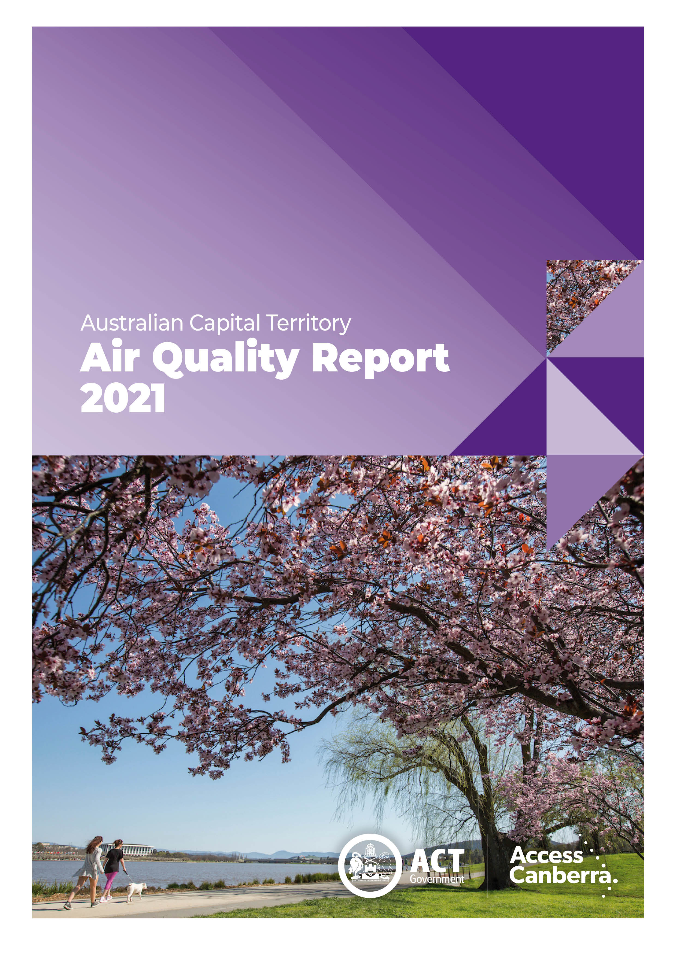

TABLE OF CONTENTS
TABLE OF CONTENTS i
LIST OF TABLES ii
LIST OF FIGURES iii
LIST OF DEFINITIONS AND ABBREVIATIONS iv
OVERVIEW 5
MONITORING SUMMARY 7
Performance Monitoring Stations 7
Monitoring Methods 7
NATA Accreditation Status 8
ASSESSMENT OF COMPLIANCE WITH STANDARDS AND GOAL 9
Carbon monoxide 11
Nitrogen dioxide 12
Ozone 14
PM₁₀ 16
PM_{2.5} 18
ANALYSIS OF AIR QUALITY MONITORING 20
Carbon monoxide 20
Nitrogen dioxide 20
Ozone 20
PM₁₀ 21
PM_{2.5} 21
ASSESSMENT OF PROGRESS TOWARDS ACHIEVING THE GOAL 23
APPENDIX A: STATISTICAL SUMMARY AND TRENDS 25
Carbon monoxide 25
Nitrogen dioxide 27
Ozone 30
PM₁₀ 33
PM_{2.5} 37

LIST OF TABLES
Table 1: Summary of stations’ siting compliance with AS 3580.1.1:2016 7
Table 2: Methods used for monitoring AAQ NEPM pollutants 8
Table 3: AAQ NEPM standards in 2021 10
Table 4: 2021 compliance summary for CO 11
Table 5: 2021 compliance summary for NO₂ 12
Table 6: 2021 compliance summary for O₃ 14
Table 7: 2021 compliance summary for PM₁₀ 16
Table 8: 2021 compliance summary for PM_{2.5} 18
Table 9: 2021 summary statistics for daily peak 8-hour CO 20
Table 10: 2021 summary statistics for daily peak 1-hour NO₂ 20
Table 11: 2021 summary statistics for daily peak 8-hour O₃ 21
Table 12: 2021 summary statistics for daily PM₁₀ 21
Table 13: 2021 summary statistics for daily PM_{2.5} 22
Table 14: 2021 PM_{2.5} exceedances 22
Table 15: Statistical summary for daily maximum 8-hour CO Monash 2012 – 2021 25
Table 16: Statistical summary for daily maximum 8-hour CO Florey 2014 – 2021 26
Table 17: Statistical summary for daily maximum 1-hour NO₂ Monash 2012 – 2021 27
Table 18: Statistical summary for daily maximum 1-hour NO₂ Florey 2014 – 2021 28
Table 19: Statistical summary for daily maximum 8-hour O₃ Monash 2012 – 2021 30
Table 20: Statistical summary for daily maximum 8-hour O₃ Civic 2012 – 2021 31
Table 21: Statistical summary for daily maximum 8-hour O₃ Florey 2014 – 2021 32
Table 22: Statistical summary for daily maximum daily PM₁₀ Monash 2012 – 2021 33
Table 23: Statistical summary for daily maximum daily PM₁₀ Civic 2012 – 2021 34
Table 24: Statistical summary for daily maximum daily PM₁₀ Florey 2014 – 2021 36
Table 25: Statistical summary for daily maximum daily PM_{2.5} Monash 2012 – 2021 37
Table 26: Statistical summary for daily maximum daily PM_{2.5} Civic 2016 – 2021 39
Table 27: Statistical summary for daily maximum daily PM_{2.5} Florey 2014 – 2021 40

LIST OF FIGURES
Figure 1: Daily maximum for CO 8-hour average – Monash 11
Figure 2: Daily maximum for CO 8-hour average – Florey 12
Figure 3: Daily maximum for NO₂ 1-hour average – Monash 13
Figure 4: Daily maximum for NO₂ 1-hour average – Florey 13
Figure 5: Daily maximum for O₃ 8-hour average – Monash 14
Figure 6: Daily maximum for O₃ 8-hour average – Civic 15
Figure 7: Daily maximum for O₃ 8-hour average – Florey 15
Figure 8: Daily maximum for PM₁₀ – Monash 16
Figure 9: Daily maximum for PM₁₀ – Civic 17
Figure 10: Daily maximum for PM₁₀ – Florey 17
Figure 11: Daily maximum for PM_{2.5} – Monash 18
Figure 12: Daily maximum for PM_{2.5} – Civic 19
Figure 13: Daily maximum for PM_{2.5} – Florey 19
Figure 14: Statistical summary for daily maximum 8-hour CO Monash 2012 – 2021 25
Figure 15: Statistical summary for daily maximum 8-hour CO Florey 2014 – 2021 26
Figure 16: Statistical summary for daily maximum 1-hour NO₂ Monash 2012 – 2021 27
Figure 17: Annual average 1-hour NO₂ Monash 2012 – 2021 28
Figure 18: Statistical summary for daily maximum 1-hour NO₂ Florey 2014 – 2021 29
Figure 19: Annual average 1-hour NO₂ Florey 2014 – 2021 29
Figure 20: Statistical summary for daily maximum 8-hour O₃ Monash 2012 – 2021 30
Figure 21: Statistical summary for daily maximum 8-hour O₃ Civic 2012 – 2021 31
Figure 22: Statistical summary for daily maximum 1-hour O₃ Florey 2014 – 2021 32
Figure 23: Statistical summary for daily PM₁₀ Monash 2012 – 2021 33
Figure 24: Annual average daily PM₁₀ Monash 2012 – 2021 34
Figure 25: Statistical summary for daily PM₁₀ Civic 2012 – 2021 35
Figure 26: Annual average daily PM₁₀ Civic 2012 – 2021 35
Figure 27: Statistical summary for daily PM₁₀ Florey 2014 – 2021 36
Figure 28: Annual average daily PM₁₀ Florey 2014 – 2021 37
Figure 29: Statistical summary for daily PM_{2.5} Monash 2012 – 2021 38
Figure 30: Annual average daily PM_{2.5} Monash 2012 – 2021 38
Figure 31: Statistical summary for daily PM_{2.5} Civic 2016 – 2021 39
Figure 32: Annual average daily PM_{2.5} Civic 2016 – 2021 40
Figure 33: Statistical summary for daily PM_{2.5} Florey 2014 – 2021 41
Figure 34: Annual average daily PM_{2.5} Florey 2014 – 2021 41

LIST OF DEFINITIONS AND ABBREVIATIONS
Term | Definition
AAQ NEPM | National Environment Protection (Ambient Air Quality) Measure
ACT | Australian Capital Territory
CO | Carbon Monoxide
BAM | Beta Attenuation Monitor
Exceptional event | Exceptional event means a fire or dust occurrence that adversely affects air quality at a particular location and causes an exceedance of one (1) day average standards in excess of normal historical fluctuations and background levels and is directly related to: bushfire; jurisdiction authorised hazard reduction burning; or continental scale windblown dust
NATA | National Association of Testing Authorities
ND | Not Demonstrated
NO₂ | Nitrogen Dioxide
O₃ | Ozone
PMS | Performance Monitoring Station
PM_{2.5} | Particles with an equivalent aerodynamic diameter less than or equal to 2.5 micrometres
PM₁₀ | Particles with an equivalent aerodynamic diameter less than or equal to 10 micrometres
ppm | Parts per million by volume – parts of pollutant per million parts of air
Q | Quarter (e.g. Q1 means the first quarter of the year)
SO₂ | Sulfur Dioxide
µg/m³ | micrograms per cubic metre

OVERVIEW
The ACT Air Quality Report 2021 (‘the Report’) presents the results of ambient air quality monitoring in the ACT for 2021 and assesses the results in accordance with the requirements of the National Environment Protection (Ambient Air Quality) Measure (AAQ NEPM) made by the National Environment Protection Council on 26 June 1998.
On 18 May 2021 the AAQ NEPM was amended to update the ambient air quality pollutant concentration standards for nitrogen dioxide, sulfur dioxide and ozone. Several other changes were also made during this variation. The key amendments are detailed in the Section on “ASSESSMENT OF COMPLIANCE WITH STANDARDS AND GOAL”.
Air quality in this Report is assessed against the revised AAQ NEPM standards shown in Table 3. In accordance with its agreed policy position, the ACT assesses its compliance for the annual average for particulate matter less than 10 microns (PM₁₀) against a lower standard of an annual average of 20 μg/m³ rather than the 25 μg/m³ standard. This means that it is reporting against a more stringent target than in the published national standard.
The ACT monitors four of the six NEPM pollutants:
- carbon monoxide (CO)
- nitrogen dioxide (NO₂)
- photochemical oxidants as ozone (O₃)
- particulate matter (as PM₁₀, particles less than or equal to 10 microns in diameter and PM_{2.5}, particles less than or equal to 2.5 microns in diameter).
The ACT does not monitor sulfur dioxide (SO₂) as is primarily an industrial pollutant and the ACT does not have much heavy industry. In 2002, lead monitoring ceased with the phase out of leaded petrol.
A summary of the 2021 Report is:
- Canberra's air quality dramatically improved in 2021 compared to 2019 and 2020 due to the absence of bushfires and reduction of dust storms. There were no exceedances of the AAQ NEPM standards for carbon monoxide, nitrogen dioxide and ozone at any of the ACT's monitoring stations;
- Without the impacts from prolonged drought and unprecedented bushfires, the daily PM₁₀ standard was not exceeded in 2021, compared to 27 exceedance days in 2020 and 29 exceedance days in 2019;
- Annual average levels for particulate matter (PM₁₀ and PM_{2.5}) were at some of the lowest levels experienced in the past 10 years; and
- PM_{2.5} was the only pollutant that exceeded the national standard. This was exceeded for 5 days in 2021, which were related to controlled burns in NSW and wood heater emissions in the ACT and occurred between late April and early July:
  - Two exceedances (29 April and 30 April) were likely attributable to smoke from hazard reduction burns in NSW;
  - One exceedance (1 May) was likely attributable to a combination of smoke from hazard reduction burns in NSW and wood heater use; and
  - Two exceedances (21 May and 8 July) were likely attributable to smoke from wood heater use.

MONITORING SUMMARY

Performance Monitoring Stations
The ACT Government has been undertaking ambient air quality monitoring in Canberra since the early 1990’s. The Health Directorate is responsible for the Government’s ambient air quality monitoring network. The Environment Protection Authority within the Chief Minister, Treasury and Economic Development Directorate is responsible for annual reporting under the AAQ NEPM.
The ACT monitoring network consists of three monitoring stations located at:
- Monash – approximately 300 metres west of Cockcroft Avenue in open urban space area;
- Civic – at the northern end of the carpark on the western side of the Olympic swimming pool adjacent to Allara Street; and
- Florey – at the end of Neumann Place, on public land.
The compliance and non-compliance criteria for the monitoring stations against the siting standard AS/NZS 3580.1.1:2016 are listed in Table 1 below.
Table 1: Summary of stations’ siting compliance with AS 3580.1.1:2016
Station | Height above ground | Minimum distance to support structure | Clear sky angle of 120° | Unrestricted airflow of 270°/360° | 20m from trees | No boilers or incinerators nearby | Minimum distance from road or traffic
Monash
Civic
Florey
Monash and Florey stations are the ACT’s two performance monitoring stations as per the requirements under Section 14 of the AAQ NEPM and they fully comply with relevant standards.
In addition, the ACT Government carries out key pollutants monitoring at Civic station to better inform the community concerning ambient air quality and support formation of government policy.
The Monash and Florey stations contain instrumentation that continuously monitors carbon monoxide, nitrogen dioxide, ozone and particles as PM₁₀ and PM_{2.5}. Following the establishment of the Florey station on 28 February 2014, the Civic station only monitors selected, key pollutants, including ozone and particles as PM₁₀ and PM_{2.5}.

Monitoring Methods
The ACT monitoring is conducted in accordance with the relevant Australian Standards as shown in Table 2. Data not meeting the requirements of these Standards are identified as invalid and not included in this Report.

Table 2: Methods used for monitoring AAQ NEPM pollutants
Pollutant | Standard | Title | Method Used
Carbon monoxide | AS 3580.7.1-2011 | Methods for sampling and analysis of ambient air - Determination of carbon monoxide - Direct-reading instrumental method | Gas filter correlation/  Infrared
Nitrogen dioxide | AS 3580.5.1-2011 | Methods for sampling and analysis of ambient air - Determination of oxides of nitrogen - Direct-reading instrumental method | Gas phase  chemiluminescence
Photochemical  oxidant (ozone) | AS 3580.6.1-2016 | Methods for sampling and analysis of ambient air - Determination of ozone - Direct-reading instrumental method | Non-dispersive ultraviolet
PM₁₀ | AS/NZS 3580.9.11-2016 | Method for sampling and analysis of ambient air Method – Determination of suspended particles matter – PM₁₀ beta attenuation monitors | Beta Attenuation Monitor
PM_{2.5} | AS/NZS 3580.9.12:2013 | Methods for sampling and analysis of ambient air - Method 9.12: Determination of suspended particulate matter - PM2.5 beta attenuation monitors | Beta Attenuation Monitor

NATA Accreditation Status
The ACT Government monitoring network is accredited by NATA for the measurement of all AAQ NEPM pollutants except sulfur dioxide and lead as required under Clause 12 of the AAQ NEPM.

ASSESSMENT OF COMPLIANCE WITH STANDARDS AND GOAL
For the purpose of this Report, air quality is assessed against the AAQ NEPM standards as specified in Schedule 2 of the AAQ NEPM and ACT policy position. The standards against which air quality is assessed are concentrations in parts per million (ppm) or micrograms per cubic metre (µg/m³) (refer to Table 3, column 4).
On 18 May 2021, the AAQ NEPM was amended to introduce the new national standards for NO₂, SO₂ and O₃. The amendment, taking into account the latest scientific evidence about the health impacts, primarily includes:
- significantly strengthen NO₂ reporting standards for 1-hour and 1-year averaging periods;
- establish a new O₃ standard with an 8-hour averaging period that reflects the health evidence;
- significantly strengthen SO₂ reporting standards for 1-hour and 24-hour averaging periods;
- remove annual SO₂ and 1-hour and 4-hour O₃ averaging periods to align the standards with the recent health evidence;
- remove single day exceedances allowed for all gaseous pollutants; and
- apply the existing exceptional events rule O₃ given the linkages between elevated O₃ levels and fire events.
While the amended AAQ NEPM took effect partway through the year during 2021, air quality in this Report is assessed against the new and more stringent national standards for the whole year. The goal of the AAQ NEPM is to achieve the NEPM standards specified in Schedule 2 of the AAQ NEPM.
Table 3: AAQ NEPM standards in 2021
Pollutant | Averaging Period | Old NEPM Standards | New NEPM Standards | Change
Carbon monoxide | 8 hours | 9.0 ppm | 9.0 ppm | No change
Nitrogen dioxide | 1 hour  1 year | 0.12 ppm  0.03 ppm | 0.08 ppm  0.015 ppm | Strengthened  Strengthened
Photochemical oxidants (as ozone) | 1 hour  4 hours  8 hours | 0.10 ppm  0.08 ppm | -  -  0.065 ppm | Removed  Removed  Established
Sulfur dioxide | 1 hour  1 day  1 year | 0.20 ppm  0.08 ppm  0.02 ppm | 0.10 ppm  0.02 ppm | Strengthened  Strengthened  Removed
Lead | 1 year | 0.50 μg/m³ | 0.50 μg/m³ | No change
Particles as PM₁₀ | 1 day  1 year | 50 μg/m³  25 μg/m³ | 50 μg/m³  25 μg/m³ | No change  No change
Particles as PM_{2.5} | 1 day  1 year | 25 μg/m³  8 μg/m³ | 25 μg/m³  8 μg/m³ | No change  No change
In accordance with its agreed policy position, the ACT assesses its compliance for the annual average for PM₁₀ against a lower standard of 20 μg/m³ rather than the AAQ NEPM standard of 25 μg/m³. There is an additional goal to further reduce PM_{2.5} concentrations to below a daily concentration of 20 μg/m³ and an annual concentration of 7 μg/m³ by 2025.
Table 4 to Table 8 summarise compliance with the standards of the AAQ NEPM and ACT policy position. For each pollutant, the data availability (quarterly and annual), the number of days when standards were exceeded, the annual average (where an annual standard exists) and an assessment of compliance, are given for each monitoring station. Although Civic station is not a NEPM performance monitoring station, measured data from this station is included in this Report to better understand ambient air quality in the ACT, especially in the city area.
Air quality is assessed as complying with the AAQ NEPM (i.e. ‘MET’) if the maximum recorded concentration is no more than the standard specified in Table 3 and data availability was at least 75 percent in each quarter of the year.
Air quality is assessed as not complying with the AAQ NEPM (i.e. ‘NOT MET’) if the maximum recorded concentration is more than the standard specified in Table 3.
Air quality is assessed as ‘NOT DEMONSTRATED’ (i.e. ‘ND’) if there has been insufficient data collected to demonstrate that the standards and goal have been met or not met.
For the purpose of reporting compliance against PM₁₀ and PM_{2.5} daily average standards, monitoring data that has been determined as being directly associated with an exceptional event has been excluded in accordance with the AAQ NEPM.
These categories (ie MET, NOT MET and ND) are used in Tables 4 to 8 on the following pages.

Carbon monoxide
During 2021, no exceedances of the carbon monoxide standard were recorded and compliance was demonstrated at Florey. Due to instrument failure, there was insufficient data collected in the fourth quarter at Monash. As a result, compliance was not demonstrated at Monash.
Table 4: 2021 compliance summary for CO
AAQ NEPM standard - 9.0 ppm (8-hour average)
Monitoring station | Data availability rates  (% of hours) |  |  |  |  | Number of exceedances  (days) | NEPM goal compliance
 | Q1 | Q2 | Q3 | Q4 | Annual
Monash  Florey | 95.7  95.8 | 95.7  95.8 | 95.6  95.7 | 66.0  93.4 | 88.2  95.2 | 0  0 | ND  MET

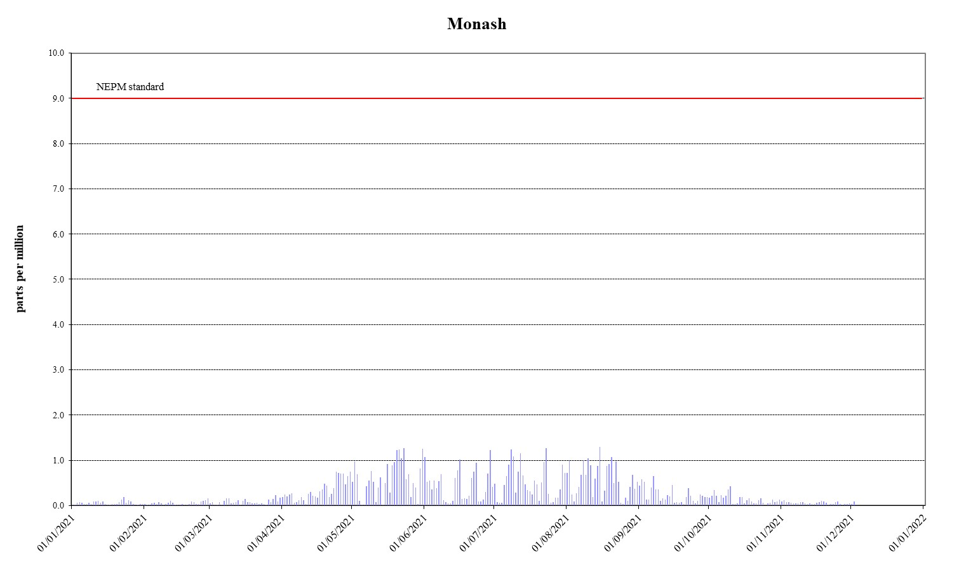

Figure 1: Daily maximum for CO 8-hour average – Monash
`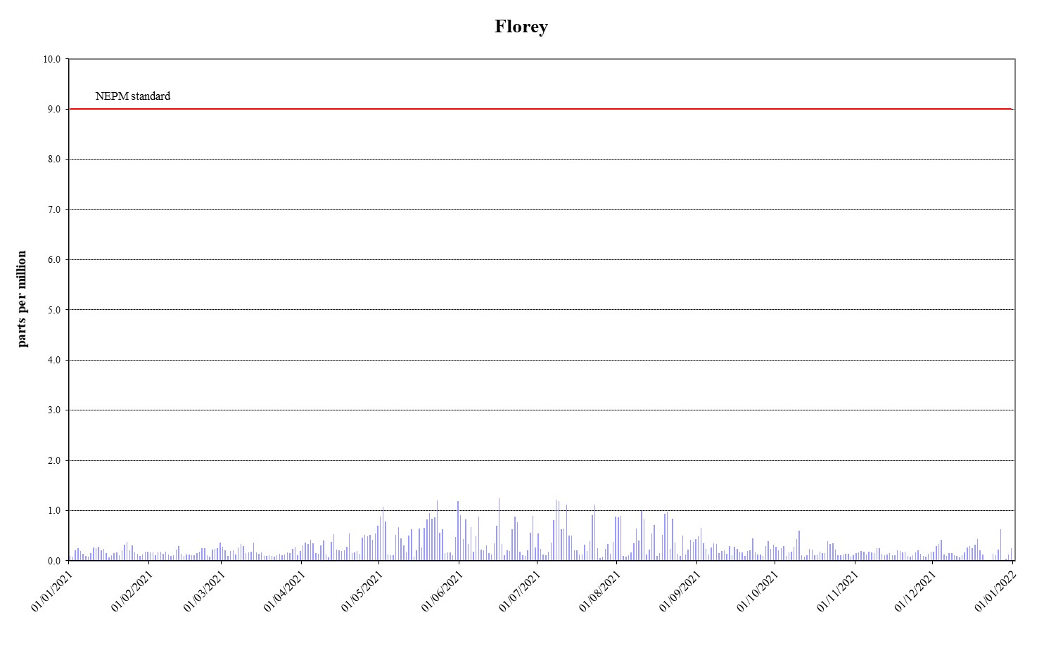
Figure 2: Daily maximum for CO 8-hour average – Florey

Nitrogen dioxide
During 2021, no exceedances of the nitrogen dioxide standards were recorded and compliance was demonstrated at Monash and Florey.
The annual average levels remained low and met the standard at Monash and Florey.
Table 5: 2021 compliance summary for NO₂
AAQ NEPM standard – 0.08 ppm (1-hour average), 0.015 ppm (1-year average)
Monitoring station | Data availability rates  (% of hours) |  |  |  |  | 1 Hour |  | 1 Year
 | Q1 | Q2 | Q3 | Q4 | Annual | Number of exceedances | NEPM goal compliance | Annual average  (ppm) | NEPM goal compliance
Monash  Florey | 95.7  92.1 | 95.7  92.3 | 95.6  91.9 | 95.7  90.2 | 95.7  91.6 | 0  0 | MET  MET | 0.003  0.004 | MET  MET

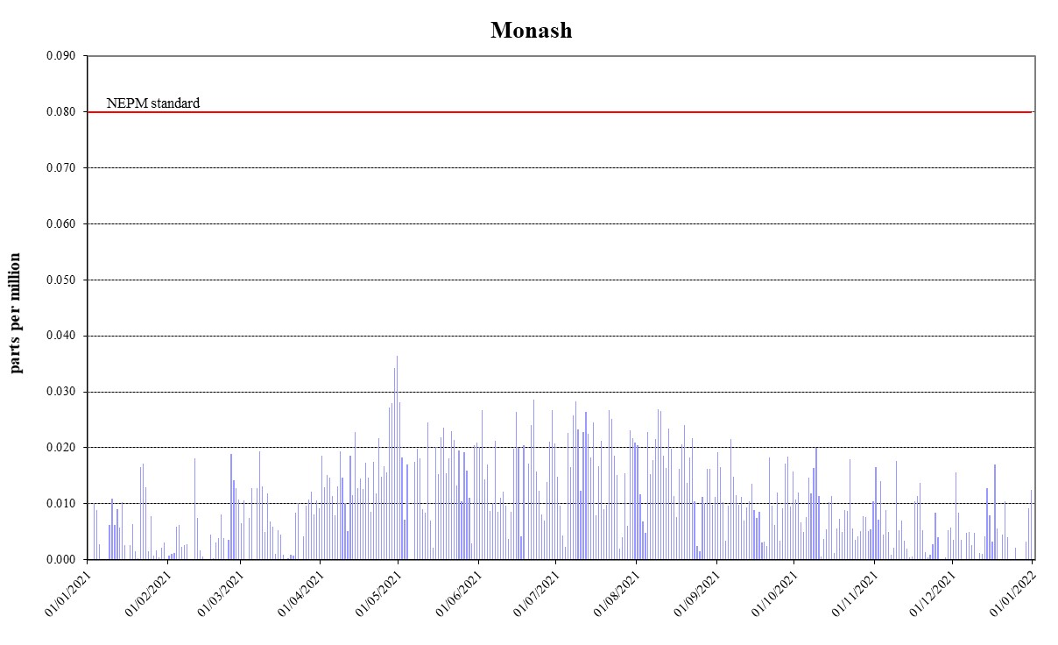
Figure 3: Daily maximum for NO₂ 1-hour average – Monash
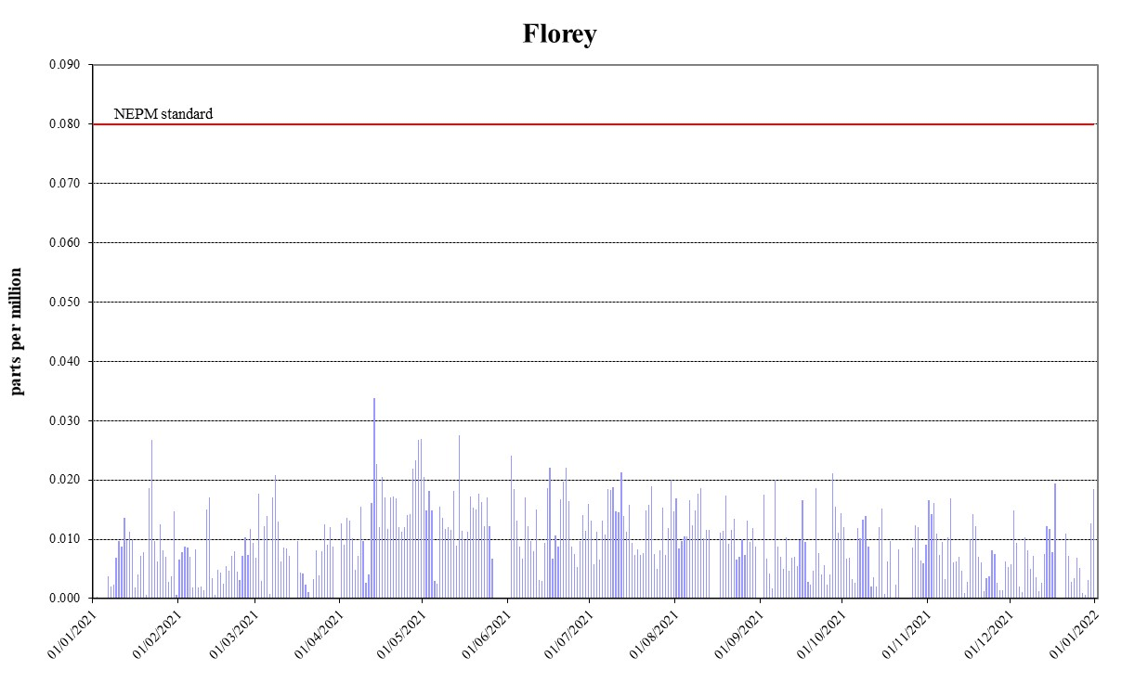
Figure 4: Daily maximum for NO₂ 1-hour average – Florey

Ozone
During 2021, no exceedances of the 8-hour standard for ozone were recorded and compliance was demonstrated at all monitoring stations.
Table 6: 2021 compliance summary for O₃
AAQ NEPM standard – 0.065 ppm (8-hour average)
Monitoring station | Data availability rates  (% of hours) |  |  |  |  | Number of exceedances | NEPM goal compliance
 | Q1 | Q2 | Q3 | Q4 | Annual
Monash  Civic  Florey | 95.7  95.8  95.8 | 95.7  95.8  95.8 | 95.8  95.8  95.8 | 95.7  94.6  95.8 | 95.7  95.5  95.8 | 0  0  0 | MET  MET  MET

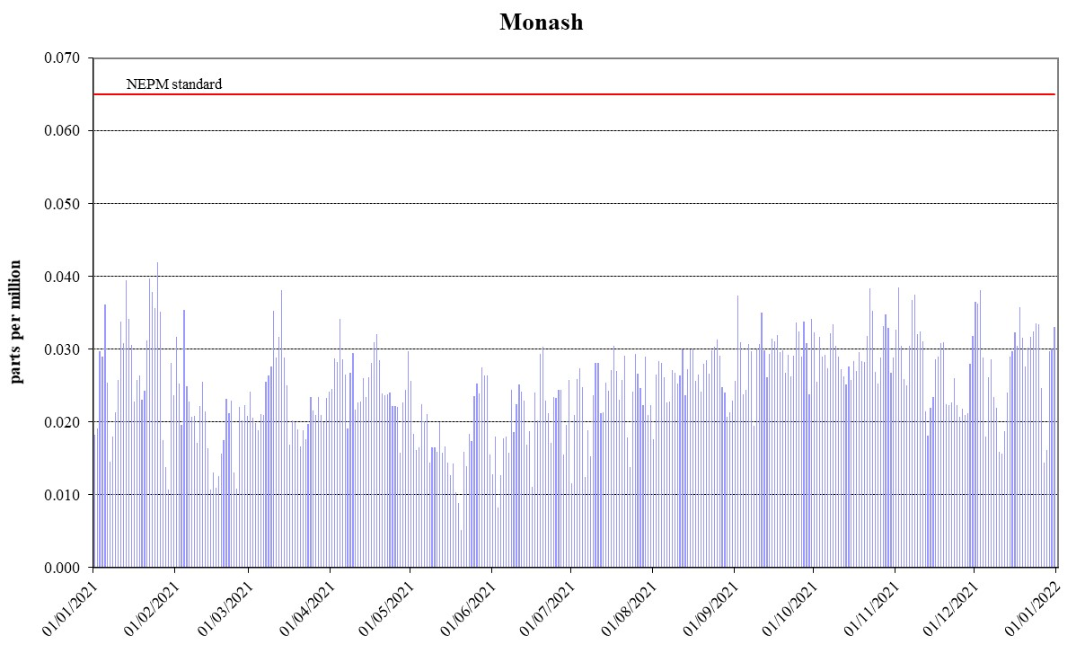
Figure 5: Daily maximum for O₃ 8-hour average – Monash

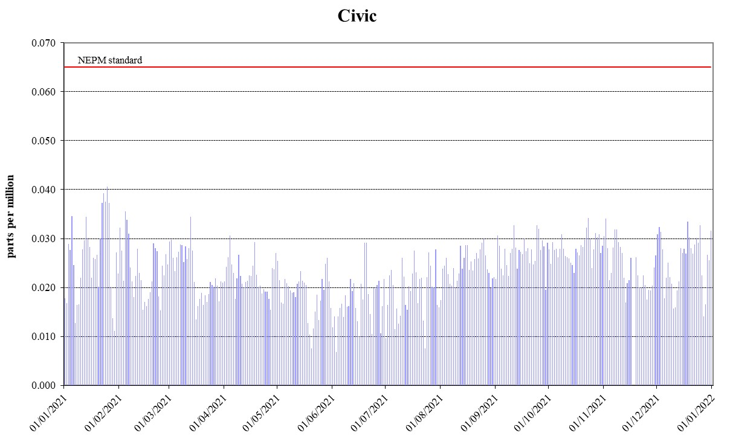
Figure 6: Daily maximum for O₃ 8-hour average – Civic
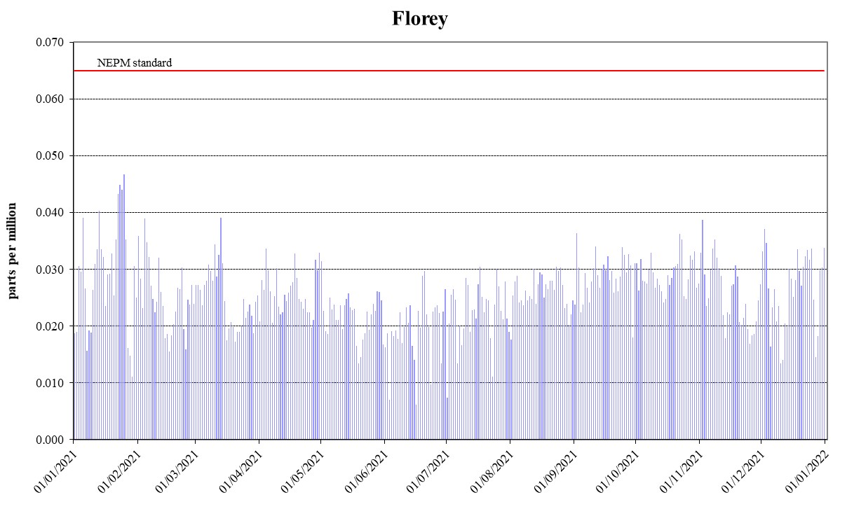
Figure 7: Daily maximum for O₃ 8-hour average – Florey

PM₁₀
During 2021, no exceedances of the daily PM₁₀ standard were recorded and compliance was demonstrated at all monitoring stations.
The annual average PM₁₀ levels at all stations met the ACT policy position of 20 μg/m³.
Table 7: 2021 compliance summary for PM₁₀
AAQ NEPM standard 50 μg/m³ 1-day average, 20 μg/m³ (1-year average)*
Monitoring station | Data availability rates  (% of days) |  |  |  |  | 1 Day |  | 1 Year
 | Q1 | Q2 | Q3 | Q4 | Annual | Number of exceedances | NEPM goal compliance | Annual average  (μg/m³) | ACT goal compliance
Monash  Civic  Florey | 100  92.2  97.8 | 100  100  100 | 97.8  100  97.8 | 100  82.6  100 | 99.5  93.7  99.5 | 0  0  0 | MET  MET  MET | 10.3  8.7  9.6 | MET  MET  MET

* ACT policy position 20 µg/m³ not AAQ NEPM standard of 25 µg/m³ .

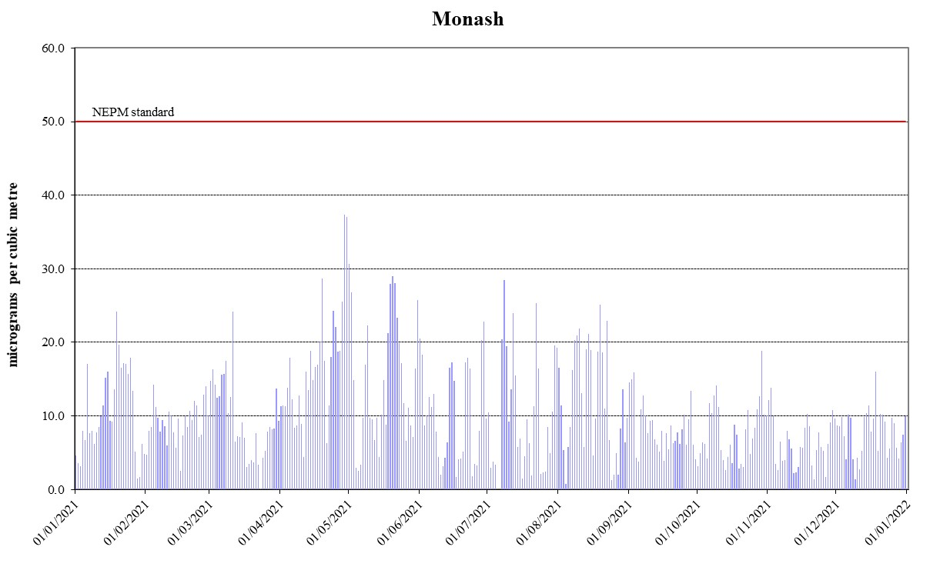

Figure 8: Daily maximum for PM₁₀ – Monash
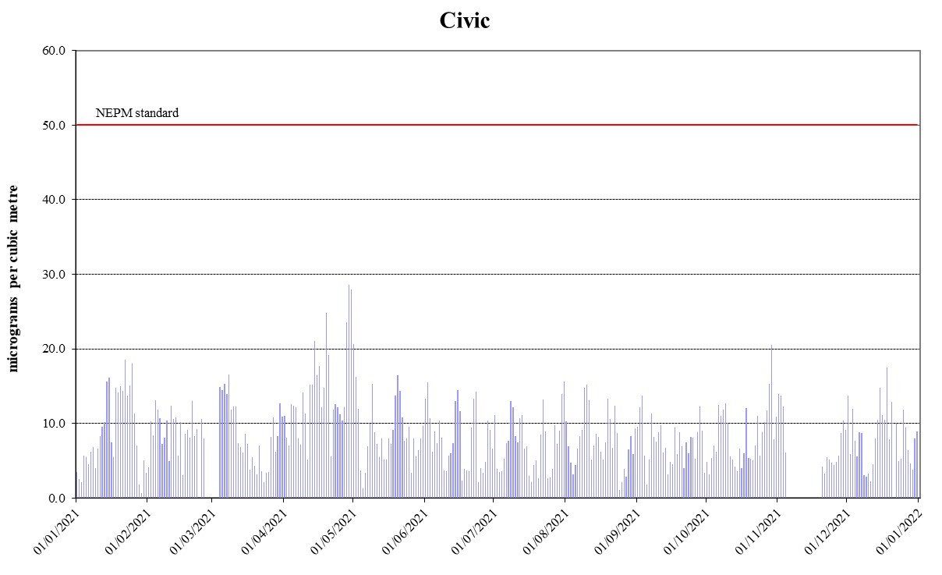
Figure 9: Daily maximum for PM₁₀ – Civic
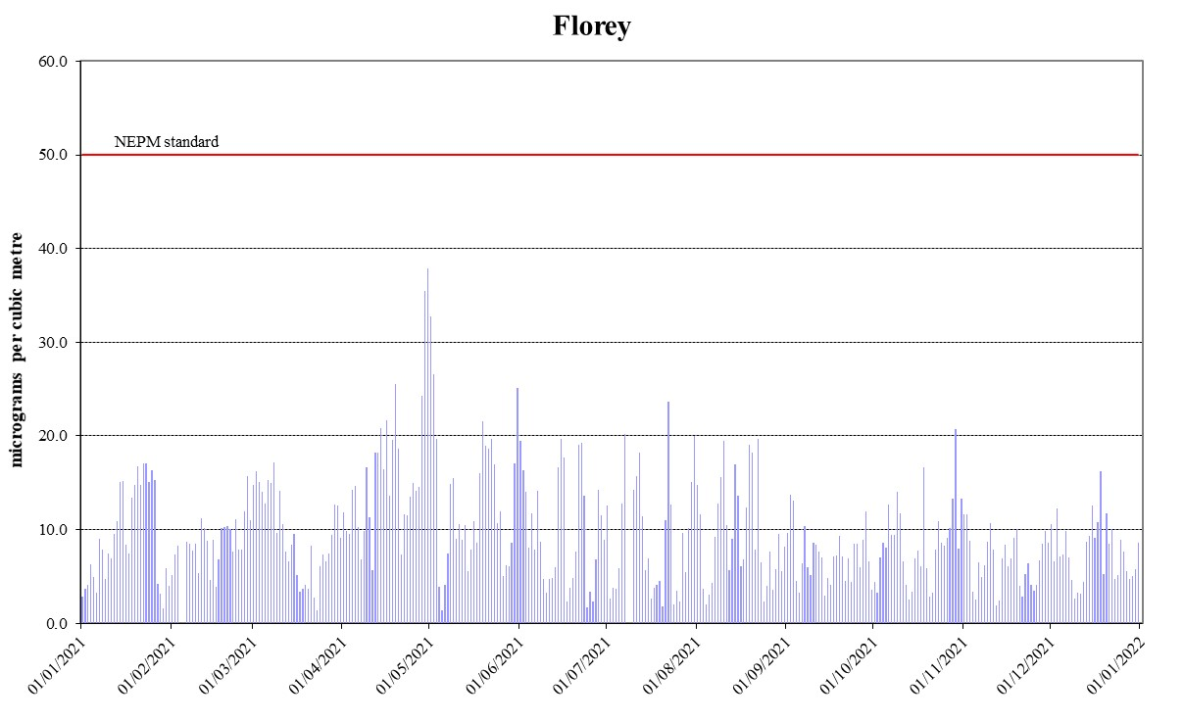
Figure 10: Daily maximum for PM₁₀ – Florey

PM_{2.5}
During 2021, there were exceedances of daily PM_{2.5} standard on 5 days at Monash (5 days) and Florey (3 days). Two exceedance days (April 29 and 30 April) were likely attributable to smoke from hazard reduction burns in NSW. Under the exceptional event rule they have been excluded when assessing compliance against the daily standard. Compliance against the daily PM_{2.5} standard was not met at Monash and Florey. No daily exceedances against the daily PM_{2.5} standard were recorded at Civic. Annual average PM_{2.5} data at all stations met the 8 μg/m³ AAQ NEPM standard.
Table 8: 2021 compliance summary for PM_{2.5}
AAQ NEPM standard – 25 μg/m³ (1-day), 8 μg/m³ (1-year)
Monitoring station | Data availability rates  (% of days) |  |  |  |  | 1 Day |  | 1 Year
 | Q1 | Q2 | Q3 | Q4 | Annual | Number of exceedances* | NEPM goal compliance | Annual average  (μg/m³) | NEPM goal compliance
Monash  Civic  Florey | 97.8  93.3  98.9 | 100  97.8  100 | 100  100  98.9 | 96.7  95.7  95.7 | 98.6  96.7  98.4 | 3  0  1 | NOT MET  MET  NOT MET | 6.8  5.0  6.2 | MET  MET  MET

* the number excludes exceptional events.

55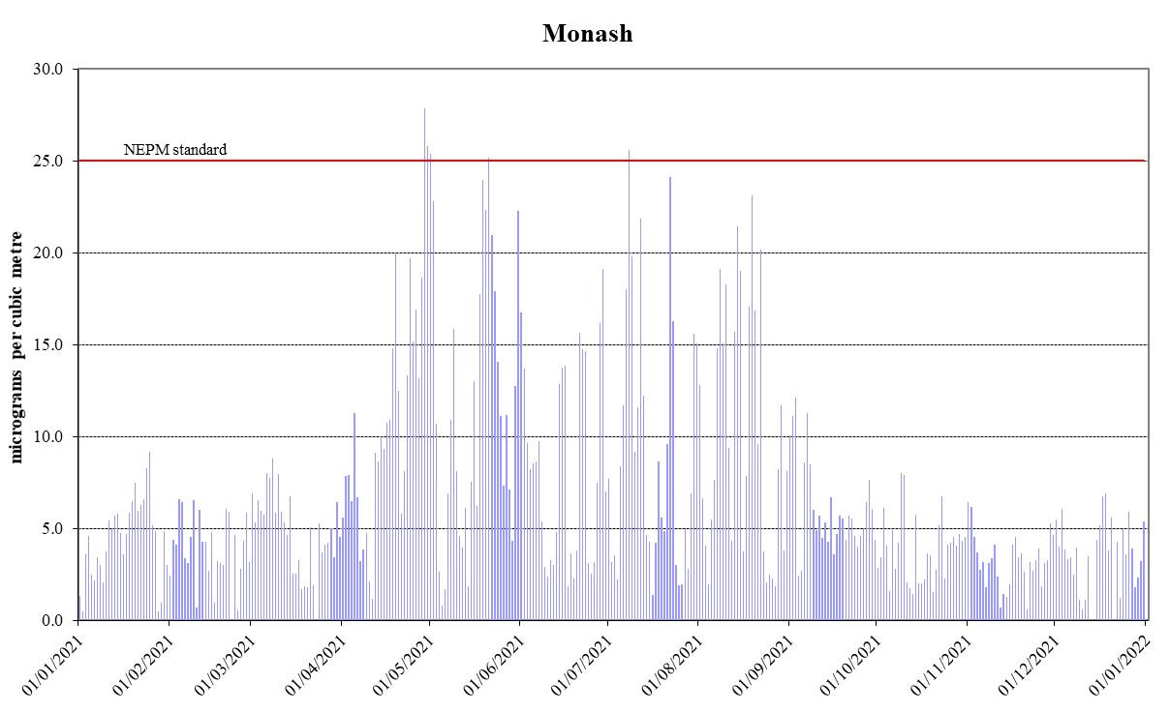
Figure 11: Daily maximum for PM_{2.5} – Monash
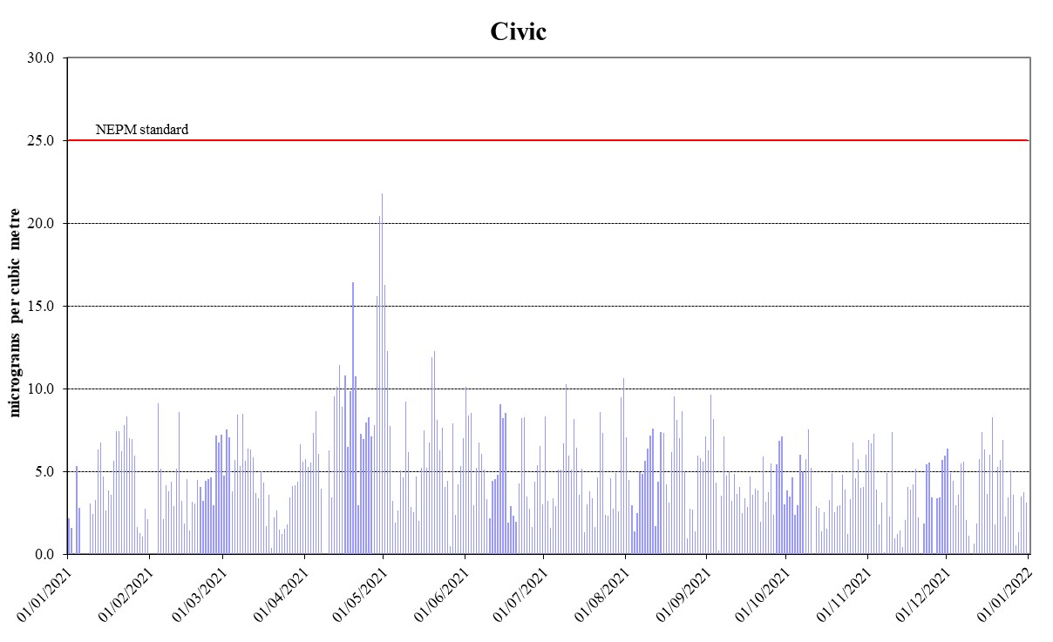
Figure 12: Daily maximum for PM_{2.5} – Civic
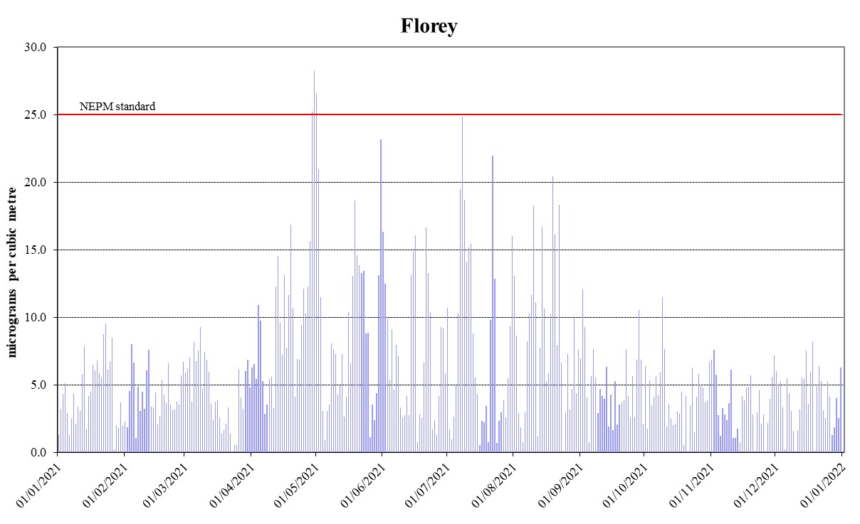
Figure 13: Daily maximum for PM_{2.5} – Florey

ANALYSIS OF AIR QUALITY MONITORING
Annual summary statistics contained in Table 9 to Table 13 below assess air quality against the standards and the extent of compliance with the goal. In each case a result of ‘below the standard’ indicates that compliance is achieved. Instances where the standard has been exceeded are highlighted in bold.

Carbon monoxide
Carbon monoxide levels in 2021 dropped back to a level well below the standard at all monitoring stations, compared to 2019 and 2020. The highest recorded value in the ACT during 2021 was 1.3 ppm at Monash, which was the lowest level in the past ten years.
Table 9: 2021 summary statistics for daily peak 8-hour CO
AAQ NEPM standard - 9.0 ppm (8-hour average)
Monitoring station | Number of valid days | Highest  (ppm) | Highest  (date/time)
Monash  Florey | 336  362 | 1.3  1.2 | 15 Aug 07:00  16 Jun 09:00

Nitrogen dioxide
Similar to carbon monoxide, nitrogen dioxide levels dropped back to a level well below the standard. The highest recorded 1-hour value during 2021 was 0.036 ppm at Monash, which is only 45% of the new standard. The highest recorded annual average in 2021 was 0.004ppm at Florey (refer to Table 5). This is 27% of the new annual standard 0.015ppm.
Table 10: 2021 summary statistics for daily peak 1-hour NO₂
AAQ NEPM standard 0.08 ppm (1-hour average)
Monitoring station | Number of valid days | Highest  (ppm) | Highest  (date/time)
Monash  Florey | 365  339 | 0.036  0.034 | 30 Apr 19:00  13 Apr 10:00

Ozone
Ozone levels in 2021 were below the new 8-hour standard. The highest recorded value in the ACT during 2021 was 0.047 ppm at Florey, which is 72% of the standard.

Table 11: 2021 summary statistics for daily peak 8-hour O₃
AAQ NEPM standard 0.065 ppm (8-hour average)
Monitoring station | Number of valid days | Highest  (ppm) | Highest  (date/time)
Monash  Civic  Florey | 365  363  365 | 0.042  0.041  0.047 | 25 Jan 20:00  25 Jan 20:00  25 Jan 19:00

PM₁₀
PM₁₀ levels were significantly reduced in 2021 without the impacts from prolonged drought and unprecedented bushfires. The highest daily PM₁₀ level was recorded at Florey on 30 April 2021, with the concentration of 37.9μg/m³. The highest recorded annual average in 2021 was 10.3μg/m³ at Monash (refer to Table 7), which is 52% of the ACT policy standard of 20μg/m³.
Table 12: 2021 summary statistics for daily PM₁₀
AAQ NEPM daily standard 50 μg/m³
Monitoring station | Number of valid days | Highest  (μg/m³) | Highest  (date)
Monash  Civic  Florey | 363  342  361 | 37.3  28.6  37.9 | 29 April  29 April  30 April

PM_{2.5}
The daily standard for PM_{2.5} was only exceeded on 5 days in 2021 at one or more of the monitoring stations, compared to 29 days in 2019 and 39 days in 2020.
Two exceedance days in April were likely attributable to smoke from hazard reduction burns in NSW. One exceedance (1 May) was likely attributable to a combination of smoke from hazard reduction burns in NSW and wood heater use at night. Two exceedances (21 May and 8 July) were likely attributable to smoke from wood heater use.
The highest daily PM_{2.5} level was 28.2μg/m³ which was recorded at Florey on 30 April 2021. The highest recorded annual average in 2021 was 6.8μg/m³ at Monash (refer to Table 8).

Table 13: 2021 summary statistics for daily PM_{2.5}
AAQ NEPM daily standard 25 μg/m³
Monitoring station | Number of valid days | Highest  (μg/m³) | Highest  (date)
Monash  Civic  Florey | 360  353  359 | 27.9  21.8  28.2 | 29 April  30 April  30 April

Table 14: 2021 PM_{2.5} exceedances
Date | Monitoring Station |  |  | Inferred Cause | Exceptional Event
 | Monash  (μg/m³) | Civic  (μg/m³) | Florey  (μg/m³)
29 April 2021 | 27.9 |  | 25.2 | Controlled Burn | Yes
30 April 2021 | 25.8 |  | 28.2 | Controlled Burn | Yes
01 May 2021 | 25.4 |  | 26.6 | Controlled Burn Wood Heater | No
21 May 2021 | 25.2 |  |  | Wood Heater | No
08 July 2021 | 25.6 |  |  | Wood Heater | No

ASSESSMENT OF PROGRESS TOWARDS ACHIEVING THE GOAL
Historical monitoring results indicate that the only AAQ NEPM pollutant of concern in the ACT air shed is particulate matter, which increases significantly during winter because of emissions from domestic wood heaters. In more recent years, especially 2018 to 2020, exceedances of the particulate matter standards have also been attributed to smoke from hazard reduction burns, bushfires and dust storms.
Compared to 2019 and 2020, carbon monoxide, nitrogen dioxide and ozone concentrations dropped back to pre-bushfire levels. The AAQ NEPM standards for these pollutants were met during the whole year. PM₁₀ levels were also significantly reduced in 2021 in the absence of prolonged drought and bushfires.
PM_{2.5} levels increase significantly during the cooler months of the year which can be seen in Figure 11 to Figure 13. PM_{2.5} is the pollutant most affected by woodsmoke as the majority of combustion particles are less than 1 micron in diameter.
The ACT Government acknowledges that wood heater emissions have an adverse effect on air quality during winter, and continue to implement an integrated program to address this including:
- Provides public information on air quality levels in the ACT through the online Air Quality Index and AirRater App;
- The annual 'Burn Right Tonight' community education campaign which reminds ACT residents how to use wood heaters correctly to minimise air pollution;
- The regulation of firewood merchants to ensure only seasoned wood is sold;
- The regulation of wood heaters sold in the ACT to ensure they meet the current Australian Standards for emissions and efficiency;
- The prohibition of wood heaters in new developments where planning studies show that they would have an adverse impact on air quality. The ACT Government has taken this approach for the development of the Molonglo Valley (except Wright), and previously with the suburbs of Dunlop and East O'Malley;
- Compliance and enforcement activities for wood heater emissions with a focus on correct wood heater operation;
- Administering the Wood Heater Replacement Program to replace old inefficient wood heaters with high efficiency alternatives; and
- Releasing the “Bushfire Smoke and Air Quality Strategy 2021-25” which will guide the ACT Government’s approach to prevent, prepare for, respond to, and recover from significant bushfire smoke events and management of the smoke from wood heaters.

APPENDIX A: STATISTICAL SUMMARY AND TRENDS
The following section provides a basic statistical summary, using percentiles, for Monash, Civic and Florey stations and for each standard in the past ten years. While the 8-hour O₃ standard was only established in 2021, the long-term data for this new standard is back-calculated and present below. Daily maximum values are also presented in the following tables.

Carbon monoxide
Table 15: Statistical summary for daily maximum 8-hour CO Monash 2012 – 2021
Year | Data  Availability  (%) | No. of  Exceedances  (days) | Max  conc.  (ppm) | 95th  percentile  (ppm) | 75th  percentile  (ppm) | 50th  percentile  (ppm)
2012 | 99.7 | 0 | 1.8 | 1.2 | 0.6 | 0.3
2013 | 95.9 | 0 | 2.1 | 1.5 | 0.6 | 0.3
2014 | 94.0 | 0 | 1.8 | 1.4 | 0.7 | 0.4
2015 | 94.8 | 0 | 1.9 | 1.4 | 0.6 | 0.3
2016 | 95.8 | 0 | 1.7 | 1.0 | 0.4 | 0.2
2017 | 95.4 | 0 | 1.6 | 1.2 | 0.6 | 0.2
2018 | 92.3 | 0 | 1.5 | 1.2 | 0.5 | 0.2
2019 | 72.1 | 1 | 12.4 | 1.1 | 0.4 | 0.1
2020 | 94.9 | 2 | 22.0 | 1.5 | 0.6 | 0.2
2021 | 88.2 | 0 | 1.3 | 1.0 | 0.4 | 0.1

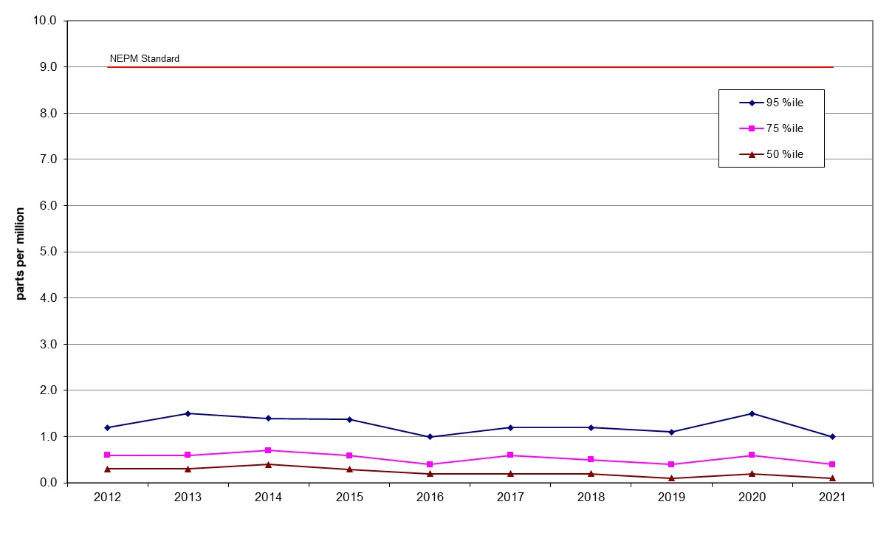
Figure 14: Statistical summary for daily maximum 8-hour CO Monash 2012 – 2021
Table 16: Statistical summary for daily maximum 8-hour CO Florey 2014 – 2021
Year | Data  Availability  (%) | No. of  Exceedances  (days) | Max  conc.  (ppm) | 95th  percentile  (ppm) | 75th  percentile  (ppm) | 50th  percentile  (ppm)
2014 | 79.2 | 0 | 2.2 | 1.4 | 0.7 | 0.3
2015 | 94.9 | 0 | 2.0 | 1.5 | 0.6 | 0.3
2016 | 95.5 | 0 | 1.9 | 1.2 | 0.5 | 0.3
2017 | 94.7 | 0 | 1.8 | 1.4 | 0.5 | 0.2
2018 | 94.7 | 0 | 1.5 | 1.1 | 0.5 | 0.3
2019 | 95.3 | 0 | 8.6 | 1.2 | 0.6 | 0.3
2020 | 94.7 | 2 | 14.6 | 1.3 | 0.6 | 0.3
2021 | 95.2 | 0 | 1.2 | 0.9 | 0.4 | 0.2

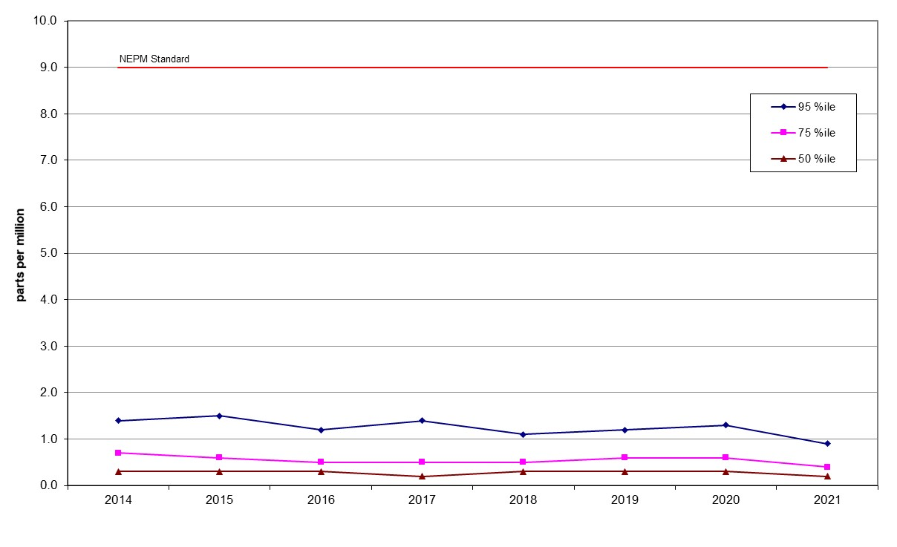
Figure 15: Statistical summary for daily maximum 8-hour CO Florey 2014 – 2021

Nitrogen dioxide
Table 17: Statistical summary for daily maximum 1-hour NO₂ Monash 2012 – 2021
Year | Data  Availability  (%) | No. of  Exceedances  (days) | Max  conc.  (ppm) | Annual average  (ppm) | 95th  percentile  (ppm) | 75th  percentile  (ppm) | 50th  percentile  (ppm)
2012 | 97.5 | 0 | 0.033 | 0.006 | 0.026 | 0.021 | 0.014
2013 | 97.5 | 0 | 0.037 | 0.005 | 0.027 | 0.021 | 0.014
2014 | 94.1 | 0 | 0.036 | 0.005 | 0.027 | 0.020 | 0.015
2015 | 94.8 | 0 | 0.032 | 0.004 | 0.026 | 0.020 | 0.014
2016 | 95.6 | 0 | 0.036 | 0.004 | 0.027 | 0.019 | 0.012
2017 | 95.6 | 0 | 0.031 | 0.004 | 0.027 | 0.021 | 0.013
2018 | 95.5 | 0 | 0.039 | 0.004 | 0.028 | 0.020 | 0.014
2019 | 94.9 | 0 | 0.084 | 0.005 | 0.027 | 0.021 | 0.014
2020 | 95.7 | 0 | 0.116 | 0.004 | 0.027 | 0.019 | 0.011
2021 | 95.7 | 0 | 0.036 | 0.003 | 0.024 | 0.016 | 0.010

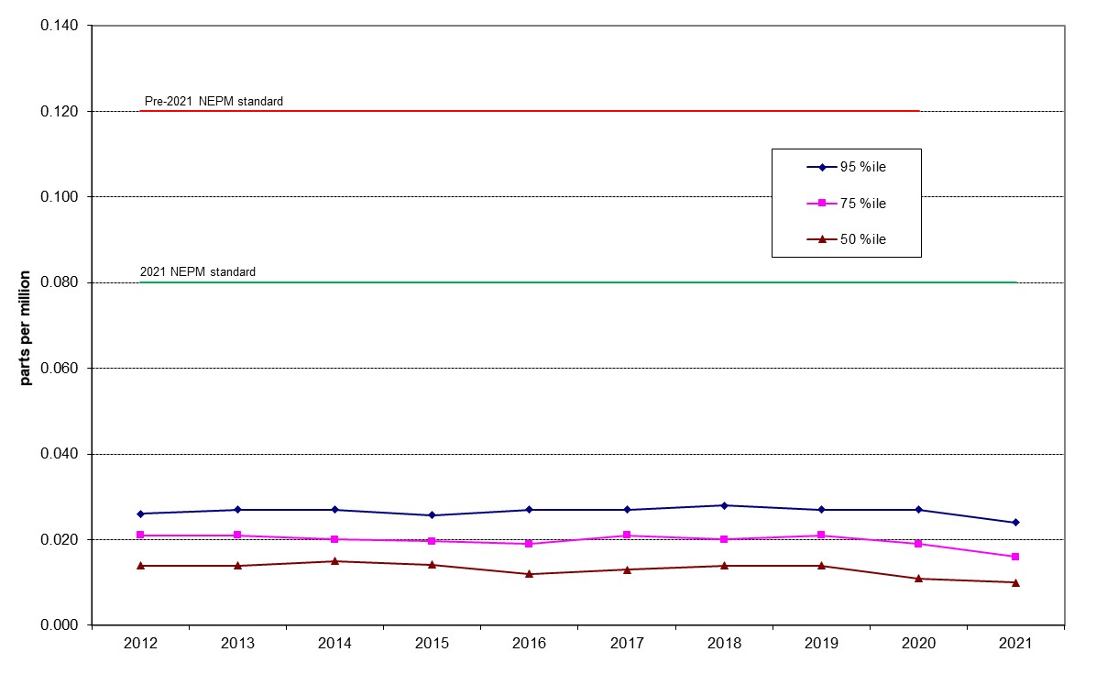

Figure 16: Statistical summary for daily maximum 1-hour NO₂ Monash 2012 – 2021

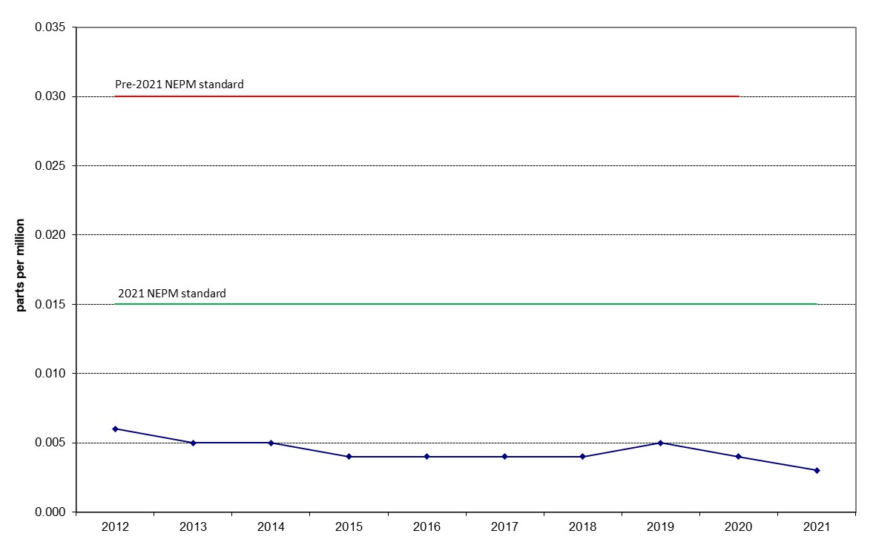

Figure 17: Annual average 1-hour NO₂ Monash 2012 – 2021

Table 18: Statistical summary for daily maximum 1-hour NO₂ Florey 2014 – 2021
Year | Data  Availability  (%) | No. of  Exceedances  (days) | Max  conc.  (ppm) | Annual average  (ppm) | 95th  percentile  (ppm) | 75th  percentile  (ppm) | 50th  percentile  (ppm)
2014 | 78.3 | 0 | 0.045 | 0.006 | 0.027 | 0.020 | 0.015
2015 | 91.5 | 0 | 0.033 | 0.005 | 0.027 | 0.020 | 0.014
2016 | 94.7 | 0 | 0.034 | 0.004 | 0.027 | 0.019 | 0.013
2017 | 93.7 | 0 | 0.033 | 0.005 | 0.025 | 0.020 | 0.015
2018 | 93.3 | 0 | 0.039 | 0.005 | 0.028 | 0.022 | 0.015
2019 | 92.4 | 0 | 0.062 | 0.005 | 0.027 | 0.020 | 0.014
2020 | 94.1 | 2 | 0.171 | 0.004 | 0.024 | 0.017 | 0.011
2021 | 91.6 | 0 | 0.034 | 0.004 | 0.020 | 0.013 | 0.009

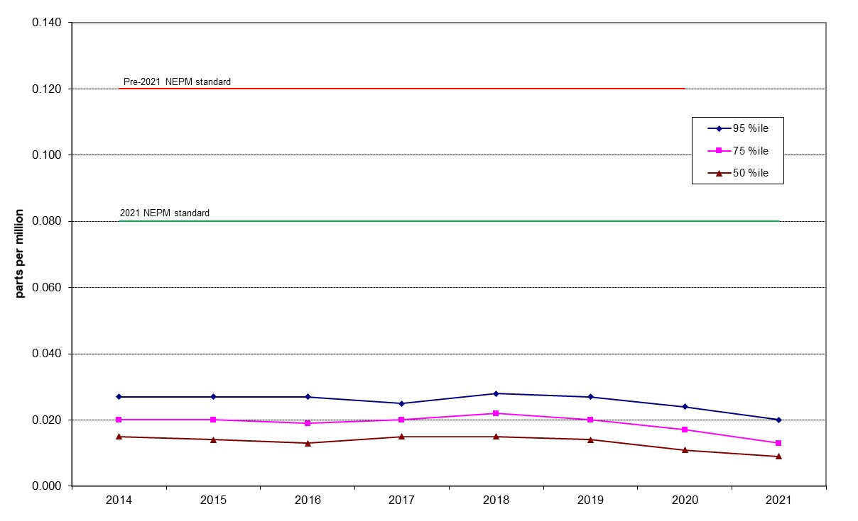
Figure 18: Statistical summary for daily maximum 1-hour NO₂ Florey 2014 – 2021
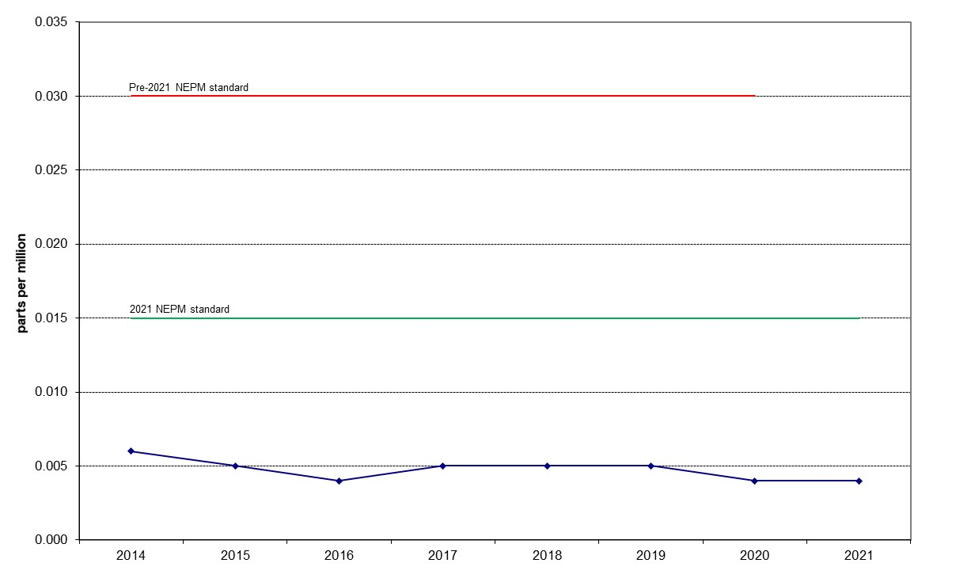
Figure 19: Annual average 1-hour NO₂ Florey 2014 – 2021

Ozone
Table 19: Statistical summary for daily maximum 8-hour O₃ Monash 2012 – 2021
Year | Data  Availability  (%) | No. of  Exceedances  (days) | Max  conc.  (ppm) | 95th  percentile  (ppm) | 75th  percentile  (ppm) | 50th  percentile  (ppm)
2012 | 100 | 0 | 0.050 | 0.032 | 0.023 | 0.016
2013 | 97.8 | 0 | 0.054 | 0.032 | 0.025 | 0.018
2014 | 94.8 | 0 | 0.057 | 0.035 | 0.025 | 0.019
2015 | 92.8 | 0 | 0.047 | 0.032 | 0.022 | 0.014
2016 | 95.2 | 0 | 0.049 | 0.031 | 0.022 | 0.017
2017 | 95.5 | 0 | 0.052 | 0.036 | 0.027 | 0.020
2018 | 95.8 | 0 | 0.053 | 0.036 | 0.028 | 0.022
2019 | 95.8 | 10 | 0.107 | 0.042 | 0.029 | 0.022
2020 | 95.8 | 6 | 0.093 | 0.036 | 0.026 | 0.020
2021 | 95.7 | 0 | 0.042 | 0.030 | 0.023 | 0.017

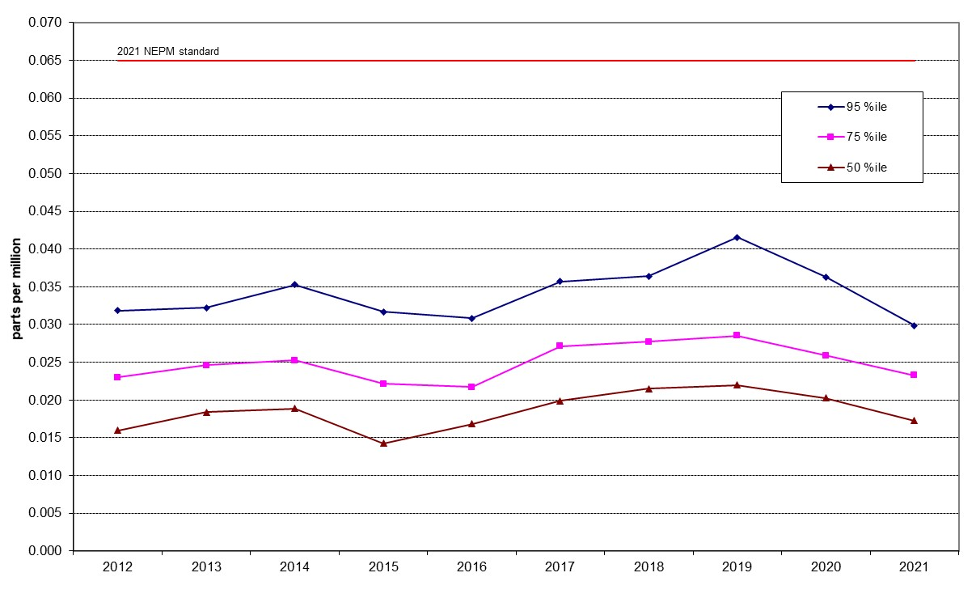

Figure 20: Statistical summary for daily maximum 8-hour O₃ Monash 2012 – 2021

Table 20: Statistical summary for daily maximum 8-hour O₃ Civic 2012 – 2021
Year | Data  Availability  (%) | No. of  Exceedances  (days) | Max  conc.  (ppm) | 95th  percentile  (ppm) | 75th  percentile  (ppm) | 50th  percentile  (ppm)
2012 | 100 | 0 | 0.040 | 0.023 | 0.016 | 0.011
2013 | 92.1 | 0 | 0.050 | 0.026 | 0.019 | 0.013
2014 | 94.0 | 0 | 0.044 | 0.028 | 0.017 | 0.012
2015 | 89.0 | 0 | 0.040 | 0.025 | 0.018 | 0.013
2016 | 95.8 | 0 | 0.042 | 0.027 | 0.020 | 0.015
2017 | 95.8 | 0 | 0.046 | 0.032 | 0.023 | 0.017
2018 | 95.2 | 0 | 0.050 | 0.032 | 0.024 | 0.018
2019 | 95.8 | 4 | 0.088 | 0.039 | 0.026 | 0.020
2020 | 95.8 | 3 | 0.076 | 0.032 | 0.023 | 0.018
2021 | 95.5 | 0 | 0.041 | 0.028 | 0.022 | 0.017

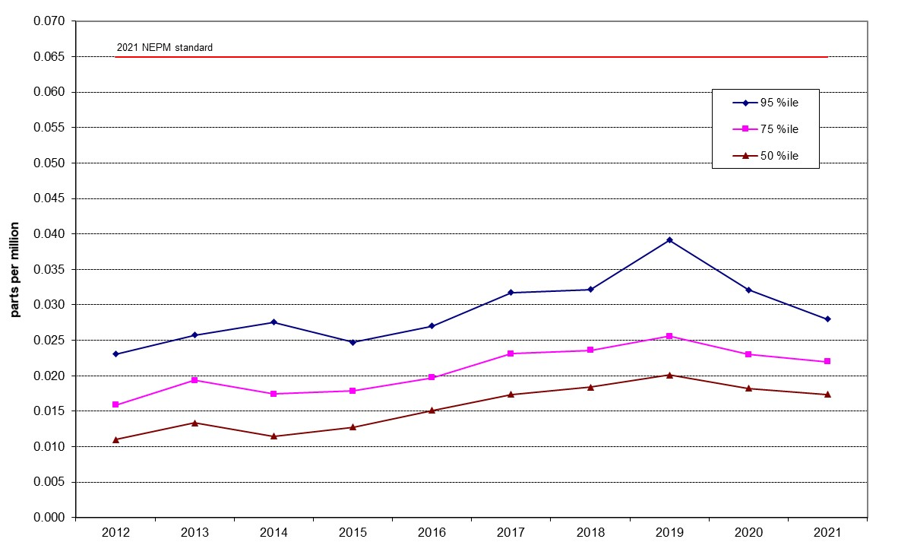

Figure 21: Statistical summary for daily maximum 8-hour O₃ Civic 2012 – 2021

Table 21: Statistical summary for daily maximum 8-hour O₃ Florey 2014 – 2021
Year | Data  Availability  (%) | No. of  Exceedances  (days) | Max  conc.  (ppm) | 95th  percentile  (ppm) | 75th  percentile  (ppm) | 50th  percentile  (ppm)
2014 | 79.4 | 0 | 0.037 | 0.024 | 0.017 | 0.010
2015 | 94.2 | 0 | 0.034 | 0.023 | 0.016 | 0.010
2016 | 95.8 | 0 | 0.046 | 0.029 | 0.022 | 0.016
2017 | 95.5 | 0 | 0.052 | 0.036 | 0.026 | 0.020
2018 | 95.2 | 0 | 0.054 | 0.036 | 0.027 | 0.021
2019 | 95.3 | 10 | 0.099 | 0.042 | 0.027 | 0.021
2020 | 92.0 | 6 | 0.089 | 0.037 | 0.026 | 0.020
2021 | 95.8 | 0 | 0.047 | 0.030 | 0.023 | 0.018

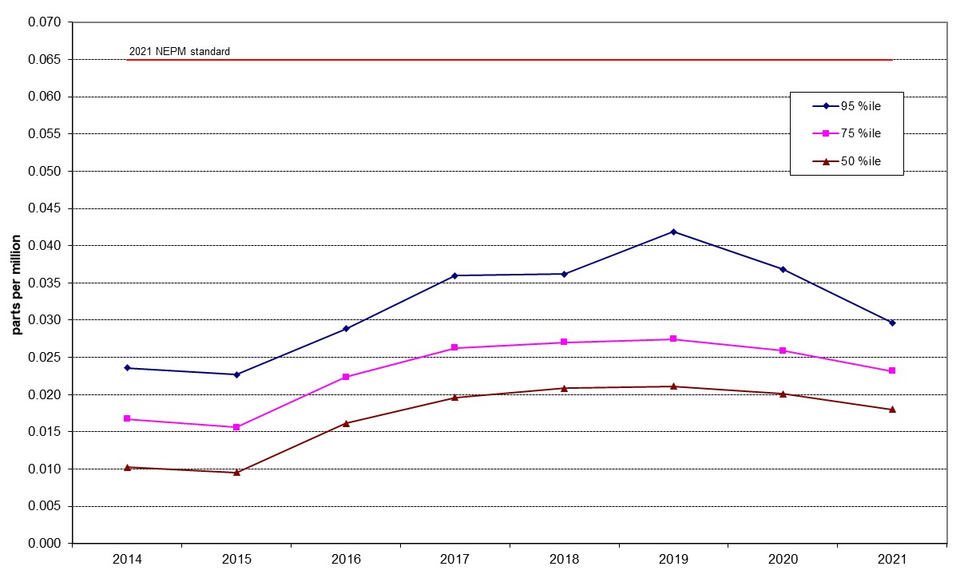

Figure 22: Statistical summary for daily maximum 1-hour O₃ Florey 2014 – 2021

PM₁₀
Table 22: Statistical summary for daily maximum daily PM₁₀ Monash 2012 – 2021
Year | Data  Availability  (%) | No. of  Exceedances  (days) | Max  conc.  (μg/m³) | Annual average  (μg/m³) | 95th  percentile  (μg/m³) | 75th  percentile  (μg/m³) | 50th  percentile  (μg/m³)
2012 | 98.6 | 0 | 41.0 | 10.4 | 19.7 | 13.7 | 9.7
2013 | 95.6 | 0 | 43.5 | 9.8 | 20.2 | 13.1 | 8.9
2014 | 97.8 | 0 | 39.3 | 10 | 19.1 | 12.9 | 9.6
2015 | 98.4 | 0 | 49.4 | 9.9 | 19.5 | 13.1 | 9.5
2016 | 99.5 | 0 | 31.9 | 9.7 | 21.5 | 12.7 | 9.0
2017 | 98.9 | 0 | 28.3 | 9.8 | 20.5 | 12.3 | 9.0
2018 | 99.2 | 4 | 139.2 | 11.8 | 23.0 | 14.8 | 10.4
2019 | 98.4 | 22 | 385.7 | 19.1 | 61.1 | 17.8 | 11.4
2020 | 99.2 | 21 | 1046.1 | 22.4 | 54.3 | 17.8 | 10.4
2021 | 99.5 | 0 | 37.3 | 10.3 | 22.9 | 13.7 | 9.1

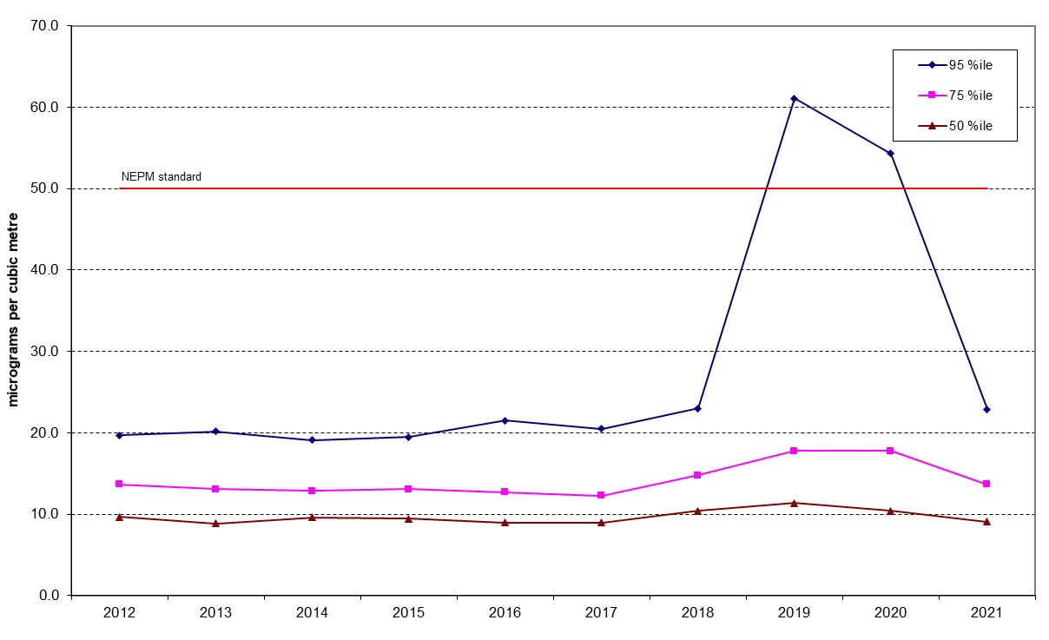
Figure 23: Statistical summary for daily PM₁₀ Monash 2012 – 2021
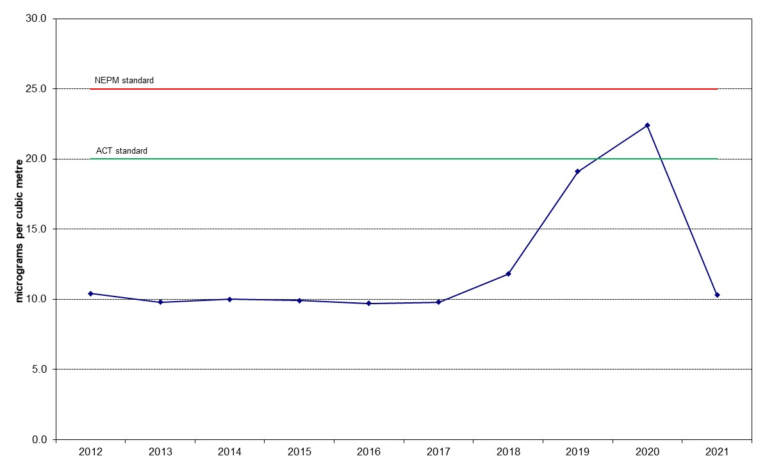

Figure 24: Annual average daily PM₁₀ Monash 2012 – 2021

Table 23: Statistical summary for daily maximum daily PM₁₀ Civic 2012 – 2021
Year | Data  Availability  (%) | No. of  Exceedances  (days) | Max  conc.  (μg/m³) | Annual average  (μg/m³) | 95th  percentile  (μg/m³) | 75th  percentile  (μg/m³) | 50th  percentile  (μg/m³)
2012 | 95.1 | 0 | 49.5 | 9.4 | 17.0 | 12.1 | 8.7
2013 | 92.9 | 1 | 57.8 | 9.7 | 19.9 | 12.0 | 8.6
2014 | 95.1 | 0 | 31.4 | 9.8 | 17.7 | 12.6 | 9.3
2015 | 97.5 | 1 | 64.3 | 11.1 | 20.9 | 14.1 | 10.4
2016 | 100 | 0 | 36.6 | 10.7 | 20.6 | 14.3 | 9.7
2017 | 83.6 | 1 | 53.0 | 9.68 | 10.8 | 7.1 | 5.2
2018 | 97.8 | 1 | 179.8 | 13.5 | 24.1 | 16.1 | 11.3
2019 | 97.3 | 29 | 390.2 | 22.9 | 82.5 | 19.5 | 12.7
2020 | 98.4 | 24 | 994.9 | 21.7 | 56.7 | 15.2 | 10.0
2021 | 93.7 | 0 | 28.6 | 8.7 | 15.6 | 11.5 | 8.1
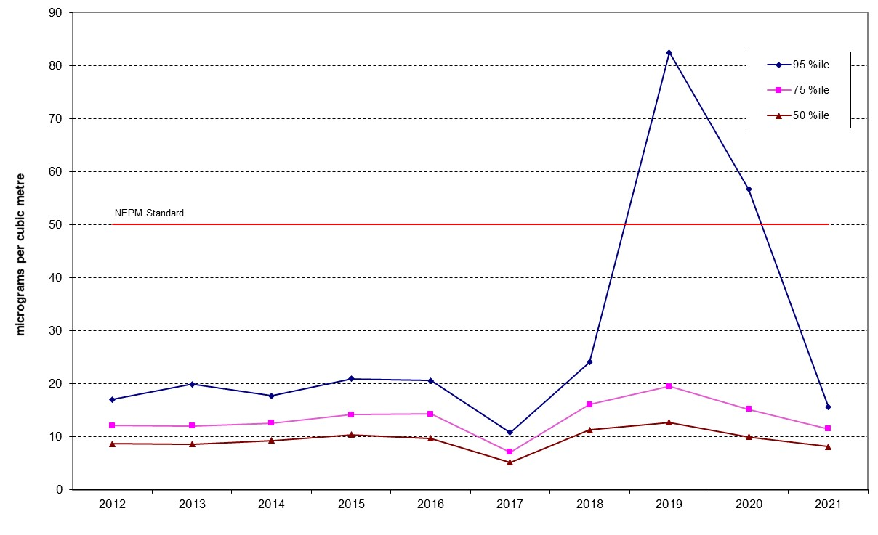
Figure 25: Statistical summary for daily PM₁₀ Civic 2012 – 2021
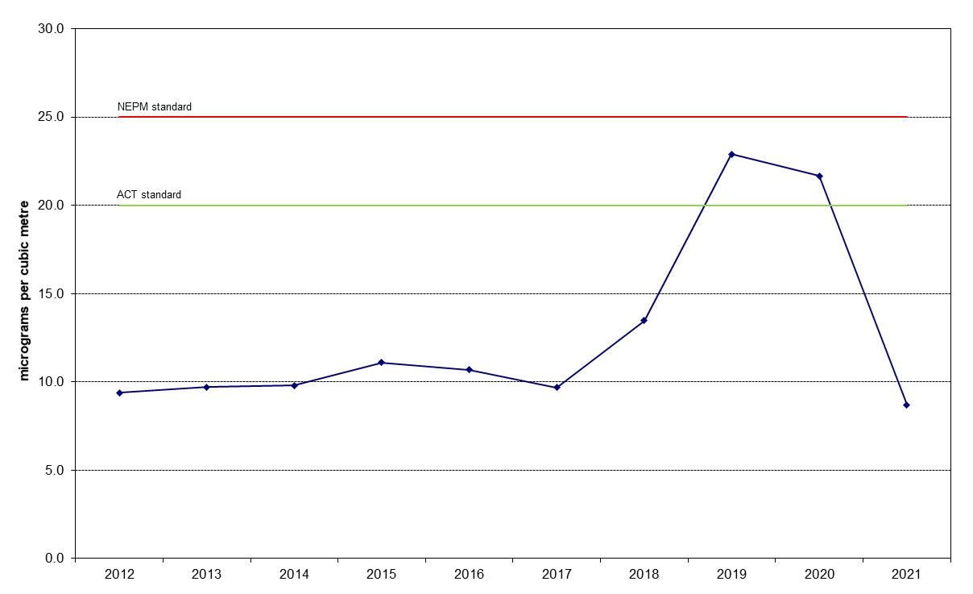

Figure 26: Annual average daily PM₁₀ Civic 2012 – 2021
Table 24: Statistical summary for daily maximum daily PM₁₀ Florey 2014 – 2021
Year | Data  Availability  (%) | No. of  Exceedances  (days) | Max  conc.  (μg/m³) | Annual average  (μg/m³) | 95th  percentile  (μg/m³) | 75th  percentile  (μg/m³) | 50th  percentile  (μg/m³)
2014 | 83.3 | 0 | 30.2 | 10.4 | 21.5 | 13.0 | 9.4
2015 | 95.6 | 0 | 70.8 | 10.7 | 21.8 | 13.7 | 9.4
2016 | 98.9 | 0 | 28.8 | 10.1 | 20.6 | 13.1 | 9.2
2017 | 98.4 | 0 | 28.1 | 9.84 | 21.8 | 12.8 | 8.5
2018 | 89.9 | 3 | 158.6 | 12.0 | 23.8 | 15.3 | 10.1
2019 | 98.1 | 28 | 379.7 | 23.8 | 96.8 | 20.6 | 13.4
2020 | 99.5 | 21 | 1075.5 | 22.8 | 57.5 | 17.9 | 10.9
2021 | 99.5 | 0 | 37.9 | 9.6 | 19.6 | 12.7 | 8.5

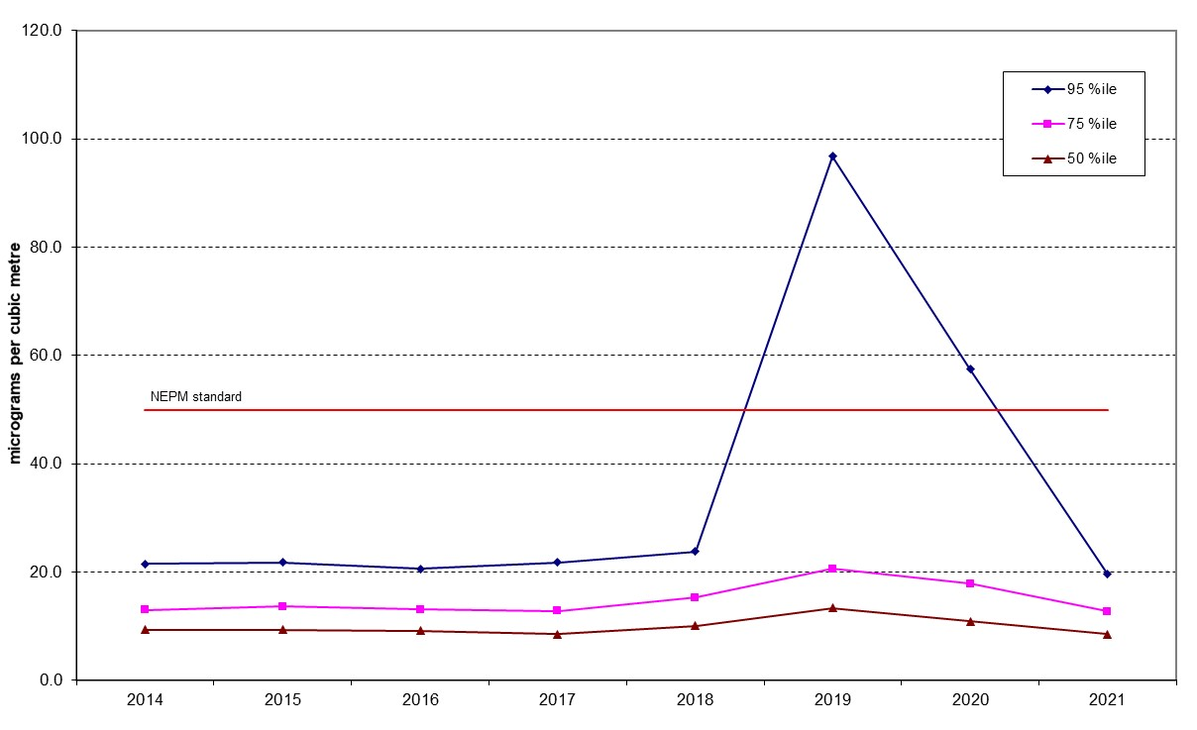

Figure 27: Statistical summary for daily PM₁₀ Florey 2014 – 2021
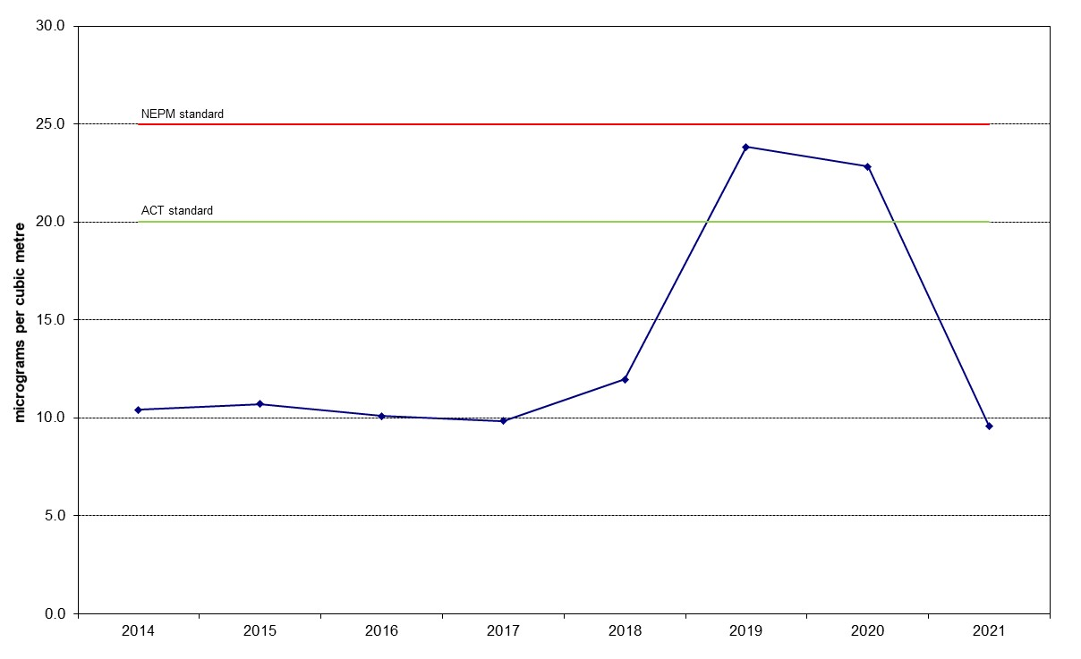

Figure 28: Annual average daily PM₁₀ Florey 2014 – 2021

PM_{2.5}
Table 25: Statistical summary for daily maximum daily PM_{2.5} Monash 2012 – 2021
Year | Data  Availability  (%) | No. of  Exceedances  (days) | Max  conc.  (μg/m³) | Annual average  (μg/m³) | 95th  percentile  (μg/m³) | 75th  percentile  (μg/m³) | 50th  percentile  (μg/m³)
2012 | 95.1 | 3 | 29.2 | 7.1 | 16.5 | 8.3 | 5.0
2013 | 98.6 | 6 | 38.4 | 6.9 | 19.2 | 8.1 | 5.2
2014 | 87.7 | 4 | 31.5 | 6.8 | 18.7 | 8.6 | 5.6
2015 | 96.4 | 6 | 33.8 | 7.4 | 19.0 | 8.2 | 5.6
2016 | 98.1 | 8 | 32.7 | 7.4 | 20.7 | 8.2 | 5.4
2017 | 98.6 | 12 | 35.2 | 7.7 | 22.5 | 9.3 | 5.3
2018 | 99.2 | 2 | 32.0 | 6.8 | 19.2 | 8.6 | 5.3
2019 | 98.9 | 28 | 307.9 | 14.1 | 42.7 | 12.5 | 7.2
2020 | 98.6 | 37 | 1146.5 | 17.9 | 38.4 | 11.3 | 5.7
2021 | 98.6 | 5 | 27.9 | 6.8 | 19.2 | 8.1 | 4.9
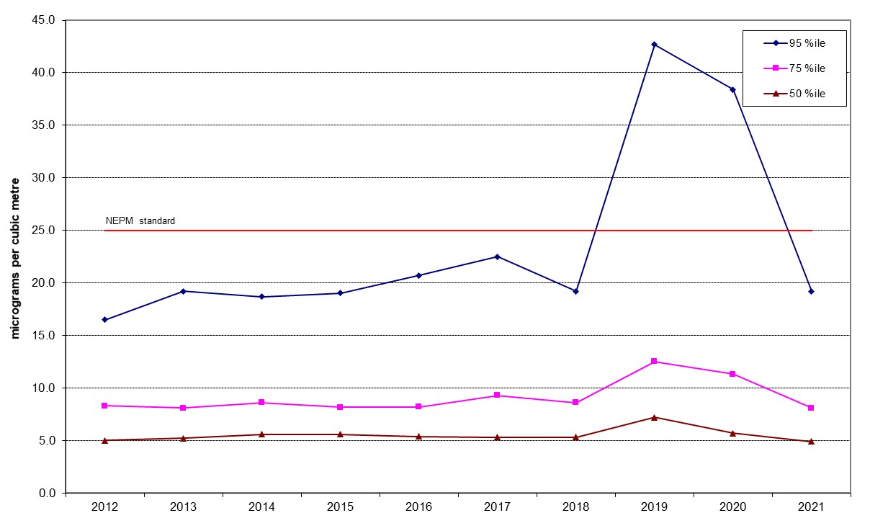
Figure 29: Statistical summary for daily PM_{2.5} Monash 2012 – 2021
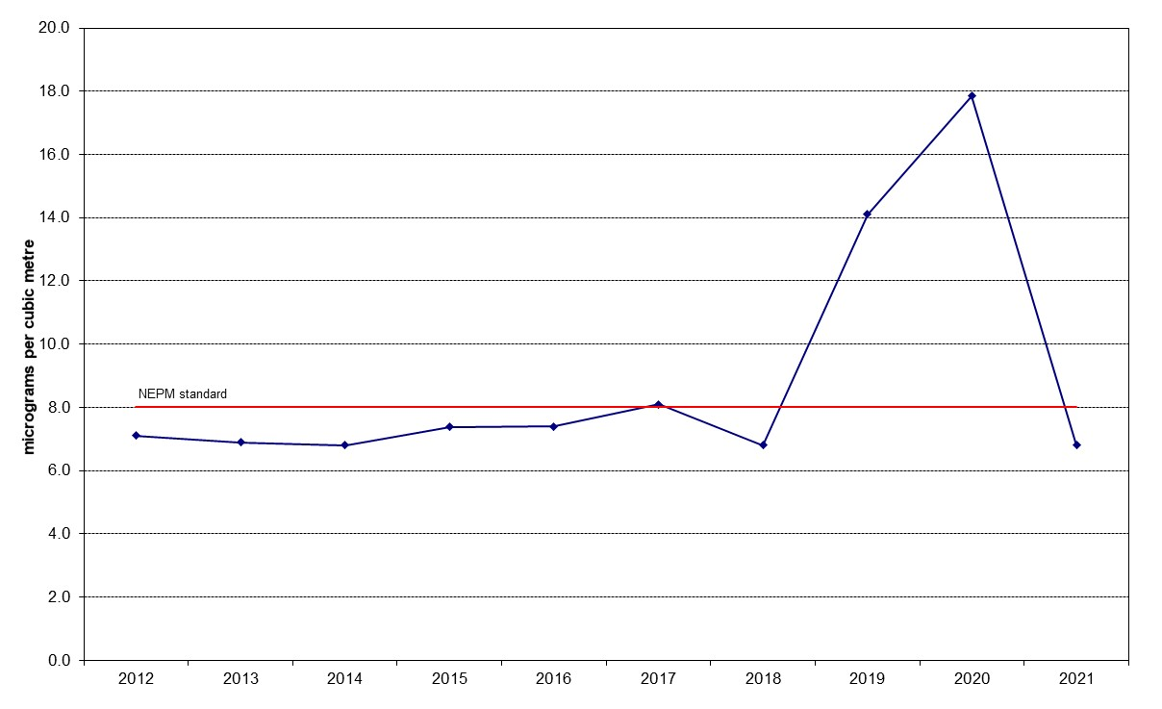
Figure 30: Annual average daily PM_{2.5} Monash 2012 – 2021

Table 26: Statistical summary for daily maximum daily PM_{2.5} Civic 2016 – 2021
Year | Data  Availability  (%) | No. of  Exceedances  (days) | Max  conc.  (μg/m³) | Annual average  (μg/m³) | 95th  percentile  (μg/m³) | 75th  percentile  (μg/m³) | 50th  percentile  (μg/m³)
2016 | 98.6 | 0 | 22.1 | 5.5 | 11.0 | 7.1 | 4.8
2017 | 94.2 | 1 | 53.8 | 5.9 | 10.8 | 7.1 | 5.2
2018 | 98.6 | 1 | 36.1 | 6.5 | 12.1 | 8.1 | 6.1
2019 | 96.4 | 29 | 390.2 | 22.9 | 82.5 | 19.5 | 12.7
2020 | 99.2 | 18 | 872.6 | 12.9 | 24.8 | 7.6 | 5.1
2021 | 96.7 | 0 | 21.8 | 5.0 | 9.5 | 6.6 | 4.6

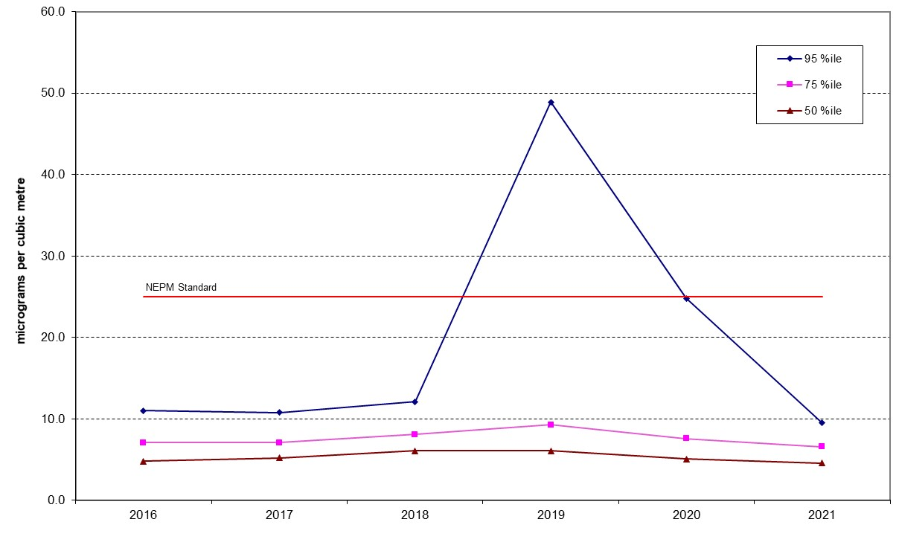

Figure 31: Statistical summary for daily PM_{2.5} Civic 2016 – 2021
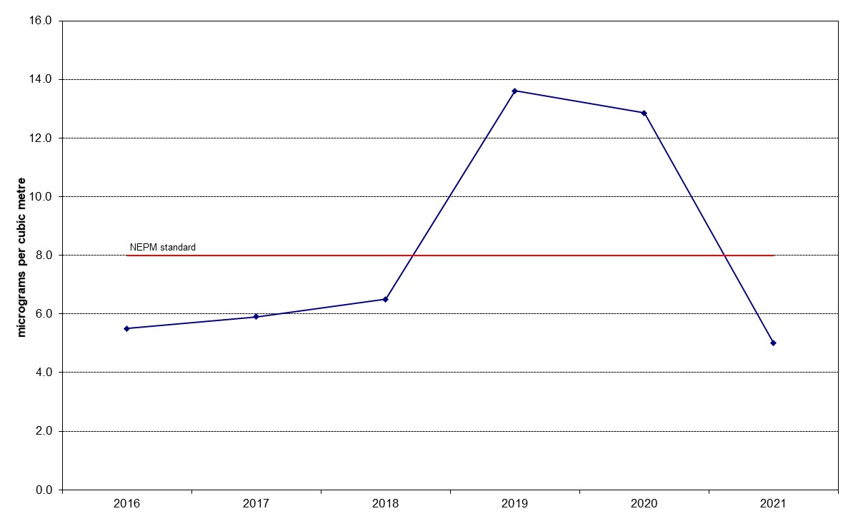

Figure 32: Annual average daily PM_{2.5} Civic 2016 – 2021

Table 27: Statistical summary for daily maximum daily PM_{2.5} Florey 2014 – 2021
Year | Data  Availability  (%) | No. of  Exceedances  (days) | Max  conc.  (μg/m³) | Annual average  (μg/m³) | 95th  percentile  (μg/m³) | 75th  percentile  (μg/m³) | 50th  percentile  (μg/m³)
2014 | 74.2 | 0 | 22.8 | 5.8 | 15.0 | 7.1 | 4.9
2015 | 96.2 | 0 | 24.3 | 6.5 | 17.1 | 7.4 | 4.8
2016 | 98.6 | 1 | 27.2 | 7.3 | 17.4 | 8.6 | 5.8
2017 | 94.2 | 0 | 23.8 | 7.2 | 17.9 | 8.7 | 5.6
2018 | 97.3 | 2 | 26.4 | 7.4 | 17.0 | 8.7 | 5.9
2019 | 98.4 | 29 | 319.6 | 14.8 | 46.9 | 12.3 | 7.2
2020 | 97.3 | 25 | 983.4 | 16.9 | 28.8 | 12.2 | 5.9
2021 | 98.4 | 3 | 28.2 | 6.2 | 16.0 | 7.6 | 4.9

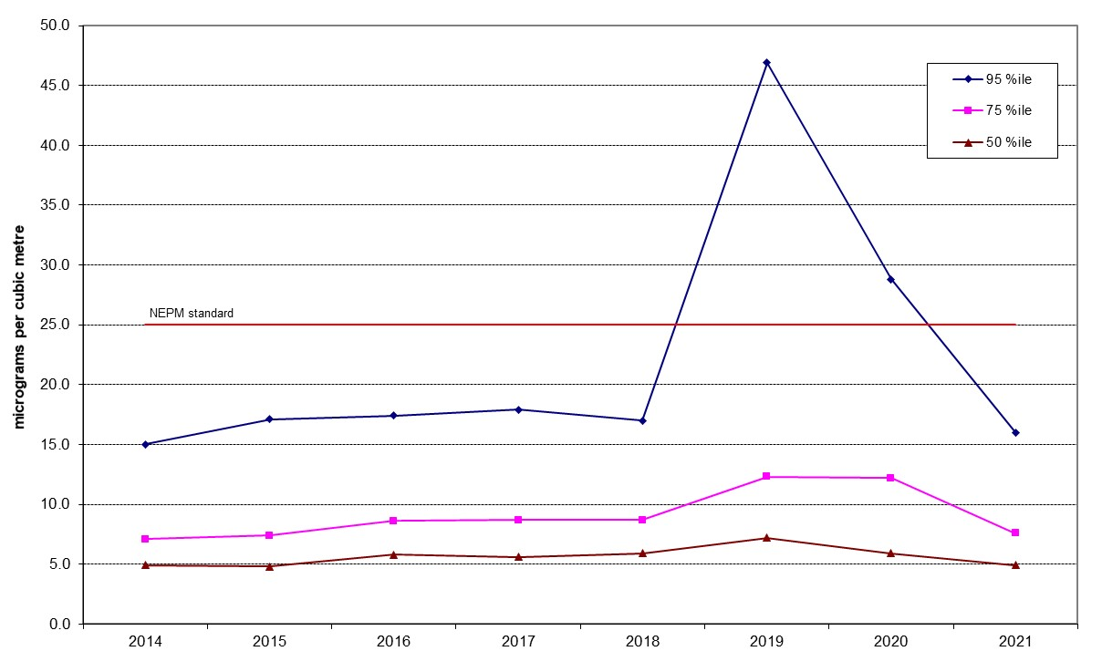
Figure 33: Statistical summary for daily PM_{2.5} Florey 2014 – 2021
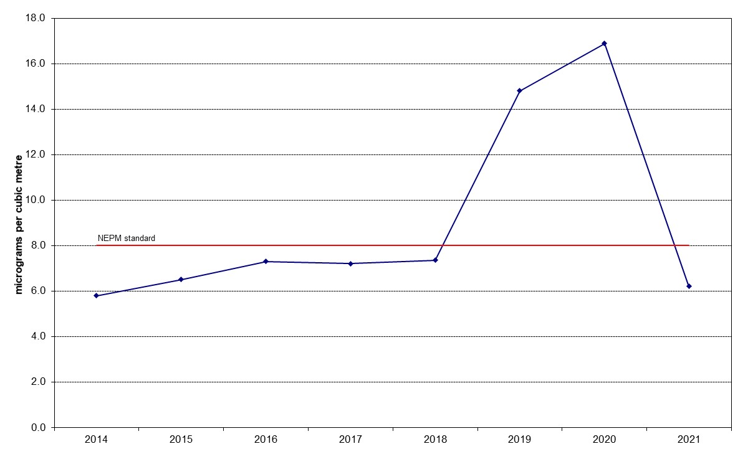
Figure 34: Annual average daily PM_{2.5} Florey 2014 – 2021

http://www.nepc.gov.au/nepms/ambient-air-quality
http://www.nepc.gov.au/nepms/ambient-air-quality/variation-ambient-air-quality-nepm-ozone-nitrogen-dioxide-and-sulfur
https://www.health.act.gov.au/about-our-health-system/population-health/environmental-monitoring/monitoring-and-regulating-air
https://www.accesscanberra.act.gov.au/s/article/air-pollution-tab-domestic
https://www.accesscanberra.act.gov.au/s/article/air-pollution-tab-business-and-industry
https://files.accesscanberra.act.gov.au/legacy/3224/Molonglo%20Valley%20air%20quality%20assessment.pdf
https://files.accesscanberra.act.gov.au/legacy/3371/Your-guide-to-using-a-wood-heater.pdf
https://www.climatechoices.act.gov.au/policy-programs/wood-heater-replacement-program
https://www.act.gov.au/bushfire-smoke-and-air-quality-strategy

