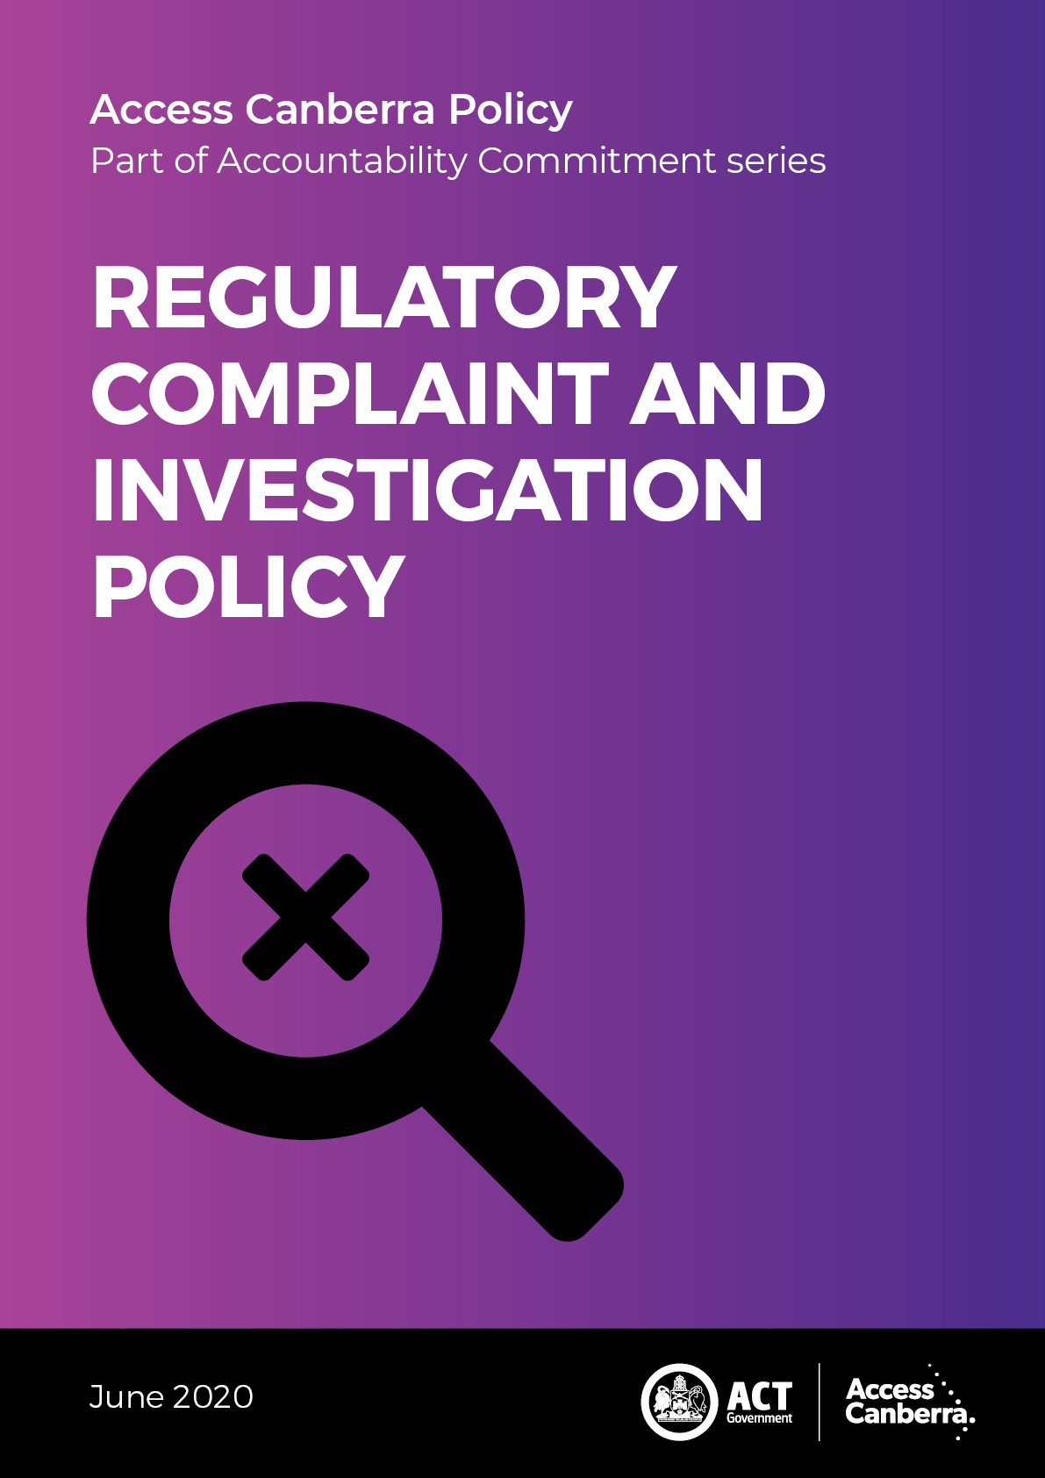

Chief Minister, Treasury and Economic Development Directorate - CMTEDD   
Access Canberra

P: 13 22 81

W: <https://www.accesscanberra.act.gov.au/s/>

Published June 2020

Complaint and Investigation Management Policy

Acknowledgement is attributed to the following organisations whose policies, procedures and associated documentation assisted in the development of these guidelines:

* ACT Auditor-General’s Office;
* Adelaide City Council;
* Australian Competition & Consumer Commission;
* Brisbane City Council;
* City of Sydney;
* Commonwealth Ombudsman;
* Commerce Commission NZ;
* Department of Veterans’ Affairs;
* Fair Trading NSW;
* Service NSW.

IMPORTANT NOTE: This information is for guidance only.

## Forward

### Purpose

The Access Canberra Accountability Commitment explains how Access Canberra will approach its role as both a service provider and a risk-based regulator, including what factors will be considered when dealing with regulatory non-compliance.

### Aim

The Accountability Commitment ensures that Access Canberra is approaching its role as a service provider and risk-based regulator in a consistent and transparent way. There are four policies that make up the Accountability Commitment series:

* Customer Service Charter;
* Decision Making Guidelines;
* Regulatory Complaint and Investigation Policy; and
* Compliance and Enforcement Policy.

This Accountability Commitment policy together with frameworks (tailored for different sectors the organisation oversees), is Access Canberra’s adopted approach to compliance and enforcement. Access Canberra will focus its resources where the risks of harm, unsafe practices or misconduct are greatest in the community.

## Content

Forward 3

Purpose 3

Aim 3

Content 4

1. INTRODUCTION 6

Purpose 6

Scope 6

Definitions 7

2. HOW TO LODGE A COMPLAINT 8

3. GUIDING PRINCIPLES 8

How to lodge a complaint 8

Regulatory complaints 8

Guiding principles 8

Complaint Management Principles 8

Prioritisation Thresholds 9

Prioritisation in case selection 9

Access Canberra Regulatory Complaint Assessment Committee 9

4. FACILITATE COMPLAINTS 10

Facilitate complaints 10

People focus 10

Anonymous complaints 10

Accessibility 10

5. RESPOND TO COMPLAINTS 11

Respond to complaints 11

Early resolution 11

Responsiveness 11

Confidentiality 12

6. MANAGE THE PARTIES TO A COMPLAINT AND/ OR INVESTIGATION 13

Manage the parties to a complaint and/or investigation 13

Complaints or investigations involving multiple agencies 13

Complaints or investigations involving multiple parties 13

Communication with complainants 13

Communication with parties during an investigation 14

Communication with the investigated party 14

Managing unreasonable conduct by people making complaints 14

7. COMPLAINT MANAGEMENT PROCESS 15

Complaint Management Process 15

Key stages in complaint and investigation management process 15

8. DECISION MAKING 19

Decision making 19

How we make decisions during an investigation 19

Decision-making after an investigation 19

Closing an investigation 20

9. TIMEFRAMES 21

Timeframes 21

Regulatory Complaints: 21

Investigations 21

10. ACCOUNTABILITY AND LEARNING 22

11. INFORMATION MANAGEMENT 22

Accountability and learning 22

Information Management 22

How we deal with information 23

Sharing information within Access Canberra and using information for another investigation 23

Protecting complainants – confidential informants’ policy 23

Criminal offending 23

Issues of public safety 23

12. MONITORING OF THE COMPLAINT MANAGEMENT PROCESS 24

13. CONTINUOUS IMPROVEMENT 24

Monitoring of the complaint management process 24

Continuous improvement 24

14. MORE INFORMATION 25

15. Compliance and enforcement policy / frameworks 25

Compliance frameworks for specific regulatory approaches 25

More information 25

To obtain more information, please: 25

Compliance and enforcement policy and frameworks 25

# 

# 1. INTRODUCTION

## Purpose

This policy is intended to ensure that Access Canberra handles complaints fairly, efficiently and effectively, and aims to:

* ensure a person’s right to complain is promoted and protected;
* inform the community of the procedures Access Canberra will use to manage complaints;
* ensure information received is handled in an appropriate manner, allowing follow-up action to be undertaken, where necessary, and to improve the focus of Access Canberra resources, and
* increase the community’s satisfaction with Access Canberra.

### Scope

All Access Canberra employees must use the complaint management process in this Policy to manage regulatory complaints.

Any person who has contact with Access Canberra, or is impacted by an industry, activity, or business we regulate, has the right to make a complaint/provide feedback.

Access Canberra expects employees at all levels to be committed to fair, effective and efficient complaint management.

### Definitions

The following definitions are used in this policy:

| Term | Definition |
| --- | --- |
| **Complaint** | Expression of dissatisfaction made to or about us, our services, employees or the management of a complaint where a response or resolution is explicitly or implicitly expected or legally required[1]. A complaint covered by this Policy can be distinguished from:  ▷ employee grievances;  ▷ public interest disclosures;  ▷ code of conduct complaints;  ▷ reports of problems or wrongdoing merely intended to bring a problem to our notice with no expectation of a response;  ▷ service requests, or  ▷ requests for information. |
| **Regulatory complaint** | A complaint about the behaviour of a business, industry or member of an industry regulated by Access Canberra. |
| **Complaint Management Process** | All policies, procedures, practices, staff, hardware and software used by us in the management of complaints. |
| **Customer/ client** | A customer for the purpose of this document is deemed to be either a member of the public or a business. |
| **Dispute** | An unresolved complaint. |
| **Employee** | Employees, contractors, consultants, volunteers, public officials and anyone who is engaged to undertake business for or with Access Canberra. |
| **Investigation** | An investigation is a process of seeking information relevant to an alleged, apparent or potential breach of the law, involving possible judicial proceedings. The primary purpose of an investigation is to gather admissible evidence for any subsequent action, whether under criminal, civil penalty, disciplinary or administrative sanctions. Investigations can also result in prevention and/or disruption action. |
| **Procedure** | A statement or instruction that sets out how our policies will be implemented and by whom. |

...a person who has contact with Access Canberra...***has the right to make a complaint or provide feedback...***

# 

# 2. HOW TO LODGE A COMPLAINT

# 3. GUIDING PRINCIPLES

## How to lodge a complaint

You can lodge a complaint by:

| icon online | using our [online correspondence form](https://www.accesscanberra.act.gov.au/s/feedback-and-complaints) |
| --- | --- |
| icon call us | calling us on **13 22 81** |
| icon post | writing to us at: Access Canberra Customer Services GPO Box 158  CANBERRA ACT 2601 |

### Regulatory complaints

Given the complex nature of complaints relating to regulatory functions and statutory requirements, they may take some time to resolve; however, we will keep you informed about the progress of your complaint.

All regulatory complaints are assessed in accordance with the principles outlined in the [*Access Canberra*](https://www.accesscanberra.act.gov.au/app/answers/detail/a_id/2750/kw/accountability)[*Accountability Commitment*](https://www.accesscanberra.act.gov.au/s/article/access-canberra-accountability-commitment).

## Guiding principles

### Complaint Management Principles

The Access Canberra [*Accountability Commitment*](https://www.accesscanberra.act.gov.au/s/article/access-canberra-accountability-commitment). The Accountability Commitment sets out how we deal with the public, how we will assess your complaint based on the risk involved or the harm caused by the alleged conduct and our customer service charter.

This policy outlines how we will manage the regulatory complaints we receive and any investigations we undertake.

### Prioritisation Thresholds

We prioritise complaints based on the level of harm and impact of the alleged conduct. Complaints will be prioritised proportionately to the risk that may occur from the conduct. This may result in complaints being resolved in various ways and in different timeframes.

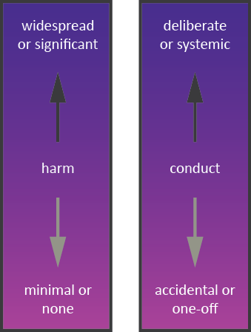

Figure 1 - Risk-harm Criteria

### Prioritisation in case selection

While Access Canberra carefully considers all matters that involve a potential breach of the law, we do not undertake a formal investigation of every matter that is brought to our attention.

We will apply a risk-based compliance approach to ensure that our resources are targeted to where the risks of harm, unsafe practices or misconduct are the greatest, thereby strengthening our capacity to take action where the community, and the environment are most at risk.

To ensure we appropriately allocate our resources, we take into consideration a range of factors when selecting matters for investigation and enforcement action.

We are more likely to investigate matters that involve the following factors:

* where there is evidence of significant consumer harm or detriment, particularly where the conduct is ongoing or systemic;
* there is a blatant disregard for the law, or pattern of deliberate non-compliance by a business, that may have the potential for substantial harm or detriment in the future;
* the conduct is impacting on vulnerable or disadvantaged groups;
* the conduct is industry-wide, involves a new or emerging issue or has a significant impact on market integrity
* enforcement action is likely to have a strategic educative or deterrent effect;
* education or engagement is not considered to be an appropriate and proportionate response to address the alleged conduct.

We are less likely to pursue matters that have the following factors:

* isolated events involving limited harm and detriment;
* matters of individual redress that are more effectively dealt with by parties through a dispute resolution service, such as the ACT Civil and Administrative Tribunal;
* matters that are more effectively dealt with by another agency.
* matters that can otherwise be more effectively resolved through education or engagement

### Access Canberra Regulatory Complaint Assessment Committee

**The Regulatory Complaint Assessment Committee (RCAC)** determines appropriate case prioritisation and treatment for regulatory complaints. The decisions of the committee are underpinned by our risk-based principles.

The Access Canberra risk-based principles outlined in the [[*Accountability Commitment*](https://www.accesscanberra.act.gov.au/s/article/access-canberra-accountability-commitment)](https://www.accesscanberra.act.gov.au/app/answers/detail/a_id/2750/kw/accountability)(Customer Service Charter, Decision Making Guidelines, Regulatory Complaint and Investigation Policy, and Compliance and Enforcement Policy), are the foundation for the decisions made by the RCAC.

...we consider the individual circumstances of each matter on a case-by-case basis...



# 4. FACILITATE COMPLAINTS

## Facilitate complaints

### People focus

People making complaints will be:

* listened to, treated with respect and actively involved in the complaint process where possible and appropriate; and
* provided with reasons for our decision/s and any options for redress or review at an appropriate point in time.

### Anonymous complaints

We accept anonymous complaints and will look into the issues raised where there is sufficient information provided to enable Access Canberra to action any issues arising from the complaint.

In certain circumstances Access Canberra will not be able to progress a compliance action in response to an anonymous complaint. For example, Environment Protection noise complaints can only be actioned if an affected person is identified.

Feedback supplied anonymously still provides us with useful information that can assist us to focus on areas of compliance and enforcement interest.

### Accessibility

We will ensure that information about how and where complaints may be made is well publicised.

We will ensure our process to manage complaints is easily understood and accessible to everyone, particularly people who may require assistance.

If a person prefers or needs another person or organisation to assist or represent them in the making and/or resolution of the complaint, we will facilitate this. Anyone may represent a person wishing to make a complaint with their consent (e.g. advocate, family member, legal or community representative, or another organisation).



# 5. RESPOND TO COMPLAINTS

## Respond to complaints

### Early resolution

Where possible for consumer complaints, Access Canberra will attempt to resolve complaints directly with the complainant. Where the complaint is resolved at the first point of contact these will be recorded and stored in accordance with the *Territory Records Act 2002*. This information will add to the pool of data and enable Access Canberra to analyse and identify process issues, more accurately track the management of complaints, and use the information received to continue to improve our service delivery, resource allocation and compliance and enforcement approaches.

### Responsiveness

We will acknowledge receipt of complaints within two business days.

We will, however, assess and prioritise complaints in accordance with our prioritisation thresholds.

If a matter concerns an immediate risk or harm to life, health or the environment, Access Canberra will prioritise and escalate its response accordingly.

We will inquire into and conduct every complaint or investigation process as efficiently as our resources permit, with the aim of avoiding unnecessary uncertainty and delay. We aim to complete complaint and investigations in a timely manner and to make decisions as promptly as possible.

See Part 9 of this policy for more details in relation to timeframes.

...We will assess and prioritise complaints in accordance with the urgency and/or seriousness...

We are committed to managing complainants’ expectations, and will inform the complainant as soon as possible of the following:

* the complaints and investigation process;
* the expected time frames for our actions;
* the progress of the complaint or investigation and reasons for any delay;
* their likely involvement in the process; and
* the possible or likely outcome of their complaint or an investigation.

We will advise people when we are unable to deal with any part of their complaint and provide advice about where such issues and/or complaints may otherwise be directed (if known and appropriate).

We will also advise people when we are unable to meet our timeframes for responding to their complaint and the reason for our delay, as appropriate.

We aim to be as open and transparent as we can in accordance with legislative requirements. There are limits to our ability to be open and transparent. In general, investigations are not conducted in an overt manner and it may, in some cases, be necessary to investigate confidentially. We are often not able to comment on a matter that we are investigating.

We make investigated parties aware, as soon as we are reasonably and legally able to do so, of the nature of the complaints or concerns that we have about their conduct, what is likely to be required of them during our investigation, and the timeframes that are likely to apply. In making this decision we are mindful of the requirements of procedural fairness and natural justice.

We take reasonable steps to provide investigated parties with a chance to respond to any alleged breach during our investigation, including through the provision of a written response or participation in a record of interview.

We take steps to ensure that those who may be the subject of an investigation or complaint also understand the investigation process and what is likely to be required of them during our investigation.

We exercise our duties, delegations, functions, and regulatory powers with integrity and professionalism.

We will address each complaint and investigation in accordance with the [*ACT Public Service Code of Conduct*](http://www.cmd.act.gov.au/__data/assets/pdf_file/0017/363230/codeofcond2012_2013edit_wtables.pdf)and with integrity and in an equitable, objective and unbiased manner.

We recognise that our investigations can have significant consequences for parties who are investigated by us or who are otherwise affected. We consider all information thoroughly and with open- mindedness as to the outcome.

Our decisions relating to investigations will be made with reference to the considerations expressed in our published enforcement criteria ([*Access Canberra*](https://www.accesscanberra.act.gov.au/app/answers/detail/a_id/2750/kw/accountability)[*Accountability Commitment*](https://www.accesscanberra.act.gov.au/s/article/access-canberra-accountability-commitment)).

Conflicts of interests, whether actual or perceived, will be managed responsibly. Internal reviews of how a complaint was managed will be conducted by a person other than the original decision maker.

### Confidentiality

We will protect the identity of people making complaints where this is practical, legally permissible and appropriate.

Personal information that identifies the person making a complaint will only be disclosed or used by Access Canberra to enable us to respond to or resolve the complaint as permitted under the relevant privacy laws.

...We aim to be as open and transparent as we can in accordance with legislative requirements...

****

# 6. MANAGE THE PARTIES TO A COMPLAINT AND/OR INVESTIGATION

## Manage the parties to a complaint and/or investigation

### Complaints or investigations involving multiple agencies

Where a complaint or investigation involves multiple organisations, we will work with the other organisation/s, where possible, to ensure that communication with the person making a complaint and/or their representative is clear and coordinated.

Subject to privacy, legal requirements and confidentiality considerations, communication and information sharing between the parties will also be organised to facilitate a timely response to the complaint.

Where a complaint or investigation involves multiple areas within our organisation, responsibility for communicating with the person making the complaint and/or their representative will also be coordinated.

### Complaints or investigations involving multiple parties

When similar complaints are made by related parties we will try to arrange to communicate with a single representative of the group.

### Communication with complainants

We will take steps to communicate with a complainant when we commence an investigation and during the investigation, when we are reasonably able to do so. Our communications with complainants will typically be limited to information about our progress and likely investigation timing.

There are likely to be stages during an investigation when we will only be able to communicate quite limited information or provide no update.

### Communication with parties during an investigation

Our investigations need to balance the competing interests of open government with the need to follow due process, the need to be able to conduct the investigation in a manner that does not compromise evidence and avenues of inquiry, ensure fair legal proceedings and the proper administration of justice. We also need to minimise any adverse inferences being drawn against a party being investigated and comply with privacy obligations. We may not always be able to communicate with persons, or publicly, on a matter that we are investigating.

What and when we can communicate will vary between investigations and may depend on the party we are communicating with.

In deciding what to communicate to a party we will consider matters like:

* the Access Canberra Accountability Commitment;
* whether the communication will assist or hinder our investigation, including the integrity of the information that may be gathered;
* the investigation status;
* the need to give investigated parties information to enable them to respond to the investigation;
* the interests of complainants, witnesses, or affected persons; and/or
* whether heightened confidentiality or commercial sensitivity attaches to the investigation.

### Communication with the investigated party

As soon as we are reasonably able to do so in the context of an investigation, Access Canberra will contact an investigated party to let them know that we have commenced an investigation, the nature of the complaint or concerns that we are investigating and an indicative timeframe for our investigation.

In some cases, we will not be able to communicate this information at an early stage, such as where contacting the investigated party would compromise the investigation, for example by making it harder to gather reliable evidence. If we have taken an alternative course of action, such as referring a complaint to another agency, we will take reasonable steps to advise an investigated party of that decision.

### Managing unreasonable conduct by people making complaints

We are committed to being accessible and responsive to all people who approach us with feedback or complaints. At the same time our success depends on:

* our ability to do our work and perform our functions in the most effective and efficient way possible;
* the health, safety and security of our employees; and
* our ability to allocate our resources fairly across all the complaints we receive.

When people behave unreasonably in their dealings with us, their conduct can significantly affect the progress and efficiency of our work and expose our staff to an unacceptable risk.

Abusive, angry, demanding or threatening contact with our employees via phone, email or in person will be considered unreasonable conduct. Any unreasonable conduct could significantly affect our ability to provide a service to you.

Access Canberra will take decisive action to manage any conduct that unreasonably affects it ability to engage and will support its employees to do the same in accordance with this policy.

...Access Canberra will contact an investigated party to let them know that we have commenced an investigation, and provide the nature of the complaint or concern we are investigating...

****

# 7. COMPLAINT MANAGEMENT PROCESS

## Complaint Management Process

### Key stages in complaint and investigation management process

#### Acknowledge

We will acknowledge receipt of each complaint promptly within two days.

Depending on the complaint priority the following details will be provided to the person making the complaint:

* the name of the person responsible for managing the complaint;
* the estimated length of time it may take to resolve your complaint; and
* a timeframe for when you can expect to receive an update from us.

We will use the most appropriate method of communicating with the complainant.

All complaints will be recorded along with supporting information where provided. We will assign a unique identifier to the complaint file, and the record of the complaint will document:

* the contact information of the person making the complaint, where provided;
* issues raised by the person making the complaint and the outcome/s they are requesting;
* any other relevant information; and
* any additional support the person making the complaint requires.

#### Assess

After acknowledging receipt of the complaint, we will confirm whether the issue/s raised in the complaint is within our control and area of regulation. We will also consider the outcome/s sought by the person making the complaint and, where there is more than one issue raised, determine whether each issue needs to be separately addressed.

When determining how a complaint will be managed, we will consider:

* how serious, complicated or urgent the complaint is;
* whether the complaint raises concerns about people’s health and safety or impact on the environment;
* the risks involved if resolution of the complaint is delayed; and
* whether a resolution requires the involvement of other organisations.

Not all complaints will require an investigation to be conducted.

#### Investigate

After assessing the complaint, some matters will continue to be managed by the Complaints Management Team whereas other matters will move to the investigation stage. This decision will be guided by the impact of the alleged conduct.

We will consider how to manage the complaint, which may include:

* gathering information from the product, person, business or area the complaint is about;
* giving the person making the complaint information or an explanation; or
* investigating the claims made in the complaint.

Which actions we decide to take will be tailored to each case and consider any statutory and/or regulatory requirements.

The investigation stage may involve gathering and analysing further relevant information/ evidence so that we can form a view on:

* what happened;
* whether what happened breaches the laws we enforce; and
* if it does, what is the most appropriate enforcement response.

We are not restricted to looking at breaches or conduct that has already happened. In the most serious cases, we can take urgent action to prevent ongoing breaches, or conduct that we have good reason to suspect may occur.

To determine whether a breach of the law may have occurred, we commonly gather information from a large variety of sources. Many different parties may hold the information we require, for example the investigated party, the public, experts, or third parties. We also use publicly available information.

We can seek and receive information voluntarily from persons or entities who are willing to assist us, or we can under some of the laws we enforce issue compulsory notices requiring interviews or the supply of information to us. This is known as coercive powers.

At any stage during an investigation we may (depending on the investigation subject matter):

* gather more information as a result of new facts or issues that arise, or to corroborate other information that has been provided;
* revisit and change the scope and focus of the investigation;
* do research or analysis, including legal, marketing, or economic research; and
* seek external expert opinion or assistance such as legal or technical advice.

...Not all complaints will require an investigation to be conducted...

...To determine whether a breach of the law may have occurred, we commonly gather information from a large variety of sources....

#### Contact

Following consideration of the complaint and, where required, any investigation into the issues raised, we will contact the person making the complaint and advise them wherever possible:

* the outcome of the complaint and any action we took;
* the reason/s for our decision;
* the remedy or resolution/s that we have proposed or put in place; and
* any options for review that may be available, such as an internal review, external review or appeal to an external agency.

If, during an investigation, we make any adverse findings about a particular person, we will consider any applicable privacy obligations and any applicable exemptions in or made pursuant to that law, before sharing our findings with the person making the complaint.

In this communication we are not usually able to discuss specific evidence provided by these parties as to do so would breach Privacy Law.

...we will consider any applicable privacy obligations and any applicable exemptions in or made pursuant to that act...

##### Figure 2 – Access Canberra Overview of Investigation Process

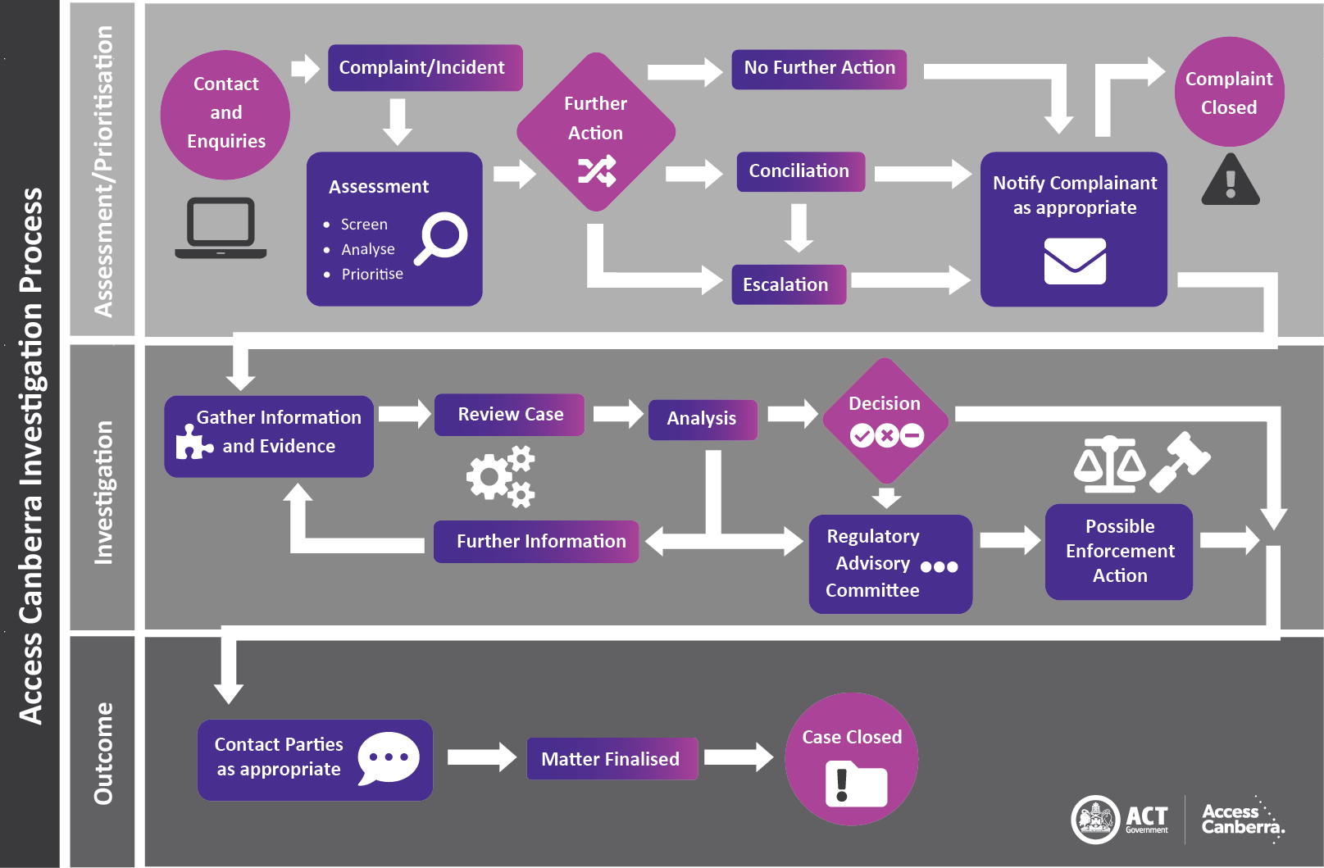

****

# 8. DECISION MAKING

## Decision making

### How we make decisions during an investigation

There are usually multiple decision points during the life of an investigation. Whether to commence, stop, or take enforcement response are all decisions. There are also decisions made along the way as to the scope, focus and best means of conducting an investigation.

### Decision-making after an investigation

Once the relevant investigation team has completed its inquiries and evidence gathering and assessed the available evidence, the investigation team may present to the Access Canberra Regulatory Advisory Committee[2] and then the relevant decision-maker:

* the relevant facts and a summary of the evidence and legal issues arising;
* the risk or harm caused by the conduct or likely to be caused by the conduct; and
* an assessment of whether there is likely to have been a breach of the law giving consideration to the obtained evidence.

The **Regulatory Advisory Committee (RAC)** seeks to support quality regulatory outcomes by ensuring that regulatory decisions are justified, proportionate, defensible and relevant processes followed prior to a regulatory decision being made. RAC will, as required, provide input at significant stages of an investigation or application process in line with relevant policies and procedures. This Committee will also consider complex applications for a licence or registration.

2*The Regulatory Advisory Committee considers the most appropriate regulatory action at an important stage of, or the conclusion of, an investigation. This may include taking no further action. This Committee will also consider complex applications for a licence or registration.*

The decision maker is delegated to make the appropriate decision. The making of a decision substantiating or not substantiating an allegation is one aspect of the decision maker’s role. The other aspect may include determining, after consultation with relevant parties and in some cases the party who has committed the breach, an appropriate sanction where the allegation has been substantiated.

...The making of a decision substantiating or not substantiating an allegation is one aspect of the decision maker’s role...

In determining an appropriate sanction additional enquiries may occur before a final decision is made. In some circumstances these enquiries may include approaching an investigated party to understand their willingness to change their behaviour or to compensate affected parties.

Details of the available enforcement responses, and the factors that we consider when choosing the most appropriate response, can be found in the Access Canberra Accountability Commitment.

### Closing an investigation

We will keep comprehensive records about:

* how we managed the complaint and investigation;
* the outcome/s of the complaint/investigation (including whether it or any aspect of it was substantiated);
* any outstanding actions that need to be followed up.

...Details of the available enforcement responses... can be found in the Access Canberra Accountability Commitment...

****

# 9. TIMEFRAMES

## Timeframes

The timeframe in which action is taken in response to a complaint made to Access Canberra will depend upon the priority assigned to the complaint. Those matters where there is significant harm or risk to the community will be actioned immediately. An example of conduct that would require this response is a large-scale pollution or contamination that poses an actual and immediate risk to the environment of the ACT. All other complaints received will be assessed and prioritised based on the risk of harm caused or likely to be caused by the alleged conduct.

The time taken to resolve complaints can vary, however wherever possible in relation to:

### Regulatory Complaints:

* we will strive to resolve less complex complaints that pose minimal risk or harm within 30 days from the date the complaint is submitted; and
* where the matter is complex and is expected to exceed this timeframe, we will keep you up to date with the progress of the complaint resolution.

### Investigations

* The exact time that an investigation takes varies considerably case-by-case, and depends on matters such as the complexity of the investigation, the discovery of new lines of enquiry, the number of investigated parties or investigated breaches, and our ability to access evidence and information. As a guide, the greater the complexity or seriousness of an investigation the likely increase in time it will take to conduct.
* In all cases, we will aim to keep the person making the affected party up to date on our progress, particularly if there are any delays.



10. ACCOUNTABILITY AND LEARNING

# 11. INFORMATION MANAGEMENT

## Accountability and learning

Access Canberra is committed to using complaints data to improve our programs, service delivery and regulatory roles. This data is used to inform our regulatory approaches and proactive compliance engagement activities.

## Information Management

Access Canberra will analyse data collected from the online [*Access Canberra Complaint Form*](https://www.accesscanberra.act.gov.au/s/feedback-and-complaints). The analysis of data will also include complaints lodged by customers who want to remain anonymous and complaints that are identified as low or no risk.

Access Canberra will provide reports and statistics in accordance with legislative requirements; to allow any trends or systemic issues to be identified; to contribute statistical information on matters of national significance. Information regarding the facts, investigations, photos, and outcomes will be de- identified of any personal information.

Access Canberra will take reasonable steps to ensure any personal information it holds is secure. Every reasonable effort is taken to protect personal information from misuse, interference or loss from unauthorised access, use, modification or disclosure in accordance with the Territory Privacy Principles (TTPs) set out in the [*Information Privacy Act 2014*](https://www.legislation.act.gov.au/a/2014-24/) and in accordance with the [*Territory Records Act 2002*](https://www.legislation.act.gov.au/a/2002-18/).

Access Canberra uses demographic information collected for the purpose of preparing statistics to enable it to better understand trends e.g. identifying certain demographics that may be vulnerable to certain scams allow us to better target our education and awareness programs.

### How we deal with information

We are committed to handling information responsibly and this includes:

* using information only as allowed by law;
* taking steps to ensure that for private, confidential, or commercially sensitive information we provide appropriate protections against disclosure; and
* using information to conduct compliance activities and investigations.

The majority of information that we receive during our investigations (whether provided voluntarily or compulsorily) is information that is not otherwise in the public domain. We are conscious of the need to ensure that parties can have confidence in our use and retention of information, including our commitment to respecting as far as possible any privacy, confidentiality, or commercial sensitivity attaching to the information.

### Sharing information within Access Canberra and using information for another investigation

We can and do share within Access Canberra any information that we receive. Information disclosed during one investigation may disclose a new issue of which we were previously unaware. For example, information received on a building investigation may disclose the existence of a consumer protection issue and can be shared between Access Canberra investigation staff. Alternatively, the information may be relevant to another investigation that is already underway.

### Protecting complainants – confidential informants’ policy

In some circumstances a complainant may feel particularly concerned at the possibility that their identity might be disclosed or become obvious through the course of the investigation.If a party is concerned about the need to protect their identity, they should advise Access Canberra when they first contact us so that appropriate supports can be put in place. measures which can be put in place to safeguard personal information where someone is concerned about others seeking to access it. Sharing information with other regulators

Where we gather information that appears to raise concerns under a law that another agency enforces, we may advise that agency, subject to legislative information sharing requirements, of our concern.

### Criminal offending

Where we obtain information that suggests serious criminal offending that falls outside our responsibilities, we will provide that information to ACT Policing, or another relevant agency.

Where we have obtained such information in confidence, or through use of our compulsory powers, we will advise the relevant agency of this.

### Issues of public safety

Where we obtain information that suggests a serious threat to public health or public safety, we will provide that information to any person or agency, such as Worksafe ACT that has a relevant interest in preventing, or a duty to prevent, that serious threat.

Where we have obtained such information in confidence, or through use of our compulsory powers, we will advise the person or agency of this.

...If a party is concerned about the need to protect their identity, they should advise Access Canberra when they first contact us...

****

# 12. MONITORING OF THE COMPLAINT MANAGEMENT PROCESS

# 13. CONTINUOUS IMPROVEMENT

## Monitoring of the complaint management process

We will continually monitor our complaint and investigation management process to:

* ensure its effectiveness in responding to and resolving complaints; and
* identify and correct deficiencies in the operation of the process.

## Continuous improvement

We are committed to improving the effectiveness and efficiency of our complaint and investigation management process, and will:

* support the making and appropriate resolution of complaints;
* implement best practices in complaint management;
* ensure best practice in investigation management;
* regularly review the complaints management process and complaint data; and
* implement appropriate changes arising out of our analysis of complaints data and continual monitoring of the process.

****

# 14. MORE INFORMATION

# 15. Compliance and enforcement policy / frameworks

### Compliance frameworks for specific regulatory approaches

Access Canberra has documented a variety of compliance and enforcement frameworks for sector- specific regulatory activities and industries. Refer to our websit[e www.act.gov.au/accessCBR](http://www.act.gov.au/accessCBR) for these including for parking, workplace and environment protection, food safety, construction, occupational and other regulatory schemes.

## More information

### To obtain more information, please:

| icon online | using our [online correspondence form](https://www.accesscanberra.act.gov.au/s/feedback-and-complaints) |
| --- | --- |
| icon call us | calling us on **13 22 81** |
| icon post | writing to us at: Access Canberra Customer Services GPO Box 158  CANBERRA ACT 2601 |

## Compliance and enforcement policy and frameworks

In delivering our services, Access Canberra considers:

* [Customer Service Charter](https://files.accesscanberra.act.gov.au/legacy/5281/200447%20-%20AC%20Customer%20Service%20Charter%20Policy%20-%20PDF%20(A26190839).pdf);
* [Decision Making Guide](https://files.accesscanberra.act.gov.au/legacy/5283/200447%20-%20AC%20Decision%20Making%20Policy%20-%20PDF%20(A26190675).pdf);
* [Regulatory Compliant and Investigation Policy](https://files.accesscanberra.act.gov.au/legacy/5277/200447%20-%20AC%20Complaint%20Investigation%20Policy%20-%20PDF%20(A26190620).pdf); and
* [Regulatory Compliance and Enforcement Policy](https://files.accesscanberra.act.gov.au/legacy/5285/200447%20-%20AC%20Regulatory%20Compliance%20Enforcement%20Policy%20-%20PDF%20(A26190738).pdf)**.**

This document should be read in conjunction with compliance and enforcement specific sector frameworks, such as:

| icon - building & constuction | [Building and construction services compliance framework](https://files.accesscanberra.act.gov.au/legacy/3062/Building%20and%20construction%20services%20compliance%20framework.pdf) |
| --- | --- |
| karate kick | [Controlled sports compliance frameworks](https://files.accesscanberra.act.gov.au/legacy/5292/AC_Controlled%20Sports%20-%20PDF.pdf) |
| hand and leaf | [Environment protection compliance framework](https://files.accesscanberra.act.gov.au/legacy/3064/Environment%20protection%20compliance%20framework.pdf) |
| icon - fair traiding | [Fair trading compliance framework](https://files.accesscanberra.act.gov.au/legacy/3066/Fair%20trading%20compliance%20framework.pdf) |
| Target Audience with solid fill | [COVID-19 Access Canberra Compliance Inspections](https://files.accesscanberra.act.gov.au/legacy/5287/Access-Canberra-Factsheet-Compliance%20visits.pdf) |
| icon - gamblign and racing | [Gambling and racing compliance framework](https://files.accesscanberra.act.gov.au/legacy/3070/Gambling%20and%20racing%20compliance%20framework.pdf) |
| icon liquor licensing | [Liquor licensing compliance framework](https://files.accesscanberra.act.gov.au/legacy/3072/Liquor%20licensing%20compliance%20framework.pdf) |
| icon - parking operations | [Parking operations compliance framework](https://files.accesscanberra.act.gov.au/legacy/3074/Parking%20operations%20compliance%20framework.pdf) |
| icon - vehicle safety | [Vehicle Safety Standards: Compliance Framework](https://files.accesscanberra.act.gov.au/legacy/5295/AC_Vehicle%20Safety%20Standards%20-%20PDF.pdf) |
| icon - working with vulnerable people | [Working with vulnerable people compliance framework](https://files.accesscanberra.act.gov.au/legacy/3076/Working%20with%20vulnerable%20people%20compliance%20framework.pdf) |

...Accountability Commitment ensures that Access Canberra is approaching its role as a service provider and risk-based regulator in a consistent and transparent way…

ACTGov Logo

Chief Minister, Treasury and Economic Development Directorate  
Access Canberra

Accountability Commitment Policy  
June 2020

1. *Australian Standard, Customer satisfaction— Guidelines for complaints handling in organizations, (ISO 10002:2004, MOD)*
2. *The Regulatory Advisory Committee considers the most appropriate regulatory action at an important stage of, or the conclusion of, an investigation.   
   This may include taking no further action. This Committee will also consider complex applications for a licence or registration.*