ACT AIR QUALITY REPORT 2019

Environment Protection Authority | June 2020

TABLE OF CONTENTS
TABLE OF CONTENTS i
LIST OF TABLES ii
LIST OF FIGURES iii
LIST OF DEFINITIONS AND ABBREVIATIONS iv
OVERVIEW 5
MONITORING SUMMARY 7
Performance Monitoring Stations 7
Monitoring Methods 7
NATA Accreditation Status 8
ASSESSMENT OF COMPLIANCE WITH STANDARDS AND GOALS 9
Carbon monoxide 11
Nitrogen dioxide 12
Ozone 14
PM₁₀ 17
PM_{2.5} 19
ANALYSIS OF AIR QUALITY MONITORING 22
Carbon monoxide 22
Nitrogen dioxide 22
Ozone 24
PM₁₀ 24
PM_{2.5} 25
ASSESSMENT OF PROGRESS TOWARDS ACHIEVING THE GOAL 26
APPENDIX A: STATISTICAL SUMMARY AND TRENDS 27
Carbon monoxide 27
Nitrogen dioxide 29
Ozone 32
PM₁₀ 38
PM_{2.5} 42

LIST OF TABLES
Table 1: Summary of stations’ siting compliance with AS 3580.1.1:2008 7
Table 2: Methods used for monitoring AAQ NEPM pollutants 8
Table 3: AAQ NEPM standards and ACT policy position 9
Table 4: 2019 compliance summary for CO 11
Table 5: 2019 compliance summary for NO₂ 12
Table 6: 2019 compliance summary for O₃ 14
Table 7: 2019 compliance summary for PM₁₀ 17
Table 8: 2019 compliance summary for PM_{2.5} 19
Table 9: 2019 summary statistics for daily peak 8-hour CO 22
Table 10: 2019 summary statistics for daily peak 1-hour NO₂ 22
Table 11: 2019 summary statistics for daily peak 1-hour O₃ 24
Table 12: 2019 summary statistics for daily peak 4-hour O₃ 24
Table 13: 2019 summary statistics for daily PM₁₀ 25
Table 14: 2019 summary statistics for daily PM_{2.5} 25
Table 15: Statistical summary for daily maximum 8-hour CO Monash 2010 – 2019 27
Table 16: Statistical summary for daily maximum 8-hour CO Florey 2014 – 2019 28
Table 17: Statistical summary for daily maximum 1-hour NO₂ Monash 2010 – 2019 29
Table 18: Statistical summary for daily maximum 1-hour NO₂ Florey 2014 – 2019 30
Table 19: Statistical summary for daily maximum 1-hour O₃ Monash 2010 – 2019 32
Table 20: Statistical summary for daily maximum 1-hour O₃ Civic 2010 – 2019 33
Table 21: Statistical summary for daily maximum 1-hour O₃ Florey 2014 – 2019 34
Table 22: Statistical summary for daily maximum 4-hour O₃ Monash 2010 – 2019 35
Table 23: Statistical summary for daily maximum 4-hour O₃ Civic 2010 – 2019 36
Table 24: Statistical summary for daily maximum 4-hour O₃ Florey 2014 – 2019 37
Table 25: Statistical summary for daily maximum daily PM₁₀ Monash 2010 – 2019 38
Table 26: Statistical summary for daily maximum daily PM₁₀ Civic 2010 – 2019 39
Table 27: Statistical summary for daily maximum daily PM₁₀ Florey 2014 – 2019 41
Table 28: Statistical summary for daily maximum daily PM_{2.5} Monash 2010 – 2019 42
Table 29: Statistical summary for daily maximum daily PM_{2.5} Civic 2016 – 2019 44
Table 30: Statistical summary for daily maximum daily PM_{2.5} Florey 2014 – 2019 45

LIST OF FIGURES
Figure 1: Daily maximum for CO 8-hour average – Monash 11
Figure 2: Daily maximum for CO 8-hour average – Florey 12
Figure 3: Daily maximum for NO₂ – Monash 13
Figure 4: Daily maximum for NO₂ – Florey 13
Figure 5: Daily maximum for 1 hour O₃ – Monash 14
Figure 6: Daily maximum for 1 hour O₃ – Civic 15
Figure 7: Daily maximum for 1 hour O₃ – Florey 15
Figure 8: Daily maximum for 4 hours O₃ - Monash 16
Figure 9: Daily maximum for 4 hours O₃ – Civic 16
Figure 10: Daily maximum for 4 hours O₃ – Florey 17
Figure 11: Daily maximum for PM₁₀ – Monash 18
Figure 12: Daily maximum for PM₁₀ – Civic 18
Figure 13: Daily maximum for PM₁₀ – Florey 19
Figure 14: Daily maximum for PM_{2.5} – Monash 20
Figure 15: Daily maximum for PM_{2.5} – Civic 20
Figure 16: Daily maximum for PM_{2.5} – Florey 21
Figure 17: Statistical summary for daily maximum 8-hour CO Monash 2010 – 2019 27
Figure 18: Statistical summary for daily maximum 8-hour CO Florey 2014 – 2019 28
Figure 19: Statistical summary for daily maximum 1-hour NO₂ Monash 2010 – 2019 29
Figure 20: Annual average 1-hour NO₂ Monash 2010 – 2019 30
Figure 21: Statistical summary for daily maximum 1-hour NO₂ Florey 2014 – 2019 31
Figure 22: Annual average 1-hour NO₂ Florey 2014 – 2019 31
Figure 23: Statistical summary for daily maximum 1-hour O₃ Monash 2010 – 2019 32
Figure 24: Statistical summary for daily maximum 1-hour O₃ Civic 2010 – 2019 33
Figure 25: Statistical summary for daily maximum 1-hour O₃ Florey 2014 – 2019 34
Figure 26: Statistical summary for daily maximum 4-hour O₃ Monash 2010 – 2019 35
Figure 27: Statistical summary for daily maximum 4-hour O₃ Civic 2010 – 2019 36
Figure 28: Statistical summary for daily maximum 4-hour O₃ Florey 2014 – 2019 37
Figure 29: Statistical summary for daily PM₁₀ Monash 2010 – 2019 38
Figure 30: Annual average daily PM₁₀ Monash 2010 – 2019 39
Figure 31: Statistical summary for daily PM₁₀ Civic 2010 – 2019 40
Figure 32: Annual average daily PM₁₀ Civic 2010 – 2019 40
Figure 33: Statistical summary for daily PM₁₀ Florey 2014 – 2019 41
Figure 34: Annual average daily PM₁₀ Florey 2010 – 2019 42
Figure 35: Statistical summary for daily PM_{2.5} Monash 2010 – 2019 43
Figure 36: Annual average daily PM_{2.5} Monash 2010 – 2019 43
Figure 37: Statistical summary for daily PM_{2.5} Civic 2016 – 2019 44
Figure 38: Annual average daily PM_{2.5} Civic 2016 – 2019 45
Figure 39: Statistical summary for daily PM_{2.5} Florey 2014 – 2019 46
Figure 40: Annual average daily PM_{2.5} Florey 2014 – 2019 46

LIST OF DEFINITIONS AND ABBREVIATIONS
Term | Definition
AAQ NEPM | National Environment Protection (Ambient Air Quality) Measure
ACT | Australian Capital Territory
CO | Carbon Monoxide
BAM | Beta Attenuation Monitor
Exceptional event | Exceptional event means a fire or dust occurrence that adversely affects air quality at a particular location and causes an exceedance of one (1) day average standards in excess of normal historical fluctuations and background levels and is directly related to: bushfire; jurisdiction authorised hazard reduction burning; or continental scale windblown dust
NATA | National Association of Testing Authorities
ND | Not Demonstrated
NO₂ | Nitrogen Dioxide
O₃ | Ozone
PMS | Performance Monitoring Station
PM_{2.5} | Particles with an equivalent aerodynamic diameter less than or equal to 2.5 micrometres
PM₁₀ | Particles with an equivalent aerodynamic diameter less than or equal to 10 micrometres
ppm | Parts per million by volume – parts of pollutant per million parts of air
Q | Quarter (e.g. Q1 means the first quarter of the year)
SO₂ | Sulfur Dioxide
µg/m³ | micrograms per cubic metre

OVERVIEW
The ACT Air Quality Report 2019 (the Report) presents the results of ambient air quality monitoring in the ACT for 2019 and assesses the results in accordance with the requirements of the National Environment Protection (Ambient Air Quality) Measure (AAQ NEPM) made by the National Environment Protection Council on 26 June 1998.
Air quality in this Report is assessed against the AAQ NEPM standards shown in Table 3. In accordance with its agreed policy position, the ACT assesses its compliance for the annual average for particulate matter less than 10 microns (PM₁₀) against a lower standard of 20 μg/m³ rather than the 25 μg/m³ standard introduced in 2016.
The ACT monitors four of the six NEPM pollutants:
- carbon monoxide (CO)
- nitrogen dioxide (NO₂)
- photochemical oxidants as ozone (O₃)
- particulate matter (as PM₁₀, particles less than 10 microns in diameter and PM_{2.5}, particles less than 2.5 microns in diameter).
The ACT has never monitored sulfur dioxide (SO₂) as it is primarily an industrial pollutant and the ACT does not have much heavy industry. In 2002, lead monitoring ceased with the phase out of leaded petrol.
A summary of the 2019 Report is:
- monitoring was performed in accordance with the ACT’s monitoring plan, AAQ NEPM Technical Papers and ACT Health’s accreditation by the National Association of Testing Authorities (NATA);
- air quality in the ACT was generally good in the first ten months of the year. However, it was severely impacted in November and December 2019 by the unprecedented bushfire activity in south eastern Australia;
- bushfires caused the 8-hour CO standard to be exceeded on 31 December 2019 across the ACT, the first such exceedance since the implementation of the AAQ NEPM in 1998;
- ozone levels exceeded both 1-hour and 4-hour standards on 20 December 2019 across the ACT due to extreme bushfire smoke;
- Ozone levels above the 4-hour standard were recorded two more times at Florey on 17 January and 9 December 2019, due to hotter weather increasing the conversion of vehicle emissions to ozone and bushfires respectively;
- particle pollution (both PM₁₀ and PM_{2.5}) increased dramatically during the bushfire crisis, which peaked in December 2019;
- the daily PM₁₀ standard was exceeded on 29 days at one or more monitoring stations, compared to six days in 2018. All of the PM₁₀ exceedances occurred outside the winter season and were due to bushfires and dust storms;
- the daily PM_{2.5} standard was exceeded on 32 days at one or more monitoring stations, compared to five days in 2018. Only two exceedances (18 and 19 May 2019) were attributed to emissions from domestic wood heaters. All other exceedances were due to bushfires and dust storms; and
- in the case of PM₁₀ and PM_{2.5}, all exceedances associated with an exceptional event were not considered when determining compliance with the relevant daily goal.

MONITORING SUMMARY

Performance Monitoring Stations
The ACT Government has been undertaking ambient air quality monitoring in Canberra since the early 1990’s. The Health Directorate is responsible for the Government’s ambient air quality monitoring network. The Environment Protection Authority (EPA) within the Chief Minister, Treasury and Economic Development Directorate is responsible for annual reporting under the AAQ NEPM.
The AAQ NEPM monitoring network in the ACT consists of three monitoring stations located at:
- Monash – approximately 300 metres west of Cockcroft Avenue in the Monash district playing fields
- Civic – at the northern end of the carpark on the western side of the Olympic swimming pool adjacent to Allara Street
- Florey – at the end of Neumann Place, on public land.
The compliance and non-compliance criteria for the monitoring stations against the siting standard AS/NZS 3580.1.1:2008 are listed in Table 1 below.
Table 1: Summary of stations’ siting compliance with AS 3580.1.1:2008
Station | Height above ground | Minimum distance to support structure | Clear sky angle of 120° | Unrestricted airflow of 270°/360° | 20m from trees | No boilers or incinerators nearby | Minimum distance from road or traffic
Monash
Civic
Florey

The Monash and Florey stations contain instrumentation that continuously monitors carbon monoxide, nitrogen dioxide, ozone and particles as PM₁₀ and PM_{2.5.} Following the establishment of the Florey station on 28 February 2014, the Civic station only monitors ozone and particles as PM₁₀ and PM_{2.5}.

Monitoring Methods
The ACT monitoring is conducted in accordance with the relevant Australian Standards as shown in Table 2. Data not meeting the requirements of these Standards are identified as invalid and not included in this report.

Table 2: Methods used for monitoring AAQ NEPM pollutants
Pollutant | Standard | Title | Method Used
Carbon monoxide | AS 3580.7.1-2011 | Methods for sampling and analysis of ambient air - Determination of carbon monoxide - Direct-reading instrumental method | Gas filter correlation/  Infrared
Nitrogen dioxide | AS 3580.5.1-2011 | Methods for sampling and analysis of ambient air - Determination of oxides of nitrogen - Direct-reading instrumental method | Gas phase  chemiluminescence
Photochemical  oxidant (ozone) | AS 3580.6.1-2016 | Methods for sampling and analysis of ambient air - Determination of ozone - Direct-reading instrumental method | Non-dispersive ultraviolet
PM₁₀ | AS/NZS 3580.9.11-2016 | Method for sampling and analysis of ambient air Method – Determination of suspended particles matter – PM₁₀ beta attenuation monitors | Beta Attenuation Monitor
PM_{2.5} | AS/NZS 3580.9.12:2013 | Methods for sampling and analysis of ambient air - Method 9.12: Determination of suspended particulate matter - PM2.5 beta attenuation monitors | Beta Attenuation Monitor

NATA Accreditation Status
The ACT Government monitoring network is accredited by NATA for the measurement of all AAQ NEPM pollutants except sulfur dioxide and lead as required under Clause 12 of the AAQ NEPM.

ASSESSMENT OF COMPLIANCE WITH STANDARDS AND GOALS
For the purpose of this Report, air quality is assessed against the AAQ NEPM standards as specified in Schedule 2 of the AAQ NEPM and ACT policy position. The figures are reproduced in Table 3 below.
The standards against which air quality is assessed are concentrations in parts per million (ppm) or micrograms per cubic metre (µg/m³) (refer to Table 3, column 3).
The goal of the AAQ NEPM is to achieve the NEPM standards as assessed in accordance with the monitoring protocol to the extent specified in Schedule 2 of the AAQ NEPM.
The extent is expressed as a maximum allowable number of exceedances for each standard (shown in column 4, Table 3).
In accordance with its agreed policy position, the ACT assesses its compliance for the annual average for PM₁₀ against a lower standard of 20 μg/m³ rather than the AAQ NEPM standard of 25 μg/m³. There is an additional goal to further reduce PM_{2.5} concentrations to below a daily concentration of 20 μg/m³ and an annual concentration of 7 μg/m³ by 2025.
Table 3: AAQ NEPM standards and ACT policy position
Pollutant | Averaging Period | Maximum concentration | Maximum allowable exceedances | Monitoring Station
Carbon monoxide | 8 hours | 9.0 ppm | 1 day a year | Monash  Florey
Nitrogen dioxide | 1 hour  1 year | 0.12 ppm  0.03 ppm | 1 day a year  None | Monash  Florey
Photochemical oxidants | 1 hour  4 hours | 0.10 ppm  0.08 ppm | 1 day a year  1 day a year | Monash  Florey  Civic
Sulfur dioxide | 1 hour  1 day  1 year | 0.20 ppm  0.08 ppm  0.02 ppm | 1 day a year  1 day a year  None | Not monitored
Lead | 1 year | 0.50 μg/m³ | None | Not monitored
Particles as PM₁₀ | 1 day  1 year | 50 μg/m³  20 μg/m³ | None  None | Monash  Florey  Civic
Particles as PM_{2.5} | 1 day  1 year | 25 μg/m³  8 μg/m³ | None  None | Monash  Florey  Civic

Tables 4 to 8 summarise compliance with the standards of the AAQ NEPM and ACT policy position. For each pollutant, the data availability (quarterly and annual), the number of days when standards were exceeded, the annual mean (where an annual standard exists) and an assessment of compliance, are given for each monitoring station.
Air quality is assessed as complying with the AAQ NEPM (i.e. ‘MET’) if the number of exceedances is no more than the number specified in Table 3 and data availability was at least 75 percent in each quarter of the year.
Air quality is assessed as not complying with the AAQ NEPM (i.e. ‘NOT MET’) if there is more than the number of exceedances specified in Table 3. For the purpose of reporting compliance against PM₁₀ and PM_{2.5} daily average standards, monitoring data that has been determined as being directly associated with an exceptional event has been excluded.
Air quality is assessed as ‘NOT DEMONSTRATED’ (i.e. ‘ND’) if there has been insufficient data collected to demonstrate that the standards and goal have been met or not met.
These categories (i.e. MET, NOT MET and ND) are used in Tables 4 to 8 on the following pages.

Carbon monoxide
During 2019, there was one exceedance of the carbon monoxide standard at Monash due to bushfire smoke. Compliance was demonstrated at Florey. Due to instrument failure, insufficient data was collected at Monash to demonstrate the compliance.
Table 4: 2019 compliance summary for CO
AAQ NEPM standard - 9.0 ppm (8-hour average)
Performance monitoring station | Data availability rates  (% of hours) |  |  |  |  | Number of exceedances  (days) | Performance against the standards and goal
 | Q1 | Q2 | Q3 | Q4 | Annual
Monash  Florey | 91.7  95.6 | 23.6  94.2 | 77.4  95.7 | 95.7  95.6 | 72.1  95.3 | 1  0 | ND  MET

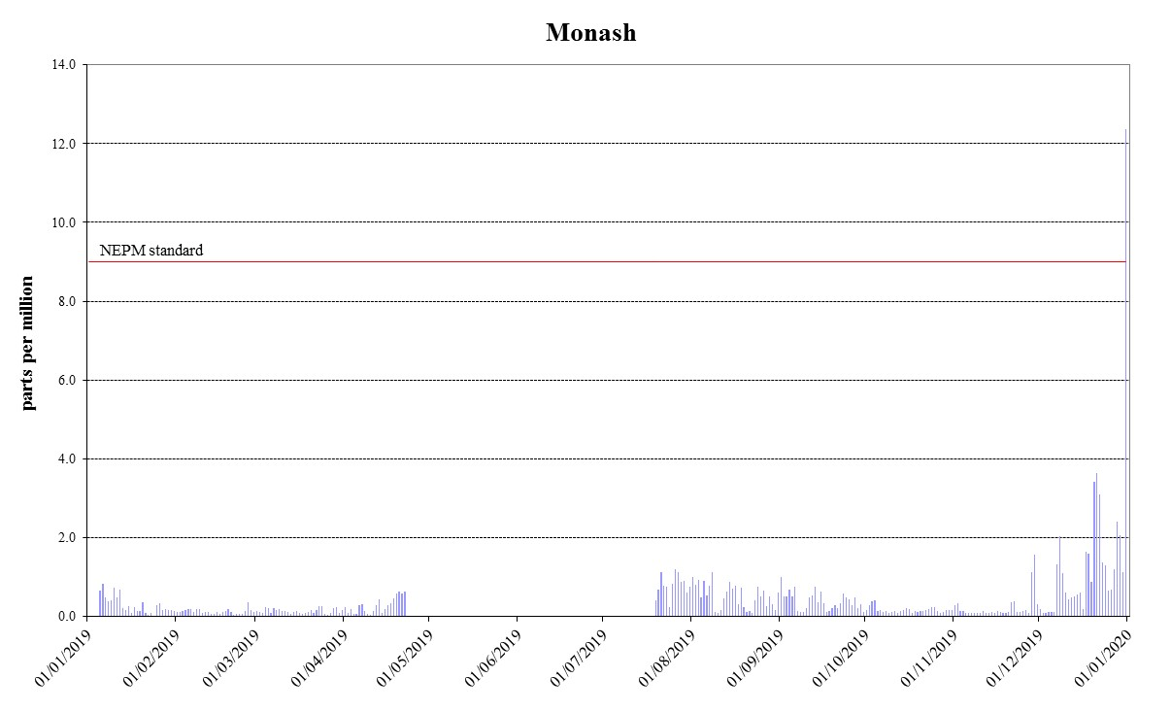

Figure 1: Daily maximum for CO 8-hour average – Monash
`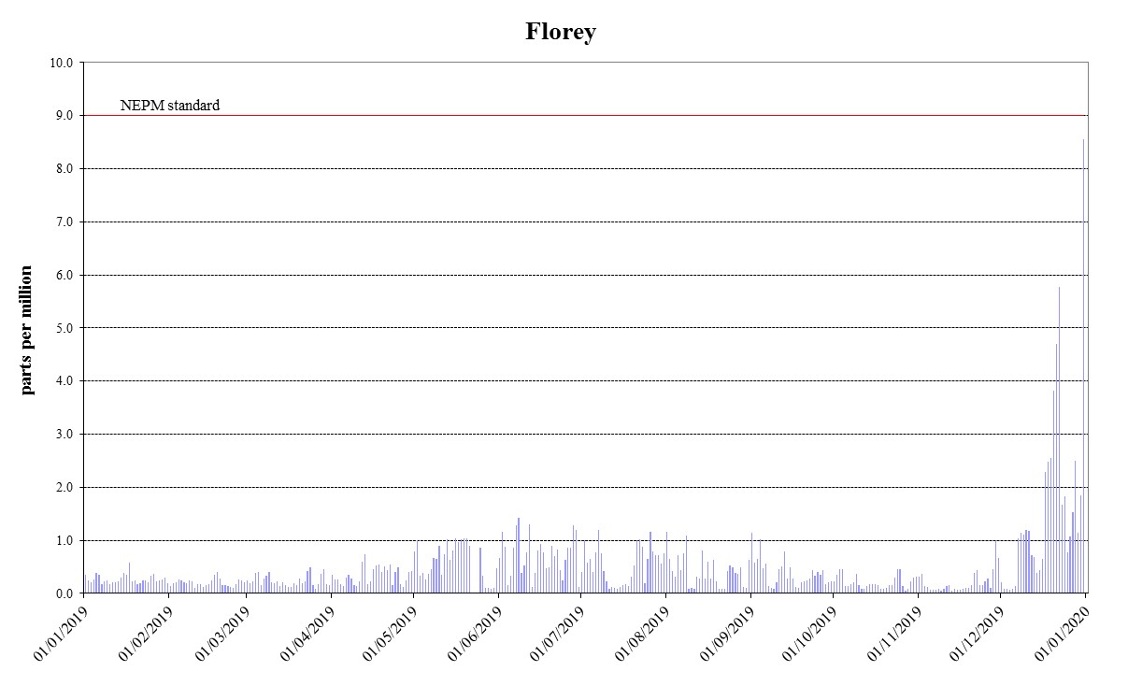
Figure 2: Daily maximum for CO 8-hour average – Florey

Nitrogen dioxide
During 2019, no exceedances of the nitrogen dioxide standards were recorded and compliance was demonstrated at Monash and Florey.
Table 5: 2019 compliance summary for NO₂
AAQ NEPM standard – 0.12 ppm (1-hour average), 0.03 ppm (1-year average)
Performance monitoring station | Data availability rates  (% of hours) |  |  |  |  | Annual mean  Concentration  (ppm) | Number of  1 hour exceedances  (days) | Performance against the standards and goal
 |  |  |  |  |  |  |  | 1 hour | 1 year
 | Q1 | Q2 | Q3 | Q4 | Annual
Monash  Florey | 95.6  95.5 | 95.7  91.0 | 92.4  95.7 | 95.7  87.6 | 94.9  92.4 | 0.005  0.005 | 0  0 | MET  MET | MET  MET
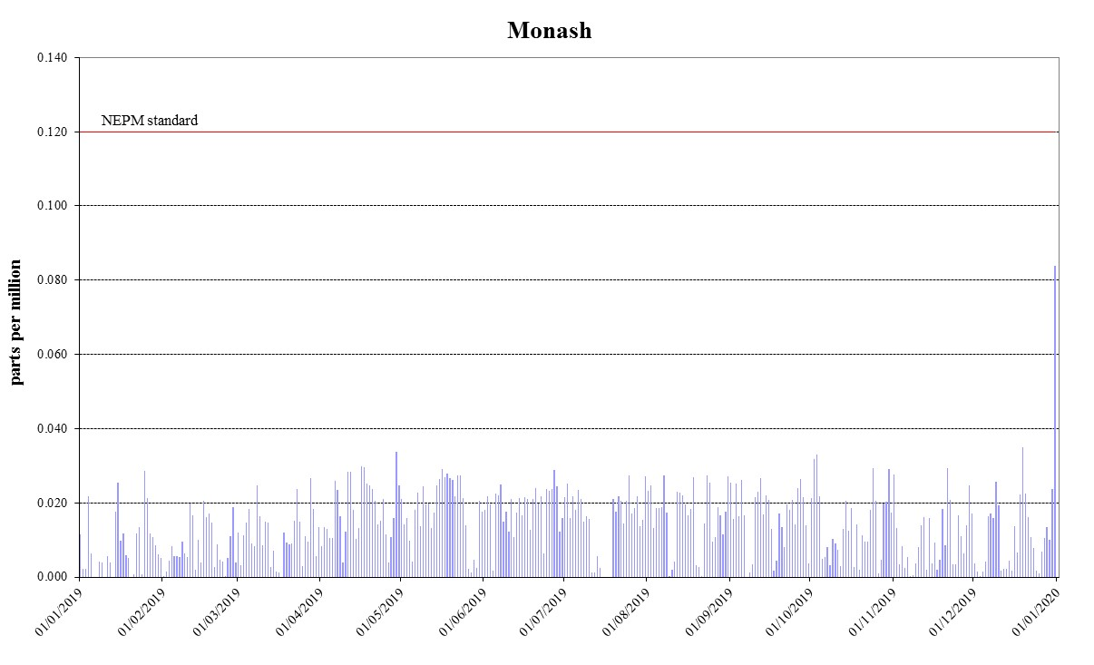
Figure 3: Daily maximum for NO₂ – Monash
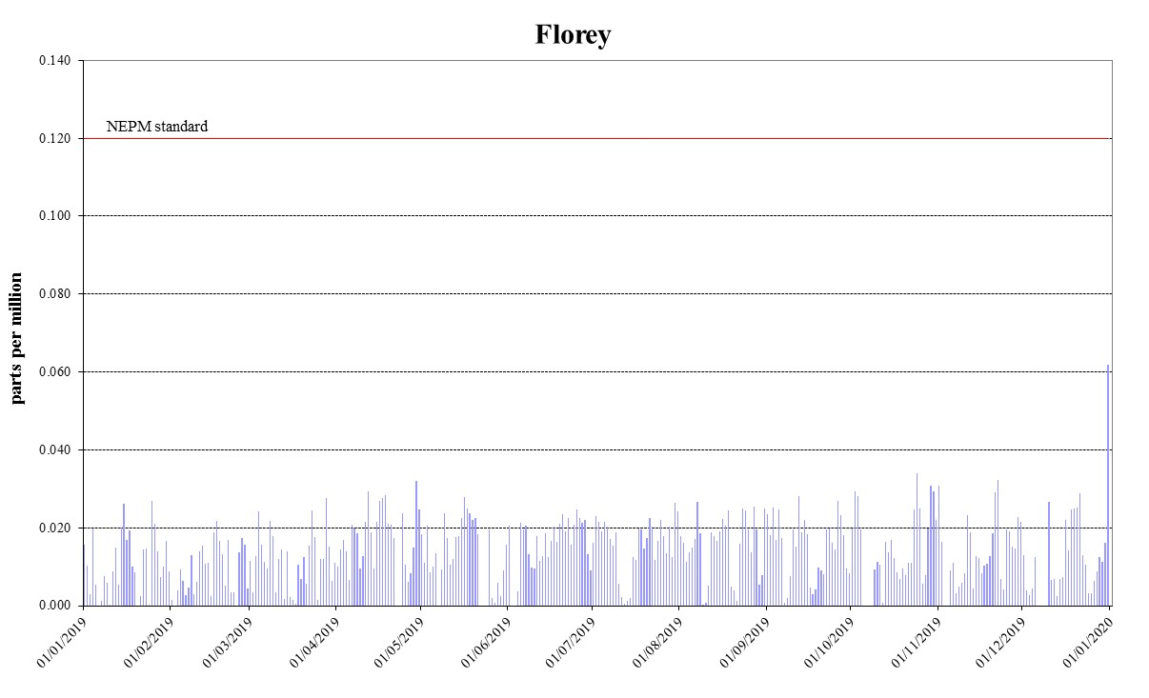
Figure 4: Daily maximum for NO₂ – Florey

Ozone
On 20 December 2019, ozone levels above the 1-hour and 4-hour standards were recorded at all stations due to the bushfire impact. Despite this exceedance, compliance was demonstrated at Monash and Civic. The 4-hour standard was exceeded two more times at Florey on 17 January and
9 December. As a result, compliance for 4-hour ozone standard was not met at Florey.
Table 6: 2019 compliance summary for O₃
AAQ NEPM standard – 0.10 ppm (1-hour average), 0.08 ppm (4-hour average)
Performance monitoring station | Data availability rates  (% of hours) |  |  |  |  | Number of exceedances  (days) |  | Performance against the standards and goal
 | Q1 | Q2 | Q3 | Q4 | Annual | 1 hour | 4 hours | 1 hour | 4 hours
Monash  Civic  Florey | 95.8  95.8  95.8 | 95.7  96.0  94.1 | 95.7  95.8  95.7 | 95.8  95.7  95.6 | 95.8  95.8  95.3 | 1  1  1 | 1  1  3 | MET  MET  MET | MET  MET  NOT MET

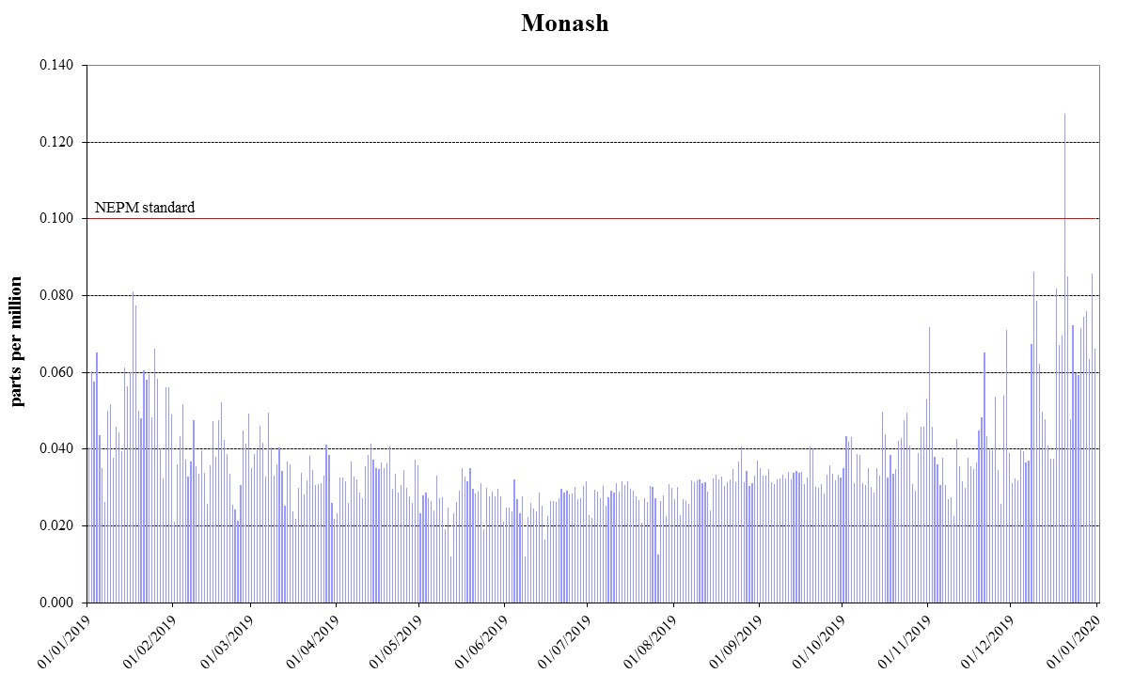
Figure 5: Daily maximum for 1 hour O₃ – Monash

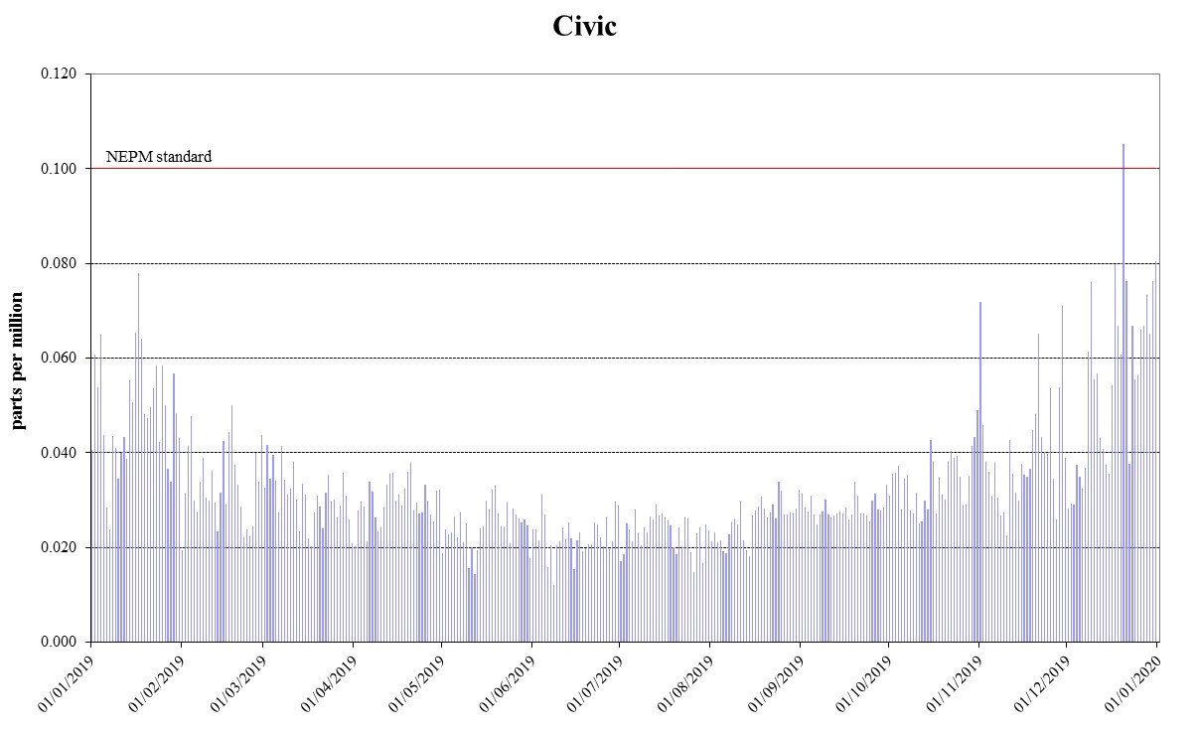
Figure 6: Daily maximum for 1 hour O₃ – Civic
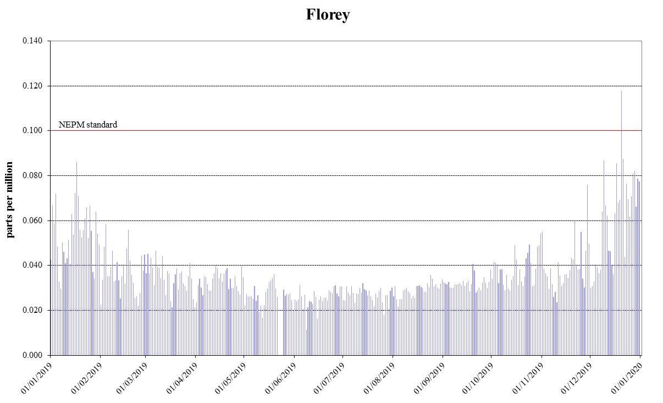
Figure 7: Daily maximum for 1 hour O₃ – Florey
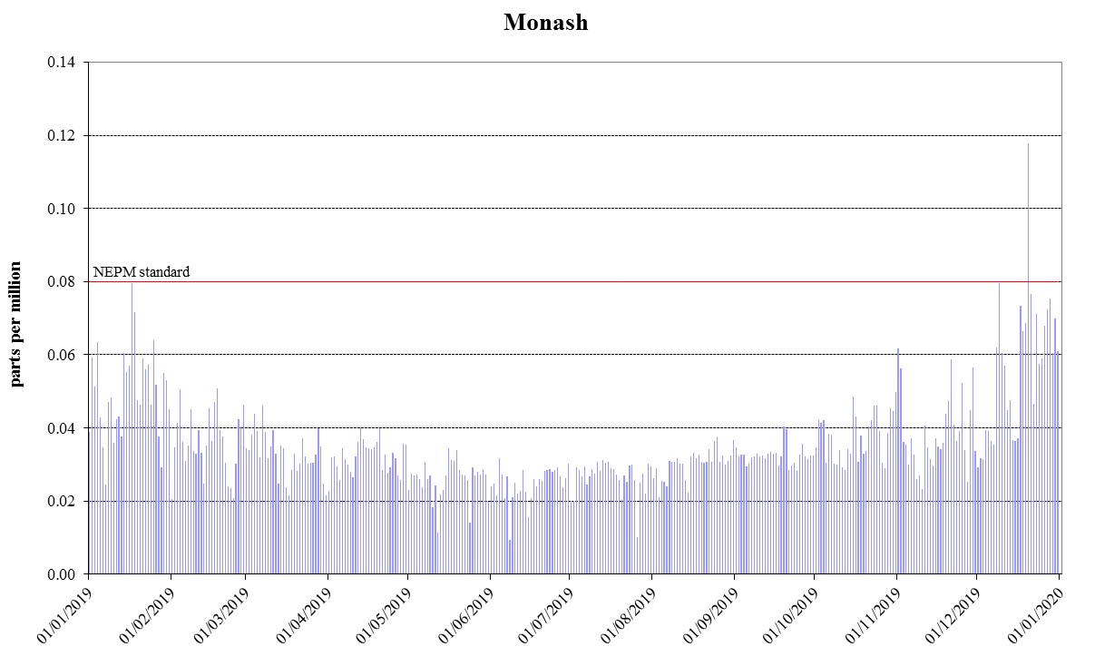
Figure 8: Daily maximum for 4 hours O₃ - Monash
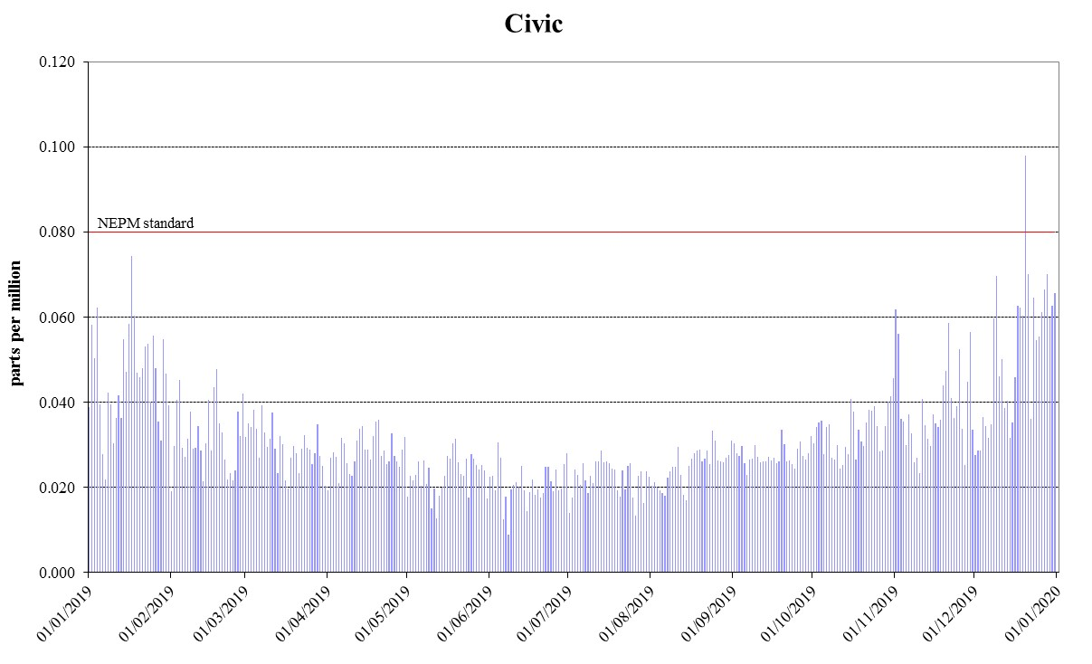
Figure 9: Daily maximum for 4 hours O₃ – Civic
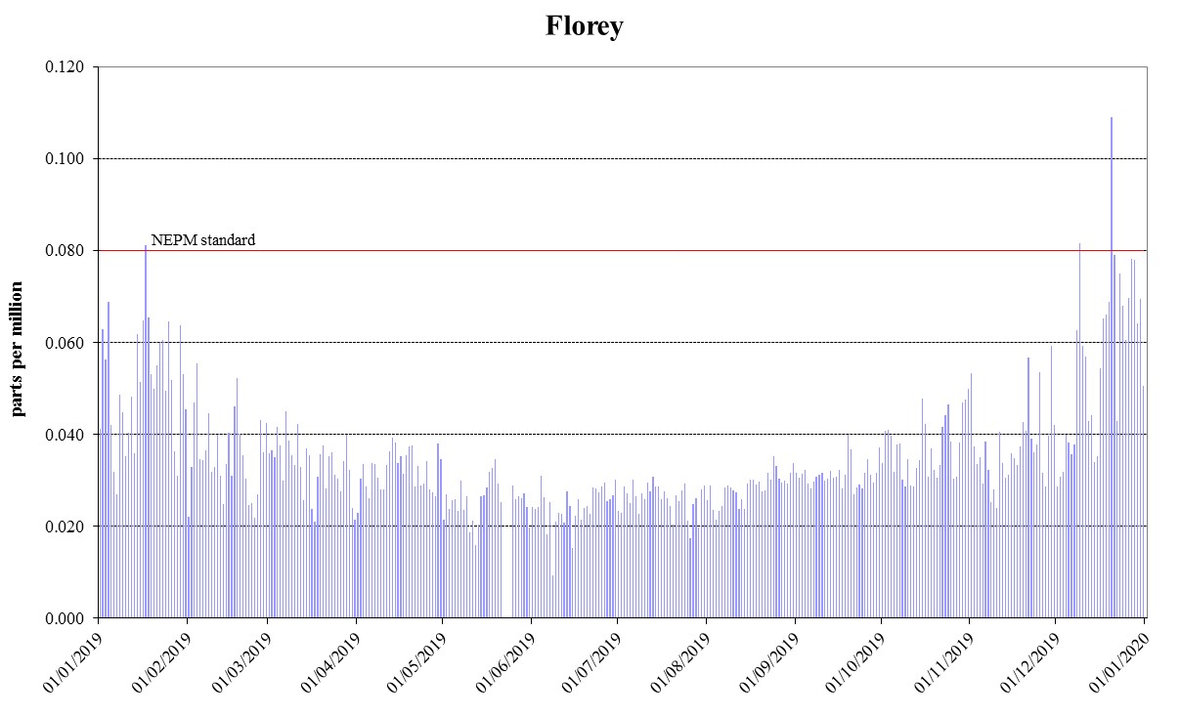
Figure 10: Daily maximum for 4 hours O₃ – Florey

PM₁₀
During 2019, there were exceedances of daily PM₁₀ standard on 29 days outside the winter season due to bushfires (21 days) and dust storms (8 days). Compliance against the daily PM₁₀ standard was demonstrated at all stations as theses exceedances being exceptional events are removed. While annual average PM₁₀ data at all monitoring stations met the 25 μg/m³ AAQ NEPM standard, annual average levels at Civic and Florey slightly exceeded the 20 μg/m³ ACT policy position.
Table 7: 2019 compliance summary for PM₁₀
AAQ NEPM standard 50 μg/m³ 1-day average, 20 μg/m³ (1-year average)*
Performance monitoring station | Data availability rates  (% of days) |  |  |  |  | Annual mean  Concentration  (μg/m³) | Number of exceedances  (total/EE**) | Performance against the standards and goal
 | Q1 | Q2 | Q3 | Q4 | Annual
Monash  Civic  Florey | 95.6  92.2  95.6 | 100  97.8  97.8 | 98.9  100  98.9 | 98.9  98.9  100 | 98.4  97.3  98.1 | 19.1  22.9  23.8 | 22/22  29/29  28/28 | MET  NOT MET*  NOT MET*

* ACT policy position 20 µg/m³ not AAQ NEPM standard of 25 µg/m³. ** Exception event.

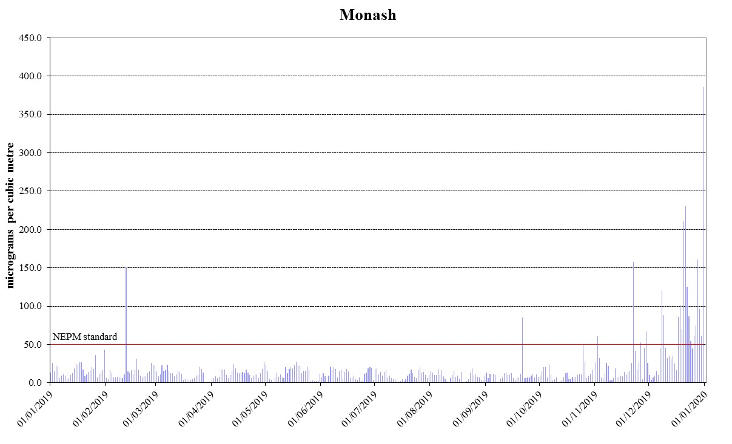
Figure 11: Daily maximum for PM₁₀ – Monash
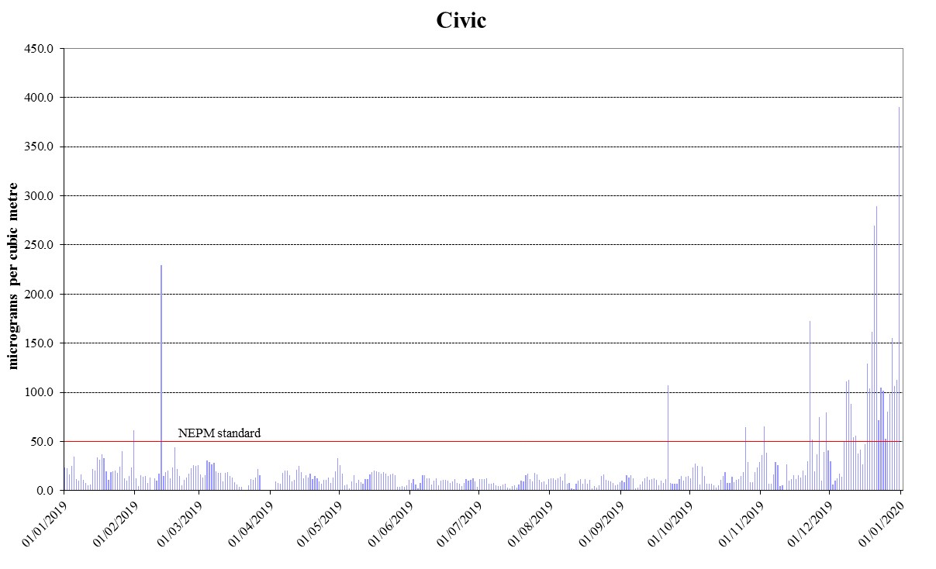
Figure 12: Daily maximum for PM₁₀ – Civic
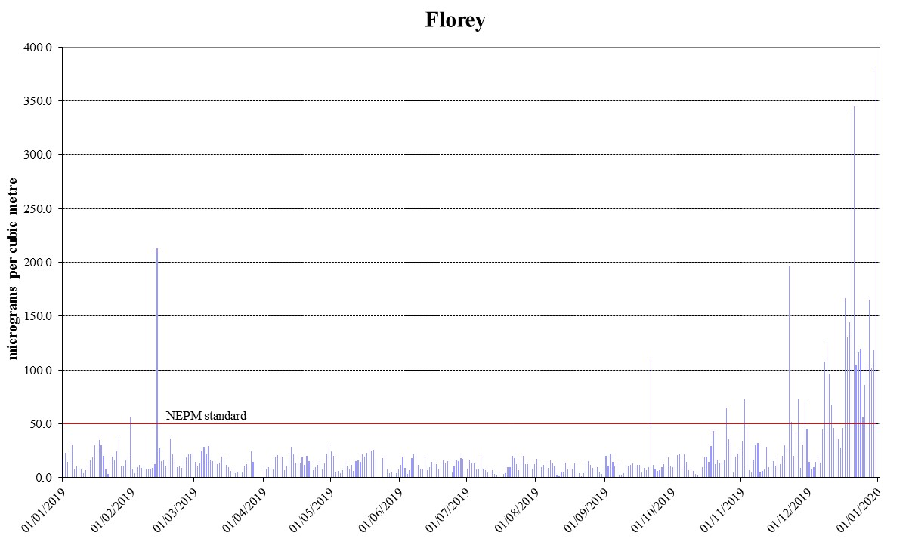
Figure 13: Daily maximum for PM₁₀ – Florey

PM_{2.5}
During 2019, there were exceedances of daily PM_{2.5} standard on 32 days which primarily occurred outside the winter season and were due to bushfires (27 days) and dust storms (3 days). Compliance against the daily PM_{2.5} standard was demonstrated at Civic when the exceptional events were removed. Compliance against the AAQ NEPM PM_{2.5} standards was not met at Monash due to two wood heater related exceedances on 18 and 19 May 2019.
Annual average PM_{2.5} data at all monitoring stations did not met the 8 μg/m³ AAQ NEPM standard.
Table 8: 2019 compliance summary for PM_{2.5}
AAQ NEPM standard – 25 μg/m³ (1-day), 8 μg/m³ (1-year)
Performance monitoring station | Data availability rates  (% of days) |  |  |  |  | Annual mean  Concentration  (μg/m³) | Number of  exceedances  (total/EE*) | Performance against the standards and goal
 | Q1 | Q2 | Q3 | Q4 | Annual
Monash  Civic  Florey | 100  91.1  97.8 | 100  96.7  96.7 | 98.9  100  100 | 96.7  97.8  98.9 | 98.9  96.4  98.4 | 14.1  12.8  14.8 | 28/26  29/29  29/29 | NOT MET  NOT MET  NOT MET
* Exception event

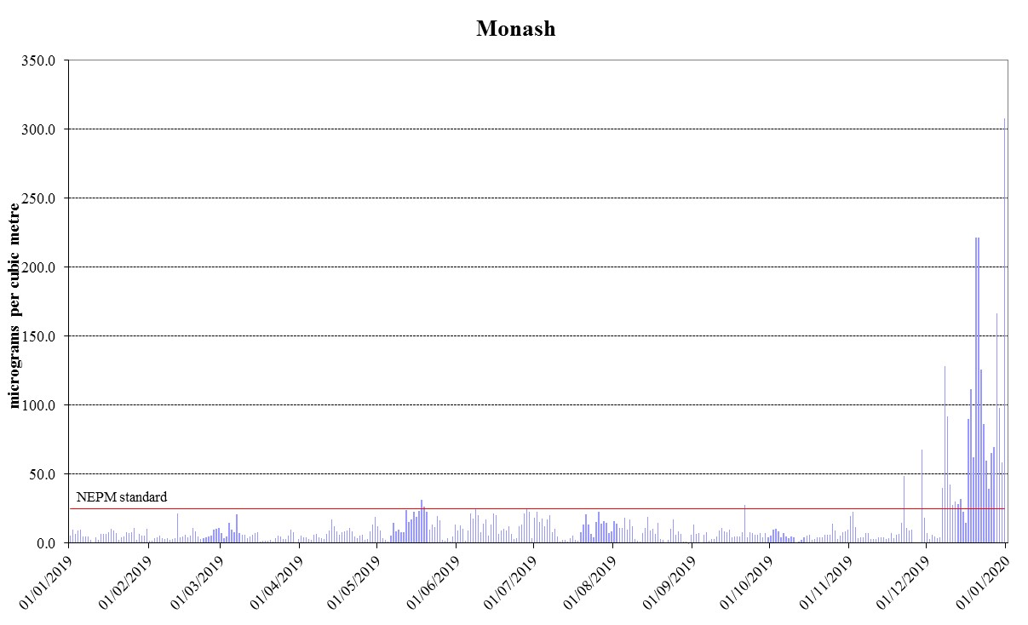
Figure 14: Daily maximum for PM_{2.5} – Monash
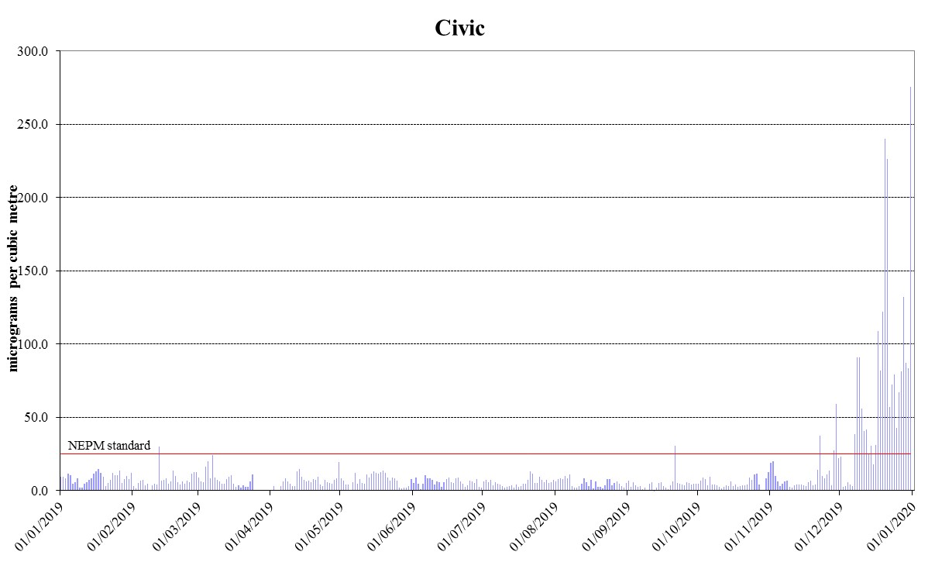
Figure 15: Daily maximum for PM_{2.5} – Civic
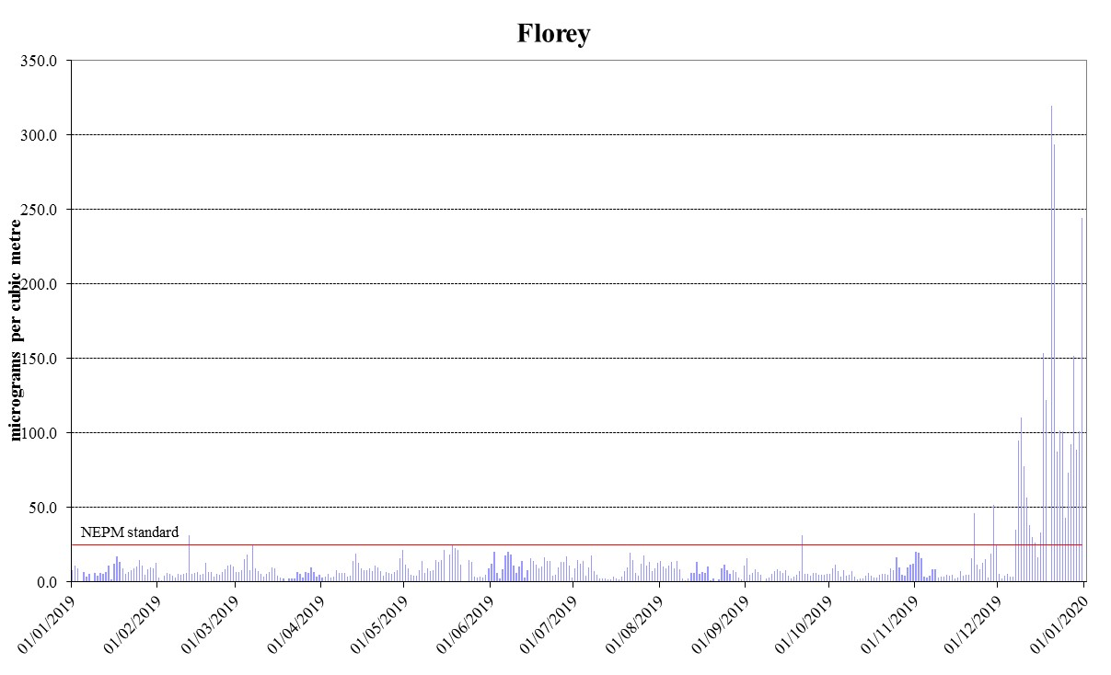
Figure 16: Daily maximum for PM_{2.5} – Florey

ANALYSIS OF AIR QUALITY MONITORING
Annual summary statistics contained in Table 9 to Table 14 below assess air quality against the standards and the extent of compliance with the goal. Instances where the standard has been exceeded are highlighted in bold.

Carbon monoxide
Carbon monoxide levels significantly increased across the ACT in December 2019 due to bushfires. One exceedance was measured at Monash on 31 December 2019, with a new record of 12.4 ppm. This was the first exceedance of the carbon monoxide standard since the commencement of air quality monitoring in the ACT.
Table 9: 2019 summary statistics for daily peak 8-hour CO
AAQ NEPM standard - 9.0 ppm (8-hour average)
Performance monitoring station | Number of valid days | Highest  (ppm) | Highest  (date/time) | 2nd Highest  (ppm) | 2nd Highest  (date/time)
Monash  Florey | 273  362 | 12.4  8.6 | 31 Dec 00:00  31 Dec 00:00 | 3.6  5.8 | 21 Dec 01:00  22 Dec 03:00

Nitrogen dioxide
While the bushfire smoke adversely impacted the nitrogen dioxide levels, no exceedances were recorded across the ACT. The highest recorded 1-hour value during 2019 was 0.084 ppm at Monash. Annual average remained well below the standard in 2019. The annual average in 2019 was 0.005ppm at both Monash and Florey. This is 17% of the annual standard 0.03ppm.
Table 10: 2019 summary statistics for daily peak 1-hour NO₂
AAQ NEPM standard 0.12 ppm (1-hour average)
Performance monitoring station | Number of valid days | Highest  (ppm) | Highest  (date/time) | 2nd Highest  (ppm) | 2nd Highest  (date/time)
Monash  Florey | 361  347 | 0.084  0.062 | 31 Dec 22:00  31 Dec 21:00 | 0.035  0.034 | 19 Dec 7:00  24 Oct 21:00

Ozone
Ozone levels were higher this year compared with the previous year due to effects of the extensive bushfire smoke, coupled with warm and dry weather in 2019. There were three days in 2019 when ozone levels were above the standards. On 20 December 2019 the most extensive ozone event for 2019 occurred. On this day, all monitoring stations recorded ozone levels over the 1-hour and
4-hour standards. Ozone levels above the 4-hour standard were recorded two more times at Florey on 17 January and 9 December 2019, due to hotter weather increasing the conversion of vehicle emissions to ozone and bushfires respectively. The highest recorded 1-hour value in the ACT during 2019 was 0.127 ppm at Monash. The highest recorded 4-hour value in the ACT during 2019 was 0.118 ppm at Monash.
Table 11: 2019 summary statistics for daily peak 1-hour O₃
AAQ NEPM standard 0.10 ppm (1-hour average)
Performance monitoring station | Number of valid days | Highest  (ppm) | Highest  (date/time) | 2nd Highest  (ppm) | 2nd Highest  (date/time)
Monash  Civic  Florey | 365  365  362 | 0.127  0.105  0.118 | 20 Dec 13:00  20 Dec 12:00  20 Dec 12:00 | 0.086  0.080  0.087 | 09 Dec 12:00  31 Dec 20:00  21 Dec 11:00

Table 12: 2019 summary statistics for daily peak 4-hour O₃
AAQ NEPM standard 0.08 ppm (4-hour average)
Performance monitoring station | Number of valid days | Highest  (ppm) | Highest  (date/time) | 2nd Highest  (ppm) | 2nd Highest  (date/time)
Monash  Civic  Florey | 365  365  362 | 0.118  0.098  0.109 | 20 Dec 15:00  20 Dec 15:00  20 Dec 15:00 | 0.080  0.074  0.082 | 17 Jan 16:00  17 Jan 16:00  09 Dec 15:00

PM₁₀
There were 29 days when daily PM₁₀ standard was exceeded in 2019. The highest daily PM₁₀ level was 390.2μg/m³ which was recorded at Civic on 31 December 2019.
The high number of daily PM₁₀ exceedances was primarily attributed to the extensive bushfires throughout New South Wales (21 days) impacting the ACT and the increasing frequency of widespread dust storms (8 days). Under the exceptional event rule they have been excluded when assessing compliance against the daily standard.
Whilst monitoring data from exceptional events is excluded for reporting compliance for daily averaging standards it is still included for one year averaging standards, which has led to an abrupt increase in the annual averages.
The highest recorded annual average in 2019 was 23.8μg/m³ at Florey (refer to Table 7) up from a maximum of 13.5μg/m³ (Civic) in 2018. This is below the national annual standard of 25μg/m³, but was slightly over the ACT annual standard of 20μg/m³.
Table 13: 2019 summary statistics for daily PM₁₀
AAQ NEPM daily standard 50 μg/m³
Performance monitoring station | Number of valid days | Highest  (μg/m³) | Highest  (date)
Monash  Civic  Florey | 359  355  358 | 385.7  390.2  379.7 | 31 December  31 December  31 December

PM_{2.5}
The daily standard for PM_{2.5} was exceeded on 32 days in 2019. Only two of the exceeding days, which occurred on 18 and 19 May 2019, were a result of domestic wood heater emissions in winter. The other exceedances were due to bushfire smoke (27 days) and dust storms (3 days).
The highest daily PM_{2.5} level was 319.6μg/m³ which was recorded at Florey on 20 December 2019.
Whilst monitoring data from exceptional events is excluded for reporting compliance for daily averaging standards it is still included for one year averaging standards. Given the length of time the Canberra airshed was affected by bushfire smoke there was an abrupt increase in annual average PM_{2.5} levels in 2019, compared with previous years.
All monitoring stations recorded annual average PM_{2.5} concentrations above the national standard 8 μg/m³. The highest recorded annual average in 2019 was 14.8μg/m³ at Florey (refer to Table 8) up from a maximum of 7.1μg/m³ (Florey) in 2018.
Table 14: 2019 summary statistics for daily PM_{2.5}
AAQ NEPM daily standard 25 μg/m³
Performance monitoring station | Number of valid days | Highest  (μg/m³) | Highest  (date)
Monash  Civic  Florey | 361  352  359 | 307.9  275.5  319.6 | 31 December  31 December  20 December

ASSESSMENT OF PROGRESS TOWARDS ACHIEVING THE GOAL
Historical monitoring results indicate that the only AAQ NEPM pollutant of concern in the ACT air shed is particulate matter, which increases significantly during winter because of emissions from domestic wood heaters. In more recent years exceedances of the particulate matter standards have also been attributed to dust storms and smoke from hazard reduction burns and bushfires.
However, 2019 will go down on record as one of our worst years for air pollution due to the ACT being impacted by smoke from the bushfires burning in south-eastern New South Wales which started in November 2019 and continued into early 2020.
Concentrations of carbon monoxide and nitrogen dioxide met the AAQ NEPM standards, with the exception of one exceedance of the 8-hour carbon monoxide standard at Monash during the bushfire period.
Ozone levels increased compared with 2018, because of the bushfire crisis together with warm and dry weather in 2019, meeting the AAQ NEPM standards on 99% of all days.
Daily maximum and annual average particulate matter levels (PM₁₀ and PM_{2.5}) dramatically increased due to the unprecedented levels of the bushfire smoke. Additionally, Bureau of Meteorology data shows that rainfall was well below average and daytime maximum temperatures were well above average in 2019. The record breaking drought conditions also led to an increase in widespread dust events throughout the year.
Ironically, these warmer temperatures resulted in one of the best winters the ACT has experienced for wood heater pollution with only two PM_{2.5} exceedance days related to emissions from domestic wood heaters.
Notwithstanding this result, the ACT Government acknowledges that wood heater emissions are a problem and will continue to implement an integrated program to address this including:
- implementing the ‘Burn Right Tonight’ public education campaign;
- regulating of the sale of firewood; and
- administering the Wood Heater Replacement Program.
Bushfire smoke and dust storms continue to present a threat to future air quality in the ACT, particularly as climate change is set to exacerbate the frequency and intensity of bushfire events, coupled with rising temperatures and prolonged dry weather. Similarly, rising temperatures will also result in an increase in the ACTs ozone levels because as temperature increase so does the conversion of vehicle emissions to ozone

APPENDIX A: STATISTICAL SUMMARY AND TRENDS
The following section provides a basic statistical summary, using percentiles, for Monash, Florey and Civic stations and for each standard in the past ten years. Percentiles for daily maximum values are presented.

Carbon monoxide
Table 15: Statistical summary for daily maximum 8-hour CO Monash 2010 – 2019
Year | Data  Availability  (%) | No. of  Exceedances  (days) | Max  conc.  (ppm) | 95th  percentile  (ppm) | 75th  percentile  (ppm) | 50th  percentile  (ppm)
2010 | 99.2 | 0 | 1.8 | 1.4 | 0.6 | 0.3
2011 | 98.6 | 0 | 2.2 | 1.5 | 0.5 | 0.2
2012 | 99.7 | 0 | 1.8 | 1.2 | 0.6 | 0.3
2013 | 95.9 | 0 | 2.1 | 1.5 | 0.6 | 0.3
2014 | 94.0 | 0 | 1.8 | 1.4 | 0.7 | 0.4
2015 | 94.8 | 0 | 1.9 | 1.4 | 0.6 | 0.3
2016 | 95.8 | 0 | 1.7 | 1.0 | 0.4 | 0.2
2017 | 95.4 | 0 | 1.6 | 1.2 | 0.6 | 0.2
2018 | 92.3 | 0 | 1.5 | 1.2 | 0.5 | 0.2
2019 | 72.1 | 1 | 12.4 | 1.1 | 0.4 | 0.1

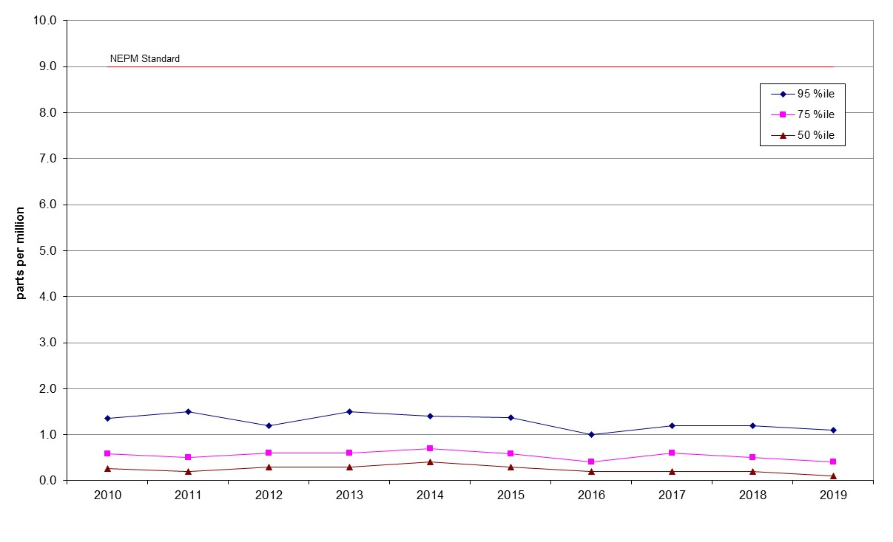
Figure 17: Statistical summary for daily maximum 8-hour CO Monash 2010 – 2019
Table 16: Statistical summary for daily maximum 8-hour CO Florey 2014 – 2019
Year | Data  Availability  (%) | No. of  Exceedances  (days) | Max  conc.  (ppm) | 95th  percentile  (ppm) | 75th  percentile  (ppm) | 50th  percentile  (ppm)
2014 | 79.2 | 0 | 2.2 | 1.4 | 0.7 | 0.3
2015 | 94.9 | 0 | 2.0 | 1.5 | 0.6 | 0.3
2016 | 95.5 | 0 | 1.9 | 1.2 | 0.5 | 0.3
2017 | 94.7 | 0 | 1.8 | 1.4 | 0.5 | 0.2
2018 | 94.7 | 0 | 1.5 | 1.1 | 0.5 | 0.3
2019 | 95.3 | 0 | 8.6 | 1.2 | 0.6 | 0.3

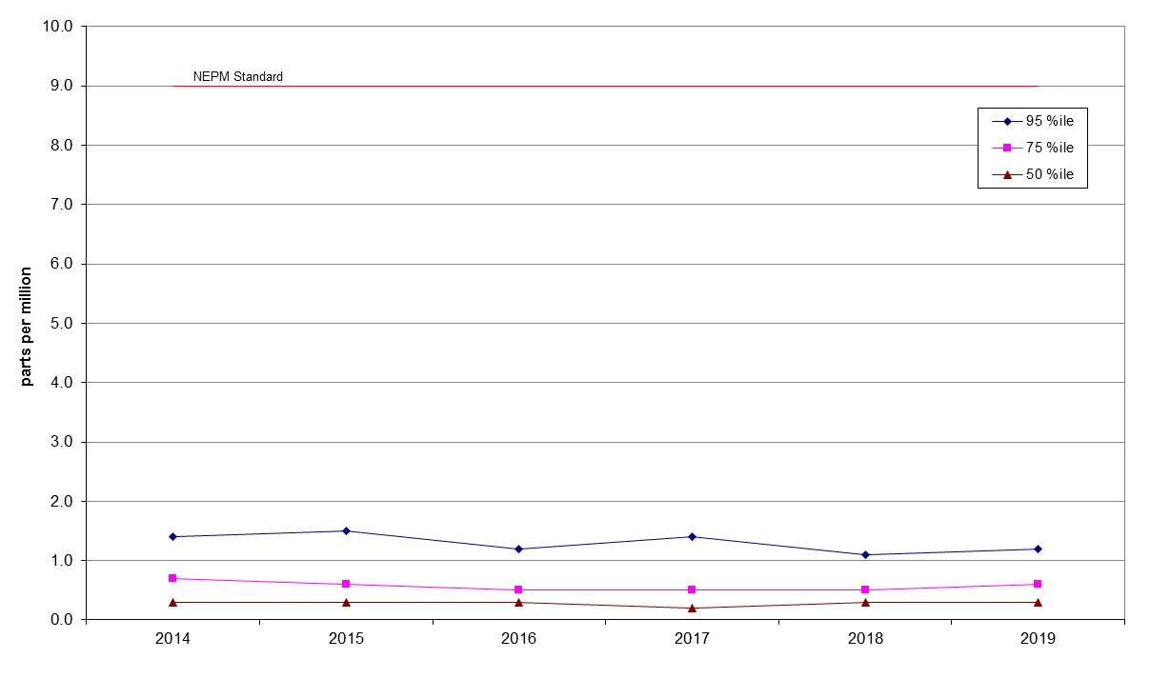
Figure 18: Statistical summary for daily maximum 8-hour CO Florey 2014 – 2019

Nitrogen dioxide
Table 17: Statistical summary for daily maximum 1-hour NO₂ Monash 2010 – 2019
Year | Data  Availability  (%) | No. of  Exceedances  (days) | Max  conc.  (ppm) | Annual average  (ppm) | 95th  percentile  (ppm) | 75th  percentile  (ppm) | 50th  percentile  (ppm)
2010 | 89.1 | 0 | 0.037 | 0.006 | 0.025 | 0.021 | 0.017
2011 | 96.7 | 0 | 0.043 | 0.005 | 0.029 | 0.022 | 0.015
2012 | 97.5 | 0 | 0.033 | 0.006 | 0.026 | 0.021 | 0.014
2013 | 97.5 | 0 | 0.037 | 0.005 | 0.027 | 0.021 | 0.014
2014 | 94.1 | 0 | 0.036 | 0.005 | 0.027 | 0.020 | 0.015
2015 | 94.8 | 0 | 0.032 | 0.004 | 0.026 | 0.020 | 0.014
2016 | 95.6 | 0 | 0.036 | 0.004 | 0.027 | 0.019 | 0.012
2017 | 95.6 | 0 | 0.031 | 0.004 | 0.027 | 0.021 | 0.013
20198 | 95.5 | 0 | 0.039 | 0.004 | 0.028 | 0.020 | 0.014
2019 | 94.9 | 0 | 0.084 | 0.005 | 0.027 | 0.021 | 0.014

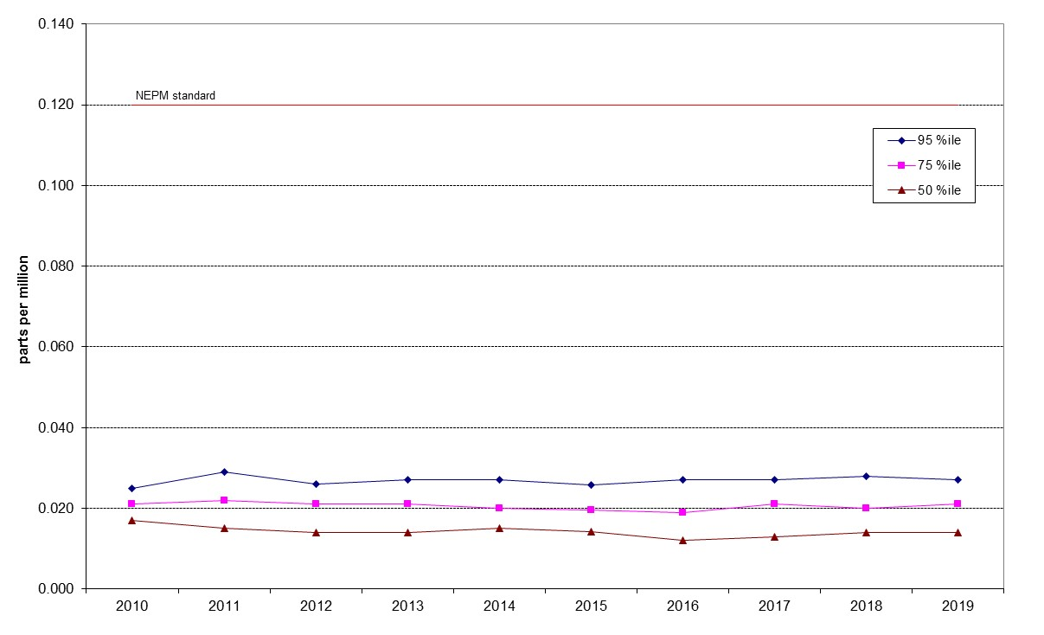

Figure 19: Statistical summary for daily maximum 1-hour NO₂ Monash 2010 – 2019

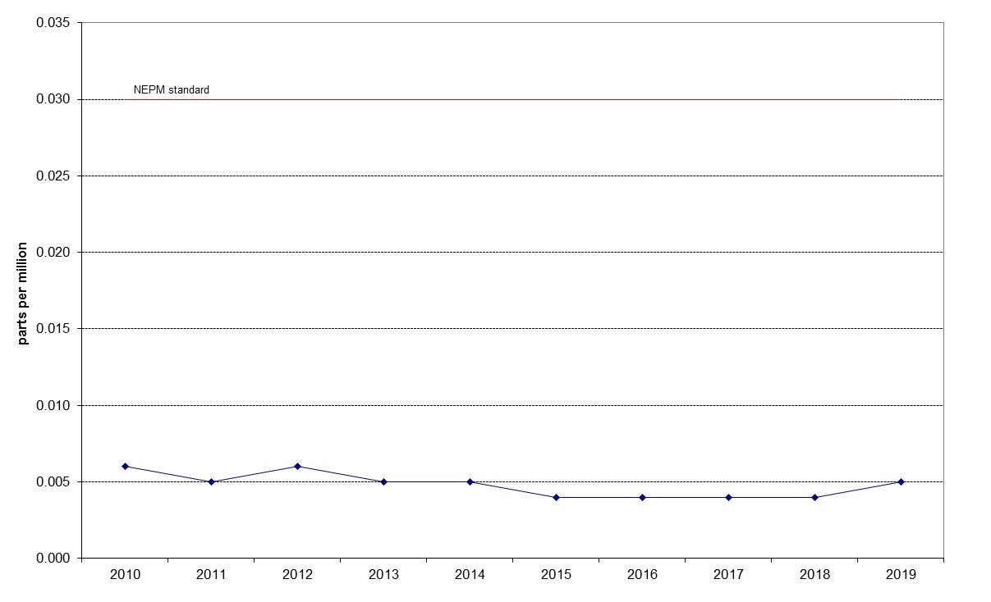

Figure 20: Annual average 1-hour NO₂ Monash 2010 – 2019

Table 18: Statistical summary for daily maximum 1-hour NO₂ Florey 2014 – 2019
Year | Data  Availability  (%) | No. of  Exceedances  (days) | Max  conc.  (ppm) | Annual average  (ppm) | 95th  percentile  (ppm) | 75th  percentile  (ppm) | 50th  percentile  (ppm)
2014 | 78.3 | 0 | 0.045 | 0.006 | 0.027 | 0.020 | 0.015
2015 | 91.5 | 0 | 0.033 | 0.005 | 0.027 | 0.020 | 0.014
2016 | 94.7 | 0 | 0.034 | 0.004 | 0.027 | 0.019 | 0.013
2017 | 93.7 | 0 | 0.033 | 0.005 | 0.025 | 0.020 | 0.015
2018 | 93.3 | 0 | 0.039 | 0.005 | 0.028 | 0.022 | 0.015
2019 | 92.4 | 0 | 0.062 | 0.005 | 0.027 | 0.020 | 0.014

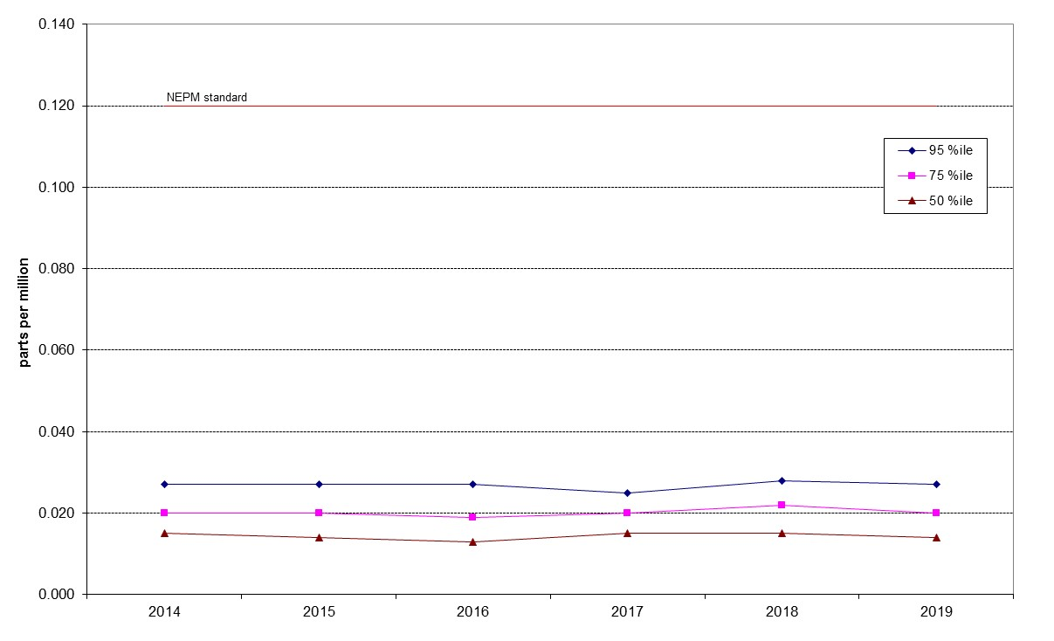
Figure 21: Statistical summary for daily maximum 1-hour NO₂ Florey 2014 – 2019
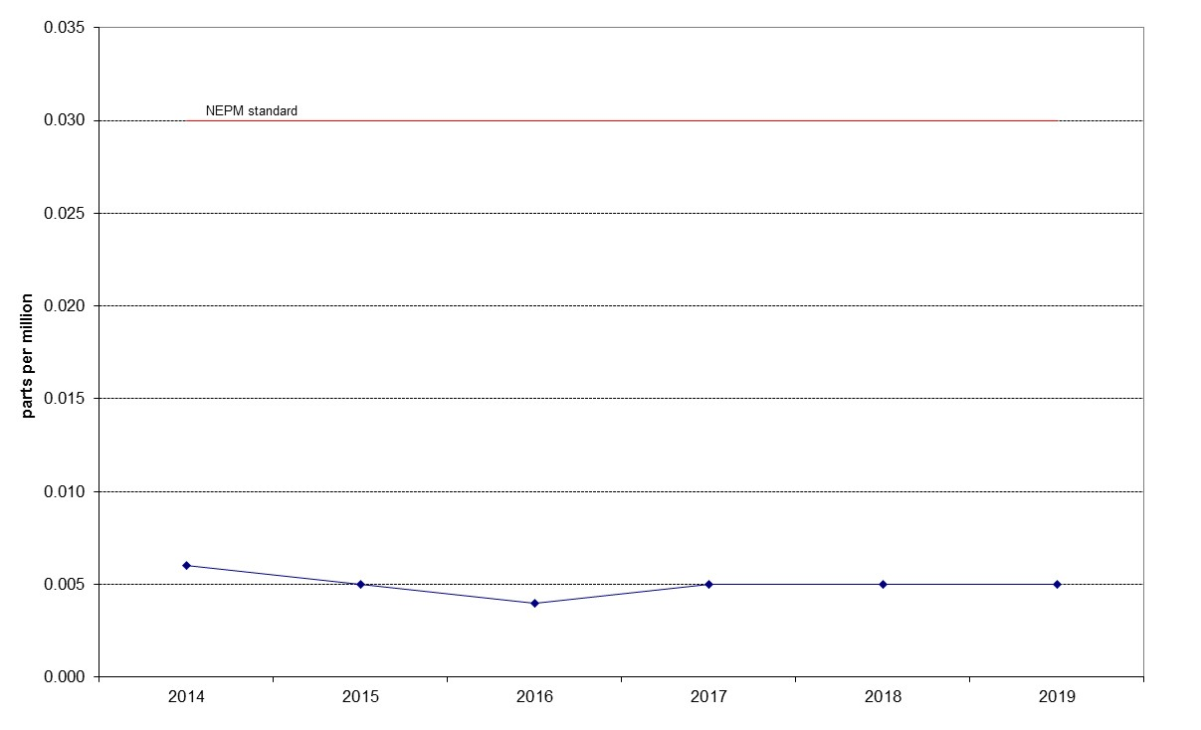
Figure 22: Annual average 1-hour NO₂ Florey 2014 – 2019

Ozone
Table 19: Statistical summary for daily maximum 1-hour O₃ Monash 2010 – 2019
Year | Data  Availability  (%) | No. of  Exceedances  (days) | Max  conc.  (ppm) | 95th  percentile  (ppm) | 75th  percentile  (ppm) | 50th  percentile  (ppm)
2010 | 86.6 | 0 | 0.051 | 0.042 | 0.033 | 0.030
2011 | 99.2 | 0 | 0.056 | 0.044 | 0.033 | 0.028
2012 | 100 | 0 | 0.055 | 0.043 | 0.034 | 0.029
2013 | 97.8 | 0 | 0.062 | 0.045 | 0.035 | 0.029
2014 | 94.8 | 0 | 0.087 | 0.050 | 0.036 | 0.030
2015 | 92.8 | 0 | 0.065 | 0.044 | 0.034 | 0.026
2016 | 95.2 | 0 | 0.057 | 0.044 | 0.032 | 0.026
2017 | 95.5 | 0 | 0.060 | 0.049 | 0.038 | 0.032
2018 | 95.8 | 0 | 0.062 | 0.050 | 0.039 | 0.032
2019 | 95.8 | 1 | 0.127 | 0.066 | 0.040 | 0.033

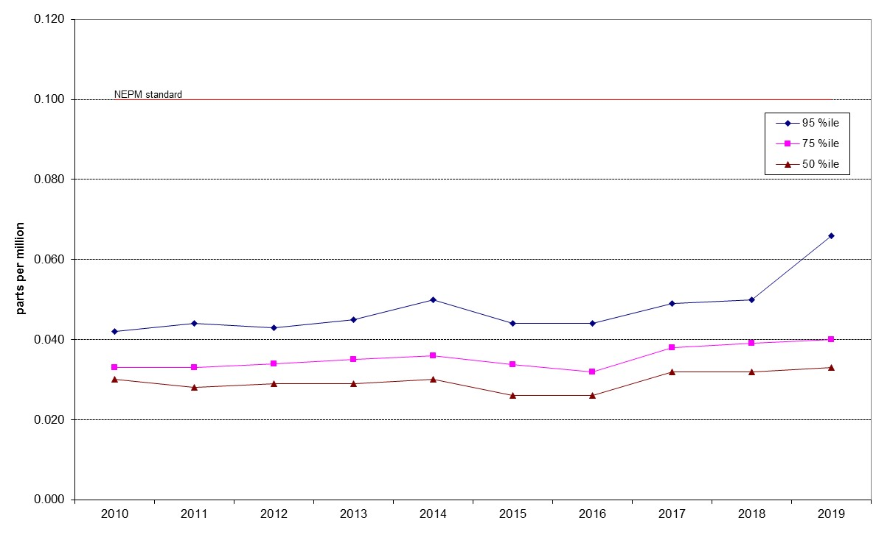

Figure 23: Statistical summary for daily maximum 1-hour O₃ Monash 2010 – 2019

Table 20: Statistical summary for daily maximum 1-hour O₃ Civic 2010 – 2019
Year | Data  Availability  (%) | No. of  Exceedances  (days) | Max  conc.  (ppm) | 95th  percentile  (ppm) | 75th  percentile  (ppm) | 50th  percentile  (ppm)
2010 | 99.2 | 0 | 0.058 | 0.040 | 0.029 | 0.025
2011 | 96.4 | 0 | 0.052 | 0.041 | 0.030 | 0.026
2012 | 100 | 0 | 0.053 | 0.034 | 0.024 | 0.020
2013 | 92.1 | 0 | 0.060 | 0.036 | 0.028 | 0.024
2014 | 94.0 | 0 | 0.060 | 0.039 | 0.028 | 0.022
2015 | 89.0 | 0 | 0.042 | 0.034 | 0.026 | 0.022
2016 | 95.8 | 0 | 0.047 | 0.036 | 0.028 | 0.024
2017 | 95.8 | 0 | 0.053 | 0.045 | 0.034 | 0.028
2018 | 95.2 | 0 | 0.056 | 0.046 | 0.032 | 0.028
2019 | 95.8 | 4 | 0.169 | 0.065 | 0.037 | 0.029

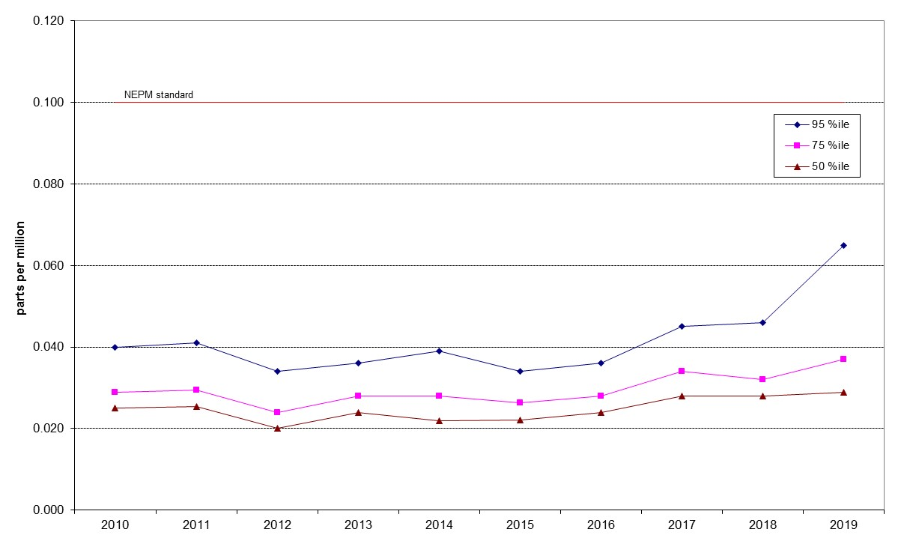

Figure 24: Statistical summary for daily maximum 1-hour O₃ Civic 2010 – 2019

Table 21: Statistical summary for daily maximum 1-hour O₃ Florey 2014 – 2019
Year | Data  Availability  (%) | No. of  Exceedances  (days) | Max  conc.  (ppm) | 95th  percentile  (ppm) | 75th  percentile  (ppm) | 50th  percentile  (ppm)
2014 | 79.4 | 0 | 0.074 | 0.034 | 0.027 | 0.023
2015 | 94.2 | 0 | 0.040 | 0.032 | 0.025 | 0.021
2016 | 95.8 | 0 | 0.050 | 0.040 | 0.031 | 0.027
2017 | 95.5 | 0 | 0.057 | 0.048 | 0.038 | 0.032
2018 | 95.2 | 0 | 0.059 | 0.050 | 0.038 | 0.032
2019 | 95.3 | 1 | 0.118 | 0.067 | 0.039 | 0.032

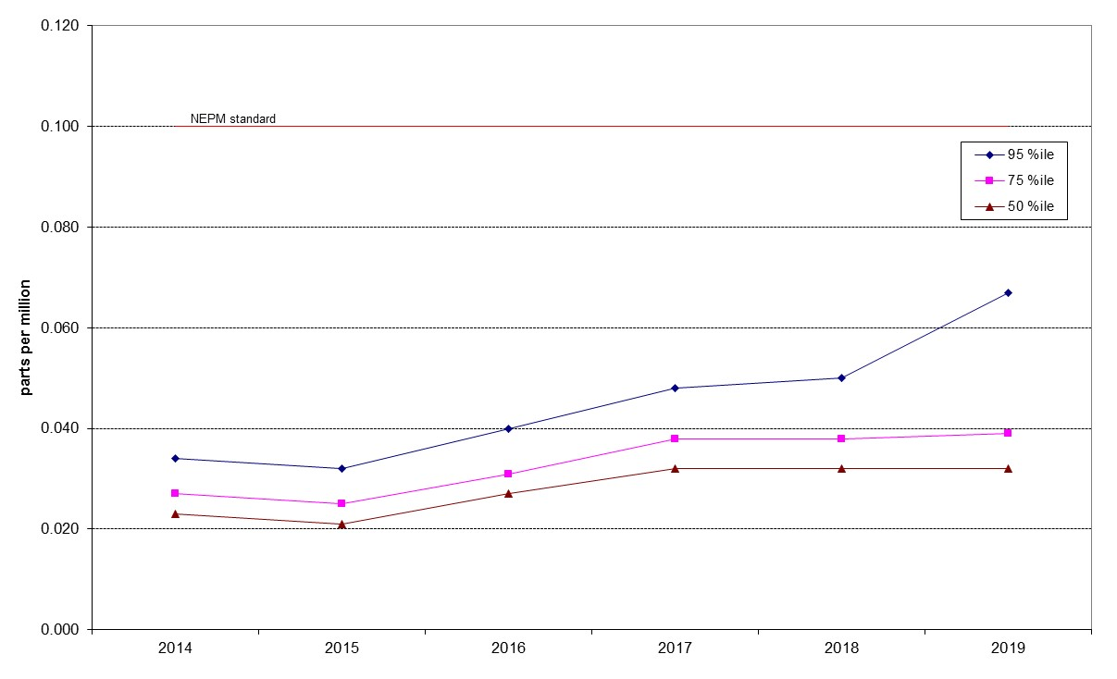

Figure 25: Statistical summary for daily maximum 1-hour O₃ Florey 2014 – 2019

Table 22: Statistical summary for daily maximum 4-hour O₃ Monash 2010 – 2019
Year | Data  Availability  (%) | No. of  Exceedances  (days) | Max  conc.  (ppm) | 95th  percentile  (ppm) | 75th  percentile  (ppm) | 50th  percentile  (ppm)
2010 | 86.6 | 0 | 0.049 | 0.040 | 0.032 | 0.029
2011 | 98.9 | 0 | 0.054 | 0.041 | 0.032 | 0.027
2012 | 99.7 | 0 | 0.052 | 0.043 | 0.034 | 0.029
2013 | 97.8 | 0 | 0.059 | 0.042 | 0.033 | 0.028
2014 | 94.8 | 0 | 0.060 | 0.046 | 0.034 | 0.029
2015 | 92.8 | 0 | 0.050 | 0.041 | 0.033 | 0.025
2016 | 95.2 | 0 | 0.055 | 0.042 | 0.030 | 0.025
2017 | 95.5 | 0 | 0.055 | 0.047 | 0.036 | 0.031
2018 | 95.8 | 0 | 0.057 | 0.049 | 0.038 | 0.032
2019 | 95.8 | 1 | 0.118 | 0.061 | 0.039 | 0.032

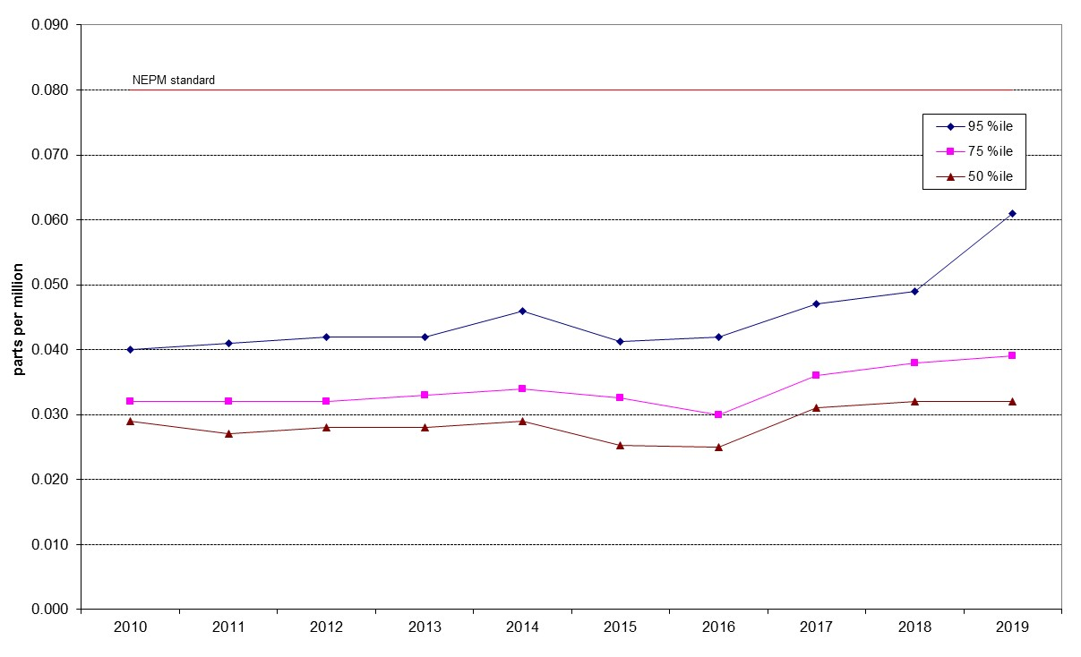

Figure 26: Statistical summary for daily maximum 4-hour O₃ Monash 2010 – 2019

Table 23: Statistical summary for daily maximum 4-hour O₃ Civic 2010 – 2019
Year | Data  Availability  (%) | No. of  Exceedances  (days) | Max  conc.  (ppm) | 95th  percentile  (ppm) | 75th  percentile  (ppm) | 50th  percentile  (ppm)
2010 | 99.2 | 0 | 0.056 | 0.037 | 0.028 | 0.024
2011 | 96.4 | 0 | 0.050 | 0.038 | 0.029 | 0.025
2012 | 100 | 0 | 0.042 | 0.032 | 0.023 | 0.019
2013 | 91.8 | 0 | 0.057 | 0.034 | 0.027 | 0.023
2014 | 94.0 | 0 | 0.047 | 0.036 | 0.026 | 0.020
2015 | 89.0 | 0 | 0.041 | 0.031 | 0.025 | 0.021
2016 | 95.8 | 0 | 0.045 | 0.035 | 0.027 | 0.023
2017 | 95.8 | 0 | 0.049 | 0.042 | 0.033 | 0.027
2018 | 95.2 | 0 | 0.053 | 0.044 | 0.031 | 0.026
2019 | 95.8 | 1 | 0.098 | 0.060 | 0.036 | 0.029

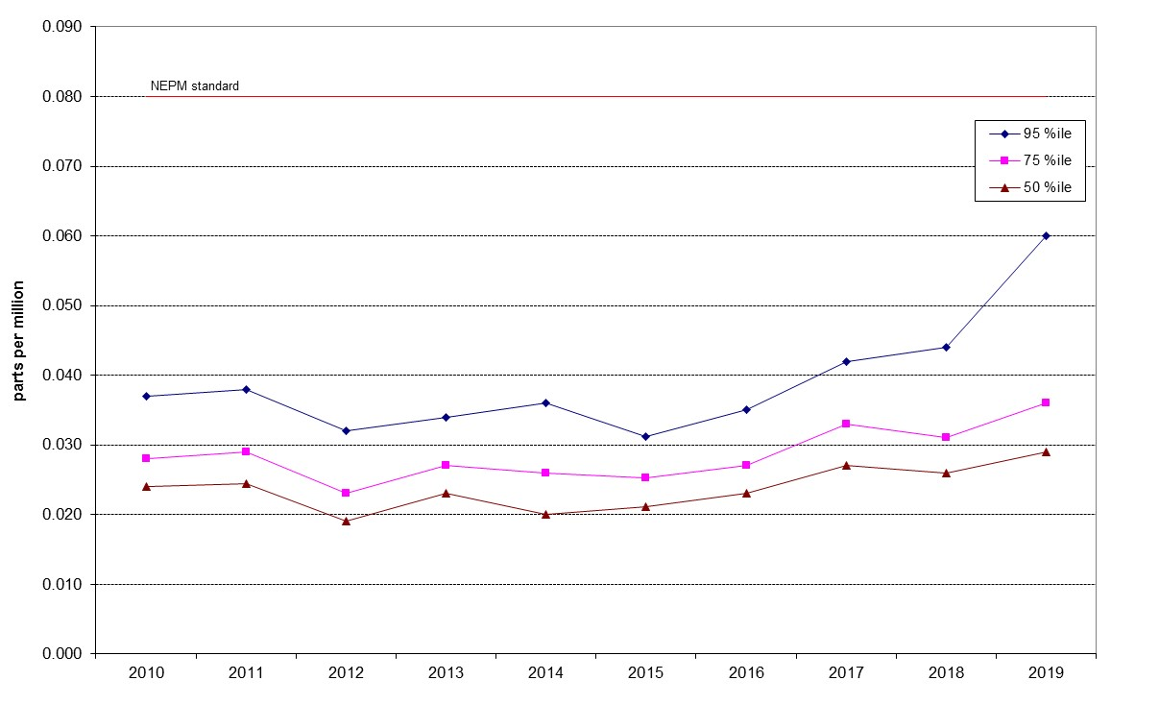

Figure 27: Statistical summary for daily maximum 4-hour O₃ Civic 2010 – 2019

Table 24: Statistical summary for daily maximum 4-hour O₃ Florey 2014 – 2019
Year | Data  Availability  (%) | No. of  Exceedances  (days) | Max  conc.  (ppm) | 95th  percentile  (ppm) | 75th  percentile  (ppm) | 50th  percentile  (ppm)
2014 | 79.4 | 0 | 0.040 | 0.031 | 0.026 | 0.022
2015 | 94.2 | 0 | 0.037 | 0.031 | 0.025 | 0.020
2016 | 95.8 | 0 | 0.050 | 0.038 | 0.029 | 0.026
2017 | 95.5 | 0 | 0.054 | 0.046 | 0.037 | 0.031
2018 | 95.2 | 0 | 0.057 | 0.048 | 0.037 | 0.031
2019 | 95.3 | 3 | 0.109 | 0.064 | 0.038 | 0.031

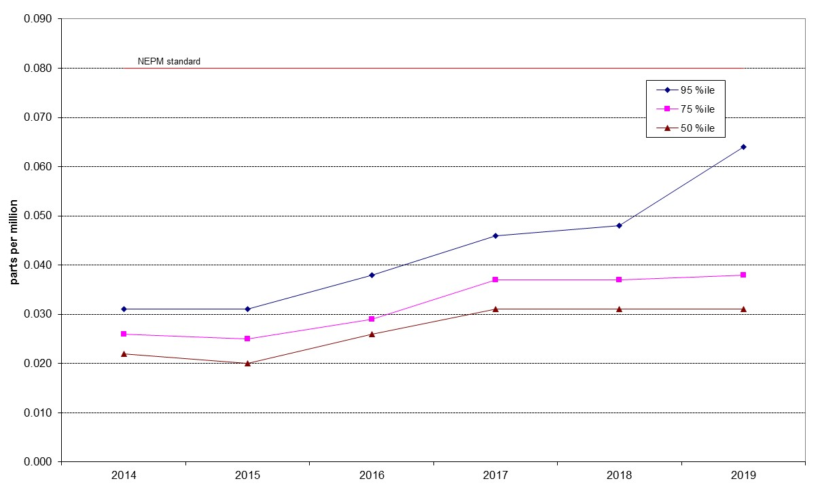

Figure 28: Statistical summary for daily maximum 4-hour O₃ Florey 2014 – 2019

PM₁₀
Table 25: Statistical summary for daily maximum daily PM₁₀ Monash 2010 – 2019
Year | Data  Availability  (%) | No. of  Exceedances  (days) | Max  conc.  (μg/m³) | Annual average  (μg/m³) | 95th  percentile  (μg/m³) | 75th  percentile  (μg/m³) | 50th  percentile  (μg/m³)
2010 | 95.4 | 0 | 48.4 | 11.1 | 23.5 | 14.7 | 10.0
2011 | 99.2 | 0 | 40.0 | 10.4 | 22.8 | 13.2 | 8.7
2012 | 98.6 | 0 | 41.0 | 10.4 | 19.7 | 13.7 | 9.7
2013 | 95.6 | 0 | 43.5 | 9.8 | 20.2 | 13.1 | 8.9
2014 | 97.8 | 0 | 39.3 | 10 | 19.1 | 12.9 | 9.6
2015 | 98.4 | 0 | 49.4 | 9.9 | 19.5 | 13.1 | 9.5
2016 | 99.5 | 0 | 31.9 | 9.7 | 21.5 | 12.7 | 9.0
2017 | 98.9 | 0 | 28.3 | 9.8 | 20.5 | 12.3 | 9.0
2018 | 99.2 | 4 | 139.2 | 11.8 | 23.0 | 14.8 | 10.4
2019 | 98.4 | 22 | 385.7 | 19.1 | 61.1 | 17.8 | 11.4

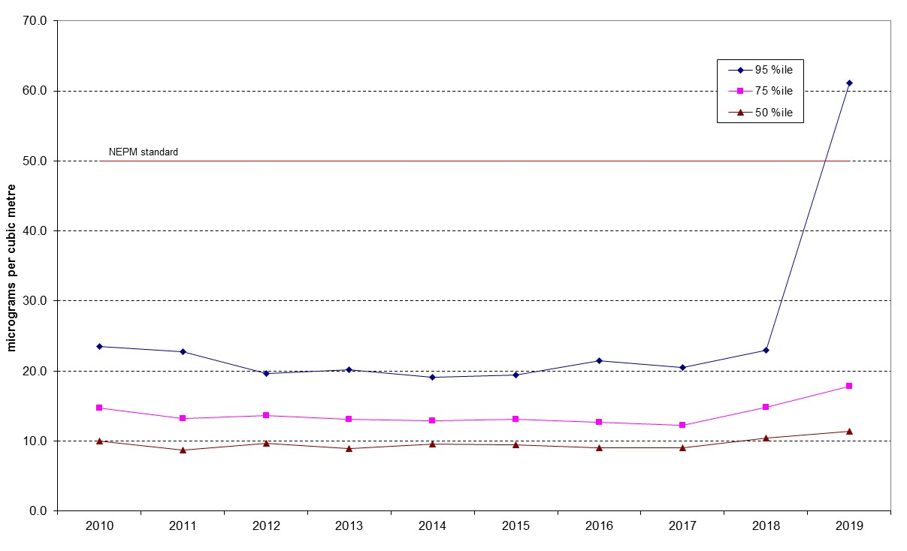
Figure 29: Statistical summary for daily PM₁₀ Monash 2010 – 2019
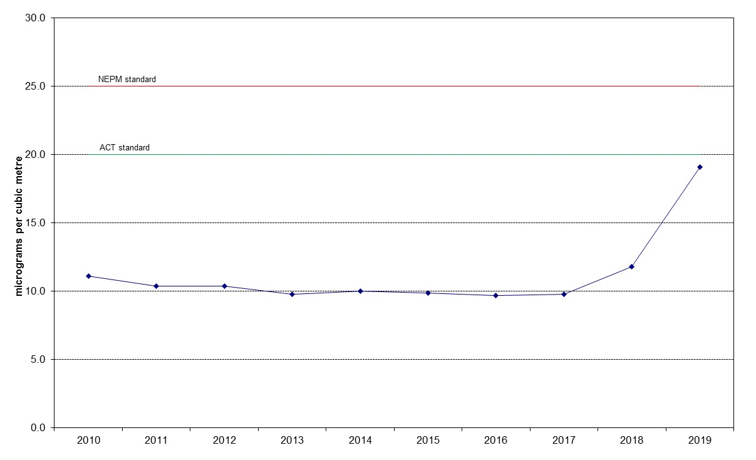

Figure 30: Annual average daily PM₁₀ Monash 2010 – 2019

Table 26: Statistical summary for daily maximum daily PM₁₀ Civic 2010 – 2019
Year | Data  Availability  (%) | No. of  Exceedances  (days) | Max  conc.  (μg/m³) | Annual average  (μg/m³) | 95th  percentile  (μg/m³) | 75th  percentile  (μg/m³) | 50th  percentile  (μg/m³)
2010 | 57.6 | 0 | 23.8 | 8.5 | 14.7 | 11.1 | 8.4
2011 | 97.0 | 0 | 29.2 | 8.7 | 16.9 | 11.0 | 7.9
2012 | 95.1 | 0 | 49.5 | 9.4 | 17.0 | 12.1 | 8.7
2013 | 92.9 | 1 | 57.8 | 9.7 | 19.9 | 12.0 | 8.6
2014 | 95.1 | 0 | 31.4 | 9.8 | 17.7 | 12.6 | 9.3
2015 | 97.5 | 1 | 64.3 | 11.1 | 20.9 | 14.1 | 10.4
2016 | 100 | 0 | 36.6 | 10.7 | 20.6 | 14.3 | 9.7
2017 | 83.6 | 1 | 53.0 | 9.68 | 10.8 | 7.1 | 5.2
2018 | 97.8 | 1 | 179.8 | 13.5 | 24.1 | 16.1 | 11.3
2019 | 97.3 | 29 | 390.2 | 22.9 | 82.5 | 19.5 | 12.7

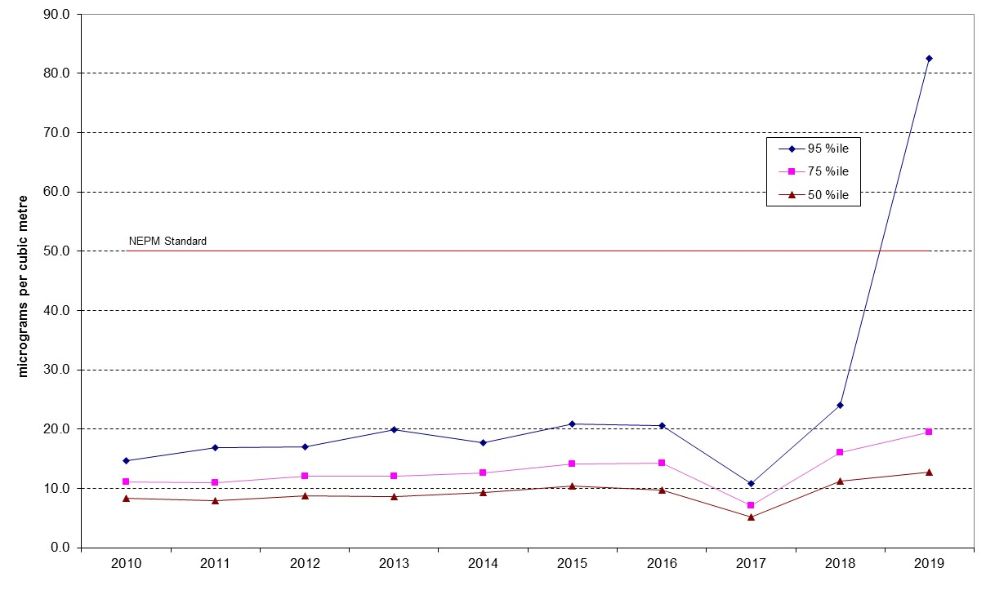
Figure 31: Statistical summary for daily PM₁₀ Civic 2010 – 2019
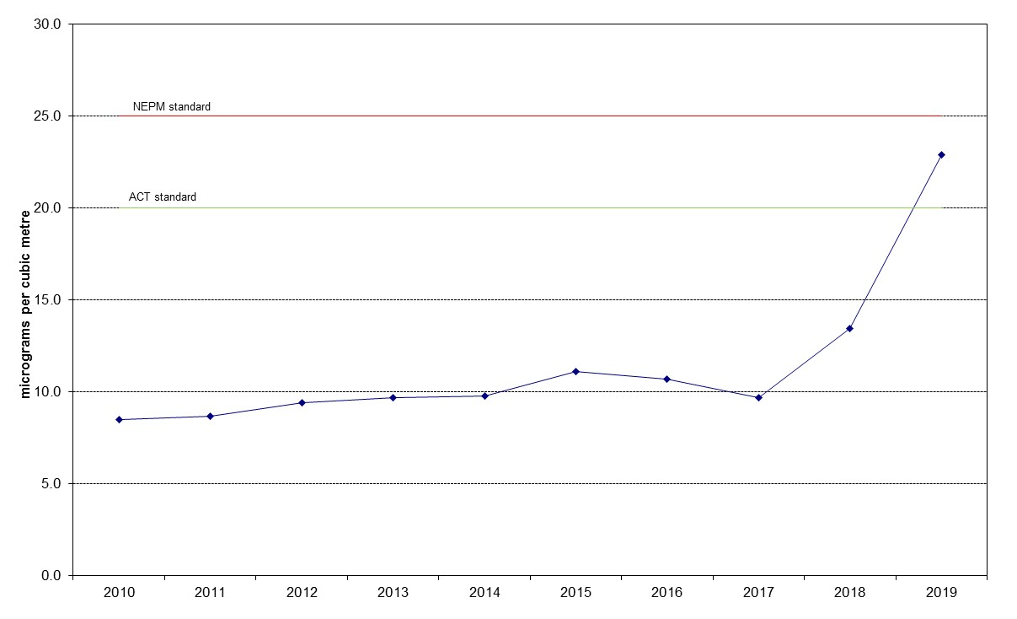

Figure 32: Annual average daily PM₁₀ Civic 2010 – 2019
Table 27: Statistical summary for daily maximum daily PM₁₀ Florey 2014 – 2019
Year | Data  Availability  (%) | No. of  Exceedances  (days) | Max  conc.  (μg/m³) | Annual average  (μg/m³) | 95th  percentile  (μg/m³) | 75th  percentile  (μg/m³) | 50th  percentile  (μg/m³)
2014 | 83.3 | 0 | 30.2 | 10.4 | 21.5 | 13.0 | 9.4
2015 | 95.6 | 0 | 70.8 | 10.7 | 21.8 | 13.7 | 9.4
2016 | 98.9 | 0 | 28.8 | 10.1 | 20.6 | 13.1 | 9.2
2017 | 98.4 | 0 | 28.1 | 9.84 | 21.8 | 12.8 | 8.5
2018 | 89.9 | 3 | 158.6 | 12.0 | 23.8 | 15.3 | 10.1
2019 | 98.1 | 28 | 379.7 | 23.8 | 96.8 | 20.6 | 13.4

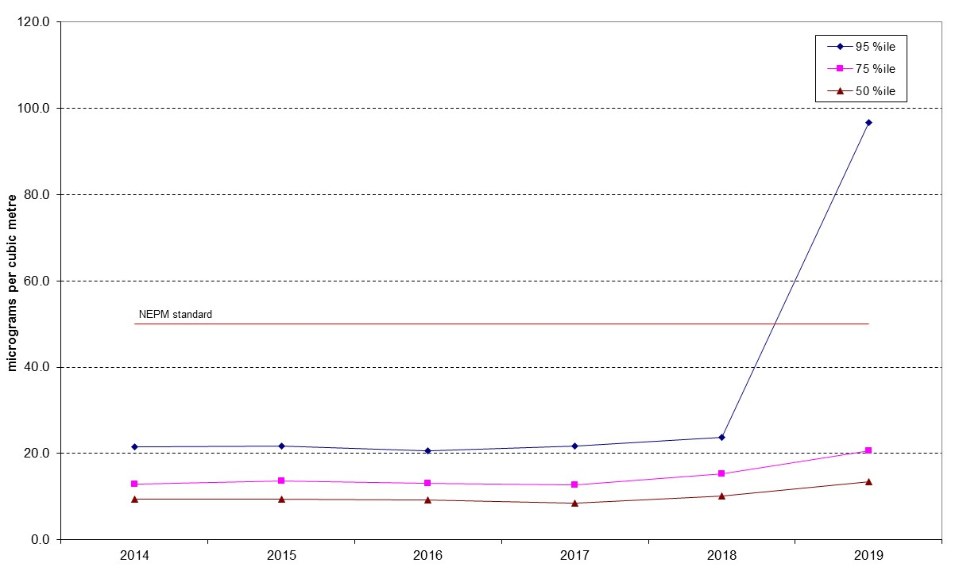

Figure 33: Statistical summary for daily PM₁₀ Florey 2014 – 2019

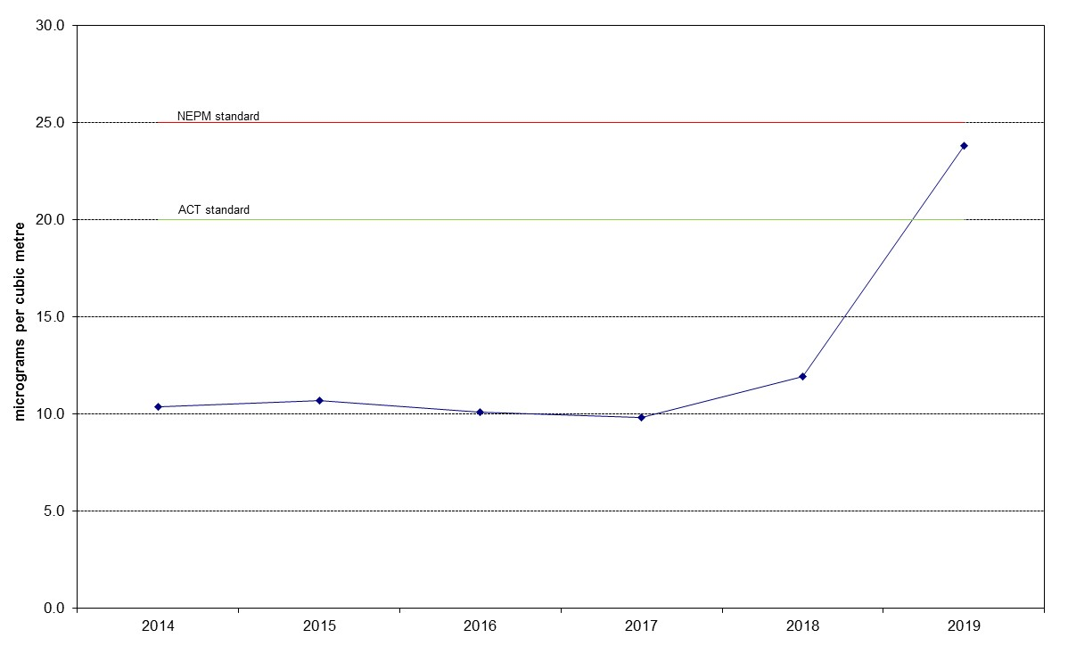

Figure 34: Annual average daily PM₁₀ Florey 2010 – 2019

PM_{2.5}
Table 28: Statistical summary for daily maximum daily PM_{2.5} Monash 2010 – 2019
Year | Data  Availability  (%) | No. of  Exceedances  (days) | Max  conc.  (μg/m³) | Annual average  (μg/m³) | 95th  percentile  (μg/m³) | 75th  percentile  (μg/m³) | 50th  percentile  (μg/m³)
2010 | 95.1 | 2 | 52.4 | 6.7 | 17.4 | 7.8 | 4.4
2011 | 92.1 | 4 | 32.8 | 6.5 | 20.0 | 7.0 | 4.5
2012 | 95.1 | 3 | 29.2 | 7.1 | 16.5 | 8.3 | 5.0
2013 | 98.6 | 6 | 38.4 | 6.9 | 19.2 | 8.1 | 5.2
2014 | 87.7 | 4 | 31.5 | 6.8 | 18.7 | 8.6 | 5.6
2015 | 96.4 | 6 | 33.8 | 7.4 | 19.0 | 8.2 | 5.6
2016 | 98.1 | 8 | 32.7 | 7.4 | 20.7 | 8.2 | 5.4
2017 | 98.6 | 12 | 35.2 | 7.7 | 22.5 | 9.3 | 5.3
2018 | 99.2 | 2 | 32.0 | 6.8 | 19.2 | 8.6 | 5.3
2019 | 98.9 | 28 | 307.9 | 14.1 | 42.7 | 12.5 | 7.2
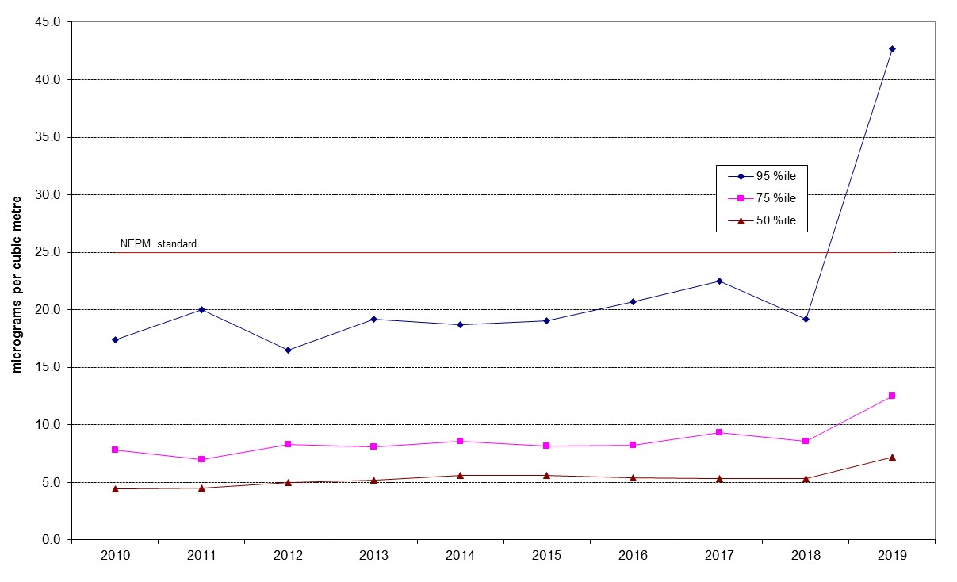
Figure 35: Statistical summary for daily PM_{2.5} Monash 2010 – 2019
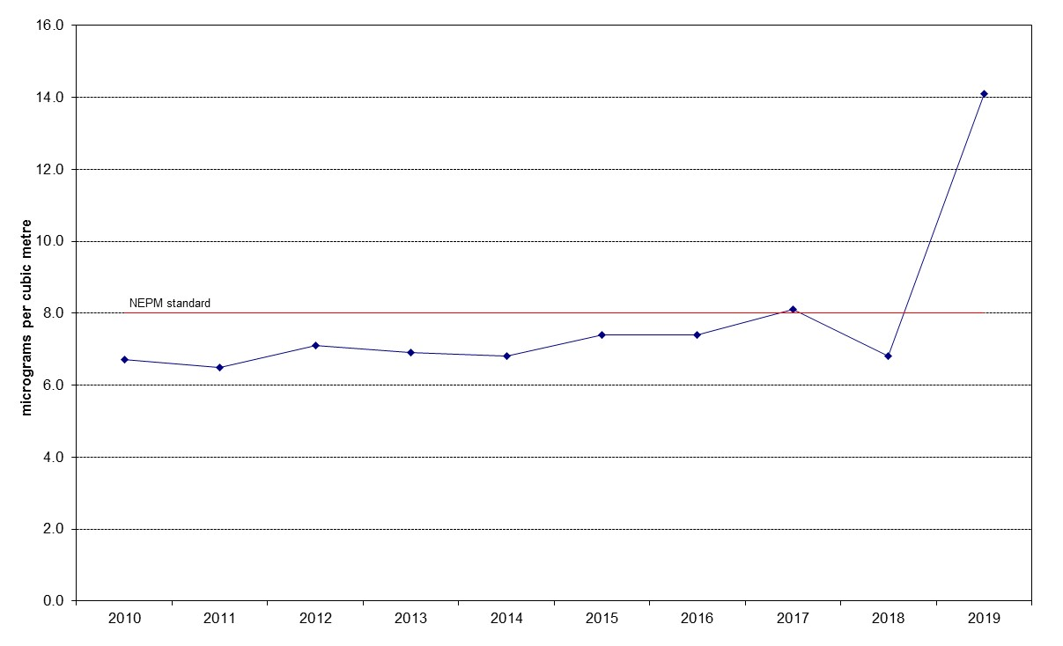
Figure 36: Annual average daily PM_{2.5} Monash 2010 – 2019

Table 29: Statistical summary for daily maximum daily PM_{2.5} Civic 2016 – 2019
Year | Data  Availability  (%) | No. of  Exceedances  (days) | Max  conc.  (μg/m³) | Annual average  (μg/m³) | 95th  percentile  (μg/m³) | 75th  percentile  (μg/m³) | 50th  percentile  (μg/m³)
2016 | 98.6 | 0 | 22.1 | 5.5 | 11.0 | 7.1 | 4.8
2017 | 94.2 | 1 | 53.8 | 5.9 | 10.8 | 7.1 | 5.2
2018 | 98.6 | 1 | 36.1 | 6.5 | 12.1 | 8.1 | 6.1
2019 | 96.4 | 29 | 390.2 | 22.9 | 82.5 | 19.5 | 12.7

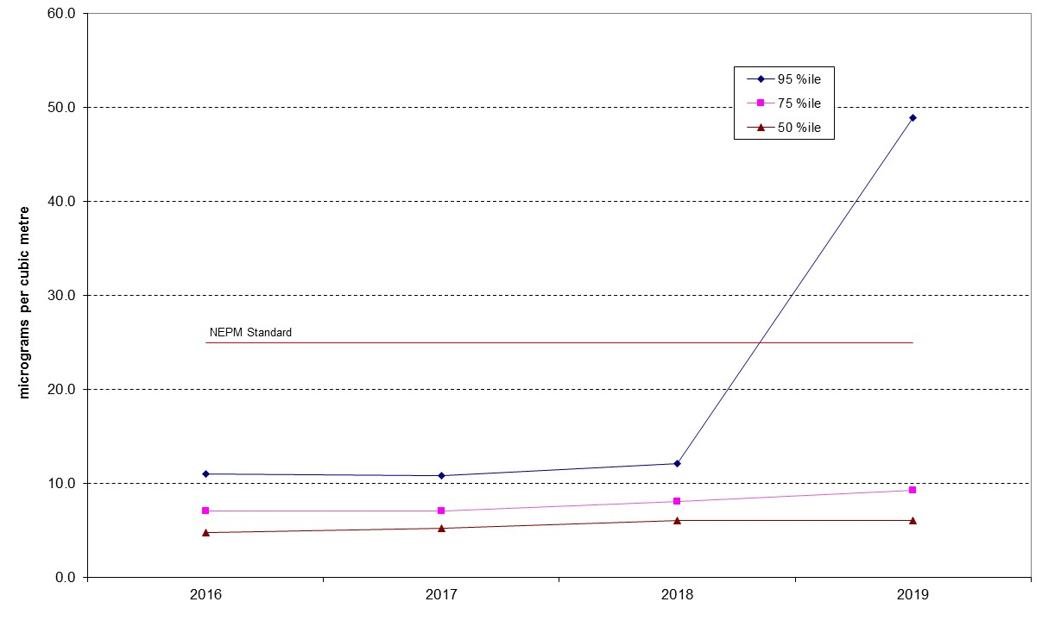

Figure 37: Statistical summary for daily PM_{2.5} Civic 2016 – 2019
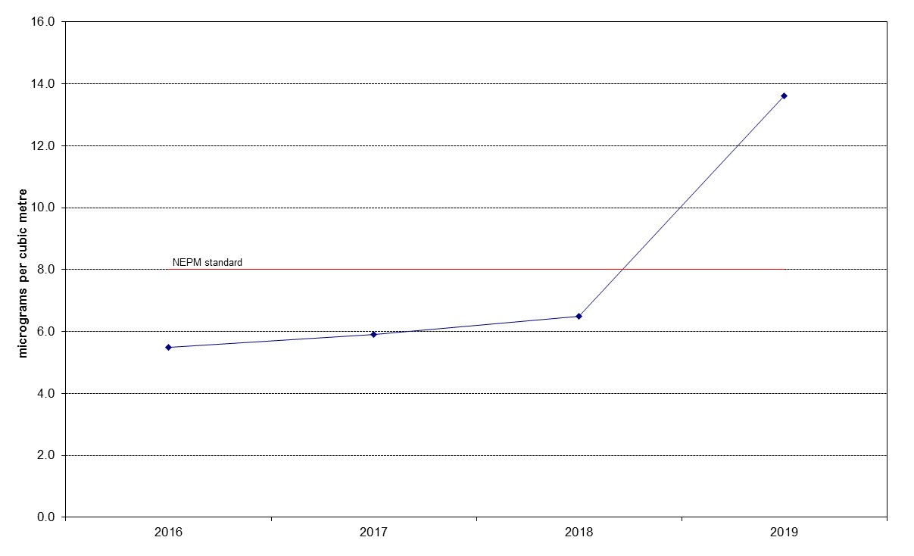

Figure 38: Annual average daily PM_{2.5} Civic 2016 – 2019

Table 30: Statistical summary for daily maximum daily PM_{2.5} Florey 2014 – 2019
Year | Data  Availability  (%) | No. of  Exceedances  (days) | Max  conc.  (μg/m³) | Annual average  (μg/m³) | 95th  percentile  (μg/m³) | 75th  percentile  (μg/m³) | 50th  percentile  (μg/m³)
2014 | 74.2 | 0 | 22.8 | 5.8 | 15.0 | 7.1 | 4.9
2015 | 96.2 | 0 | 24.3 | 6.5 | 17.1 | 7.4 | 4.8
2016 | 98.6 | 1 | 27.2 | 7.3 | 17.4 | 8.6 | 5.8
2017 | 94.2 | 0 | 23.8 | 7.2 | 17.9 | 8.7 | 5.6
2018 | 97.3 | 2 | 26.4 | 7.4 | 17.0 | 8.7 | 5.9
2019 | 98.4 | 29 | 319.6 | 14.8 | 46.9 | 12.3 | 7.2

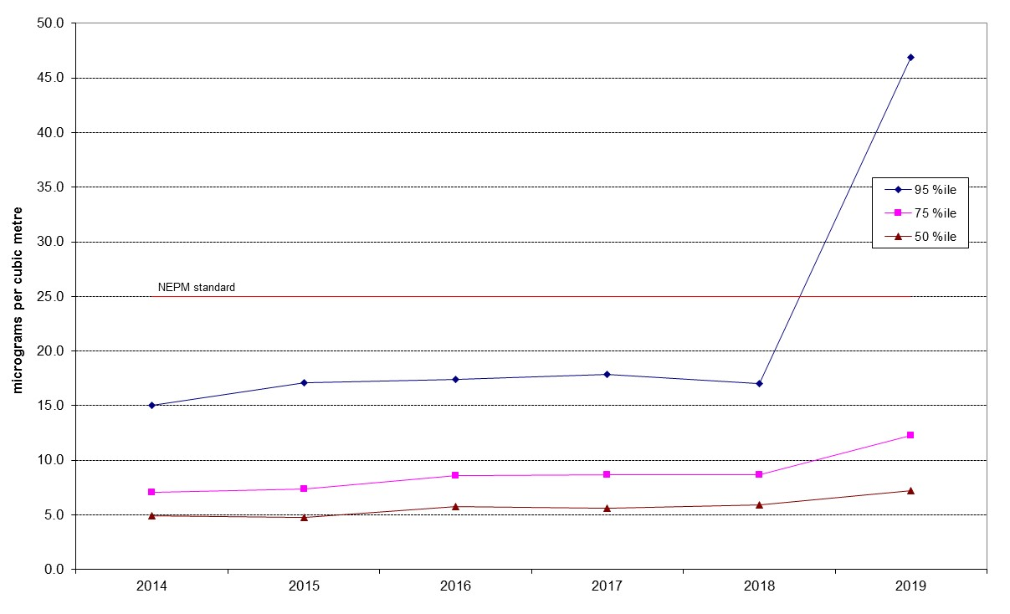
Figure 39: Statistical summary for daily PM_{2.5} Florey 2014 – 2019
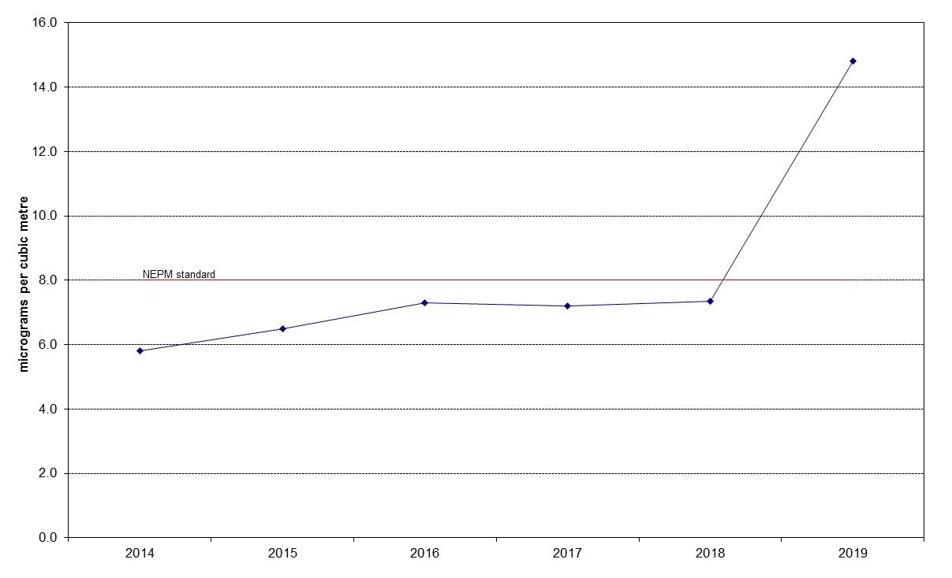
Figure 40: Annual average daily PM_{2.5} Florey 2014 – 2019

