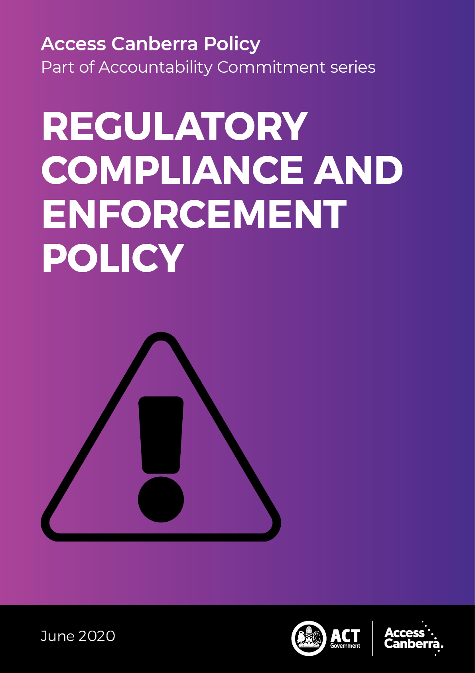

Chief Minister, Treasury and Economic Development Directorate - CMTEDD

Access Canberra

P: 13 22 81

W: <https://www.accesscanberra.act.gov.au/app/home>

Published June 2020 | Reviewed June 2023

IMPORTANT NOTE: This information is for guidance only.

Forward

### Purpose

The Access Canberra Accountability Commitment explains how Access Canberra will approach its role as both a service provider and a risk-based regulator, including what factors will be considered when dealing with regulatory non-compliance.

### Aim

The Accountability Commitment ensures that Access Canberra is approaching its role as a service provider and risk-based regulator in a consistent and transparent way. There are four policies that make up the Accountability Commitment series:

* Customer Service Charter;
* Decision Making Guidelines;
* Regulatory Complaint and Investigation Policy; and
* Compliance and Enforcement Policy.

This Accountability Commitment policy together with frameworks (tailored for different sectors the organisation oversees), is Access Canberra’s adopted approach to compliance and enforcement. Access Canberra will focus its resources where the risks of harm, unsafe practices or misconduct are greatest in the community.

Content

Forward 3

Purpose 3

Aim 3

WHO WE ARE 5

Access Canberra’s role 5

FEEDBACK AND COMPLAINTS 6

Feedback and complaints 6

General feedback 6

REGULATORY COMPLIANCE AND ENFORCEMENT 7

Principles 7

Principles 7

Prioritisation in case selection 8

Approach to compliance 9

Information to support compliance 9

Tools to address non-compliance 9

Choosing a compliance option 10

Governance 11

Committees 11

Compliance frameworks for specific regulatory approaches 11

Regulatory toolkit 12

DECISION MAKING APPROACH 13

Who has the authority to make a decision in Access Canberra? 13

Prioritisation Thresholds 14

Objectivity and fairness 14

Review of decision 14

COMPLIANCE AND ENFORCEMENT POLICYAND FRAMEWORK 15

icon who we are

# Who we are

## Access Canberra’s role

Access Canberra is a one-stop shop for ACT Government customer and regulatory services.

Access Canberra is a one-stop shop for ACT Government customer and regulatory services. We provide an easy, streamlined method to access government information and undertake transactions with the ACT Government.

Access Canberra is committed to delivering excellent, integrated services for ACT businesses, community groups and individuals seeking service, support, protection and advice from the ACT Government on a range of matters including:

* Building, land and lease regulation;
* Electricity, natural gas, water, sewerage and industry technical regulation
* Environment protection and water regulation
* Fair trading and registration, inspection and regulatory services
* Occupational licensing
* Racing and gambling legislation
* Controlled Sports registrations
* Transport regulation and licensing

icon feedback adn complaints

# FEEDBACK AND COMPLAINTS

We value the feedback we receive about our service delivery and will use it to continually improve our service and performance...

## Feedback and complaints

We value the feedback we receive about our service delivery and will use it to continually improve our service and performance.

### General feedback

Access Canberra is committed to providing excellent service.

You can provide general feedback by:

| icon online | using our [online correspondence form](https://www.accesscanberra.act.gov.au/app/ask/c/170,253) |
| --- | --- |
| icon call us | calling us on **13 22 81** |
| icon post | writing to us at: Access Canberra Customer Services GPO Box 158  CANBERRA ACT 2601 |

jigsaw piece

# REGULATORY COMPLIANCE AND ENFORCEMENT

## Principles

The approach we take to our regulatory decisions and actions.

Access Canberra aims to adopt the right regulatory response for the right situation.

### Principles

The key principles underpinning our regulatory activities and decisions are:

*Risk-based* - We will apply a risk-based compliance approach to ensure that our resources are targeted to where the risks of harm, unsafe practices or misconduct are the greatest, thereby strengthening our capacity to take action where the community and the environment are most at risk. Access Canberra will prioritise its actions based on a range of considerations, including the following:

* conduct that causes harm or risk to life, health or the environment;
* conduct that is systemic and is likely to have a detrimental effect on the community and/or the environment, and
* conduct that demonstrates a blatant disregard for the law.

*Proportionate* – we will have regard for the current harm/risk, the experience and past conduct of a person or business when determining our regulatory response.

*Effective* – we will apply the appropriate compliance tool to ensure that our regulatory interventions are responsive to the relevant circumstances and will achieve the desired outcomes. We will aim for consistent enforcement outcomes for similar conduct.

*Constructive* – we will provide advice, guidance and support to help business and the community comply with relevant laws.

*Accountable* – we are willing to explain our decisions whilst protecting the integrity of our investigations. We will balance confidentiality requirements with the need to inform businesses and the community about our regulatory actions.

*Transparent* – we will demonstrate impartiality and act with integrity. The community and those who we regulate will know what to expect when engaging with us.

*Timely* – we will conduct our investigations, compliance activities and enforcement action as efficiently as possible to limit disruption to business operations and to provide certainty about our actions. We will be adaptable to responding to new priorities, technologies and changing environments.

Principles underpinning our regulatory activities and decisions

## Prioritisation in case selection

While Access Canberra carefully considers all matters that involve a potential breach of the law, we do not undertake a formal investigation of every matter that is brought to our attention.

We will apply a risk-based compliance approach to ensure that our resources are targeted to where the risks of harm, unsafe practices or misconduct are the greatest, thereby strengthening our capacity to take action where the community, and the environment are most at risk.

To ensure we appropriately allocate our resources, we take into consideration a range of factors when selecting matters for investigation and enforcement action.

We are more likely to investigate matters that the following factors:

* where there is evidence of significant harm or detriment, particularly where the conduct is ongoing;
* there is a blatant disregard for the law, or pattern of deliberate non-compliance that may have the potential for substantial harm or detriment in the future;
* the conduct is impacting on vulnerable or disadvantaged groups;
* enforcement action is likely to have a strategic educative or deterrent effect;
* education or engagement is not considered to be an appropriate and proportionate response to address the alleged conduct.

We are less likely to pursue matters that have the following factors:

* isolated events involving limited harm and detriment;
* matters of individual redress that are more effectively dealt with by parties through a dispute resolution service, such as the ACT Civil and Administrative Tribunal;
* matters that are more effectively dealt with by another agency.

While these factors guide how we prioritise matters for investigation and enforcement action, we consider the individual circumstances of each matter on a case-by-case basis.

## Approach to compliance

Access Canberra uses a range of tools to encourage and ensure compliance with the law. As a regulator, we work to minimise harm to consumers and businesses through a compliance approach that strongly emphasises prevention and targeted enforcement action.

### Information to support compliance

Access Canberra recognises that well-informed consumers and businesses drive voluntary compliance with the law.

We use a range of mediums to engage with consumers, businesses and licensed individuals to educate them about their rights and obligations under the law. We provide information through face-to-face engagement, digital platforms, and telephone-based services.

As well as providing information services, in some circumstances Access Canberra also provides conciliation services. Our conciliation services are primarily offered electronically and by telephone.

While we are unable to make binding decisions or force parties to participate, our conciliation services seek to obtain a timely resolution of matters that is consistent with the law.

### Tools to address non-compliance

Access Canberra regulates a number of laws that provide a range of tools to address non-compliance with the laws that it enforces[1], including:

*Warning letters and Cautions:* A warning letter or a caution may be issued where there is evidence that the law has been broken and the business can be reasonably expected to know and understand their obligations.

*Business improvement engagement:* we will engage with you directly to improve identify compliance failures and explain regulatory requirements.*Compliance monitoring audits and inspections:* We may undertake checks and proactive inspections and audits to monitor compliance.

*Statutory notices or directions:* Where we are empowered by law, we may issue a statutory notice requiring an individual or business to take action, cease non-compliant conduct, or remedy a defect.

*Demerit points:* We may issue demerit points for non-compliant conduct, which at certain thresholds may result in a licence being suspended or cancelled.

*Enforceable undertakings:* An enforceable undertaking is a high level sanction which is legally binding and is used where the alleged contravention is of a serious nature. An enforceable undertaking provides an opportunity for individual and organisational reform to implement better practices and/or remedy harm.

*Infringement notices:* We may issue an infringement notice asserting a breach of the law and imposing a financial penalty. An infringement notice may allow straightforward breaches of the law to be resolved by payment of a fine, rather than court action.

*Public warning notices:* We may issue public warning notice to alert consumers to a suspected breach of certain provisions of the law. A key consideration when issuing a public warning notice is whether there is an imminent need to inform consumers so they can avoid suffering detriment.

*Licence conditions, suspensions or cancellations:* We may place conditions on a licence or seek to cancel or suspend a licence.

*Occupational discipline actions:* We may take occupational discipline action through the ACT Civil and Administrative Tribunal for alleged contraventions of licence conditions.

*Injunctions:* we may seek an order from the Court to stop you from engaging in unlawful conduct.

*Civil court actions:* We may commence civil proceedings in response to non-compliant activity. We may seek a range of civil remedies including injunctions, penalties, consumer redress, disqualification orders, and adverse publicity orders. We may also seek orders to recover the costs of civil proceedings.

*Criminal prosecutions:* We may refer a matter to the Director of Public Prosecutions for the conviction and punishment of a party under the criminal provisions of the law.

...Access Canberra regulates a number of laws that provide a range of tools to address   
non-compliance...

Access Canberra may use these tools in combination. Not all tools are applicable to all the laws that we enforce.

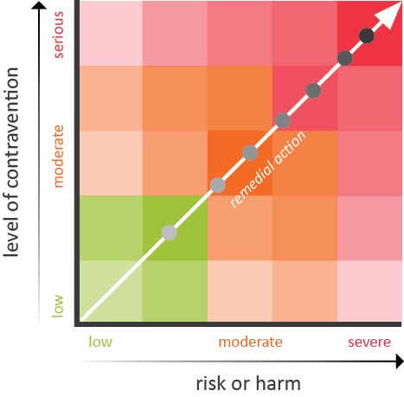

Approach to enforcement and response level

As per the Regulatory toolkit, Access Canberra will use the right regulatory approach for the right situation.

## Choosing a compliance option

To ensure we achieve the right regulatory approach for the right situation, and provide rigorous support for our statutory office holders, we will draw on a range of activities and tools to encourage and enforce compliance with the laws that we regulate.

Access Canberra makes decisions and carries out regulatory activities based on assessment of the risk of harm and likelihood of an event occurring.

Access Canberra is responsive to the culture, conduct and context of those we regulate when deciding whether an interventionist response is required.

Access Canberra encourages compliance through education and awareness but will apply escalating enforcement actions to those that demonstrate a disregard for the law and whose conduct has, or is likely, to cause harm to consumers, business, the community or the environment.

Access Canberra’s approach to fostering compliance and management of non-compliance is illustrated in Regulatory Response Figure.

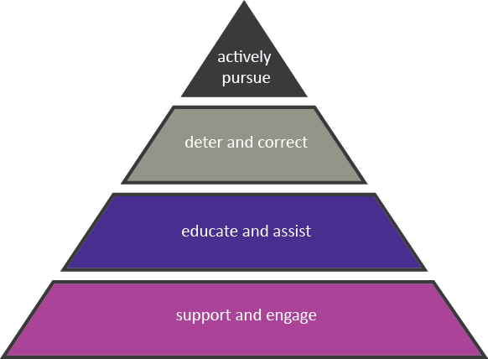

Regulatory Response

## Governance

Our regulatory activities are undertaken within a governance framework to ensure efficient and effective allocation of resources and adherence to our guiding principles.

## Committees

Access Canberra operates several committees which oversight regulatory activity to ensure consistency of approach. The Regulatory Complaint Assessment Committee determines appropriate case prioritisation and treatment for regulatory complaints. The decisions of the committee are underpinned by our risk-based principles.

The **Regulatory Advisory Committee (RAC)** seeks to support quality regulatory outcomes by ensuring that regulatory decisions are justified, proportionate, defensible and relevant processes are followed prior to a regulatory decision being made. RAC will, as required, provide input at significant stages of an investigation in line with relevant policies and procedures.This Committee will also consider complex applications for a licence or registration.

… The decisions of the committee are underpinned by our risk-based principles…

## Compliance frameworks for specific regulatory approaches

Access Canberra has documented a variety of compliance and enforcement frameworks for sector-specific regulatory activities and industries. Refer to our website www.act.gov.au/accessCBR for these including for parking, environment protection, food safety, construction, occupational and other regulatory schemes.

… Refer to our website www.act.gov.au/accessCBR  
for these...

## Regulatory toolkit

To ensure we achieve the right regulatory approach for the right situation, and provide rigorous support for our statutory office holders, we will draw on a range of activities and powers as allowed to encourage and enforce compliance with the laws that we regulate.

##### Regulatory Toolkit

|  |  |
| --- | --- |
| Advice | We will respond to request for advice and will proactively make contact with a business to inform them of their obligations. |
| Education Campaigns | We will focus on a specific industry or issues to promote and explain regulation requirements. |
| Trader Engagement Program | We will engage with you directly to improve identified compliance failures. |
| Dispute Resolution | In some circumstances we may assist in resolving disputes between consumers and businesses. |
| Written Warnings | If you have not complied with your regulatory obligations we will write to you. We may take further action if your conduct continues. |
| Audits/Inspection | We will undertake checks and proactive inspections/audits to monitor compliance levels. In some instances we will intervene to prevent continued con-compliance. |
| Statutory Notices or Directions | We may issue you with a Notice to undertake immediate action to address or cease non-compliant conduct. |
| Demerit Point | Under some of our regulatory schemes demerit points are accrued for non-compliance. After a certain threshold is met your licence will be suspended or cancelled. |
| Rectification Orders | We may order you to undertake rectification work to address non-compliant conduct or work. |
| Defect Notice | A defect notice is issued to an unsafe or un-roadworthy vehicle. You must take corrective action to remedy the identified defect. |
| Court Enforceable Undertakings | If you have contravened the law, a written undertaking may be considered where you agree to address the non-compliant conduct.  An enforceable undertaking is a high level sanction which is legally binding and is used where the alleged contravention is of a serious nature. An enforceable undertaking provides an opportunity for individual and organisational reform to implement better practices and/or remedy harm. |
| Infringement Notice | We may issue you with an infringement (penalty) notice for non-compliant conduct. |
| Public Naming | We will publicise information about deliberate, ongoing, non-compliant conduct in the media. |
| Licence or Registration Conditions | We may place a condition on your licence or registration to restrict you from certain activities. This action occurs in response to non-compliance, or other action that affects your ability for your licence or registration, or to minimise harm. |
| Licence Suspension | We may suspend your licence. |
| Licence Cancellation | We may seek to have your licence cancelled. |
| Occupational Discipline | If you contravene a condition of your licence, we may take action against you in the ACT Civil and Administrative Tribunal. |
| Injunctions | We may seek an order from the Court to stop you from engaging in unlawful conduct. |
| Civil Prosecution | In some circumstances we may take civil action through the Court on behalf of a consumer or to seek a specific remedy for non-compliant conduct. |
| Criminal Prosecution | We will refer serious contravention of the Law to the Director of Public Prosecutions seeking a criminal prosecution in the Court. |

icon decision making

# Decision making Approach

## Approach

The approach we take to our regulatory decisions and actions.

For comprehensive decision-making information refer to Decision Making Guidelines.

There are a number of statutory office holders who are decision makers in Access Canberra:

* Registrar-General;
* Commissioner for Fair Trading;
* Construction Occupations Registrar;
* Environment Protection Authority;
* Controlled Sports Registrar.

When a statutory officer makes a decision under legislation, there are certain requirements that need to be considered; these are addressed in this guideline.

## Who has the authority to make a decision in Access Canberra?

To be valid and effective, a decision must be made by an officer who is authorised by legislation or delegation.

An authorised person or body must exercise the decision-making power personally. An exception is the express power of delegation, where someone authorised to make a decision passes on this power to another officer to act on their behalf.

**Delegations** must be in writing and signed by the authorised body or person delegating the power. Where a decision-maker believes they may have a conflict of interest, they maybe be able to delegate the decision-making power to another appropriate staff member.

## Prioritisation Thresholds

We prioritise complaints based on the level of risk of harm and will action a complaint in an appropriate manner proportionate to risk which may result in matters being resolved in various manners.

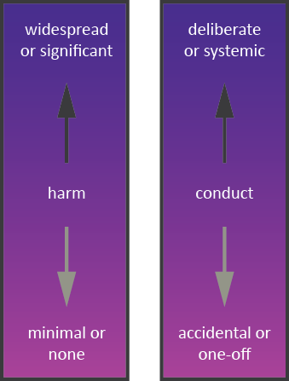

Risk-harm Criteria

## Objectivity and fairness

We will address each complaint and investigation in accordance with the [*ACT Public Service Code of Conduct*](https://www.legislation.act.gov.au/LegViewer/TextView?itemPath=%7Cni%7C2013-588%7C&versionPath=%7Cni%7C2013-588%7Ccurrent&fileName=2013-588.docx&resultList=%2Fisysquery%2F8E879EDD-ABC7-48B7-9009-6008A48CAF83%2F1-5%2Flist%2F&searchFormQuery=sQuery%3Dactps%2Bcode%2Bof%2Bconduct%26sCategory%3DcAct%26sCategory%3DcSub%26sCategory%3DcDis%26sCategory%3DcNot%26sMinister%3D0%26sDirectorate%3D0%26sStatus%3DCurrent%26sYearFrom%3D%26sYearTo%3D%26action%3Dsearch&url=%2Fisysquery%2F8e879edd-abc7-48b7-9009-6008a48caf83%2F1%2Fdoc%2F) and with integrity and in an equitable, objective and unbiased manner. We exercise our duties, delegations, functions, and regulatory powers with integrity and professionalism.

... We prioritise complaints based on the level of risk of harm...

## Review of decision

**Internal review** is the process by which a decision is reviewed by another officer within the same agency as the original decision maker. This process is often regulated by the legislation governing the original decision, but sometimes a more informal process is undertaken as a matter of good administrative practice.

An internal review may be a prerequisite to a review by the ACT Civil and Administrative Tribunal (ACAT). When reviewing a decision, ACAT has all the powers of the original decision maker as described above.

[logo](https://www.acat.act.gov.au/)

| Web: <https://www.acat.act.gov.au/> |
| --- |
| Phone: (02) 6207 1740 |
| Contact: ACAT  GPO Box 370 CANBERRA ACT 2601 |
| Email: [tribunal@act.gov.au](mailto:tribunal@act.gov.au) |

Finally, the ACT Ombudsman performs an important administrative law function by resolving complaints and monitoring the actions of government agencies, which includes any legislative decisions made within Access Canberra. The Ombudsman has strong investigatory powers and can investigate many types of complaints relating to matters of administration, either through a complaint or of own motion.

[logo](https://www.ombudsman.act.gov.au/)

| Web: <https://www.ombudsman.act.gov.au/> |
| --- |
| Phone: 1300 362 072 |
| Contact: ACT Ombudsman GPO Box 442 CANBERRA ACT 2601 |
| Email: [ombudsman@ombudsman.gov.au](mailto:ombudsman@ombudsman.gov.au) |

icon compliance framworks

# Compliance and enforcement policy and frameworks

The ‘Accountability Commitment’ policies aim to provide a practical explanation of key approaches Access Canberra takes to its role as both a service provider and a risk-based regulator.

In delivering our services, Access Canberra considers:

* [Customer Service Charter](https://www.accesscanberra.act.gov.au/app/answers/detail/a_id/2750/kw/accountability);
* [Decision Making Guide](https://www.accesscanberra.act.gov.au/app/answers/detail/a_id/2750/kw/accountability);
* [Regulatory Compliant and Investigation Policy](https://www.accesscanberra.act.gov.au/app/answers/detail/a_id/2750/kw/accountability); and
* [Regulatory Compliance and Enforcement Policy](https://www.accesscanberra.act.gov.au/app/answers/detail/a_id/2750/kw/accountability)**.**

This document should be read in conjunction with compliance and enforcement specific sector frameworks, such as:

| icon - building & constuction | [Building and construction services compliance framework](https://www.accesscanberra.act.gov.au/app/answers/detail/a_id/2750/kw/accountability) |
| --- | --- |
| karate kick | [Controlled sports compliance frameworks](https://www.accesscanberra.act.gov.au/app/answers/detail/a_id/2750/kw/accountability) |
| hand and leaf | [Environment protection compliance framework](https://www.accesscanberra.act.gov.au/app/answers/detail/a_id/2750/kw/accountability) |
| icon - fair traiding | [Fair trading compliance framework](https://www.accesscanberra.act.gov.au/app/answers/detail/a_id/2750/kw/accountability) |
| icon - food safety | [Food safety compliance framework](https://www.accesscanberra.act.gov.au/app/answers/detail/a_id/2750/kw/accountability) |
| icon - gamblign and racing | [Gambling and racing compliance framework](https://www.accesscanberra.act.gov.au/app/answers/detail/a_id/2750/kw/accountability) |
| icon liquor licensing | [Liquor licensing compliance framework](https://www.accesscanberra.act.gov.au/app/answers/detail/a_id/2750/kw/accountability) |
| icon - parking operations | [Parking operations compliance framework](https://www.accesscanberra.act.gov.au/app/answers/detail/a_id/2750/kw/accountability) |
| icon - vehicle safety | [Vehicle Safety Standards: Compliance Framework](https://www.accesscanberra.act.gov.au/app/answers/detail/a_id/2750/kw/accountability) |
| icon - working with vulnerable people | [Working with vulnerable people compliance framework](https://www.accesscanberra.act.gov.au/app/answers/detail/a_id/2750/kw/accountability) |

...Accountability Commitment ensures that Access Canberra is approaching its role as a service provider and risk-based regulator in a consistent and transparent way...

ACTGov Logo

Chief Minister, Treasury and Economic Development Directorate  
Access Canberra

Accountability Commitment Policy  
Reviewed version June 2023

1. Not all regulatory tools are available under each law