ACT AIR QUALITY REPORT 2018

Environment Protection Authority | June 2019

TABLE OF CONTENTS
TABLE OF CONTENTS i
LIST OF TABLES ii
LIST OF FIGURES iii
LIST OF DEFINITIONS AND ABBREVIATIONS iv
OVERVIEW 1
MONITORING SUMMARY 3
Performance Monitoring Stations 3
Monitoring Methods 3
NATA Accreditation Status 4
ASSESSMENT OF COMPLIANCE WITH STANDARDS AND GOALS 5
Carbon monoxide 7
Nitrogen dioxide 8
Ozone 10
PM₁₀ 13
PM_{2.5} 15
ANALYSIS OF AIR QUALITY MONITORING 18
Carbon monoxide 18
Nitrogen dioxide 18
Ozone 19
PM₁₀ 19
PM_{2.5} 20
ASSESSMENT OF PROGRESS TOWARDS ACHIEVING THE GOAL 22
APPENDIX A: STATISTICAL SUMMARY AND TRENDS 23
Carbon monoxide 23
Nitrogen dioxide 25
Ozone 28
PM₁₀ 34
PM_{2.5} 38

LIST OF TABLES
Table 1: Summary of stations’ siting compliance with AS 3580.1.1:2008 3
Table 2: Methods used for monitoring AAQ NEPM pollutants 4
Table 3: AAQ NEPM standards and goals 5
Table 4: 2018 compliance summary for CO 7
Table 5: 2018 compliance summary for NO₂ 8
Table 6: 2018 compliance summary for O₃ 10
Table 7: 2018 compliance summary for PM₁₀ 13
Table 8: 2018 compliance summary for PM_{2.5} 15
Table 9: 2018 summary statistics for daily peak 8-hour CO 18
Table 10: 2018 summary statistics for daily peak 1-hour NO₂ 18
Table 11: 2018 summary statistics for daily peak 1-hour O₃ 19
Table 12: 2018 summary statistics for daily peak 4-hour O₃ 19
Table 13: 2018 summary statistics for daily PM₁₀ 19
Table 14: 2018 PM₁₀ exceedances 20
Table 15: 2018 summary statistics for daily PM_{2.5} 20
Table 16: 2018 PM_{2.5} exceedances 20
Table 17: Statistical summary for daily maximum 8-hour CO Monash 2009 – 2018 23
Table 18: Statistical summary for daily maximum 8-hour CO Florey 2014 – 2018 24
Table 19: Statistical summary for daily maximum 1-hour NO₂ Monash 2009 – 2018 25
Table 20: Statistical summary for daily maximum 1-hour NO₂ Florey 2014 – 2018 26
Table 21: Statistical summary for daily maximum 1-hour O₃ Monash 2009 – 2018 28
Table 22: Statistical summary for daily maximum 1-hour O₃ Civic 2009 – 2018 29
Table 23: Statistical summary for daily maximum 1-hour O₃ Florey 2014 – 2018 30
Table 24: Statistical summary for daily maximum 4-hour O₃ Monash 2009 – 2018 31
Table 25: Statistical summary for daily maximum 4-hour O₃ Civic 2009 – 2018 32
Table 26: Statistical summary for daily maximum 4-hour O₃ Florey 2014 – 2018 33
Table 27: Statistical summary for daily maximum daily PM₁₀ Monash 2009 – 2018 34
Table 28: Statistical summary for daily maximum daily PM₁₀ Civic 2010 – 2018 35
Table 29: Statistical summary for daily maximum daily PM₁₀ Florey 2014 – 2018 37
Table 30: Statistical summary for daily maximum daily PM_{2.5} Monash 2009 – 2018 38
Table 31: Statistical summary for daily maximum daily PM_{2.5} Civic 2016 – 2018 40
Table 32: Statistical summary for daily maximum daily PM_{2.5} Florey 2014 – 2018 41

LIST OF FIGURES
Figure 1: Causes of PM_{2.5} exceedances 2
Figure 2: Daily maximum for CO 8-hour average – Monash 7
Figure 3: Daily maximum for CO 8-hour average – Florey 8
Figure 4: Daily maximum for NO₂ – Monash 9
Figure 5: Daily maximum for NO₂ – Florey 9
Figure 6: Daily maximum for 1 hour O₃ – Monash 10
Figure 7: Daily maximum for 1 hour O₃ – Civic 11
Figure 8: Daily maximum for 1 hour O₃ – Florey 11
Figure 9: Daily maximum for 4 hours O₃ - Monash 12
Figure 10: Daily maximum for 4 hours O₃ – Civic 12
Figure 11: Daily maximum for 4 hours O₃ – Florey 13
Figure 12: Daily maximum for PM₁₀ – Monash 14
Figure 13: Daily maximum for PM₁₀ – Civic 14
Figure 14: Daily maximum for PM₁₀ – Florey 15
Figure 15: Daily maximum for PM_{2.5} – Monash 16
Figure 16: Daily maximum for PM_{2.5} – Civic 16
Figure 17: Daily maximum for PM_{2.5} – Florey 17
Figure 18: Statistical summary for daily maximum 8-hour CO Monash 2009 – 2018 23
Figure 19: Statistical summary for daily maximum 8-hour CO Florey 2014 – 2018 24
Figure 20: Statistical summary for daily maximum 1-hour NO₂ Monash 2009 – 2018 25
Figure 21: Annual average 1-hour NO₂ Monash 2009 – 2018 26
Figure 22: Statistical summary for daily maximum 1-hour NO₂ Florey 2014 – 2018 27
Figure 23: Annual average 1-hour NO₂ Florey 2014 – 2018 27
Figure 24: Statistical summary for daily maximum 1-hour O₃ Monash 2009 – 2018 28
Figure 25: Statistical summary for daily maximum 1-hour O₃ Civic 2009 – 2018 29
Figure 26: Statistical summary for daily maximum 1-hour O₃ Florey 2014 – 2018 30
Figure 27: Statistical summary for daily maximum 4-hour O₃ Monash 2009 – 2018 31
Figure 28: Statistical summary for daily maximum 4-hour O₃ Civic 2009 – 2018 32
Figure 29: Statistical summary for daily maximum 4-hour O₃ Florey 2014 – 2018 33
Figure 30: Statistical summary for daily PM₁₀ Monash 2009 – 2018 34
Figure 31: Annual average daily PM₁₀ Monash 2009 – 2018 35
Figure 32: Statistical summary for daily PM₁₀ Civic 2010 – 2018 36
Figure 33: Annual average daily PM₁₀ Civic 2010 – 2018 36
Figure 34: Statistical summary for daily PM₁₀ Florey 2014 – 2018 37
Figure 35: Annual average daily PM₁₀ Florey 2009 – 2018 38
Figure 36: Statistical summary for daily PM_{2.5} Monash 2009 – 2018 39
Figure 37: Annual average daily PM_{2.5} Monash 2009 – 2018 39
Figure 38: Statistical summary for daily PM_{2.5} Civic 2016 – 2018 40
Figure 39: Annual average daily PM_{2.5} Civic 2016 – 2018 41
Figure 40: Statistical summary for daily PM_{2.5} Florey 2014 – 2018 42
Figure 41: Annual average daily PM_{2.5} Florey 2014 – 2018 42

LIST OF DEFINITIONS AND ABBREVIATIONS
Term | Definition
AAQ NEPM | National Environment Protection (Ambient Air Quality) Measure
ACT | Australian Capital Territory
CO | Carbon monoxide
BAM | Beta Attenuation Monitor
Exceptional event | Exceptional event means a fire or dust occurrence that adversely affects air quality at a particular location, and causes an exceedance of 1 day average standards in excess of normal historical fluctuations and background levels, and is directly related to: bushfire; jurisdiction authorised hazard reduction burning; or continental scale windblown dust
NATA | National Association of Testing Authorities
ND | Not Demonstrated
NO₂ | Nitrogen dioxide
O₃ | Ozone
PMS | Performance Monitoring Station
PM_{2.5} | Particles with an equivalent aerodynamic diameter less than or equal to 2.5 micrometres
PM₁₀ | Particles with an equivalent aerodynamic diameter less than or equal to 10 micrometres
ppm | Parts per million by volume – parts of pollutant per million parts of air
Q | Quarter (e.g. Q1 means the first quarter of the year)
SO₂ | Sulfur dioxide
µg/m³ | micrograms per cubic metre

OVERVIEW
The ACT Air Quality Report 2018 (Report) presents the results of ambient air quality monitoring in the ACT for 2018 and assesses the results in accordance with the requirements of the National Environment Protection (Ambient Air Quality) Measure (AAQ NEPM) made by the National Environment Protection Council on 26 June 1998.
Air quality in this Report is assessed against the AAQ NEPM standards shown in Table 3. In accordance with its agreed policy position, the ACT assesses its compliance for the annual average for particulate matter less than 10 microns (PM₁₀) against a lower standard of 20 μg/m³ rather than the AAQ NEPM standard of 25 μg/m³ from 2016.
The ACT monitors four of the six NEPM pollutants:
- carbon monoxide (CO);
- nitrogen dioxide (NO₂);
- photochemical oxidants as ozone (O₃);
- particulate matter PM₁₀ (particles less than 10 microns in diameter); and
- particulate matter PM_{2.5} (particles less than 2.5 microns in diameter).
The ACT has never monitored sulfur dioxide (SO₂) as it is primarily an industrial pollutant and the ACT does not have a lot of heavy industry. In 2002, lead monitoring ceased with the phase out of leaded petrol.
A summary of the 2018 monitoring results is:
- Canberra’s air quality was generally good, with no exceedances of the AAQ NEPM standards for carbon monoxide, nitrogen dioxide or ozone at any of the ACT’s monitoring stations;
- the major impacts on Canberra’s air quality came from the accumulation of particles from events such as hazard reduction burns and dust storms and human activities such as wood heaters; and
- some significantly high particle levels, PM₁₀ in particular, occurred as a result of more frequent dust storms due to the prolonged drought conditions in 2018.
Exceedances of the PM₁₀ and PM_{2.5} standards are summarised below:
- the 24-hour PM₁₀ standard was exceeded on six days across the ACT. All of the PM₁₀ exceedances occurred outside the winter season and were due to dust storms (refer to Table 14 for details);
- the 24-hour PM_{2.5} standard was exceeded on five days. The PM_{2.5} exceedance which occurred at Monash on 27 May 2018 was attributed to emissions from domestic wood heaters in winter. The other exceedances were primarily due to dust storms (refer to Table 16 for details); and

- The pie chart below shows the causes (in percentage) of PM_{2.5} exceedances.

Figure 1: Causes of PM_{2.5} exceedances
- In the case of PM₁₀ and PM_{2.5}, all exceedances associated with an exceptional event as defined in the AAQ NEPM (e.g. bushfire smoke or dust storm) were not considered when determining compliance with the relevant 24-hour goal.

MONITORING SUMMARY

Performance Monitoring Stations
The ACT Government has been undertaking ambient air quality monitoring in Canberra since the early 1990’s. The Health Directorate is responsible for the Government’s ambient air quality monitoring network. The Environment Protection Authority (EPA) within the Chief Minister, Treasury and Economic Development Directorate is responsible for annual reporting under the AAQ NEPM.
The AAQ NEPM monitoring network in the ACT consists of three monitoring stations located at:
- Monash – approximately 300 metres west of Cockcroft Avenue in the Monash district playing fields
- Civic – at the northern end of the carpark on the western side of the Olympic swimming pool adjacent to Allara Street
- Florey – at the end of Neumann Place, on public land.
The compliance and non-compliance criteria for the monitoring stations against the siting standard AS/NZS 3580.1.1:2008 are listed in Table 1 below.
Table 1: Summary of stations’ siting compliance with AS 3580.1.1:2008
Station | Height above ground | Minimum distance to support structure | Clear sky angle of 120° | Unrestricted airflow of 270°/360° | 20m from trees | No boilers or incinerators nearby | Minimum distance from road or traffic
Monash
Civic
Florey

The Monash and Florey stations contain instrumentation that continuously monitors carbon monoxide, nitrogen dioxide, ozone and particles as PM₁₀ and PM_{2.5.} Following the establishment of the Florey station on 28 February 2014, the Civic station only monitors ozone and particles as PM₁₀ and PM_{2.5}.

Monitoring Methods
The ACT monitoring is conducted in accordance with the relevant Australian Standards as shown in Table 2. Data not meeting the requirements of these Standards are identified as invalid and not included in this report.

Table 2: Methods used for monitoring AAQ NEPM pollutants
Pollutant | Standard | Title | Method Used
Carbon monoxide | AS 3580.7.1-2011 | Methods for sampling and analysis of ambient air - Determination of carbon monoxide - Direct-reading instrumental method | Gas filter correlation/  Infrared
Nitrogen dioxide | AS 3580.5.1-2011 | Methods for sampling and analysis of ambient air - Determination of oxides of nitrogen - Direct-reading instrumental method | Gas phase  chemiluminescence
Photochemical  oxidant (ozone) | AS 3580.6.1-2016 | Methods for sampling and analysis of ambient air - Determination of ozone - Direct-reading instrumental method | Non-dispersive ultraviolet
Particles  PM₁₀ | AS/NZS 3580.9.11-2016 | Method for sampling and analysis of ambient air Method – Determination of suspended particles matter – PM₁₀ beta attenuation monitors | Beta Attenuation Monitor (BAM)
PM₁₀ | AS/NZS 3580.9.6-2015 | Methods for sampling and analysis of ambient air - Determination of suspended particulate matter - PM₁₀ high volume sampler with size-selective inlet - Gravimetric method | Gravimetric reference method
PM_{2.5} | AS/NZS 3580.9.12:2013 | Methods for sampling and analysis of ambient air - Method 9.12: Determination of suspended particulate matter - PM2.5 beta attenuation monitors | BAM

NATA Accreditation Status
The ACT Government monitoring network is accredited by NATA for the measurement of all AAQ NEPM pollutants except sulfur dioxide and lead as required under Clause 12 of the AAQ NEPM.

ASSESSMENT OF COMPLIANCE WITH STANDARDS AND GOALS
For the purpose of this Report, air quality is assessed against the AAQ NEPM standards and goals as specified in Schedule 2 of the AAQ NEPM and reproduced in Table 3.
The standards against which air quality is assessed are concentrations in parts per million (ppm) or micrograms per cubic metre (µg/m³) (refer to Table 3, column 3).
The goal of the AAQ NEPM is to achieve the National Environment Protection Standards as assessed in accordance with the monitoring protocol to the extent specified in Schedule 2 of the AAQ NEPM.
The extent is expressed as a maximum allowable number of exceedances for each standard (shown in column 4, Table 3). For PM_{2.5}, there is an additional goal to further reduce concentrations to below a daily concentration of 20 μg /m³ and an annual concentration of 7 μg /m³ by 2025.
Table 3: AAQ NEPM standards and goals
Pollutant | Averaging Period | Maximum concentration | Maximum allowable exceedances | Monitoring Station
Carbon monoxide | 8 hours | 9.0 ppm | 1 day a year | Monash  Florey
Nitrogen dioxide | 1 hour  1 year | 0.12 ppm  0.03 ppm | 1 day a year  None | Monash  Florey
Photochemical oxidants | 1 hour  4 hours | 0.10 ppm  0.08 ppm | 1 day a year  1 day a year | Monash  Florey  Civic
Sulfur dioxide | 1 hour  1 day  1 year | 0.20 ppm  0.08 ppm  0.02 ppm | 1 day a year  1 day a year  None | Not monitored
Lead | 1 year | 0.50 μg/m³ | None | Not monitored
Particles as PM₁₀ | 1 day  1 year | 50 μg/m³  25 μg/m³ | None  None | Monash  Florey  Civic
Particles as PM_{2.5} | 1 day  1 year | 25 μg/m³  8 μg/m³ | None  None | Monash  Florey  Civic

Table 4 to Table 8 summarise compliance with the standards and goals of the AAQ NEPM. For each pollutant, the data availability (quarterly and annual), the number of days when standards were exceeded, the annual mean (where an annual standard exists) and an assessment of compliance, are given for each monitoring station.
Air quality is assessed as complying with the AAQ NEPM (i.e. ‘MET’) if the number of exceedances is no more than the number specified in Table 3 and data availability was at least 75% in each quarter of the year.
Air quality is assessed as not complying with the AAQ NEPM (i.e. ‘NOT MET’) if there is more than the number of exceedances specified in Table 3. For the purpose of reporting compliance against PM₁₀ and PM_{2.5} 1 day average standards, monitoring data that has been determined as being directly associated with an exceptional event has been excluded.
Air quality is assessed as ‘NOT DEMONSTRATED’ (i.e. ‘ND’) if there has been insufficient data collected to demonstrate that the standards and goal have been met or not met.
These categories (i.e. MET, NOT MET and ND) are used in Tables 4 to 8 on the following pages.

Carbon monoxide
During 2018, no exceedances of the carbon monoxide standard were recorded and compliance was demonstrated at Monash and Florey.
Table 4: 2018 compliance summary for CO
AAQ NEPM standard - 9.0 ppm (8-hour average)
Performance monitoring station | Data availability rates  (% of hours) |  |  |  |  | Number of exceedances  (days) | Performance against the standards and goal
 | Q1 | Q2 | Q3 | Q4 | Annual
Monash  Florey | 95.8  93.6 | 94.6  95.5 | 95.0  94.1 | 83.8  95.7 | 92.3  94.7 | 0  0 | MET  MET

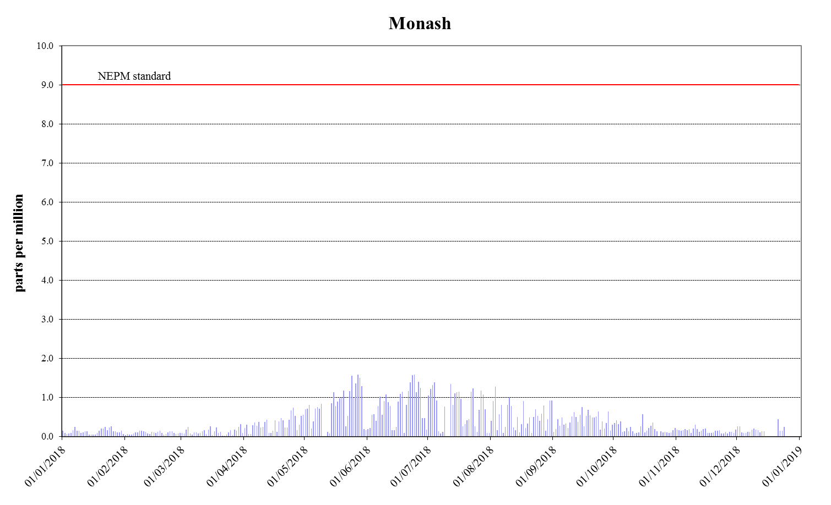
Figure 2: Daily maximum for CO 8-hour average – Monash
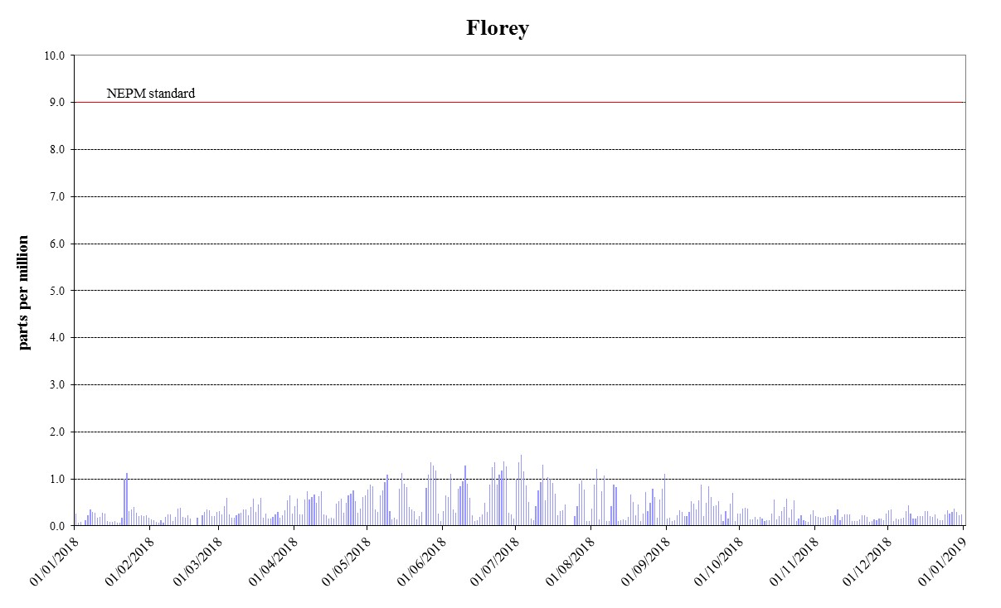
Figure 3: Daily maximum for CO 8-hour average – Florey

Nitrogen dioxide
During 2018, no exceedances of the nitrogen dioxide standards were recorded and compliance was demonstrated at Monash and Florey.
Table 5: 2018 compliance summary for NO₂
AAQ NEPM standard – 0.12 ppm (1-hour average), 0.03 ppm (1-year average)
Performance monitoring station | Data availability rates  (% of hours) |  |  |  |  | Annual mean  Concentration  (ppm) | Number of  1 hour exceedances  (days) | Performance against the standards and goal
 |  |  |  |  |  |  |  | 1 hour | 1 year
 | Q1 | Q2 | Q3 | Q4 | Annual
Monash  Florey | 95.8  90.2 | 95.7  94.7 | 95.0  93.5 | 95.6  94.7 | 95.5  93.3 | 0.004  0.005 | 0  0 | MET  MET | MET  MET
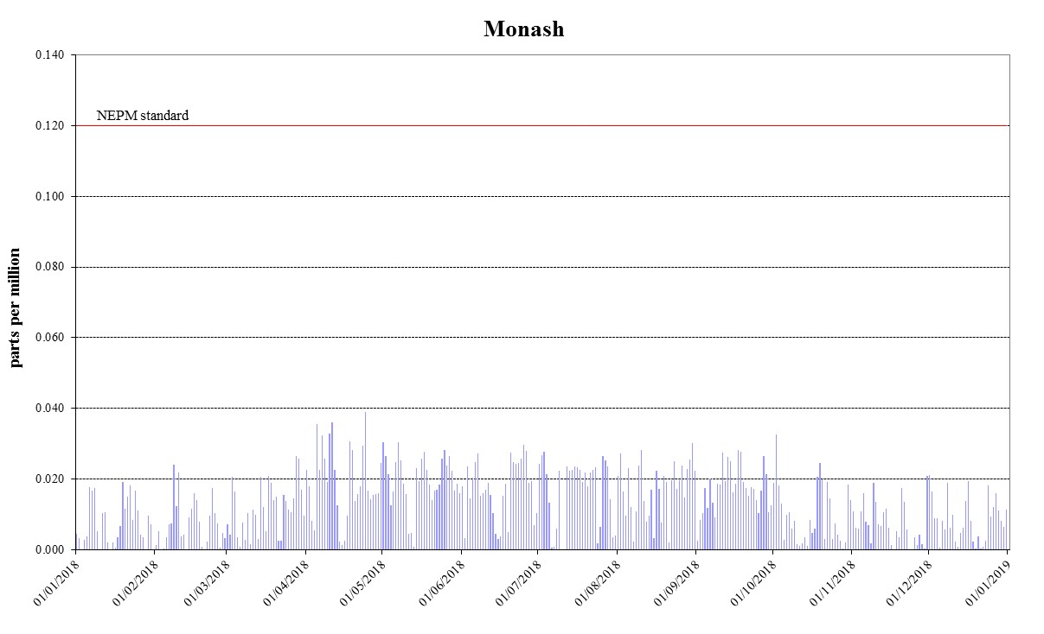
Figure 4: Daily maximum for NO₂ – Monash
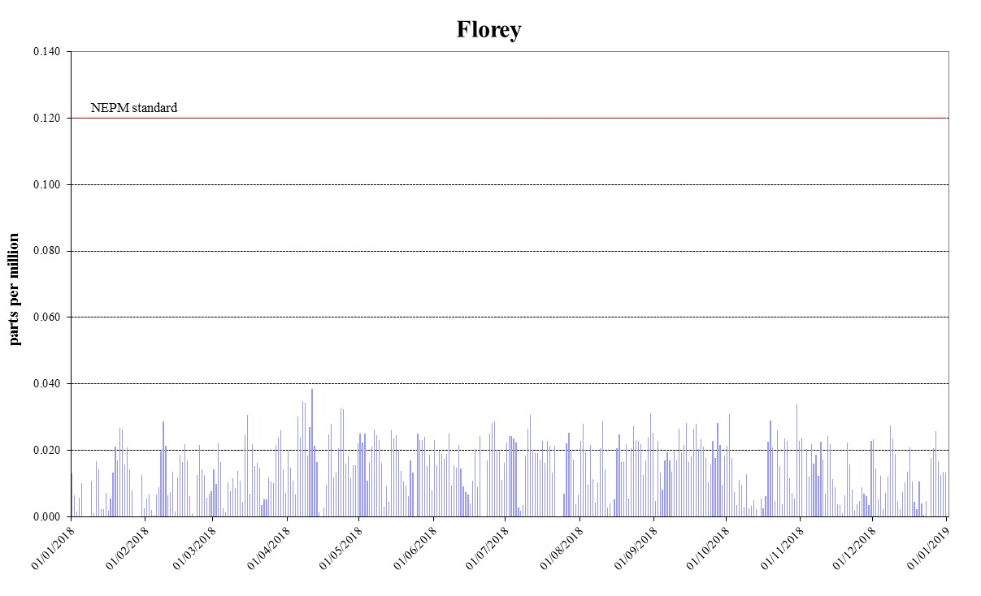
Figure 5: Daily maximum for NO₂ – Florey

Ozone
During 2018, no exceedances of the 1-hour and 4-hour standards for ozone were recorded and compliance was demonstrated at all monitoring stations.
Table 6: 2018 compliance summary for O₃
AAQ NEPM standard – 0.10 ppm (1-hour average), 0.08 ppm (4-hour average)
Performance monitoring station | Data availability rates  (% of hours) |  |  |  |  | Number of exceedances  (days) |  | Performance against the standards and goal
 | Q1 | Q2 | Q3 | Q4 | Annual | 1 hour | 4 hours | 1 hour | 4 hours
Monash  Civic  Florey | 95.8  95.7  95.3 | 95.8  95.8  95.6 | 95.8  95.8  94.1 | 95.6  93.3  95.7 | 95.8  95.2  95.2 | 0  0  0 | 0  0  0 | MET  MET  MET | MET  MET  MET

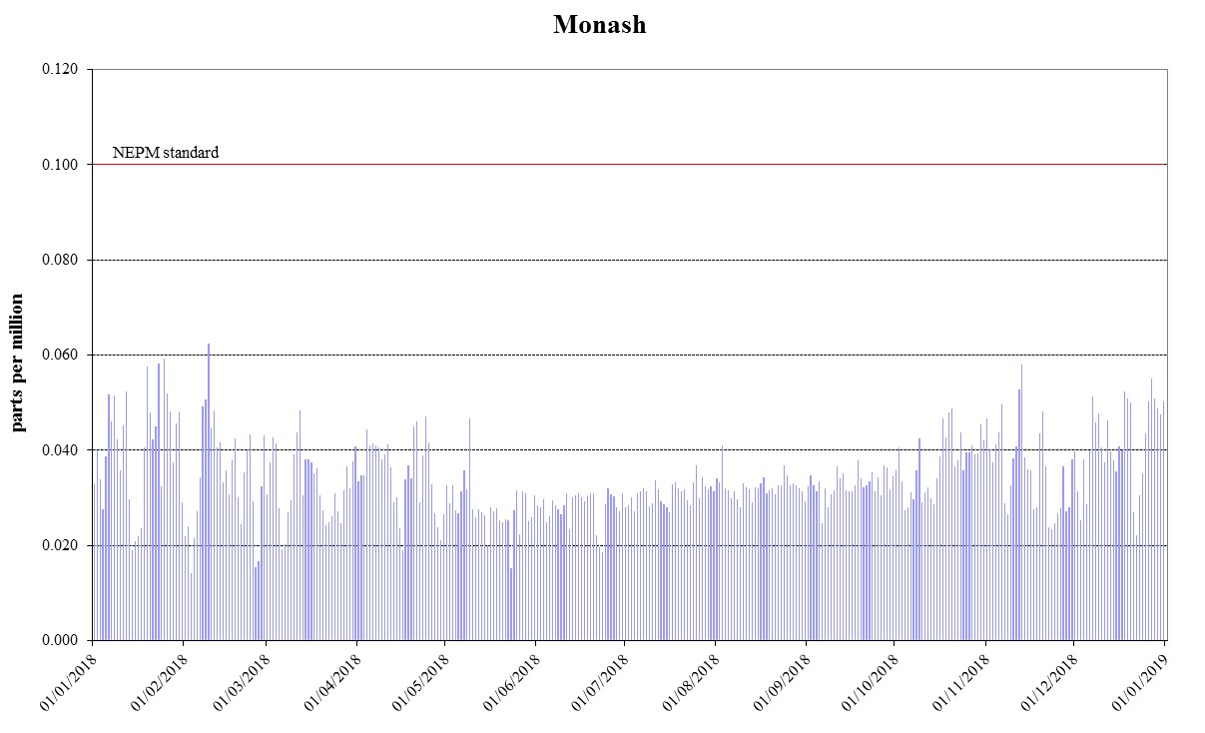
Figure 6: Daily maximum for 1 hour O₃ – Monash
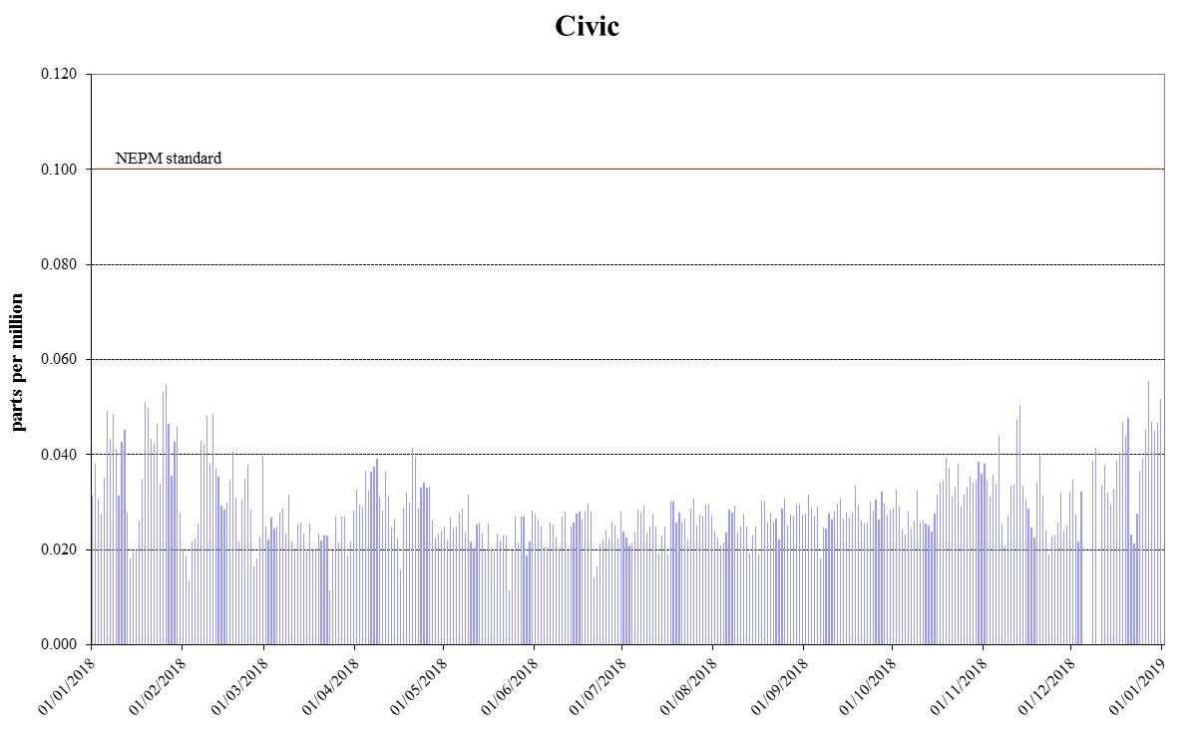
Figure 7: Daily maximum for 1 hour O₃ – Civic
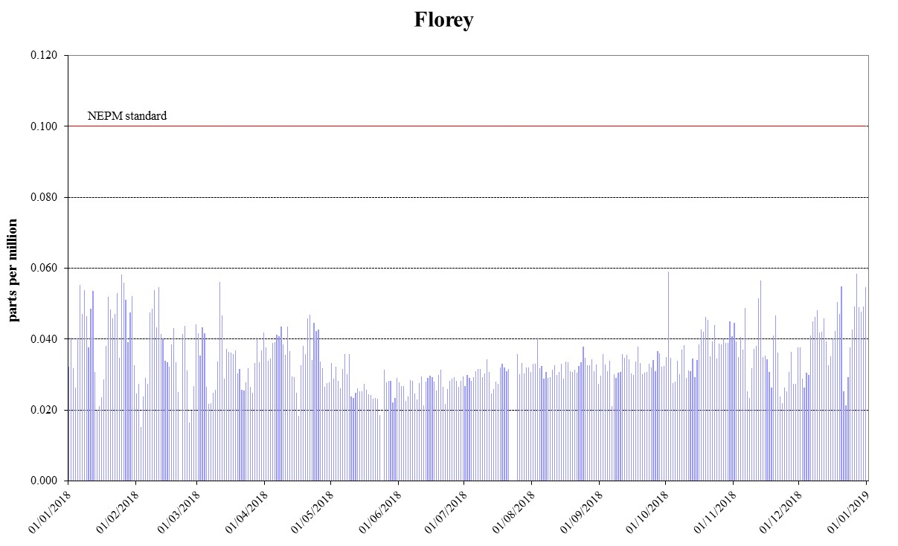
Figure 8: Daily maximum for 1 hour O₃ – Florey
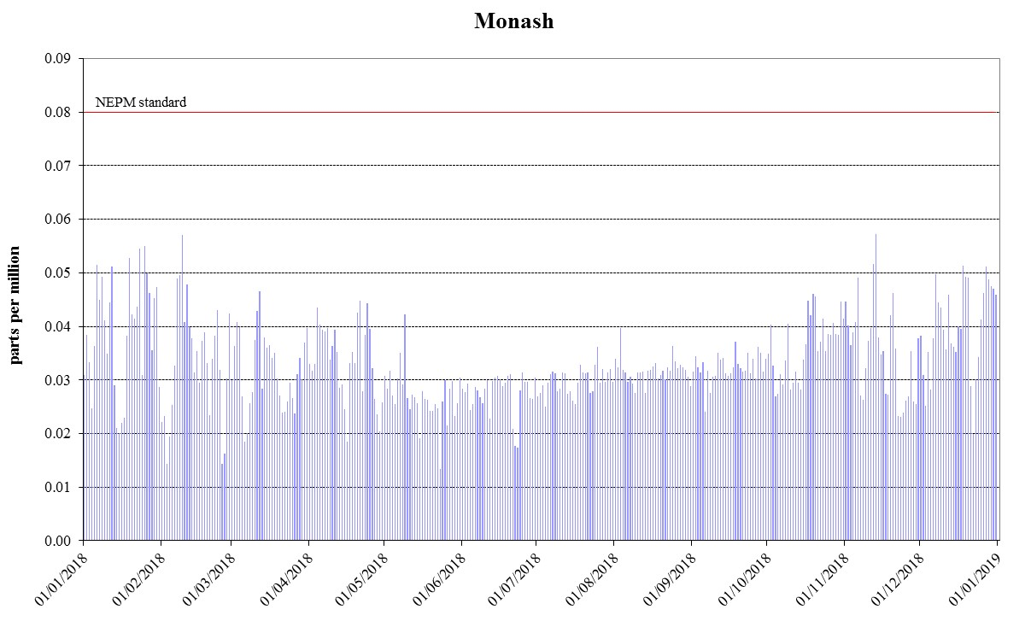
Figure 9: Daily maximum for 4 hours O₃ - Monash
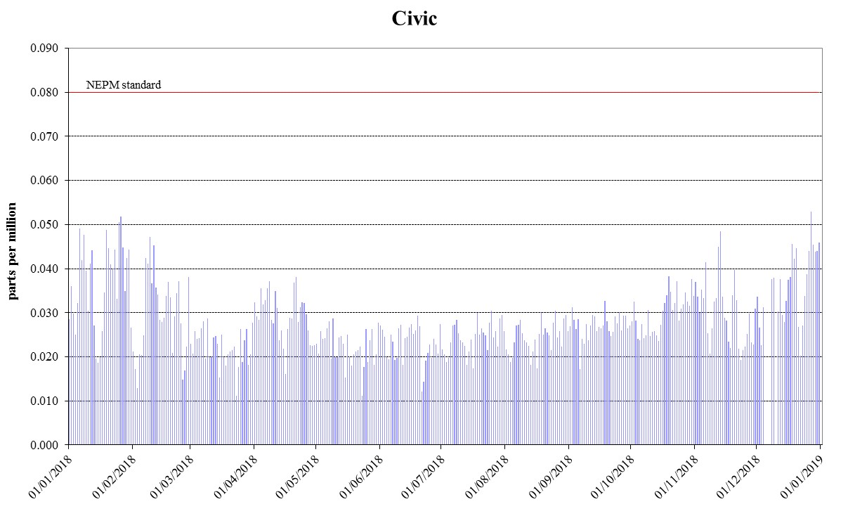
Figure 10: Daily maximum for 4 hours O₃ – Civic
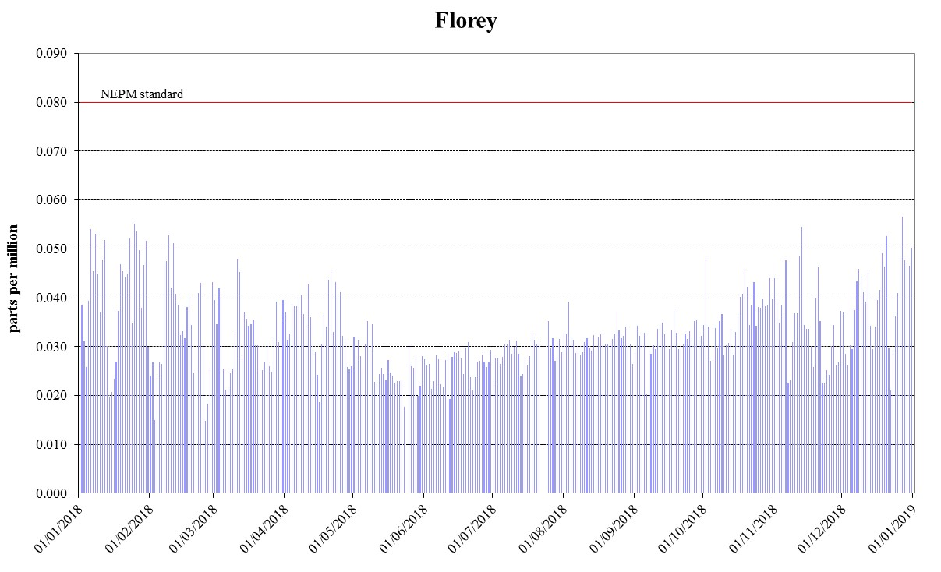
Figure 11: Daily maximum for 4 hours O₃ – Florey

PM₁₀
During 2018, there were 13 exceedances of the 24-hour PM₁₀ standard recorded in the ACT, which occurred outside the winter season and were due to dust storms**. Compliance against the AAQ NEPM PM₁₀ standard was demonstrated at all stations, when the exceedances were removed as exceptional events.
Table 7: 2018 compliance summary for PM₁₀
AAQ NEPM standard 50 μg/m³ 1-day average, 20 μg/m³ (1-year average)*
Performance monitoring station | Data availability rates  (% of days) |  |  |  |  | Annual mean  Concentration  (μg/m³) | Number of exceedances  (days) | Performance against the standards and goal
 | Q1 | Q2 | Q3 | Q4 | Annual
Monash  Civic  Florey | 98.9  93.3  90.0 | 100  100  87.9 | 100  100  87.0 | 97.8  97.8  94.6 | 99.2  97.8  89.9 | 11.8  13.5  12.0 | 4  6  3 | MET**  MET**  MET**

* ACT policy position 20 µg/m³ not AAQ NEPM standard of 25 µg/m³

** monitoring data that has been determined as being directly associated with an exceptional events such as hazard reduction burn or dust storm is excluded for the purpose of reporting compliance.

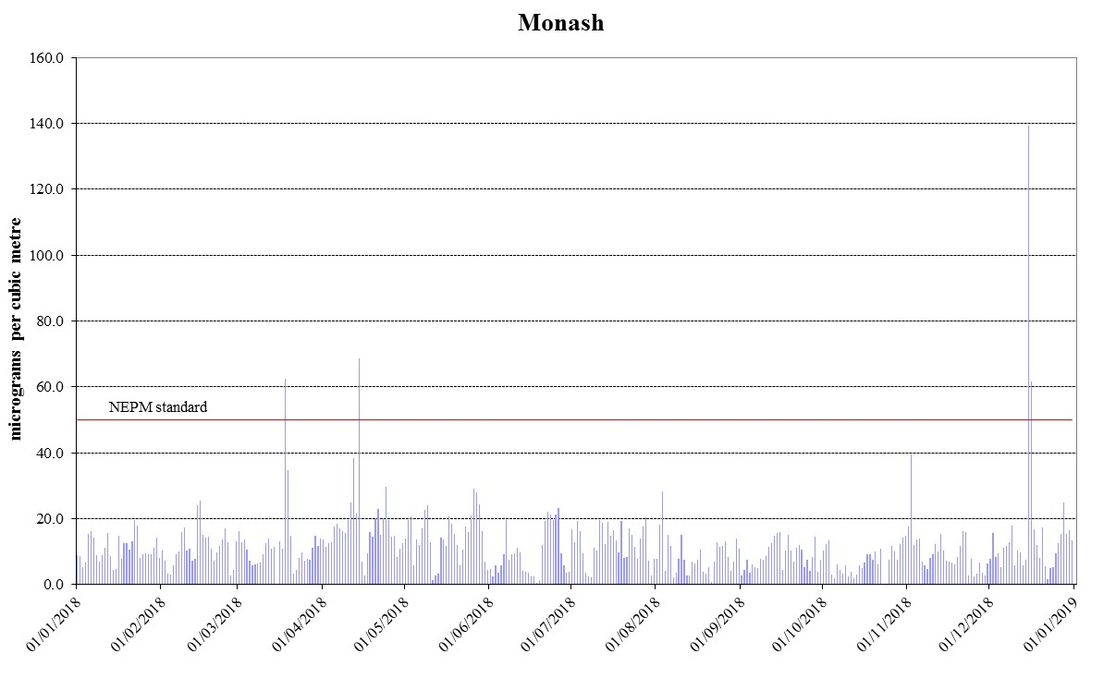
Figure 12: Daily maximum for PM₁₀ – Monash
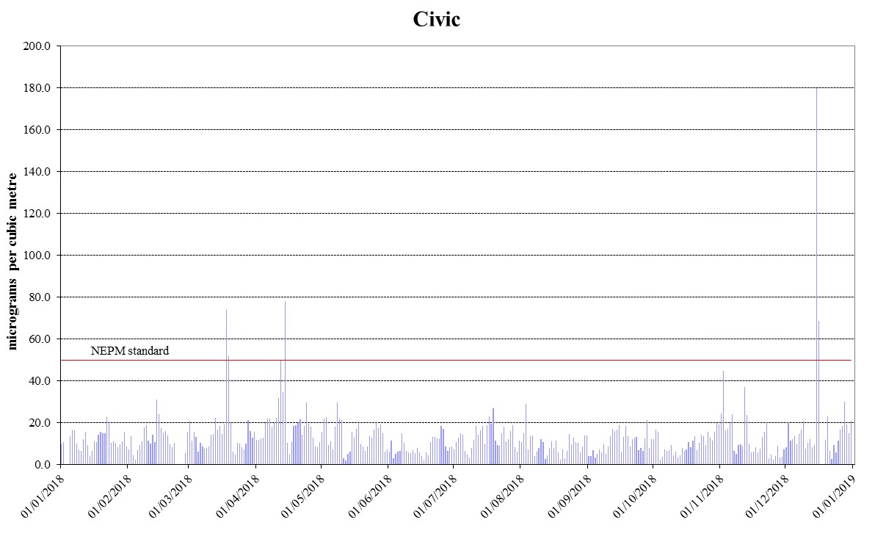
Figure 13: Daily maximum for PM₁₀ – Civic
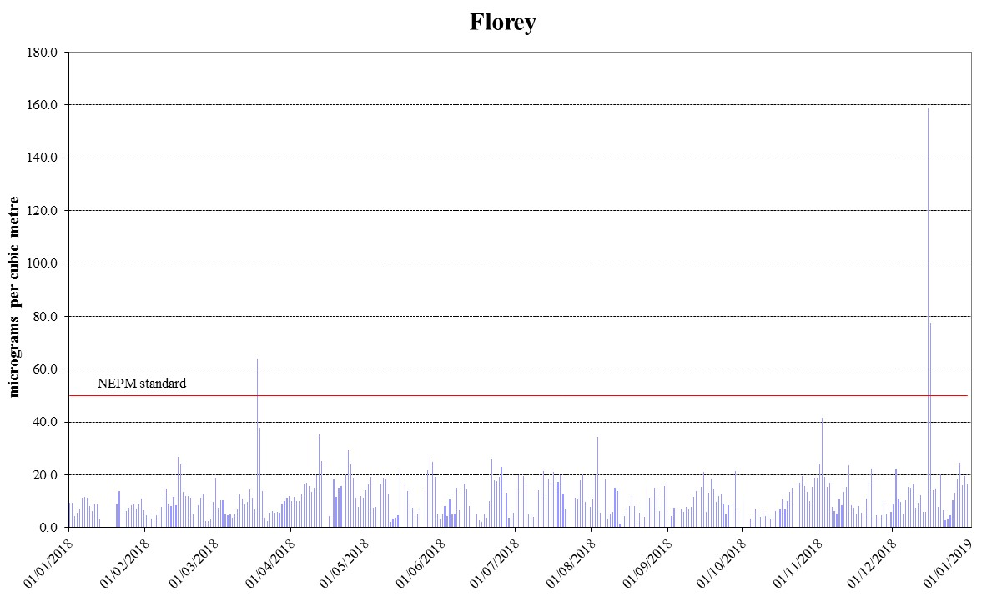
Figure 14: Daily maximum for PM₁₀ – Florey

PM_{2.5}
During 2018, there were four exceedances of the 24-hour PM_{2.5} standard which were attributed to hazard reduction burns (1) and dust storms (3) and therefore were excluded when assessing compliance against the daily goal. Compliance against the AAQ NEPM PM_{2.5} standards was met at Civic and Florey. The goal was not met at Monash due to one wood heater related exceedance on 27 May 2018.
Table 8: 2018 compliance summary for PM_{2.5}
AAQ NEPM standard – 25 μg/m³ (1-day), 8 μg/m³ (1-year)
Performance monitoring station | Data availability rates  (% of days) |  |  |  |  | Annual mean  Concentration  (μg/m³) | Number of  exceedances  (days) | Performance against the standards and goal
 | Q1 | Q2 | Q3 | Q4 | Annual
Monash  Civic  Florey | 100  100  98.9 | 98.9  100  98.9 | 97.8  100  94.6 | 100  94.6  96.7 | 99.2  98.6  97.3 | 6.8  6.5  7.1 | 2  1  2 | NOT MET  MET**  MET**

** monitoring data that has been determined as being directly associated with an exceptional events such as hazard reduction burn or dust storm is excluded for the purpose of reporting compliance.
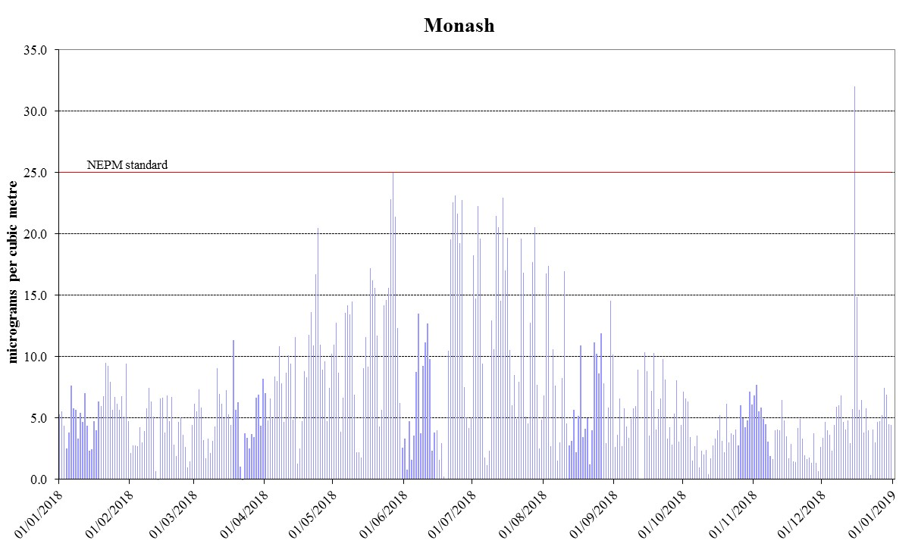
Figure 15: Daily maximum for PM_{2.5} – Monash
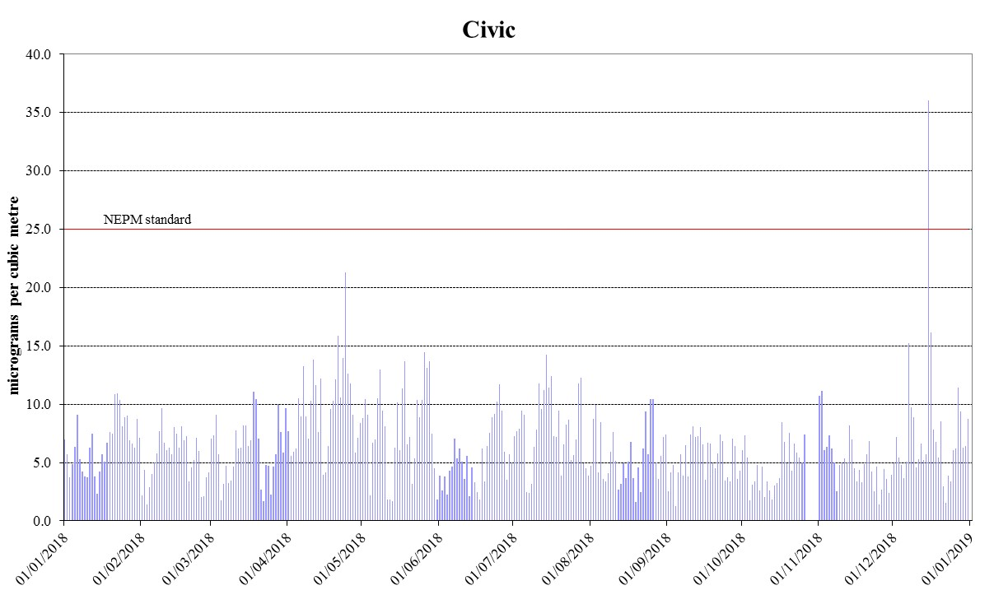
Figure 16: Daily maximum for PM_{2.5} – Civic
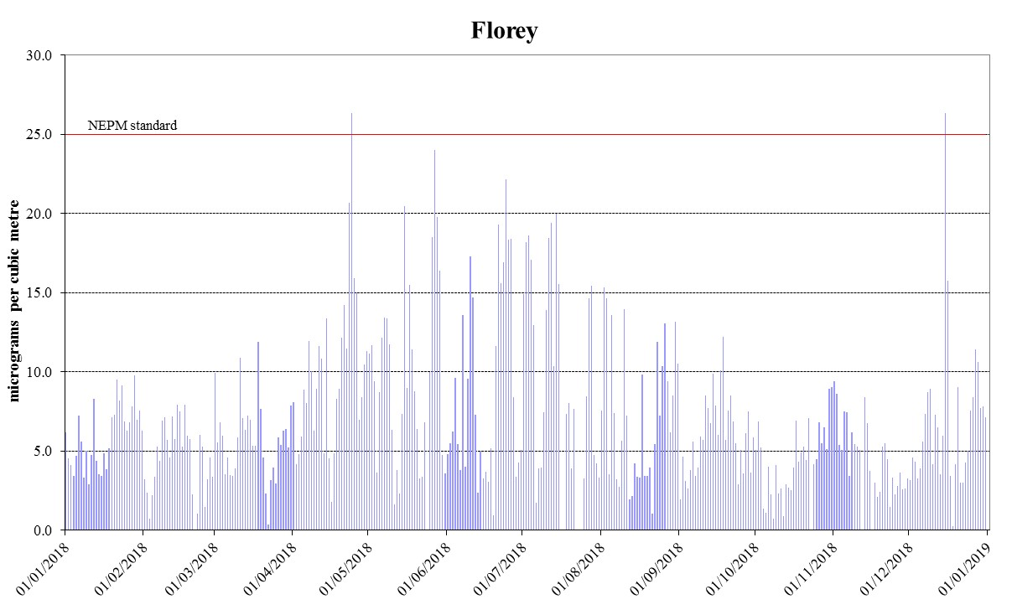
Figure 17: Daily maximum for PM_{2.5} – Florey

ANALYSIS OF AIR QUALITY MONITORING
Annual summary statistics contained in Table 9 to Table 15 below assess air quality against the standards and the extent of compliance with the goal. Instances where the standard has been exceeded are highlighted in bold.

Carbon monoxide
Table 9: 2018 summary statistics for daily peak 8-hour CO
AAQ NEPM standard - 9.0 ppm (8-hour average)
Performance monitoring station | Number of valid days | Highest  (ppm) | Highest  (date/time) | 2nd Highest  (ppm) | 2nd Highest  (date/time)
Monash  Florey | 347  358 | 1.6  1.5 | 27 May 04:00  03 Jul 03:00 | 1.6  1.4 | 24 Jun 06:00  26 Jun 03:00

Carbon monoxide levels are well below the AAQ NEPM standard at all monitoring stations. The highest recorded value in the ACT during 2018 was 1.6 ppm at Monash, which is 18% of the standard.

Nitrogen dioxide
Table 10: 2018 summary statistics for daily peak 1-hour NO₂
AAQ NEPM standard 0.12 ppm (1-hour average)
Performance monitoring station | Number of valid days | Highest  (ppm) | Highest  (date/time) | 2nd Highest  (ppm) | 2nd Highest  (date/time)
Monash  Florey | 363  349 | 0.039  0.039 | 24 Apr 19:00  11 Apr 19:00 | 0.036  0.035 | 11 Apr 20:00  07 Apr 19:00

Nitrogen dioxide levels are well below the AAQ NEPM standard and have remained stable over the last decade. The highest recorded 1-hour value during 2018 was 0.039 ppm at both Monash and Florey, which is only 32.5% of the standard. The highest recorded annual average in 2018 was 0.005ppm at Florey (refer to Table 5). This is 17% of the annual standard 0.03ppm.

Ozone
Table 11: 2018 summary statistics for daily peak 1-hour O₃
AAQ NEPM standard 0.10 ppm (1-hour average)
Performance monitoring station | Number of valid days | Highest  (ppm) | Highest  (date/time) | 2nd Highest  (ppm) | 2nd Highest  (date/time)
Monash  Civic  Florey | 365  361  360 | 0.062  0.056  0.059 | 09 Feb 11:00  27 Dec 12:00  02 Oct 13:00 | 0.059  0.055  0.058 | 25 Jan 17:00  26 Jan 11:00  27 Dec 12:00

Table 12: 2018 summary statistics for daily peak 4-hour O₃
AAQ NEPM standard 0.08 ppm (4-hour average)
Performance monitoring station | Number of valid days | Highest  (ppm) | Highest  (date/time) | 2nd Highest  (ppm) | 2nd Highest  (date/time)
Monash  Civic  Florey | 365  361  360 | 0.057  0.053  0.057 | 13 Nov 14:00  27 Dec 19:00  27 Dec 13:00 | 0.057  0.052  0.055 | 09 Feb 13:00  26 Jan 14:00  25 Jan 18:00

Ozone levels are below the AAQ NEPM standard. The highest recorded 1-hour value in the ACT during 2018 was 0.062 ppm at Monash, which is 62% of the standard. The highest recorded 4-hour value in the ACT during 2018 was 0.057 ppm at Monash and Florey, which is 71% of the standard.

PM₁₀
Table 13: 2018 summary statistics for daily PM₁₀
AAQ NEPM daily standard 50 μg/m³
Performance monitoring station | Number of valid days | Highest  (μg/m³) | Highest  (date)
Monash  Civic  Florey | 362  357  328 | 139.2  179.8  158.6 | 15 December  15 December  15 December

Table 14: 2018 PM₁₀ exceedances
Date | Monitoring Station |  |  | Inferred Cause | Exceptional Event
 | Monash  (μg/m³) | Civic  (μg/m³) | Florey  (μg/m³)
18 March | 62.4 | 74.0 | 64.1 | Dust Storm | Yes
19 March |  | 52.0 |  | Dust Storm | Yes
12 April |  | 50.2 |  | Dust Storm | Yes
14 April | 68.6 | 78.2 |  | Dust Storm | Yes
15 December | 139.2 | 179.8 | 158.6 | Dust Storm | Yes
16 December | 61.7 | 68.6 | 77.6 | Dust Storm | Yes

While there were 13 exceedances of the standard recorded in the ACT during 2018, these were attributed to dust storms and were excluded when assessing compliance against the daily goal.
The highest daily PM₁₀ level was recorded at Civic on 15 December 2018, with the concentration of 179.8μg/m³.
The highest recorded annual average in 2018 was 13.5μg/m³ at Civic (refer to Table 7). This is 67.5% of the policy standard annual of 20μg/m³.

PM_{2.5}
Table 15: 2018 summary statistics for daily PM_{2.5}
AAQ NEPM daily standard 25 μg/m³
Performance monitoring station | Number of valid days | Highest  (μg/m³) | Highest  (date)
Monash  Civic  Florey | 362  357  328 | 32.0  36.1  26.4 | 15 December  15 December  15 December

Table 16: 2018 PM_{2.5} exceedances
Date | Monitoring Station |  |  | Inferred Cause | Exceptional Event
 | Monash  (μg/m³) | Civic  (μg/m³) | Florey  (μg/m³)
24 April |  |  | 26.4 | Controlled Burn | Yes
27 May | 25.1 |  |  | Wood Heater | No
15 December | 32.0 | 36.1 | 26.4 | Dust Storm | Yes

The daily reporting standard for PM_{2.5} was exceeded five times. Only one of the exceedances at Monash (27 May 2018) was a result of increased domestic wood heater emissions during the winter months. The other four exceedances were due to hazard reduction burns and dust storms.
The highest daily PM₁₀ level was recorded at Civic on 15 December 2018, with the concentration of 36.1μg/m³.
The highest recorded annual average in 2018 was 7.1μg/m³ at Florey (refer to Table 8). This is 89% of the annual standard 8μg/m³.

ASSESSMENT OF PROGRESS TOWARDS ACHIEVING THE GOAL
The goals and standards have been consistently met in the ACT for carbon monoxide, nitrogen dioxide, and ozone since the commencement of the AAQ NEPM in 1998.
Historical monitoring results indicate that the only AAQ NEPM pollutant of concern in the ACT air shed is particulate matter, which increases significantly during winter because of emissions from domestic wood heaters, especially in the Tuggeranong Valley. Levels are exacerbated by the topography of the valley which is subject to temperature inversions and poor pollution dispersion.
In more recent years exceedances of the particulate matter standards have also been attributed to dust storms and smoke from controlled burns. During 2018, while there were 13 PM₁₀ exceedances and five PM_{2.5} exceedances, only one PM_{2.5} exceedance was related to emissions from domestic wood heaters.
PM_{2.5} is the pollutant most affected by woodsmoke as the majority of particles are less than 1 micron in diameter. Figure 15 to Figure 17 clearly show that PM_{2.5} levels increase significantly during the cooler months of the year. In the last few years the annual average PM_{2.5} readings for Monash and Florey have also increased and are now approaching the NEPM standard. Excluding temporal variation, this rise is more than likely because of an increase in wood heater use and/or installation as a result of the increasing cost of gas and electricity.
The ACT Government acknowledges that woodsmoke is a problem and will continue to implement an integrated program to address this including:
- the ‘Burn Right Tonight’ public education campaign;
- regulating of the sale of firewood and wood heaters, including the introduction of stricter emission and efficiency standards in September 2019; and
- administering the Wood Heater Replacement Program.
The Environment, Planning and Sustainable Development Directorate undertook a review of the efficacy of the Government’s woodsmoke programs. The review found that there had been a steady decline in applications for the Wood Heater Replacement Program. As a result, the Minister for Climate Change and Sustainability approved an increase of the rebate for the removal of a wood heater for a trial period from 1 April and 30 June 2019. It is expected that more wood heaters will be replaced during this trial period.
In 2019, there will be an increased emphasis on how to clean and correctly operate wood heaters so they can perform efficiently and reduce air emissions.

APPENDIX A: STATISTICAL SUMMARY AND TRENDS
The following section provides a basic statistical summary, using percentiles, for Monash, Florey and Civic stations and for each standard in the past ten years. Percentiles for daily maximum values are presented.

Carbon monoxide
Table 17: Statistical summary for daily maximum 8-hour CO Monash 2009 – 2018
Year | Data  Availability  (%) | No. of  Exceedances  (days) | Max  conc.  (ppm) | 95th  percentile  (ppm) | 75th  percentile  (ppm) | 50th  percentile  (ppm)
2009 | 96.4 | 0 | 2.0 | 1.4 | 0.6 | 0.3
2010 | 99.2 | 0 | 1.8 | 1.4 | 0.6 | 0.3
2011 | 98.6 | 0 | 2.2 | 1.5 | 0.5 | 0.2
2012 | 99.7 | 0 | 1.8 | 1.2 | 0.6 | 0.3
2013 | 95.9 | 0 | 2.1 | 1.5 | 0.6 | 0.3
2014 | 94.0 | 0 | 1.8 | 1.4 | 0.7 | 0.4
2015 | 94.8 | 0 | 1.9 | 1.4 | 0.6 | 0.3
2016 | 95.8 | 0 | 1.7 | 1.0 | 0.4 | 0.2
2017 | 95.4 | 0 | 1.6 | 1.2 | 0.6 | 0.2
2018 | 92.3 | 0 | 1.5 | 1.2 | 0.5 | 0.2

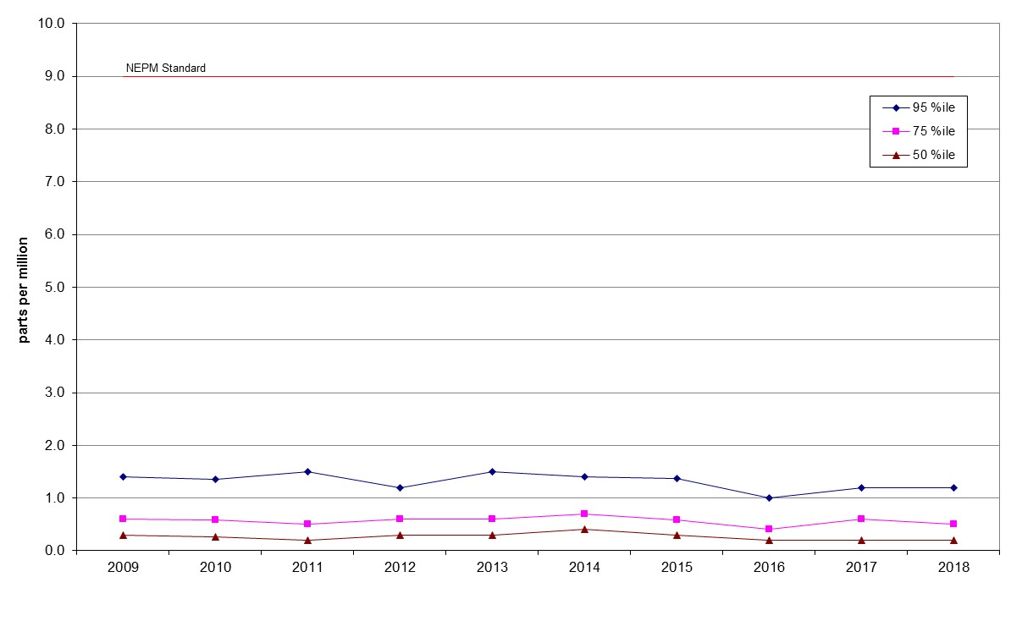
Figure 18: Statistical summary for daily maximum 8-hour CO Monash 2009 – 2018
Table 18: Statistical summary for daily maximum 8-hour CO Florey 2014 – 2018
Year | Data  Availability  (%) | No. of  Exceedances  (days) | Max  conc.  (ppm) | 95th  percentile  (ppm) | 75th  percentile  (ppm) | 50th  percentile  (ppm)
2014 | 79.2 | 0 | 2.2 | 1.4 | 0.7 | 0.3
2015 | 94.9 | 0 | 2.0 | 1.5 | 0.6 | 0.3
2016 | 95.5 | 0 | 1.9 | 1.2 | 0.5 | 0.3
2017 | 94.7 | 0 | 1.8 | 1.4 | 0.5 | 0.2
2018 | 94.7 | 0 | 1.5 | 1.1 | 0.5 | 0.3

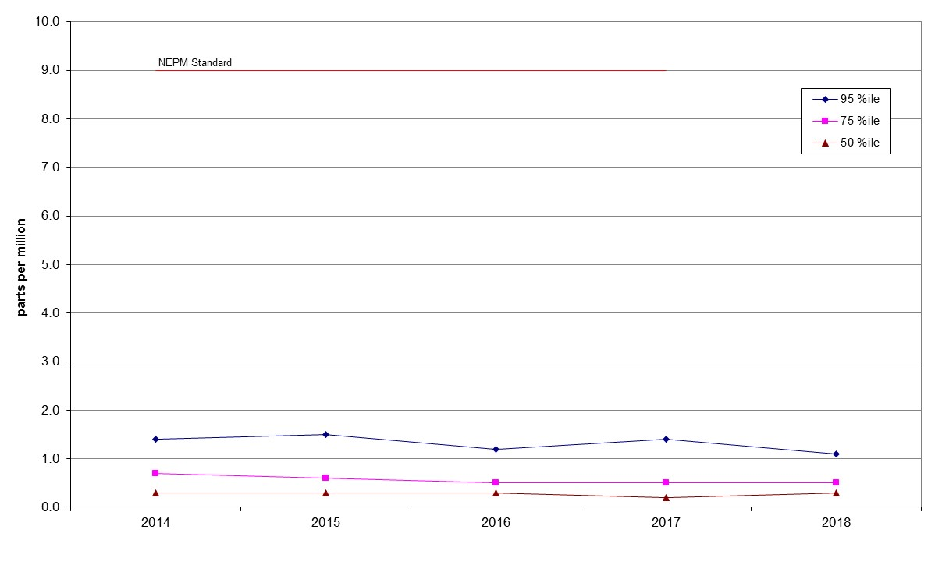
Figure 19: Statistical summary for daily maximum 8-hour CO Florey 2014 – 2018

Nitrogen dioxide
Table 19: Statistical summary for daily maximum 1-hour NO₂ Monash 2009 – 2018
Year | Data  Availability  (%) | No. of  Exceedances  (days) | Max  conc.  (ppm) | Annual average  (ppm) | 95th  percentile  (ppm) | 75th  percentile  (ppm) | 50th  percentile  (ppm)
2009 | 92.6 | 0 | 0.041 | 0.008 | 0.029 | 0.023 | 0.019
2010 | 89.1 | 0 | 0.037 | 0.006 | 0.025 | 0.021 | 0.017
2011 | 96.7 | 0 | 0.043 | 0.005 | 0.029 | 0.022 | 0.015
2012 | 97.5 | 0 | 0.033 | 0.006 | 0.026 | 0.021 | 0.014
2013 | 97.5 | 0 | 0.037 | 0.005 | 0.027 | 0.021 | 0.014
2014 | 94.1 | 0 | 0.036 | 0.005 | 0.027 | 0.020 | 0.015
2015 | 94.8 | 0 | 0.032 | 0.004 | 0.026 | 0.020 | 0.014
2016 | 95.6 | 0 | 0.036 | 0.004 | 0.027 | 0.019 | 0.012
2017 | 95.6 | 0 | 0.031 | 0.004 | 0.027 | 0.021 | 0.013
2018 | 95.5 | 0 | 0.039 | 0.004 | 0.028 | 0.020 | 0.014

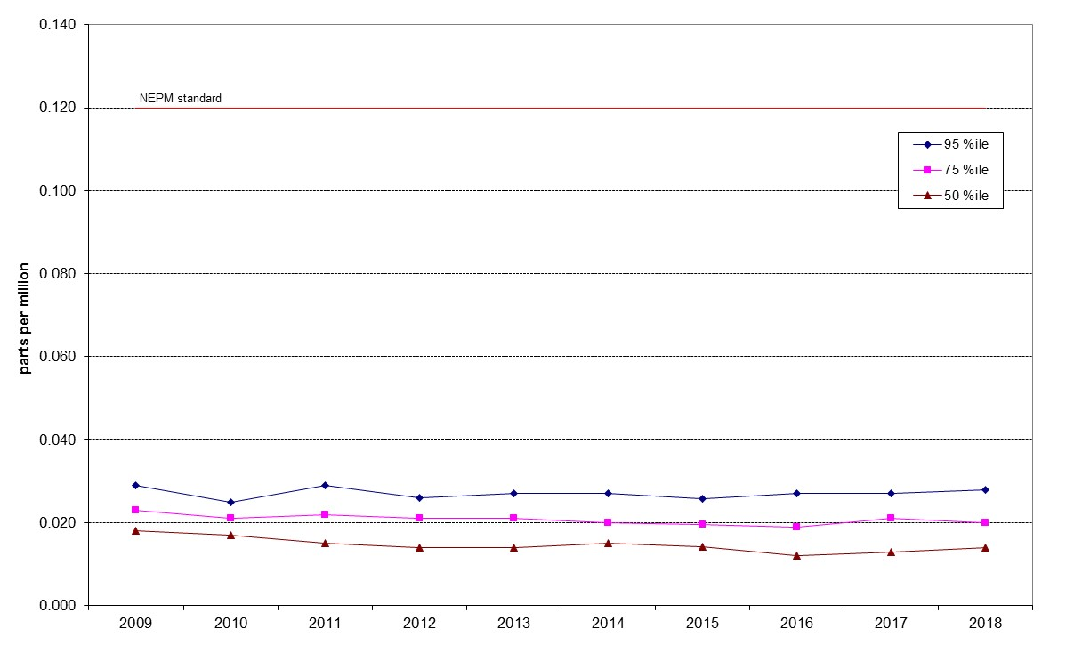

Figure 20: Statistical summary for daily maximum 1-hour NO₂ Monash 2009 – 2018

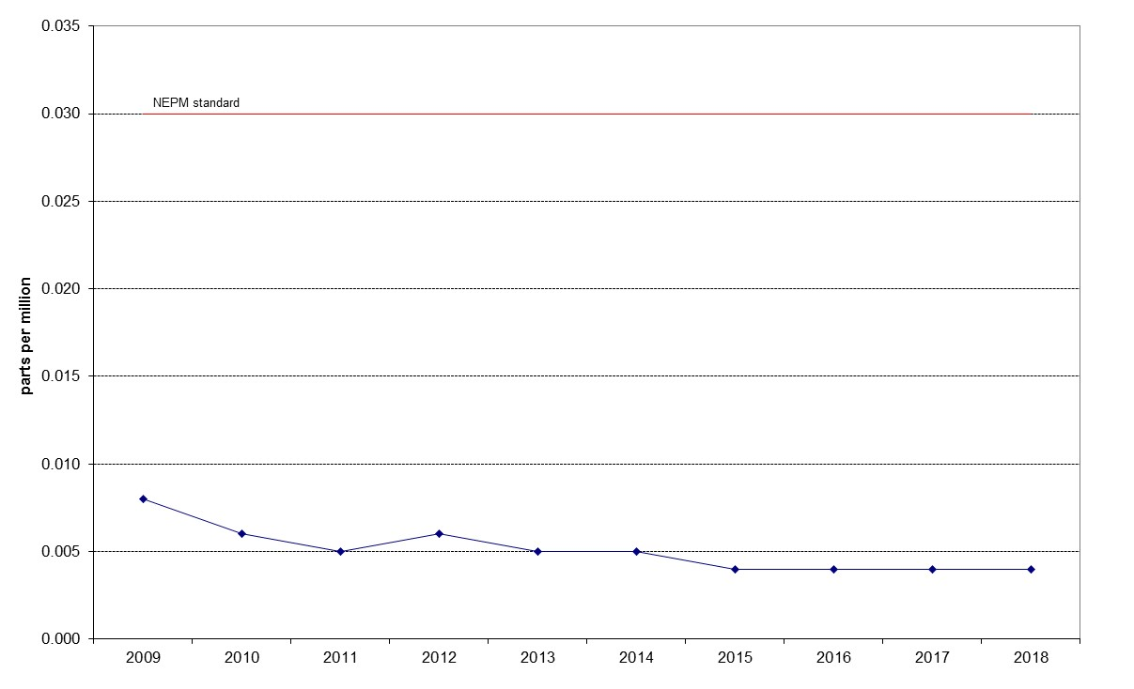

Figure 21: Annual average 1-hour NO₂ Monash 2009 – 2018

Table 20: Statistical summary for daily maximum 1-hour NO₂ Florey 2014 – 2018
Year | Data  Availability  (%) | No. of  Exceedances  (days) | Max  conc.  (ppm) | Annual average  (ppm) | 95th  percentile  (ppm) | 75th  percentile  (ppm) | 50th  percentile  (ppm)
2014 | 78.3 | 0 | 0.045 | 0.006 | 0.027 | 0.020 | 0.015
2015 | 91.5 | 0 | 0.033 | 0.005 | 0.027 | 0.020 | 0.014
2016 | 94.7 | 0 | 0.034 | 0.004 | 0.027 | 0.019 | 0.013
2017 | 93.7 | 0 | 0.033 | 0.005 | 0.025 | 0.020 | 0.015
2018 | 93.3 | 0 | 0.039 | 0.005 | 0.028 | 0.022 | 0.015

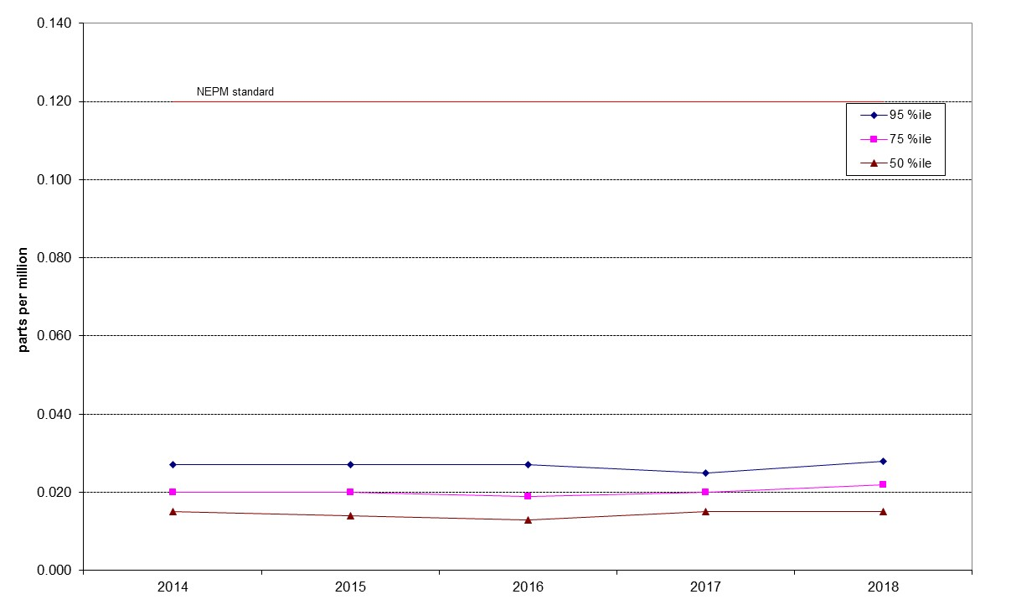
Figure 22: Statistical summary for daily maximum 1-hour NO₂ Florey 2014 – 2018
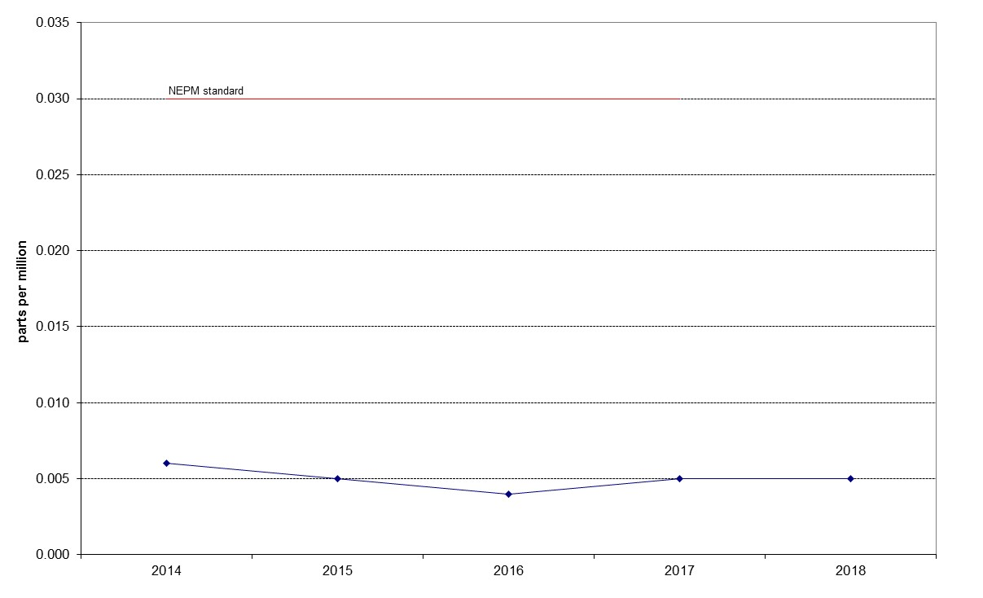
Figure 23: Annual average 1-hour NO₂ Florey 2014 – 2018

Ozone
Table 21: Statistical summary for daily maximum 1-hour O₃ Monash 2009 – 2018
Year | Data  Availability  (%) | No. of  Exceedances  (days) | Max  conc.  (ppm) | 95th  percentile  (ppm) | 75th  percentile  (ppm) | 50th  percentile  (ppm)
2009 | 96.4 | 0 | 0.073 | 0.052 | 0.038 | 0.030
2010 | 86.6 | 0 | 0.051 | 0.042 | 0.033 | 0.030
2011 | 99.2 | 0 | 0.056 | 0.044 | 0.033 | 0.028
2012 | 100 | 0 | 0.055 | 0.043 | 0.034 | 0.029
2013 | 97.8 | 0 | 0.062 | 0.045 | 0.035 | 0.029
2014 | 94.8 | 0 | 0.087 | 0.050 | 0.036 | 0.030
2015 | 92.8 | 0 | 0.065 | 0.044 | 0.034 | 0.026
2016 | 95.2 | 0 | 0.057 | 0.044 | 0.032 | 0.026
2017 | 95.5 | 0 | 0.060 | 0.049 | 0.038 | 0.032
2018 | 95.8 | 0 | 0.062 | 0.050 | 0.039 | 0.032

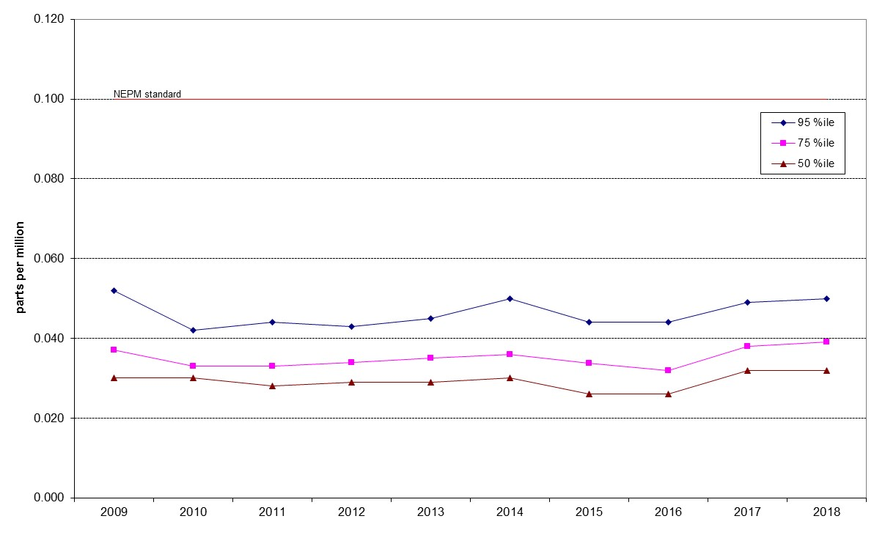

Figure 24: Statistical summary for daily maximum 1-hour O₃ Monash 2009 – 2018

Table 22: Statistical summary for daily maximum 1-hour O₃ Civic 2009 – 2018
Year | Data  Availability  (%) | No. of  Exceedances  (days) | Max  conc.  (ppm) | 95th  percentile  (ppm) | 75th  percentile  (ppm) | 50th  percentile  (ppm)
2009 | 97.8 | 0 | 0.060 | 0.044 | 0.031 | 0.024
2010 | 99.2 | 0 | 0.058 | 0.040 | 0.029 | 0.025
2011 | 96.4 | 0 | 0.052 | 0.041 | 0.030 | 0.026
2012 | 100 | 0 | 0.053 | 0.034 | 0.024 | 0.020
2013 | 92.1 | 0 | 0.060 | 0.036 | 0.028 | 0.024
2014 | 94.0 | 0 | 0.060 | 0.039 | 0.028 | 0.022
2015 | 89.0 | 0 | 0.042 | 0.034 | 0.026 | 0.022
2016 | 95.8 | 0 | 0.047 | 0.036 | 0.028 | 0.024
2017 | 95.8 | 0 | 0.053 | 0.045 | 0.034 | 0.028
2018 | 95.2 | 0 | 0.056 | 0.046 | 0.032 | 0.028

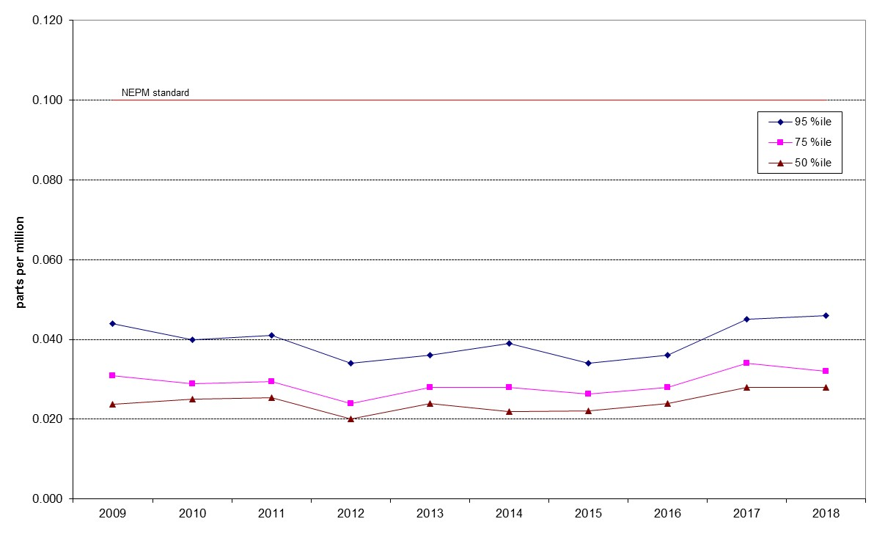

Figure 25: Statistical summary for daily maximum 1-hour O₃ Civic 2009 – 2018

Table 23: Statistical summary for daily maximum 1-hour O₃ Florey 2014 – 2018
Year | Data  Availability  (%) | No. of  Exceedances  (days) | Max  conc.  (ppm) | 95th  percentile  (ppm) | 75th  percentile  (ppm) | 50th  percentile  (ppm)
2014 | 79.4 | 0 | 0.074 | 0.034 | 0.027 | 0.023
2015 | 94.2 | 0 | 0.040 | 0.032 | 0.025 | 0.021
2016 | 95.8 | 0 | 0.050 | 0.040 | 0.031 | 0.027
2017 | 95.5 | 0 | 0.057 | 0.048 | 0.038 | 0.032
2018 | 95.2 | 0 | 0.059 | 0.050 | 0.038 | 0.032

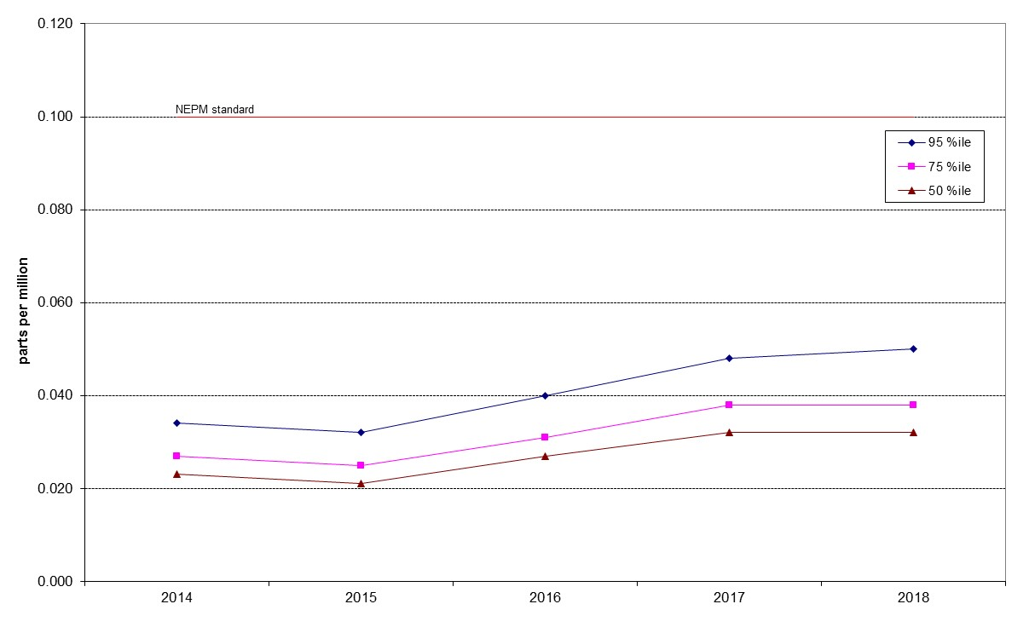

Figure 26: Statistical summary for daily maximum 1-hour O₃ Florey 2014 – 2018

Table 24: Statistical summary for daily maximum 4-hour O₃ Monash 2009 – 2018
Year | Data  Availability  (%) | No. of  Exceedances  (days) | Max  conc.  (ppm) | 95th  percentile  (ppm) | 75th  percentile  (ppm) | 50th  percentile  (ppm)
2009 | 96.2 | 0 | 0.068 | 0.048 | 0.036 | 0.029
2010 | 86.6 | 0 | 0.049 | 0.040 | 0.032 | 0.029
2011 | 98.9 | 0 | 0.054 | 0.041 | 0.032 | 0.027
2012 | 99.7 | 0 | 0.052 | 0.043 | 0.034 | 0.029
2013 | 97.8 | 0 | 0.059 | 0.042 | 0.033 | 0.028
2014 | 94.8 | 0 | 0.060 | 0.046 | 0.034 | 0.029
2015 | 92.8 | 0 | 0.050 | 0.041 | 0.033 | 0.025
2016 | 95.2 | 0 | 0.055 | 0.042 | 0.030 | 0.025
2017 | 95.5 | 0 | 0.055 | 0.047 | 0.036 | 0.031
2018 | 95.8 | 0 | 0.057 | 0.049 | 0.038 | 0.032

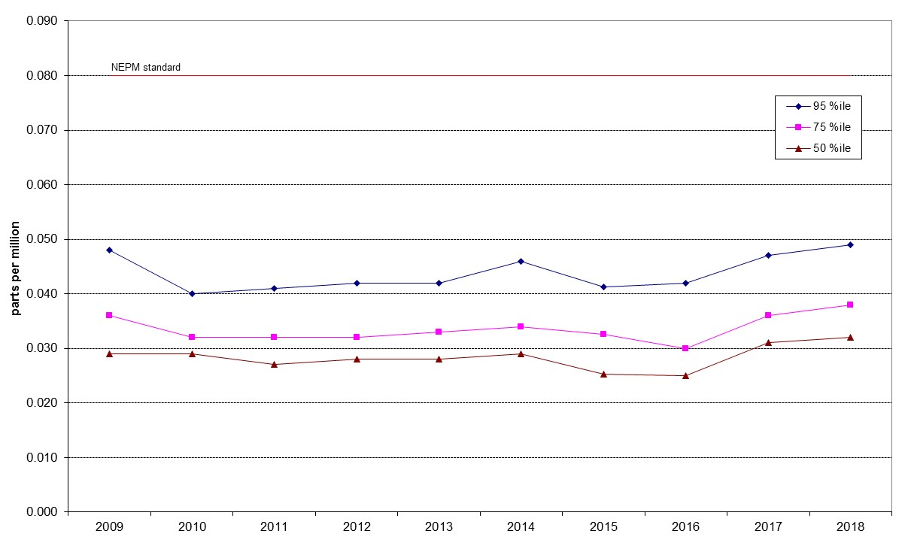

Figure 27: Statistical summary for daily maximum 4-hour O₃ Monash 2009 – 2018

Table 25: Statistical summary for daily maximum 4-hour O₃ Civic 2009 – 2018
Year | Data  Availability  (%) | No. of  Exceedances  (days) | Max  conc.  (ppm) | 95th  percentile  (ppm) | 75th  percentile  (ppm) | 50th  percentile  (ppm)
2009 | 97.8 | 0 | 0.059 | 0.041 | 0.030 | 0.023
2010 | 99.2 | 0 | 0.056 | 0.037 | 0.028 | 0.024
2011 | 96.4 | 0 | 0.050 | 0.038 | 0.029 | 0.025
2012 | 100 | 0 | 0.042 | 0.032 | 0.023 | 0.019
2013 | 91.8 | 0 | 0.057 | 0.034 | 0.027 | 0.023
2014 | 94.0 | 0 | 0.047 | 0.036 | 0.026 | 0.020
2015 | 89.0 | 0 | 0.041 | 0.031 | 0.025 | 0.021
2016 | 95.8 | 0 | 0.045 | 0.035 | 0.027 | 0.023
2017 | 95.8 | 0 | 0.049 | 0.042 | 0.033 | 0.027
2018 | 95.2 | 0 | 0.053 | 0.044 | 0.031 | 0.026

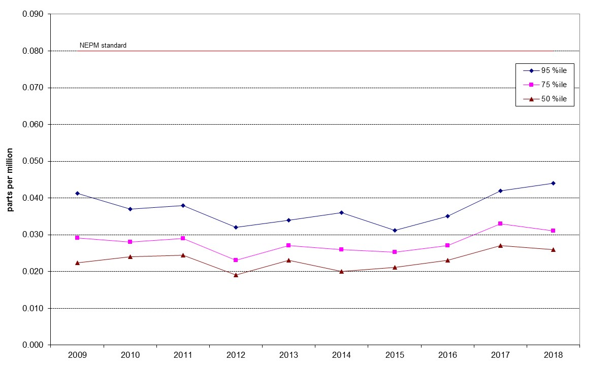

Figure 28: Statistical summary for daily maximum 4-hour O₃ Civic 2009 – 2018

Table 26: Statistical summary for daily maximum 4-hour O₃ Florey 2014 – 2018
Year | Data  Availability  (%) | No. of  Exceedances  (days) | Max  conc.  (ppm) | 95th  percentile  (ppm) | 75th  percentile  (ppm) | 50th  percentile  (ppm)
2014 | 79.4 | 0 | 0.040 | 0.031 | 0.026 | 0.022
2015 | 94.2 | 0 | 0.037 | 0.031 | 0.025 | 0.020
2016 | 95.8 | 0 | 0.050 | 0.038 | 0.029 | 0.026
2017 | 95.5 | 0 | 0.054 | 0.046 | 0.037 | 0.031
2018 | 95.2 | 0 | 0.057 | 0.048 | 0.037 | 0.031

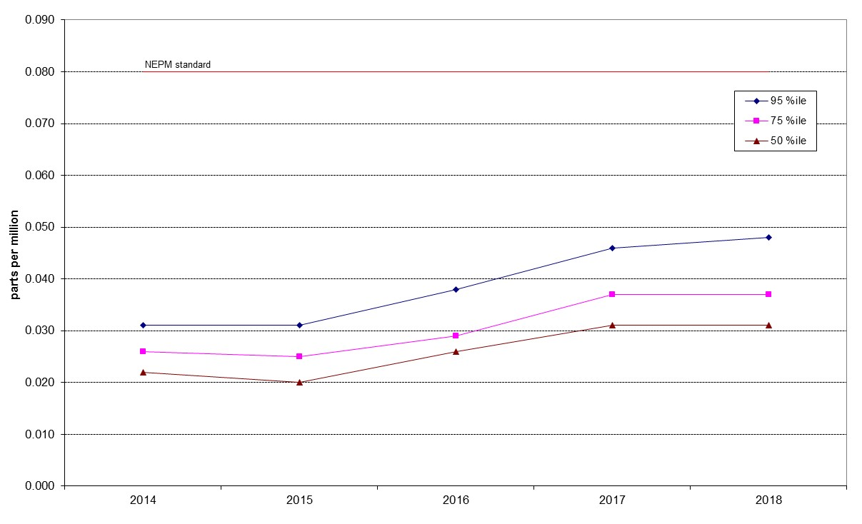

Figure 29: Statistical summary for daily maximum 4-hour O₃ Florey 2014 – 2018

PM₁₀
Table 27: Statistical summary for daily maximum daily PM₁₀ Monash 2009 – 2018
Year | Data  Availability  (%) | No. of  Exceedances  (days) | Max  conc.  (μg/m³) | Annual average  (μg/m³) | 95th  percentile  (μg/m³) | 75th  percentile  (μg/m³) | 50th  percentile  (μg/m³)
2009 | 42.3 | 9 | 210.0 | 20.3 | 50.5 | 25.5 | 15.2
2010 | 95.4 | 0 | 48.4 | 11.1 | 23.5 | 14.7 | 10.0
2011 | 99.2 | 0 | 40.0 | 10.4 | 22.8 | 13.2 | 8.7
2012 | 98.6 | 0 | 41.0 | 10.4 | 19.7 | 13.7 | 9.7
2013 | 95.6 | 0 | 43.5 | 9.8 | 20.2 | 13.1 | 8.9
2014 | 97.8 | 0 | 39.3 | 10 | 19.1 | 12.9 | 9.6
2015 | 98.4 | 0 | 49.4 | 9.9 | 19.5 | 13.1 | 9.5
2016 | 99.5 | 0 | 31.9 | 9.7 | 21.5 | 12.7 | 9.0
2017 | 98.9 | 0 | 28.3 | 9.8 | 20.5 | 12.3 | 9.0
2018 | 99.2 | 4 | 139.2 | 11.8 | 23.0 | 14.8 | 10.4

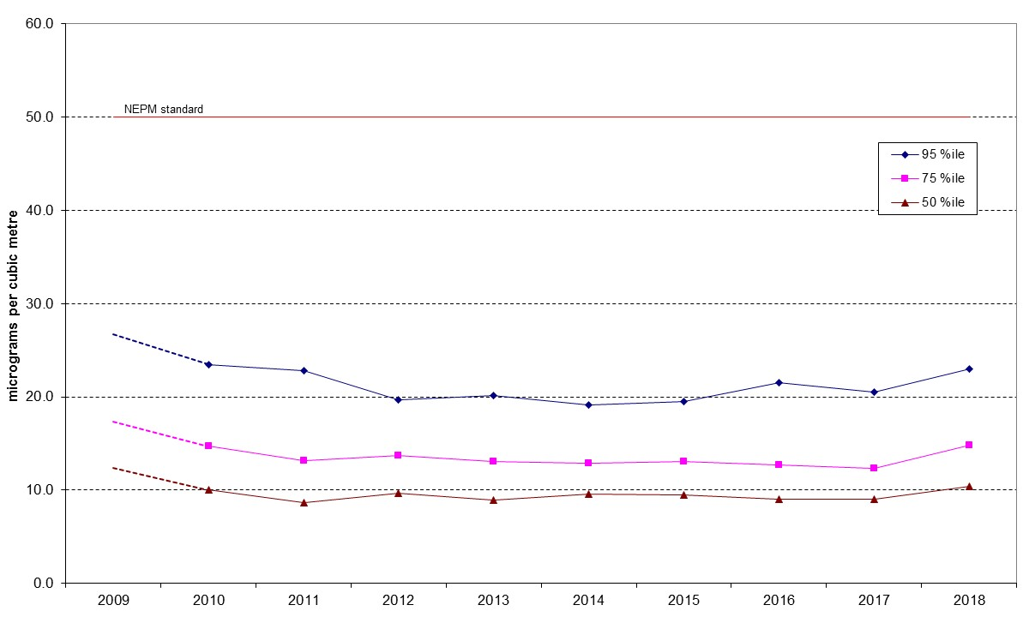
Figure 30: Statistical summary for daily PM₁₀ Monash 2009 – 2018
Note: 2009 data has not been included in Figure 30 as the percentile data has been skewed because of insufficient data in Q1 and Q2 (zero and twenty-five percent respectively) and the extreme readings associated with the dust storm which affected most of eastern Australia on 22 and 23 September, 2009.
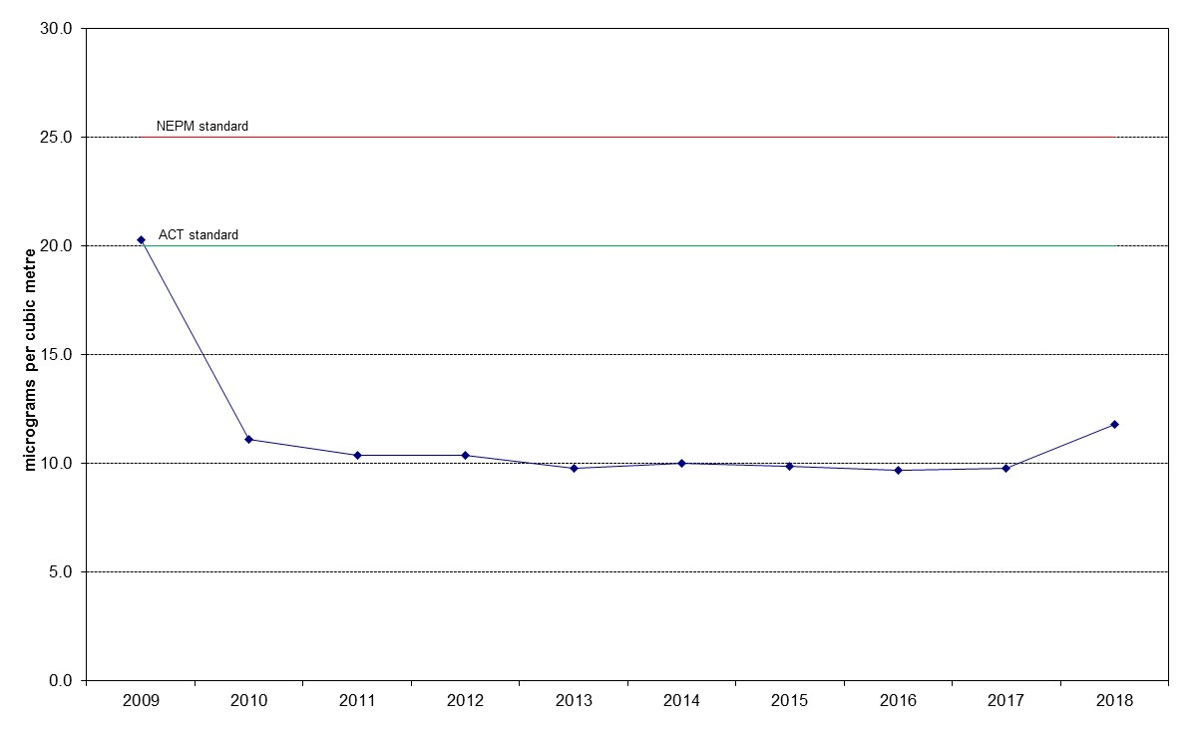

Figure 31: Annual average daily PM₁₀ Monash 2009 – 2018

Table 28: Statistical summary for daily maximum daily PM₁₀ Civic 2010 – 2018
Year | Data  Availability  (%) | No. of  Exceedances  (days) | Max  conc.  (μg/m³) | Annual average  (μg/m³) | 95th  percentile  (μg/m³) | 75th  percentile  (μg/m³) | 50th  percentile  (μg/m³)
2010 | 57.6 | 0 | 23.8 | 8.5 | 14.7 | 11.1 | 8.4
2011 | 97.0 | 0 | 29.2 | 8.7 | 16.9 | 11.0 | 7.9
2012 | 95.1 | 0 | 49.5 | 9.4 | 17.0 | 12.1 | 8.7
2013 | 92.9 | 1 | 57.8 | 9.7 | 19.9 | 12.0 | 8.6
2014 | 95.1 | 0 | 31.4 | 9.8 | 17.7 | 12.6 | 9.3
2015 | 97.5 | 1 | 64.3 | 11.1 | 20.9 | 14.1 | 10.4
2016 | 100 | 0 | 36.6 | 10.7 | 20.6 | 14.3 | 9.7
2017 | 83.6 | 1 | 53.0 | 9.68 | 10.8 | 7.1 | 5.2
2018 | 97.8 | 1 | 179.8 | 13.5 | 24.1 | 16.1 | 11.3

Note: No PM₁₀ monitoring was conducted at Civic in 2009.
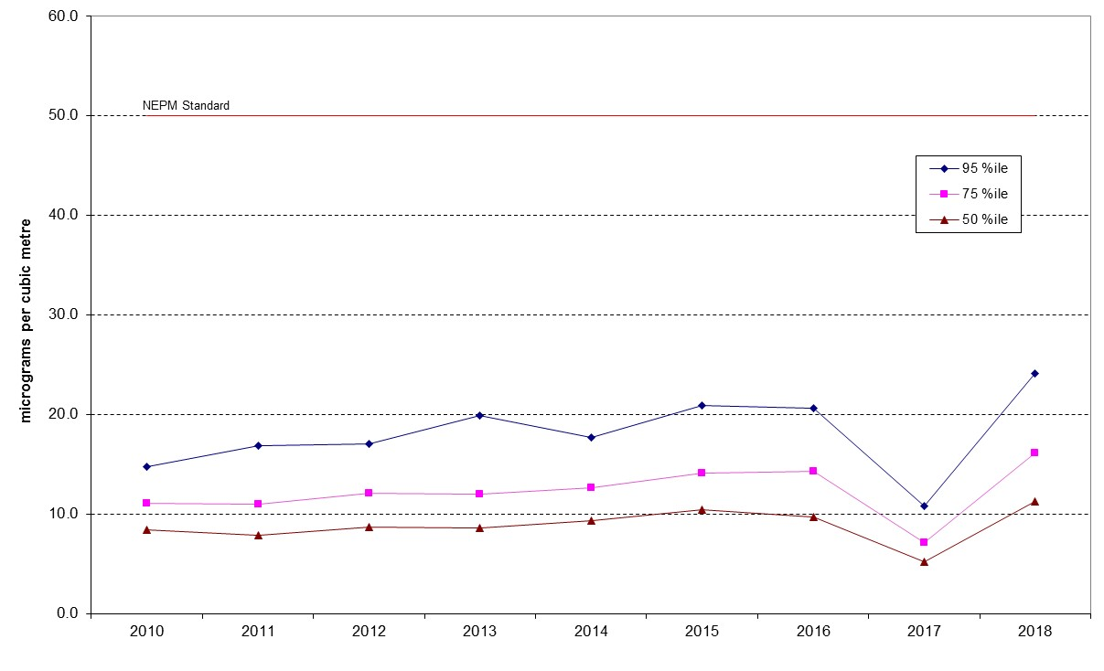
Figure 32: Statistical summary for daily PM₁₀ Civic 2010 – 2018
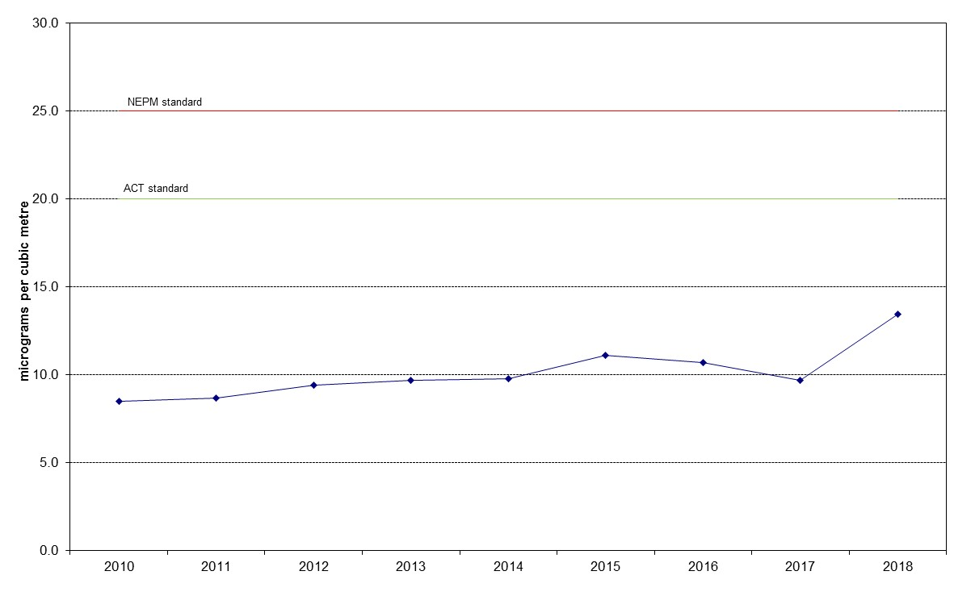

Figure 33: Annual average daily PM₁₀ Civic 2010 – 2018
Table 29: Statistical summary for daily maximum daily PM₁₀ Florey 2014 – 2018
Year | Data  Availability  (%) | No. of  Exceedances  (days) | Max  conc.  (μg/m³) | Annual average  (μg/m³) | 95th  percentile  (μg/m³) | 75th  percentile  (μg/m³) | 50th  percentile  (μg/m³)
2014 | 83.3 | 0 | 30.2 | 10.4 | 21.5 | 13.0 | 9.4
2015 | 95.6 | 0 | 70.8 | 10.7 | 21.8 | 13.7 | 9.4
2016 | 98.9 | 0 | 28.8 | 10.1 | 20.6 | 13.1 | 9.2
2017 | 98.4 | 0 | 28.1 | 9.84 | 21.8 | 12.8 | 8.5
2018 | 89.9 | 3 | 158.6 | 12.0 | 23.8 | 15.3 | 10.1

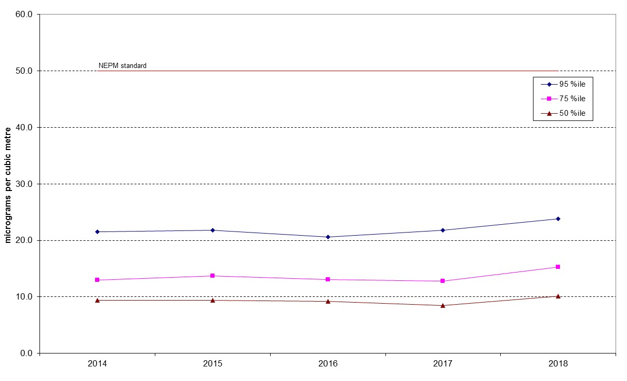

Figure 34: Statistical summary for daily PM₁₀ Florey 2014 – 2018

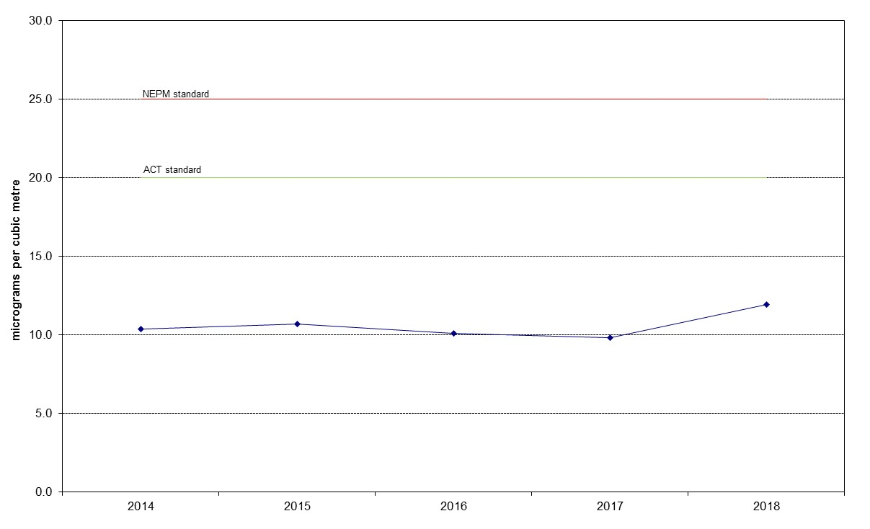

Figure 35: Annual average daily PM₁₀ Florey 2009 – 2018

PM_{2.5}
Table 30: Statistical summary for daily maximum daily PM_{2.5} Monash 2009 – 2018
Year | Data  Availability  (%) | No. of  Exceedances  (days) | Max  conc.  (μg/m³) | Annual average  (μg/m³) | 95th  percentile  (μg/m³) | 75th  percentile  (μg/m³) | 50th  percentile  (μg/m³)
2009 | 64.5 | 2 | 33.5 | 6.2 | 14.6 | 7.6 | 5.0
2010 | 95.1 | 2 | 52.4 | 6.7 | 17.4 | 7.8 | 4.4
2011 | 92.1 | 4 | 32.8 | 6.5 | 20.0 | 7.0 | 4.5
2012 | 95.1 | 3 | 29.2 | 7.1 | 16.5 | 8.3 | 5.0
2013 | 98.6 | 6 | 38.4 | 6.9 | 19.2 | 8.1 | 5.2
2014 | 87.7 | 4 | 31.5 | 6.8 | 18.7 | 8.6 | 5.6
2015 | 96.4 | 6 | 33.8 | 7.4 | 19.0 | 8.2 | 5.6
2016 | 98.1 | 8 | 32.7 | 7.4 | 20.7 | 8.2 | 5.4
2017 | 98.6 | 12 | 35.2 | 7.7 | 22.5 | 9.3 | 5.3
2018 | 99.2 | 2 | 32.0 | 6.8 | 19.2 | 8.6 | 5.3
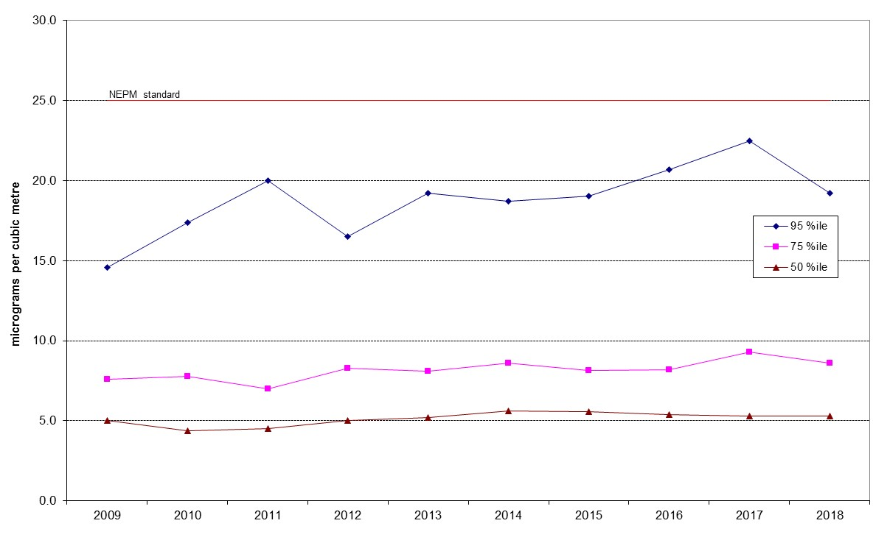
Figure 36: Statistical summary for daily PM_{2.5} Monash 2009 – 2018
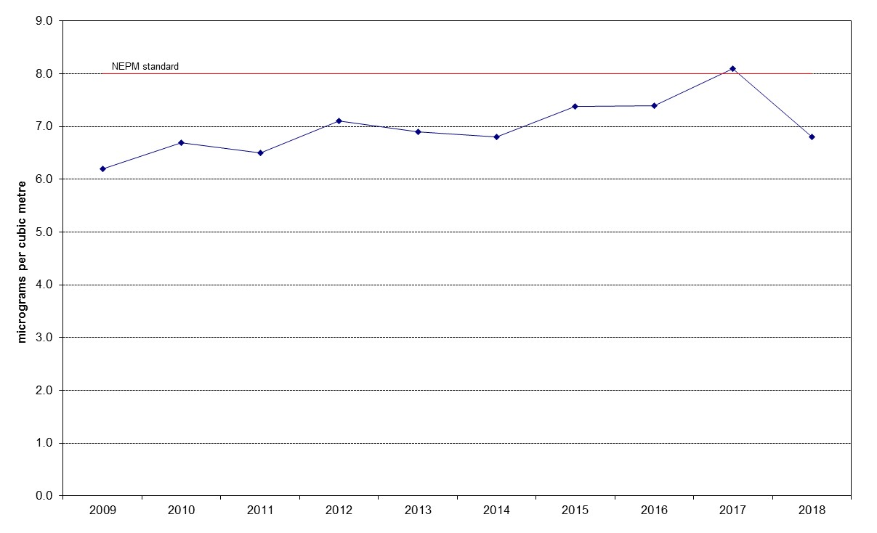
Figure 37: Annual average daily PM_{2.5} Monash 2009 – 2018

Table 31: Statistical summary for daily maximum daily PM_{2.5} Civic 2016 – 2018
Year | Data  Availability  (%) | No. of  Exceedances  (days) | Max  conc.  (μg/m³) | Annual average  (μg/m³) | 95th  percentile  (μg/m³) | 75th  percentile  (μg/m³) | 50th  percentile  (μg/m³)
2016 | 98.6 | 0 | 22.1 | 5.5 | 11.0 | 7.1 | 4.8
2017 | 94.2 | 1 | 53.8 | 5.9 | 10.8 | 7.1 | 5.2
2018 | 98.6 | 1 | 36.1 | 6.5 | 12.1 | 8.1 | 6.1

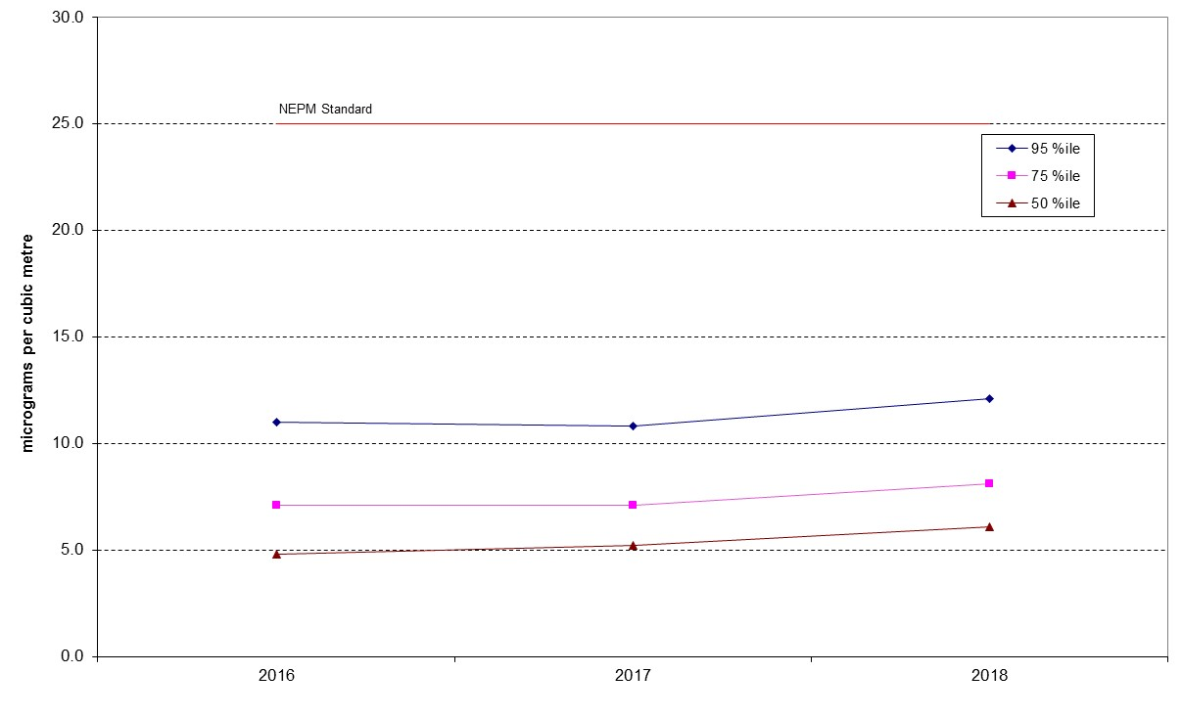

Figure 38: Statistical summary for daily PM_{2.5} Civic 2016 – 2018
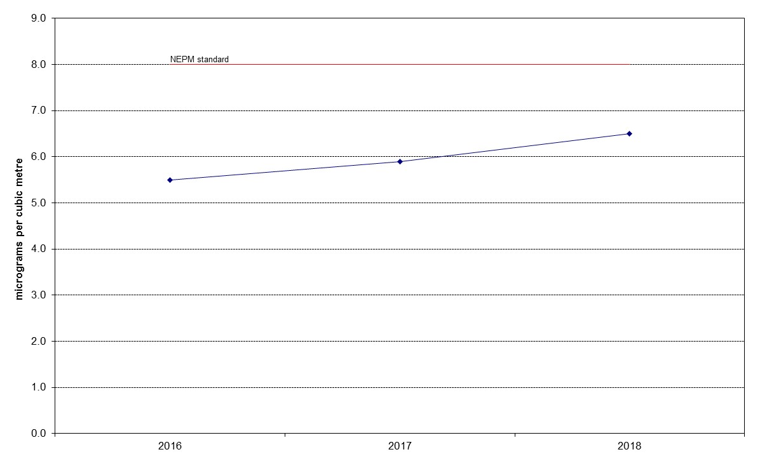

Figure 39: Annual average daily PM_{2.5} Civic 2016 – 2018

Table 32: Statistical summary for daily maximum daily PM_{2.5} Florey 2014 – 2018
Year | Data  Availability  (%) | No. of  Exceedances  (days) | Max  conc.  (μg/m³) | Annual average  (μg/m³) | 95th  percentile  (μg/m³) | 75th  percentile  (μg/m³) | 50th  percentile  (μg/m³)
2014 | 74.2 | 0 | 22.8 | 5.8 | 15.0 | 7.1 | 4.9
2015 | 96.2 | 0 | 24.3 | 6.5 | 17.1 | 7.4 | 4.8
2016 | 98.6 | 1 | 27.2 | 7.3 | 17.4 | 8.6 | 5.8
2017 | 94.2 | 0 | 23.8 | 7.2 | 17.9 | 8.7 | 5.6
2018 | 97.3 | 2 | 26.4 | 7.4 | 17.0 | 8.7 | 5.9

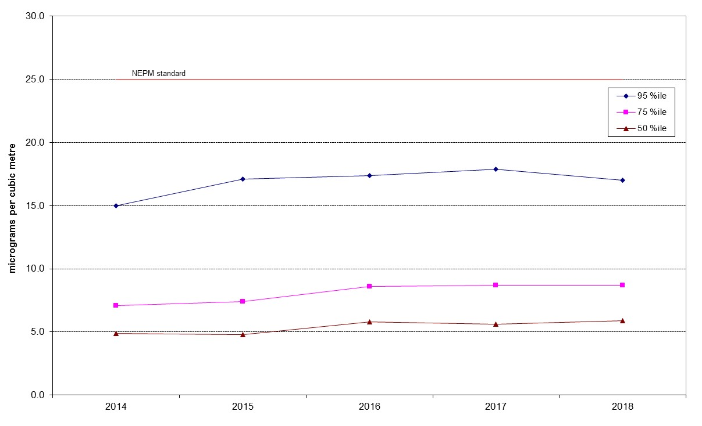
Figure 40: Statistical summary for daily PM_{2.5} Florey 2014 – 2018
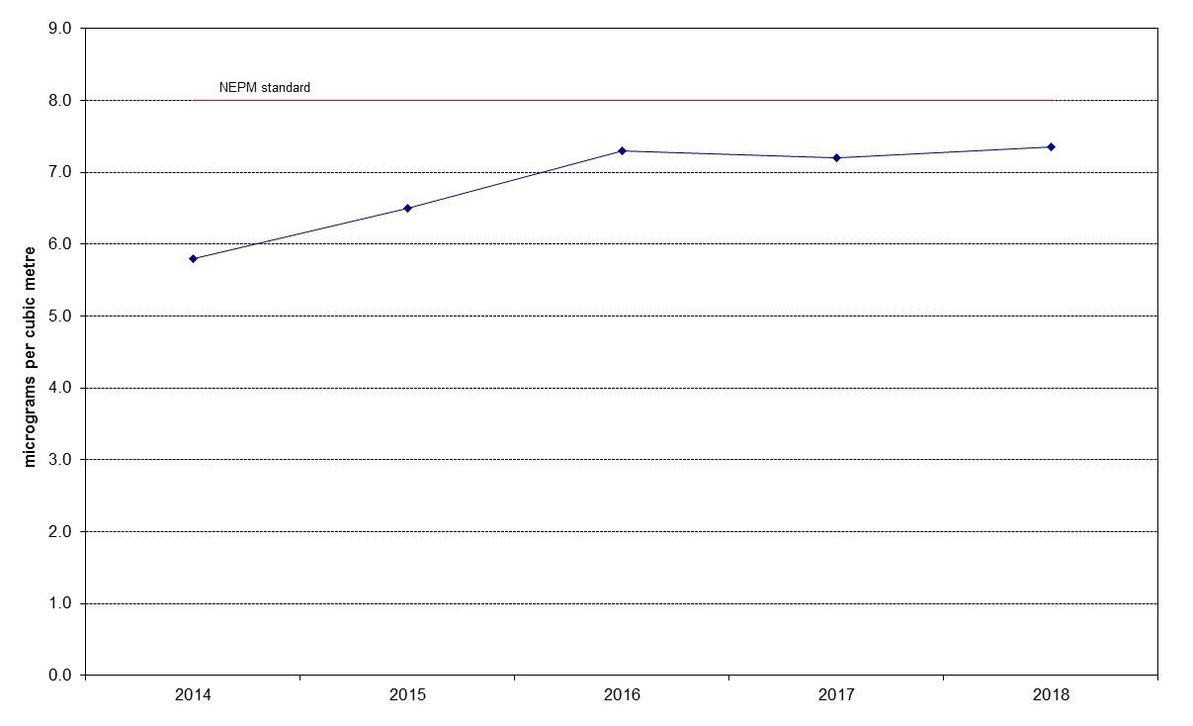
Figure 41: Annual average daily PM_{2.5} Florey 2014 – 2018

