ENVIRONMENT PROTECTION INFORMATION SHEET 12
REQUIREMENTS FOR THE BENEFICIAL REUSE OF WASTE IN THE ACT
This Information Sheet outlines the Environment Protection Authority’s (EPA) requirements for the beneficial reuse of waste in the Australian Capital Territory (ACT). The beneficial reuse of waste is supported provided it is managed in accordance with EPA’s guidanceand the requirements of the Environment Protection Act 1997 (the Act), including the need to adopt the general environmental duty under the Act to minimise environmental harm.

Background
The key objective of this information sheet is to ensure that the environment andhuman health are protected during the beneficial reuseof waste ¹.
The EPA considers beneficial reuse of waste as the application of commercial waste, whether processed or not, as a substitute for raw materials or inputs to another process or product in a way that provides a functional benefit and doesnot cause harm to human healthor the environment.

Scope
Activities suchas the reuse of soil², contaminated or not, drilling mud waste ³, virgin excavated natural material⁴, and composting activities⁵ are not in the scope of this information sheet.
This information sheet supports the objects and principles of the Environment Protection Act 1997 and Waste
Management andResource Recovery Act 2016 and is in line with the 2018 National Waste Policyoverarching principles underpinning a circular economy.
It also supports the management targets of the ACT Waste Management Strategy 2011–2025, which
establishes a hierarchyfor waste management, whichaims
to extract the maximum practical benefits fromproducts while generating the minimum amount of waste.
Note 1: The ACT Waste-to-Energy Policy 2020-25 covers non thermal means of energyrecovery from residual non- hazardous waste materials which canno longer be reused or recycled.

Note 2: The beneficial reuse options covered in this information sheet do not apply to liquid wastes or wastes classified as ‘hazardous’ in the ACT's Environmental Standards: Assessment andClassification ofLiquidand Non- liquid Wastes 2021.
Further informationon the management of hazardous materials and chemicals and be found in the EPA
Hazardous Material Environment ProtectionPolicy 2022.

The ACT Waste Management Hierarchy
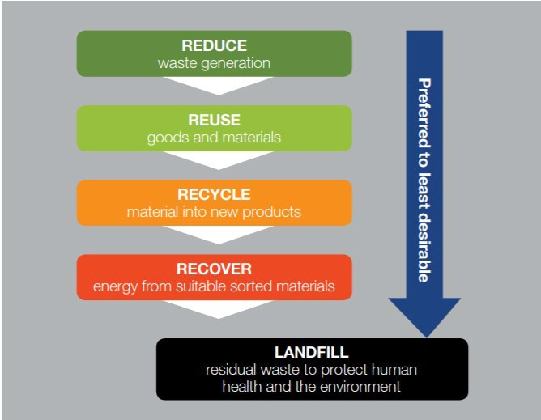

Beneficial reuse options
The following options are considered as beneficial reuse of waste:
- application of waste to land (for example, as a soil amendment or ‘fill’);
- reuse of waste in municipal infrastructure
construction (for example use of recycled glass as bedding material); or

1 The meaning of waste is that defined in Schedule 1 of the
Environment Protection Act 1997.
2 Contaminated Sites Information Sheet 4 outlines the EPA’s requirements for the classification of known and potentially contaminated soil for reuse and disposal in the ACT.
3 Information Sheet 8 provides the requirements for classification and reuse of drilling mud waste in the ACT.
4 Contaminated Sites Information Sheet 10 provides clarification of the definition of virgin excavated natural material (VENM) and advice on its use, placement and disposal in the ACT.
5 The EPA’s Commercial Composting Guide provides information on commercial composting operations and resources.
- reuse of waste in a manufacturing process where product is appliedto land (for example, use of
recycledplastics in asphalt).

Applications and Approvals
The EPA will consider and generallysupport existing beneficial reuse approvals issued by another jurisdiction. For example, a waste reuse wouldbe acceptable in the ACT for commonly recoveredand reused wastes to which

a resource recovery order and exemption was granted by NSW EPA, provided all conditions of the order and exemption canbe met for the reuse of the waste to be lawful in the ACT.
A Beneficial reuse application must be submitted for all waste reuse proposals to the EPA including:
- details of proposed waste reuse.
- a signed statement declaringthat the proposed reuse:
o is genuine, rather than a means of waste disposal,
o is beneficial or fit-for-purpose, and
o will not cause harm to human health or the environment.
- a current approval for that specific waste reuse and jurisdiction in which it was granted, including:
o details of the waste reuse policy, frameworkor equivalent in the jurisdiction the approvalwas granted;
o an assessment indicating that the approval would be applicable to the ACT, considering local
environmental and landuse conditions, restrictions and requirements.
- If there is no current reuse approval for the waste from another jurisdiction, undertakea beneficial reuse assessment in accordance with:
o an existing waste reuse policy, framework or equivalent from another jurisdiction; or
o the US EPA’s ‘Beneficial Use Compendium: A collectionof Resources and Tools to Support BeneficialUse Evaluations’; or
on a case-by-case basis, and applicants will be advised of the EPA’s decision within 20 working days.
In all cases it is highly recommended that applicants discuss the proposal with the EPA before applying for an approval.
Failure to comply with a beneficial reuse approval will be taken as a person not complyingwith their general environmental dutyunder the
Environment Protection Act 1997.

Useful resources
Additional information on current waste reuse authorisations/approvals (or equivalent), application processes and effective waste reuse policies and
frameworks in Australia can be foundin the following
links:
NSW EPA Resource Recovery Framework
https://www.epa.nsw.gov.au/your- environment/recycling-and-reuse/resource-recovery- framework
NSW EPA current orders and exemptions
https://www.epa.nsw.gov.au/your- environment/recycling-and-reuse/resource-recovery- framework/current-orders-and-exemption
EPA Victoria Waste Duties
https://www.epa.vic.gov.au/for-business/new-laws-and- your-business/manage-waste

o an assessment methodology acceptable to the EPA.
- description of the site(s)where the waste will be
reused.
- development consent or permission from the owner and occupier of the site where the waste will be
reused (if applicable).
- qualityassurance/quality control measures to be employed to ensure waste is used for intended reuse purpose.
- applications for the beneficial reuse of waste should consider best environmental practiceand best available technology.
- Beneficialreuse applications along with any supporting information must be submittedto Environmental.Standards@act.gov.au
QLD Department of Environment and Science End of Waste Framework
https://environment.des.qld.gov.au/management/waste/ business/end-of-waste-classification

For more information
Contact the Office of the EPA
by calling Access Canberra on 13 22 81 or email: Environmental.Standards@act.gov.au.

Last updated July 2022

Beneficialreuse applications willbe assessed by the EPA

Note: This guidance material has been prepared using the best information available to the Environment, Protection and Sustainable Development Directorate (EPSDD). Any information about legislative obligations or responsibilities includedin this Information Sheetis onlyapplicable to the circumstancesdescribed in the Information Sheet. You should always checkthe legislation referred to and make your own judgement about what action you may need to take to ensure you have complied with the legislation.
Accordingly, EPSDD extends no warranties as to the suitability of theinformation foryourspecificsituation.

