ACT AIR QUALITY REPORT 2014
Environment Protection Authority | June 2015

TABLE OF CONTENTS
LIST OF TABLES ii
LIST OF FIGURES iii
LIST OF DEFINITIONS AND ABBREVIATIONS iv
OVERVIEW 1
MONITORING SUMMARY 2
Current Performance Monitoring Stations 2
Monitoring Methods 3
NATA Accreditation Status 3
ASSESSMENT OF COMPLIANCE WITH STANDARDS AND 2008 GOAL 4
Carbon monoxide 6
Nitrogen dioxide 7
Ozone 9
PM₁₀ 12
PM_{2.5} 14
ANALYSIS OF AIR QUALITY MONITORING 16
Carbon monoxide 16
Nitrogen dioxide 16
Ozone 17
PM₁₀ 17
PM_{2.5} 18
ASSESSMENT OF PROGRESS TOWARDS ACHIEVING THE GOAL 19
APPENDIX A: STATISTICAL SUMMARY AND TRENDS 20
Carbon monoxide 20
Nitrogen dioxide 21
Ozone 22
PM₁₀ 26
PM_{2.5} 28

LIST OF TABLES
Table 1 Summary of stations’ siting compliance with AS 3580.1.1:2007 2
Table 2 Methods used for monitoring AAQ NEPM pollutants 3
Table 3: AAQ NEPM standards and goals 4
Table 4: 2014 compliance summary for CO 6
Table 5: 2014 compliance summary for NO₂ 7
Table 6: 2014 compliance summary for O₃ 9
Table 7: 2014 compliance summary for PM₁₀ 12
Table 8: 2014 compliance summary for PM_{2.5} 14
Table 9: 2014 summary statistics for daily peak 8-hour CO 16
Table 10: 2014 summary statistics for daily peak 1-hour NO₂ 16
Table 11: 2014 summary statistics for daily peak 1-hour O₃ 17
Table 12: 2014 summary statistics for daily peak 4-hour O₃ 17
Table 13: 2014 summary statistics for daily peak PM₁₀ 17
Table 14: 2014 summary statistics for daily peak PM_{2.5} 18
Table 15: Statistical summary for daily maximum 8-hour CO Monash 2005 – 2014 20
Table 17: Statistical summary for daily maximum 1-hour NO₂ Monash 2005 – 2014 21
Table 19: Statistical summary for daily maximum 1-hour O₃ Monash 2005 – 2014 22
Table 20: Statistical summary for daily maximum 1-hour O₃ Civic 2005 – 2014 23
Table 21: Statistical summary for daily maximum 4-hour O₃ Monash 2005 – 2014 24
Table 22: Statistical summary for daily maximum 4-hour O₃ Civic 2005 – 2014 25
Table 23: Statistical summary for daily maximum 24-hour PM₁₀ Monash 2005 – 2014 26
Table 24: Statistical summary for daily maximum 24-hour PM₁₀ Civic 2005 – 2014 27
Table 25: Statistical summary for daily maximum 24-hour PM_{2.5} Monash 2005 – 2014 28

LIST OF FIGURES
Figure 1: Daily max for CO 8-hour average – Monash 6
Figure 2: Daily max for CO 8-hour average – Florey 7
Figure 3: Daily max for NO₂ – Monash 8
Figure 4: Daily max for NO₂ – Florey 8
Figure 5: Daily max for 1 hour O₃ – Monash 9
Figure 6: Daily max for 1 hour O₃ – Civic 10
Figure 7: Daily max for 1 hour O₃ – Florey 10
Figure 8: Daily max for 4 hours O₃ - Monash 11
Figure 9: Daily max for 4 hours O₃ – Civic 11
Figure 10: Daily max for 4 hours O₃ – Florey 12
Figure 11: Daily max for PM₁₀ – Monash 13
Figure 12: Daily max for PM₁₀ – Civic 13
Figure 13: Daily max for PM₁₀ – Florey 14
Figure 14: Daily max for PM_{2.5} – Monash 15
Figure 15: Daily max for PM_{2.5} – Florey 15
Figure 16: Statistical summary for daily maximum 8-hour CO Monash 2005 – 2014 20
Figure 17: Statistical summary for daily maximum 1-hour NO₂ Monash 2005 – 2014 21
Figure 18: Annual average 1-hour NO₂ Monash 2005 – 2014 22
Figure 19: Statistical summary for daily maximum 1-hour O₃ Monash 2005 – 2014 23
Figure 20: Statistical summary for daily maximum 1-hour O₃ Civic 2005 – 2014 24
Figure 21: Statistical summary for daily maximum 4-hour O₃ Monash 2005 – 2014 25
Figure 22: Statistical summary for daily maximum 4-hour O₃ Civic 2005 – 2014 26
Figure 23: Statistical summary for daily maximum 24-hour PM₁₀ Monash 2005 – 2014 27
Figure 24: Statistical summary for daily maximum 24-hour PM₁₀ Civic 2005 – 2014 28
Figure 25: Statistical summary for daily maximum 24-hour PM_{2.5} Monash 2005 – 2014 29
Figure 26: Annual average 24-hour PM_{2.5} Monash 2005 - 2014 29

LIST OF DEFINITIONS AND ABBREVIATIONS
Term | Definition
AAQ NEPM | National Environment Protection (Ambient Air Quality ) Measure
ACT | Australian Capital Territory
CO | Carbon Monoxide
BAM | Beta Attenuation Monitor
NATA | National Association of Testing Authorities
ND | Not Demonstrated
NO₂ | Nitrogen Dioxide
O₃ | Ozone
PMS | Performance Monitoring Station
PM_{2.5} | Particles with an equivalent aerodynamic diameter less than or equal to 2.5 Micrometers
PM₁₀ | Particles with an equivalent aerodynamic diameter less than or equal to 10 Micrometers
ppm | Parts per million by volume – parts of pollutant per million parts of air
Q | Quarter (e.g. Q1 means the first quarter of the year)
SO₂ | Sulfur Dioxide
µg/m³ | micrograms per cubic metre

OVERVIEW
This report presents the results of ambient air quality monitoring in the ACT for the 2014 calendar year and assesses them in accordance with the requirements of the National Environment Protection (Ambient Air Quality) Measure (AAQ NEPM) which was made by the National Environment Protection Council on 26 June 1998.
The AAQ NEPM establishes:
- requirements for monitoring air quality;
- air quality standards that are levels of specified pollutants against which air quality can be assessed; and
- a goal that the air quality standards be met to the extent specified in the NEPM. Recognising that certain events can impact on air quality, the NEPM specifies a maximum number of days on which it is permissible to exceed the standard.
The ACT monitors four of the six NEPM pollutants, namely carbon monoxide (CO), nitrogen dioxide (NO₂), photochemical oxidants as ozone (O₃) and particulate matter (particles less than 10 microns in diameter – PM₁₀ and particles less than 2.5 microns in diameter – PM_{2.5}). Due to a lack of heavy industry, the ACT has never monitored sulfur dioxide (SO₂) as it is primarily an industrial pollutant, and lead monitoring ceased in 2002 with the phase out of leaded petrol. Monitoring was performed in accordance with the ACT’s monitoring plan, AAQ NEPM Technical Papers and ACT Health’s accreditation by the National Association of Testing Authorities (NATA).
This is the first year that the ACT’s Air Quality Report includes the data from the new monitoring station located in Florey.
Monitoring results demonstrate that Canberra’s air quality is excellent compared to other capital cities, with no exceedences of the AAQ NEPM standards for CO, NO₂, O₃, and PM₁₀. The major impacts on Canberra’s air quality in 2014 came from the accumulation of combustion particles from hazard reduction burns.
There were four exceedences of the PM_{2.5} 24-hour advisory reporting standard measured at Monash. Three exceedences occurred on 4, 10 and 23 February 2014 respectively due to smoke coming from a number of hazard reduction burns in NSW. The other exceedence happened on 3 August 2014 due to domestic wood heater emissions.

MONITORING SUMMARY

Current Performance Monitoring Stations
The ACT Government has been undertaking ambient air quality monitoring in Canberra since the early 1990’s. The Health Directorate is responsible for the Government’s ambient air quality monitoring network. The Environment Protection Authority within the Chief Minister, Treasury and Economic Development Directorate is responsible for annual reporting under the AAQ NEPM.
The AAQ NEPM monitoring network in the ACT currently consists of three monitoring stations at Monash, Civic and Florey respectively. The Monash station is approximately 300 metres west of Cockcroft Avenue in the Monash district playing fields. The Civic station is located at the northern end of the carpark on the western side of the Olympic swimming pool adjacent to Allara Street. The Florey station, which has been operational since 28 February 2014, is located at the end of Neumann Place, Florey in public land. The compliance and non-compliance criteria for the above stations against the siting standard AS/NZS 3580.1.1:2007 are listed in Table 1 below.
Table 1 Summary of stations’ siting compliance with AS 3580.1.1:2007
Station | Height above ground | Minimum distance to support structure | Clear sky angle of 120° | Unrestricted airflow of 270°/360° | 20m from trees | No boilers or incinerators nearby | Minimum distance from road or traffic
Monash | ☑ | ☑ | ☑ | ☑ | ☑ | ☑ | ☑
Civic | ☑ | ☒ | ☒ | ☒ | ☒ | ☑ | ☒
Florey | ☑ | ☑ | ☑ | ☑ | ☑ | ☑ | ☑

Both Monash and Florey stations contain instrumentation that continuously monitors CO, O₃, NO₂, PM₁₀, and PM_{2.5.} Following the establishment of the Florey station, the Civic station now only monitors O₃ and PM₁₀.

Monitoring Methods
The ACT monitoring is conducted in accordance with the relevant Australian standards as shown in Table 2. Data not meeting the requirements of these Standards are identified as invalid and not included in this report.
Table 2 Methods used for monitoring AAQ NEPM pollutants
Pollutant | Standard | Title | Method Used
Carbon Monoxide | AS 3580.7.1-2011 | Ambient Air – Determination of Carbon Monoxide – Direct Reading Instrument Method | Gas filter correlation/  Infrared.
Nitrogen dioxide | AS 3580.5.1-2011 | Ambient Air – Determination of Oxides of Nitrogen –  Chemiluminescence Method | Gas phase  chemiluminescence.
Photochemical  oxidant (ozone) | AS 3580.6.1-2011 | Ambient Air – Determination of Ozone – Direct Reading Instrument Method | Non-dispersive ultraviolet.
Particles  PM₁₀ | AS 3580.9.11-2008 | Method for sampling and analysis of ambient air Method – Determination of suspended particles matter – PM₁₀ beta attenuation monitors | Beta Attenuation Monitor (BAM)
PM₁₀ | AS/NZS 3580.9.6-2005 | Methods for sampling and analysis of ambient air - Determination of suspended particulate matter - PM₁₀ high volume sampler with size-selective inlet - Gravimetric method | Gravimetric reference method
PM_{2.5} | AS/NZS 3580.9.10-2006 | Reference Method for the Determination of Fine Particulate matter as PM_{2.5} in the Atmosphere | Gravimetric reference  method

NATA Accreditation Status
The ACT Government monitoring network is accredited by NATA for the measurement of all AAQ NEPM pollutants except SO₂ as required under Clause 12 of the AAQ NEPM.

ASSESSMENT OF COMPLIANCE WITH STANDARDS AND 2008 GOAL
For the purpose of this report, air quality is assessed against the AAQ NEPM standards and goals as specified in Schedule 2 of the AAQ NEPM and reproduced in Table 3.
The standards against which air quality is assessed are concentrations in parts per million (ppm) or micrograms per cubic metre (µg/m³) (refer to column 3, Table 3).
The goal of the AAQ NEPM is to achieve the Standards as assessed in accordance with the monitoring protocol within 10 years of commencement (i.e. 2008) to the extent specified in Schedule 2 of the AAQ NEPM. The extent is expressed as a maximum allowable number of exceedences for each standard (shown in column 4, Table 3). These are set to account for unusual meteorological conditions and, in the case of particles, natural events such as dust storms and bushfires, which cannot be controlled through normal air quality management programs.
The AAQ NEPM also specifies advisory reporting standards for PM_{2.5}. The goal for PM_{2.5} is to collect sufficient data to facilitate a review of the PM_{2.5} standards, which has been completed through the review of the AAQ NEPM.
Table 3: AAQ NEPM standards and goals
Pollutant | Averaging Period | Maximum concentration | Goal within 10 years Maximum allowable exceedences | Monitoring Station
Carbon monoxide | 8 hours | 9.0 ppm | 1 day a year | Monash  Florey
Nitrogen dioxide | 1 hour  1 year | 0.12 ppm  0.03 ppm | 1 day a year  none | Monash  Florey
Photochemical oxidants | 1 hour  4 hours | 0.10 ppm  0.08 ppm | 1 day a year  1 day a year | Monash  Florey  Civic
Sulfur dioxide | 1 hour  1 day  1 year | 0.20 ppm  0.08 ppm  0.02 ppm | 1 day a year  1 day a year  none | Not monitored
Lead | 1 year | 0.050 μg/m³ | none | Not monitored
Particles as PM₁₀ | 1 day | 50 μg/m³ | 5 days a year | Monash  Florey  Civic
Particles as PM_{2.5} | 1 day  1 year | 25 μg/m³  8 μg/m³ | Not applicable  Not applicable | Monash  Florey
The following tables (Table 4 to Table 8) summarise compliance with the standards and goals of the AAQ NEPM. For each pollutant, the data availability (quarterly and annual), the number of days when standards were exceeded, the annual mean (where an annual standard exists) and an assessment of compliance, are given for each monitoring station.
Air quality is assessed as complying with the AAQ NEPM (i.e. ’MET’) if the number of exceedences is no more than the number specified in Schedule 2 of the AAQ NEPM and data availability was at least 75% in each quarter of the year.
Air quality is assessed as not complying with the AAQ NEPM (i.e. ‘NOT MET’) if there is more than the number of exceedences specified in Schedule 2 of the AAQ NEPM.
Air quality is assessed as ‘NOT DEMONSTRATED’ (ND) if there has been insufficient data collected to demonstrate that the standards and goal have been met or not met.
During 2014, compliance was not demonstrated at Florey as this station was only fully operational from 28 February 2014 onwards and did not meet the 75% minimum data availability requirement in the first quarter.
These categories (i.e. MET, NOT MET and ND) are used in the tables on the following pages.

Carbon monoxide
During 2014, no exceedences of the CO standard were recorded in the ACT and compliance against the AAQ NEPM goal was demonstrated at Monash.
Table 4: 2014 compliance summary for CO
AAQ NEPM standard - 9.0 ppm (8-hour average)
Performance monitoring station | Data availability rates  (% of hours) |  |  |  |  | Number of exceedences  (days) | Performance against the standards and goal
Performance monitoring station | Q1 | Q2 | Q3 | Q4 | Annual | Number of exceedences  (days) | Performance against the standards and goal
Monash  Florey | 94.7  36.6 | 94.9  89.0 | 93.7  95.4 | 92.7  95.1 | 94.0  79.2 | 0  0 | MET  ND

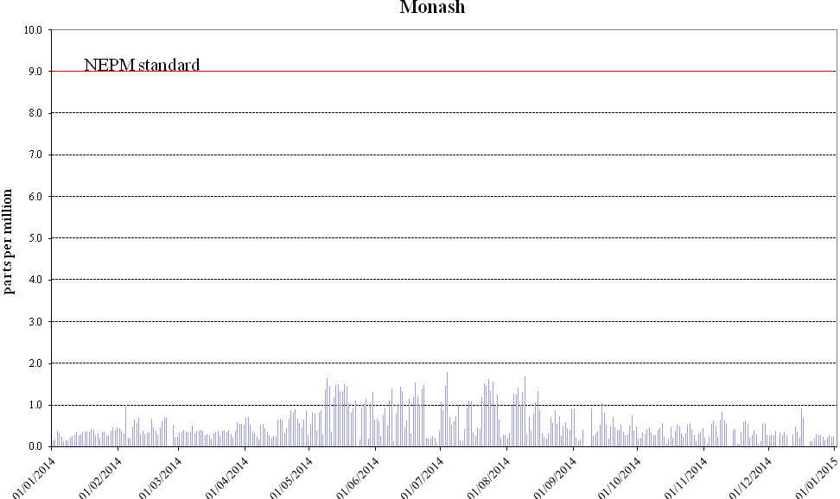
Figure 1: Daily max for CO 8-hour average – Monash
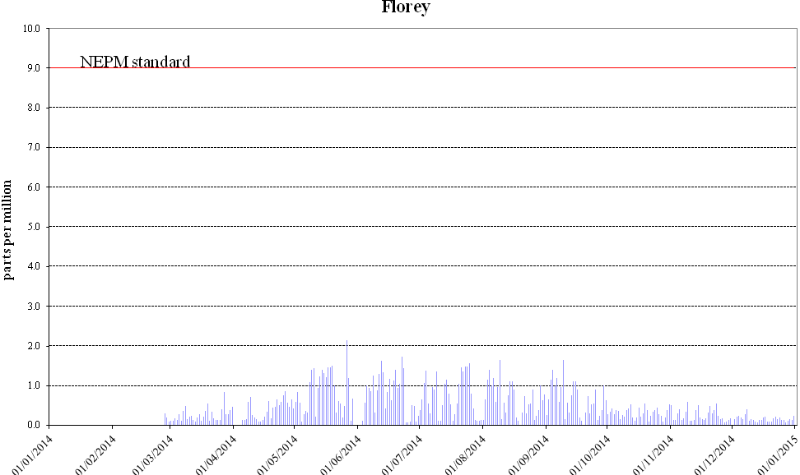
Figure 2: Daily max for CO 8-hour average – Florey

Nitrogen dioxide
During 2014, no exceedences of the NO₂ standards were recorded in the ACT. Compliance against the AAQ NEPM goal was demonstrated at Monash.
Table 5: 2014 compliance summary for NO₂
AAQ NEPM standard – 0.12 ppm (1-hour average), 0.03 ppm (1-year average)
Performance monitoring station | Data availability rates  (% of hours) |  |  |  |  | Annual mean  Concentration  (ppm) | Number of  1 hour exceedences  (days) | Performance against the standards and goal
 |  |  |  |  |  |  |  | 1 hour | 1 year
Performance monitoring station | Q1 | Q2 | Q3 | Q4 | Annual
Monash  Florey | 91.4  33.4 | 94.9  89.0 | 95.7  95.4 | 94.5  94.5 | 94.1  78.3 | 0.005  0.006 | 0  0 | MET  ND | MET  ND
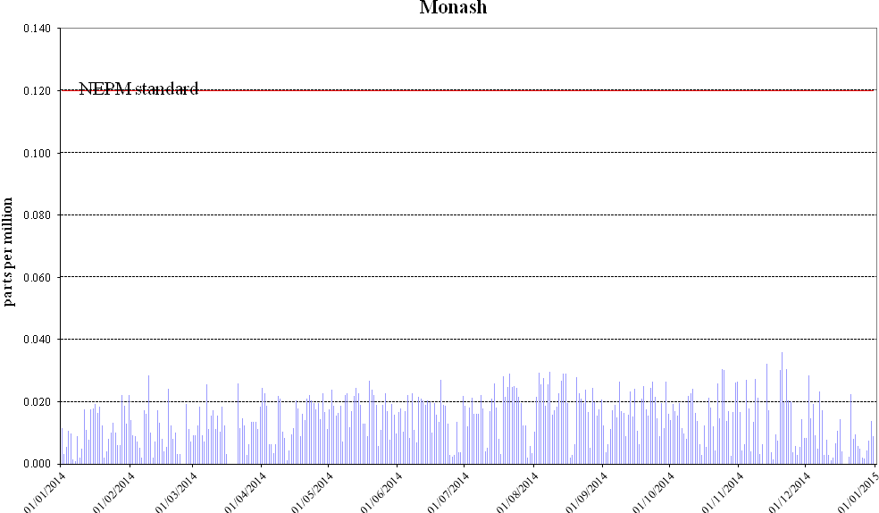
Figure 3: Daily max for NO₂ – Monash
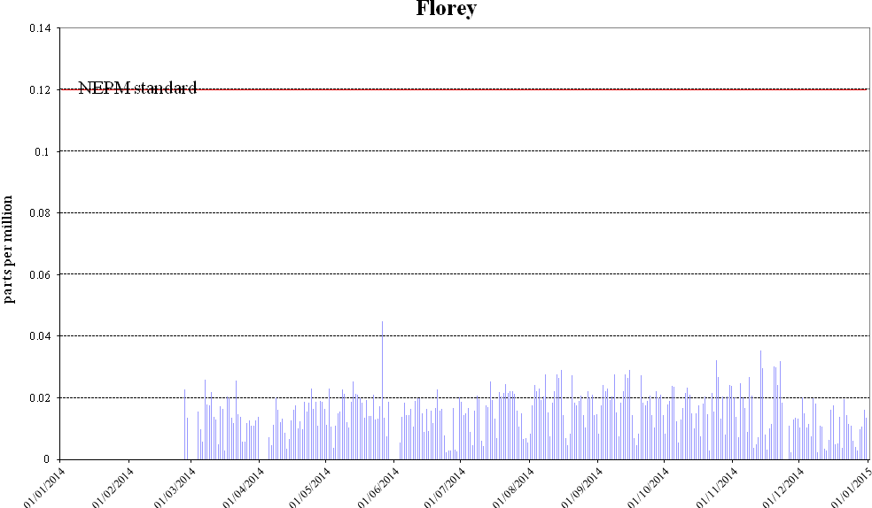
Figure 4: Daily max for NO₂ – Florey

Ozone
During 2014, no exceedences of the 1-hour and 4-hour standards for O₃ were recorded in the ACT, and compliance against the AAQ NEPM goal was demonstrated at Monash and Civic.
Table 6: 2014 compliance summary for O₃
AAQ NEPM standard – 0.10 ppm (1-hour average), 0.08 ppm (4-hour average)
Performance monitoring station | Data availability rates  (% of hours) |  |  |  |  | Number of exceedences  (days) |  | Performance against the standards and goal
Performance monitoring station | Q1 | Q2 | Q3 | Q4 | Annual | 1 hour | 4 hours | 1 hour | 4 hours
Monash  Civic  Florey | 94.8  91.6  36.5 | 95.8  95.7  89.0 | 95.7  95.5  95.6 | 92.9  93.1  95.7 | 94.8  94.0  79.4 | 0  0  0 | 0  0  0 | MET  MET  ND | MET  MET  ND

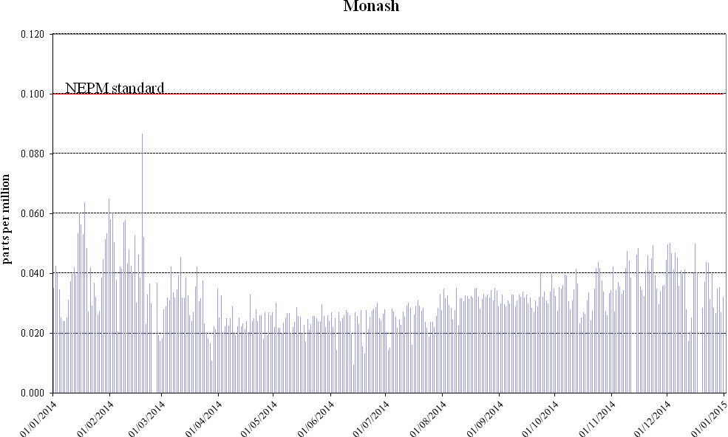
Figure 5: Daily max for 1 hour O₃ – Monash
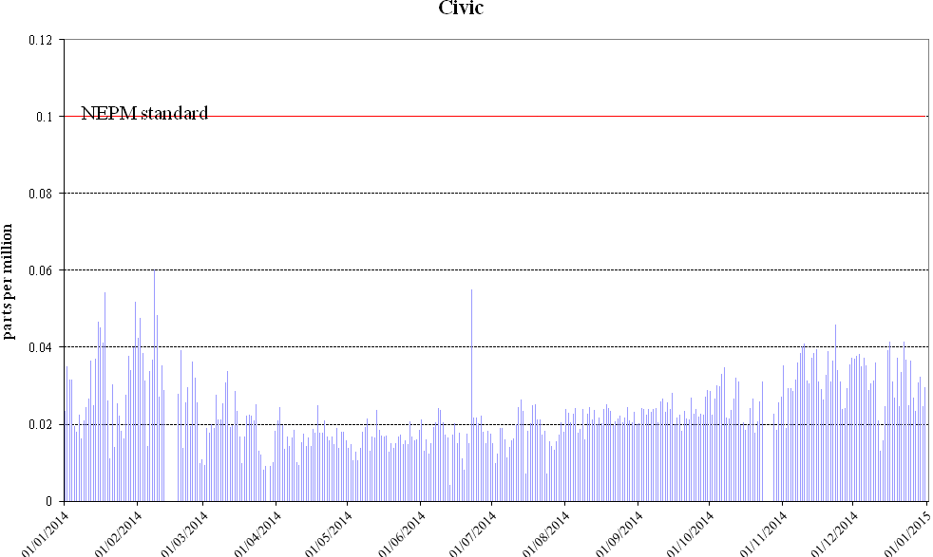
Figure 6: Daily max for 1 hour O₃ – Civic
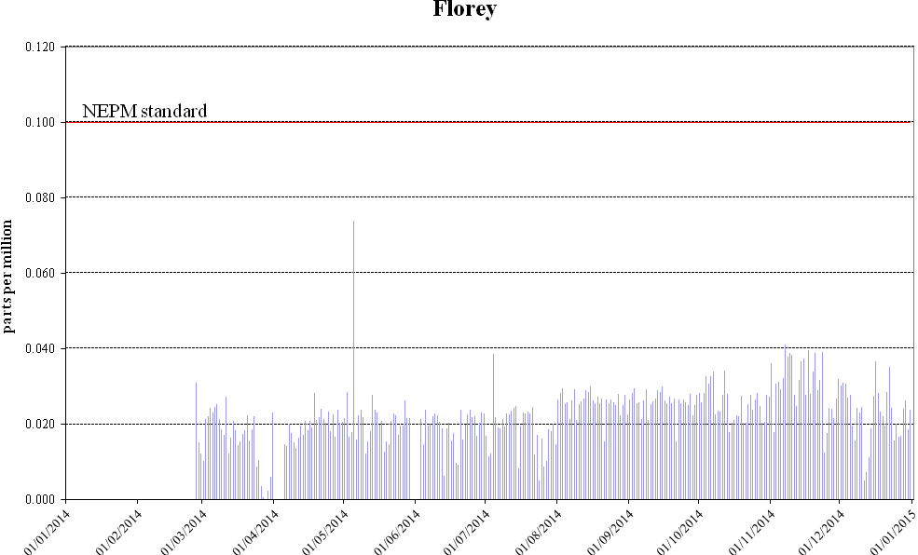
Figure 7: Daily max for 1 hour O₃ – Florey
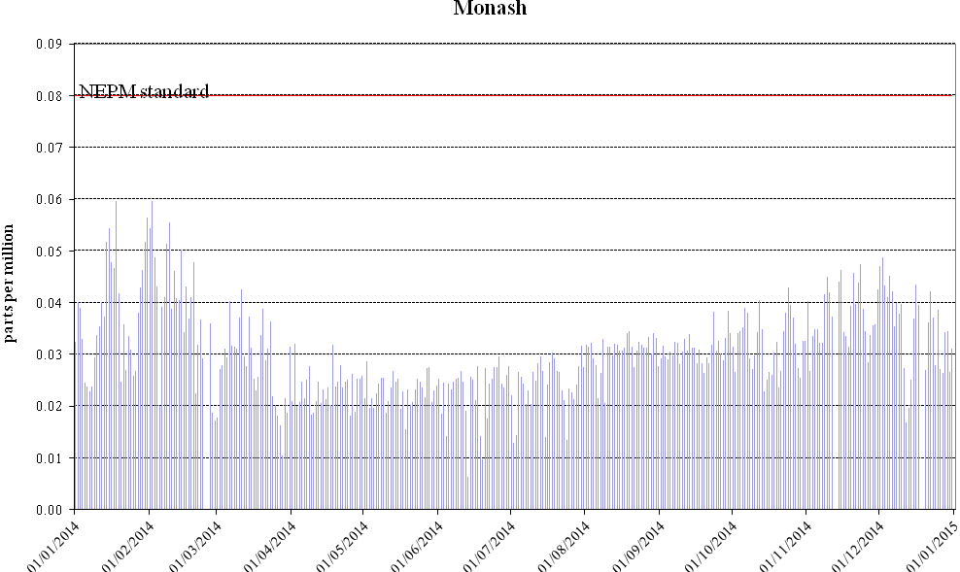
Figure 8: Daily max for 4 hours O₃ - Monash
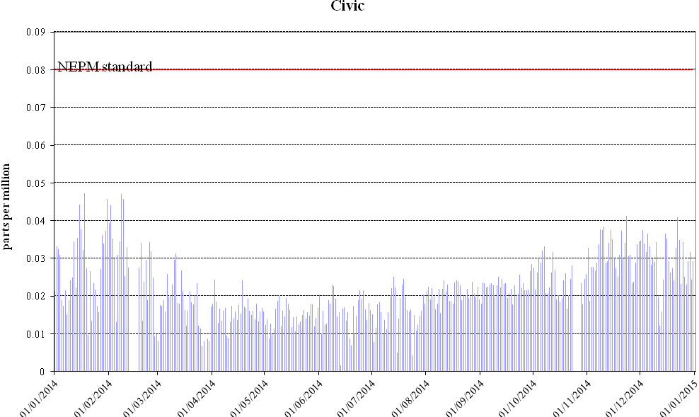
Figure 9: Daily max for 4 hours O₃ – Civic
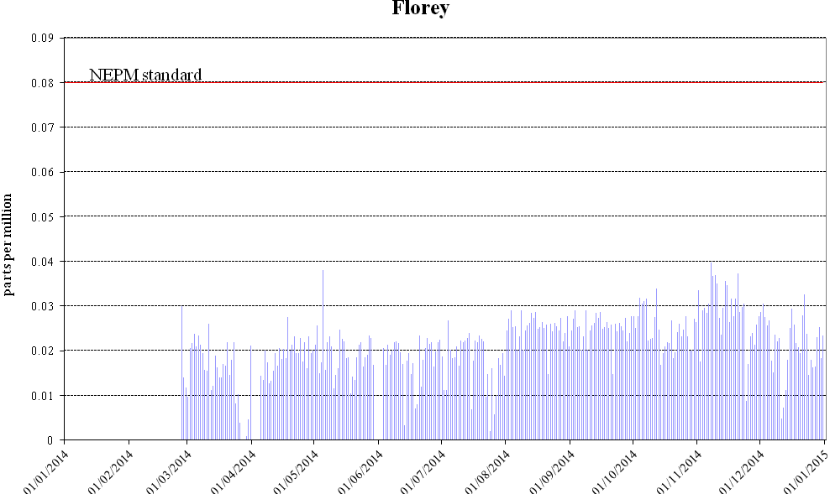
Figure 10: Daily max for 4 hours O₃ – Florey

PM₁₀
During 2014, no exceedences of the 24-hour PM₁₀ standard were recorded in the ACT. Compliance against the AAQ NEPM goal was demonstrated at Monash and Civic.
Table 7: 2014 compliance summary for PM₁₀
AAQ NEPM standard 50 μg/m³ 1-day average
Performance monitoring station | Data availability rates  (% of days) |  |  |  |  | Number of exceedences  (days) | Performance against the standards and goal
Performance monitoring station | Q1 | Q2 | Q3 | Q4 | Annual | Number of exceedences  (days) | Performance against the standards and goal
Monash  Civic  Florey | 100  97.8  46.7 | 100  95.6  89.0 | 100  94.6  97.8 | 91.3  92.4  98.9 | 97.8  95.1  83.3 | 0  0  0 | MET  MET  ND

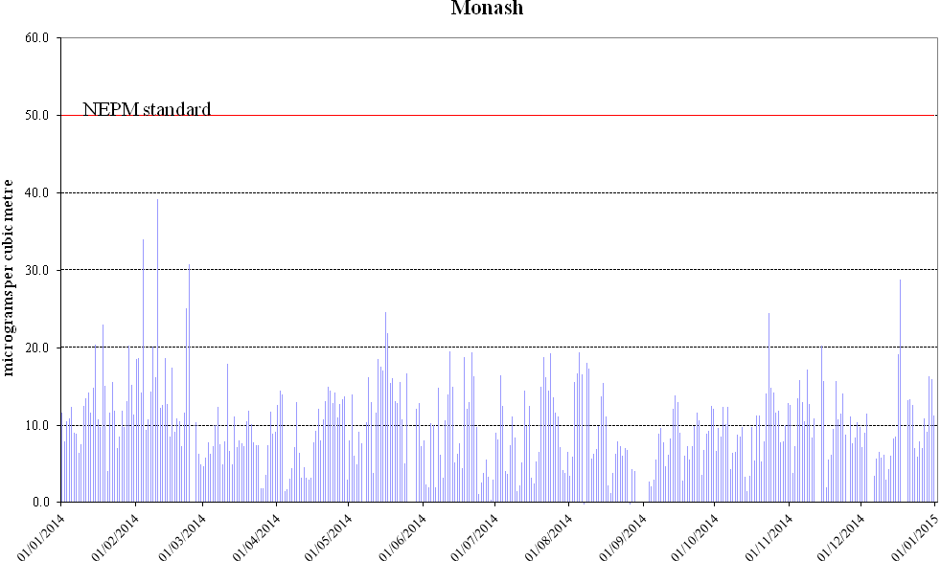
Figure 11: Daily max for PM₁₀ – Monash
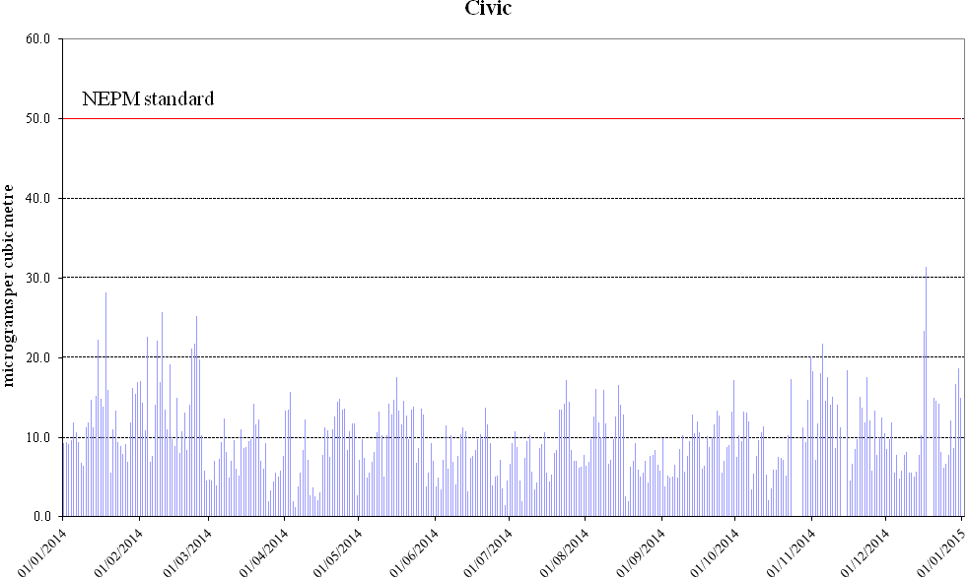
Figure 12: Daily max for PM₁₀ – Civic
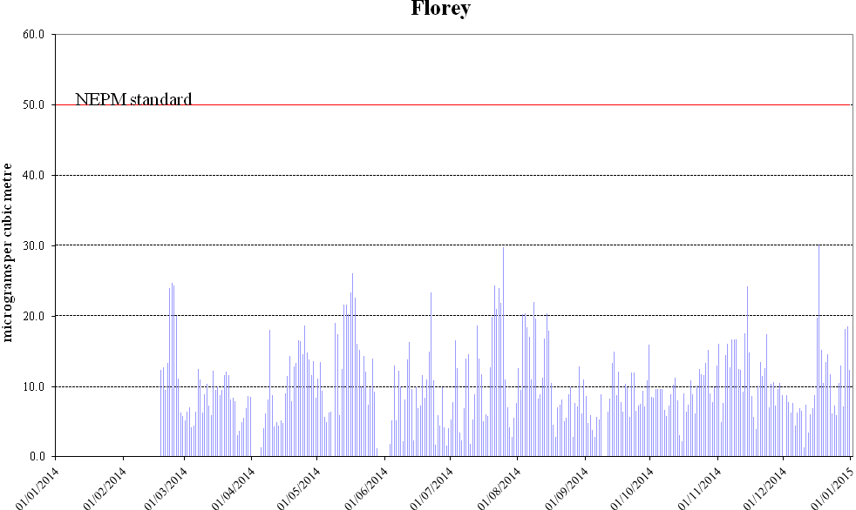
Figure 13: Daily max for PM₁₀ – Florey

PM_{2.5}
Four exceedences of the 24-hour advisory reporting standard were recorded at Monash during 2014.
Table 8: 2014 compliance summary for PM_{2.5}
AAQ NEPM standard – 25 μg/m³ (1-day), 8 μg/m³ (1-year)
Performance monitoring station | Data availability rates  (% of days) |  |  |  |  | Annual mean  Concentration  (μg/m³) | Number of  exceedences  (days)
Performance monitoring station | Q1 | Q2 | Q3 | Q4 | Annual | Annual mean  Concentration  (μg/m³) | Number of  exceedences  (days)
Monash  Florey | 97.8  43.3 | 73..6  79.1 | 82.6  85.9 | 96.7  88.0 | 87.7  74.2 | 7.1  5.9 | 4  0

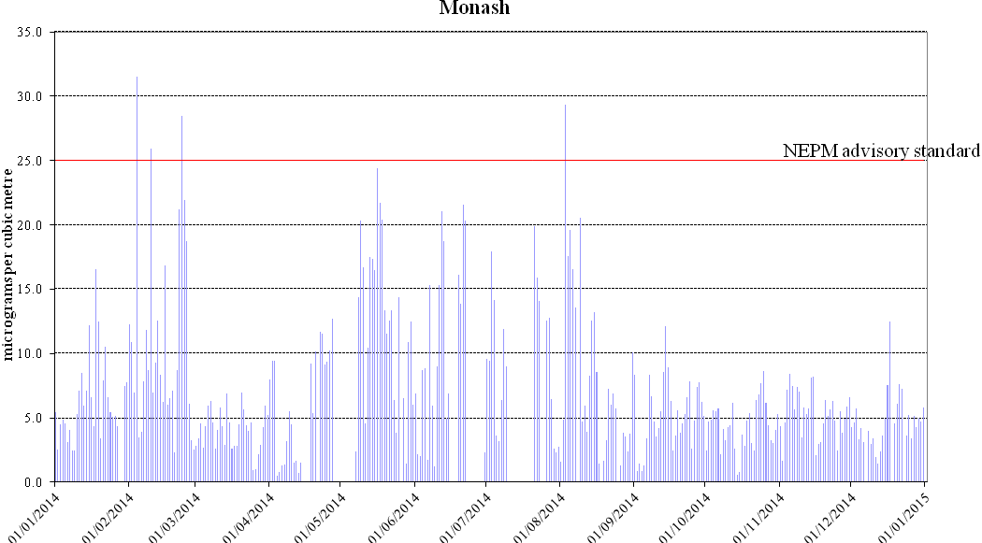
Figure 14: Daily max for PM_{2.5} – Monash
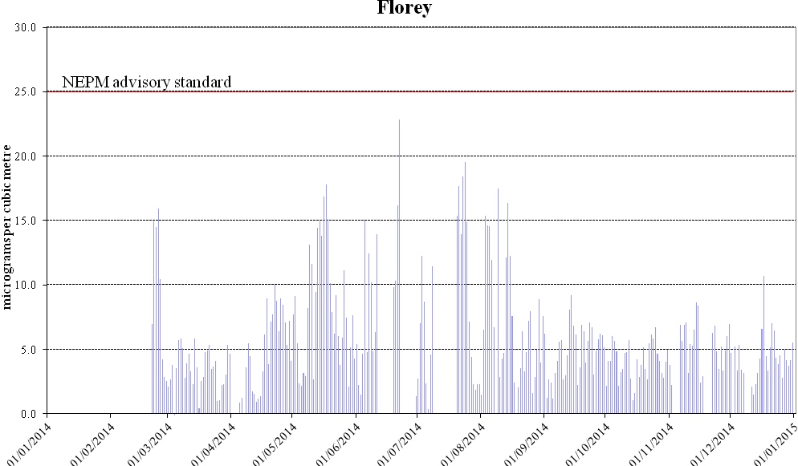
Figure 15: Daily max for PM_{2.5} – Florey

ANALYSIS OF AIR QUALITY MONITORING
Annual summary statistics contained in Table 9 to Table 14 below allow assessment of air quality against the standards and the extent of compliance with the goal. Instances where the standard or goal has been exceeded are highlighted in bold. The AAQ NEPM states that the short-term standards should not be exceeded on more than one day for CO, NO₂ and O₃, and on no more than five days per year for PM₁₀. The second highest daily value for the year (or the sixth for PM₁₀) indicates the extent to which the standards are or are not met.

Carbon monoxide
Table 9: 2014 summary statistics for daily peak 8-hour CO
AAQ NEPM standard - 9.0 ppm (8-hour average)
Performance monitoring station | Number of valid days | Highest  (ppm) | Highest  (date/time) | 2nd Highest  (ppm) | 2nd Highest  (date/time)
Monash  Florey | 365  309 | 1.8  2.2 | 04 Jul 03:00  26 May 20:00 | 1.7  1.7 | 09 Aug 06:00  22 Jun 05:00

Carbon monoxide levels are well below the AAQ NEPM standard. The highest recorded value in the ACT during 2014 was 2.2ppm at Florey, which is 24% of the standard.

Nitrogen dioxide
Table 10: 2014 summary statistics for daily peak 1-hour NO₂
AAQ NEPM standard 0.12 ppm (1-hour average)
Performance monitoring station | Number of valid days | Highest  (ppm) | Highest  (date/time) | 2nd Highest  (ppm) | 2nd Highest  (date/time)
Monash  Florey | 365  309 | 0.036  0.045 | 20 Nov 21:00  26 May 13:00 | 0.032  0.035 | 13 Nov 21:00  13 Nov 21:00

Nitrogen dioxide levels are well below the AAQ NEPM standard and have remained stable over the last decade. The highest recorded 1-hour value during 2014 was 0.045ppm at Florey, which is only 38% of the standard. The highest recorded annual average in 2014 was 0.006ppm at Florey (refer to table 5). This is 20% of the annual standard 0.03ppm.

Ozone
Table 11: 2014 summary statistics for daily peak 1-hour O₃
AAQ NEPM standard 0.10 ppm (1-hour average)
Performance monitoring station | Number of valid days | Highest  (ppm) | Highest  (date/time) | 2nd Highest  (ppm) | 2nd Highest  (date/time)
Monash  Civic  Florey | 365  365  309 | 0.087  0.060  0.074 | 18 Feb 22:00  08 Feb 11:00  05 May 13:00 | 0.065  0.055  0.041 | 31 Jan 10:00  22 Jun 00:00  07 Nov 14:00

Table 12: 2014 summary statistics for daily peak 4-hour O₃
AAQ NEPM standard 0.08 ppm (4-hour average)
Performance monitoring station | Number of valid days | Highest  (ppm) | Highest  (date/time) | 2nd Highest  (ppm) | 2nd Highest  (date/time)
Monash  Civic  Florey | 365  365  309 | 0.060  0.047  0.040 | 02 Feb 17:00  18 Jan 18:00  07 Nov 16:00 | 0.060  0.047  0.038 | 18 Jan 12:00  08 Feb 13:00  05 May 10:00

Ozone levels are below the AAQ NEPM standard. The highest recorded 1-hour value in the ACT during 2014 was 0.087ppm at Monash, which is 87% of the standard. The highest recorded 4-hour value in the ACT during 2014 was 0.060ppm at Monash, which is 75% of the standard.

PM₁₀
Table 13: 2014 summary statistics for daily peak PM₁₀
AAQ NEPM standard 50 μg/m³ (24-hour average)
Performance monitoring station | Number of valid days | Highest  (μg/m³) | Highest  (date) | 6th Highest  (μg/m³) | 6th Highest  (date)
Monash  Civic  Florey | 347  357  304 | 39.3  31.4  30.2 | 10 February  17 December  17 December | 24.6  22.6  24.4 | 15 May  04 February  24 February

PM₁₀ levels are below the AAQ NEPM standard. The highest PM₁₀ level recorded during 2014 was 39.3μg/m³ at Monash on 10 February 2014.

PM_{2.5}
Table 14: 2014 summary statistics for daily peak PM_{2.5}
AAQ NEPM standard 25 μg/m³ (24-hour average)
Performance monitoring station | Number of valid days | Highest  (μg/m³) | Highest  (date) | 6th Highest  (μg/m³) | 6th Highest  (date)
Monash  Florey | 360  271 | 31.5  22.8 | 04 February  22 June | 21.9  17.5 | 24 February  09 August

The 24-hour advisory reporting standard for PM_{2.5} was exceeded four times at Monash. Three exceedences occurred on 4, 10 and 23 February 2014 respectively due to smoke coming from a number of hazard reduction burns in NSW. The other exceedence happened on 3 August 2014 due to domestic wood heater emissions.

ASSESSMENT OF PROGRESS TOWARDS ACHIEVING THE GOAL
The ACT is currently compliant with the goal specified in Schedule 2 of the AAQ NEPM.
Historical monitoring results indicate that the only AAQ NEPM pollutant of concern in the Canberra airshed is particulate matter, which increases during winter because of emissions from domestic wood heaters. In more recent years exceedences of the particulate matter standards have also been attributed to dust storms and smoke from controlled burns.
The ACT Government acknowledges that woodsmoke is a problem and is working towards addressing the issue in an informed and measured manner to ensure a satisfactory outcome for all Canberrans.
It will continue to implement an integrated program to address woodsmoke. This will involve public education and enforcement activities, the licensing of firewood merchants, the implementation of the ‘Don’t Burn Tonight Campaign’ and ‘Burn Right Tonight Campaign’, and the on-going administration of the Wood Heater Replacement Program.
The ACT is also working with the Commonwealth and other jurisdictions at a national level to progress actions to improve air quality. At the Environment Ministers Meeting on 29 April 2014, Ministers signalled their intention to vary the AAQ NEPM for particles reflecting the latest scientific understanding on health risks arising from particle pollution. The Measure seeks to establish a more stringent reporting standard for particle pollution (PM_{2.5} and PM₁₀).

APPENDIX A: STATISTICAL SUMMARY AND TRENDS
The following section provides a basic statistical summary, using percentiles, for Monash and Civic stations and for each standard. Percentiles for daily maximum values are presented. As the Florey station is newly-established, there is insufficient data to show the statistical summary and trends.

Carbon monoxide
Table 15: Statistical summary for daily maximum 8-hour CO Monash 2005 – 2014
Year | Data  Availability  (%) | No. of  Exceedences  (days) | Max  conc.  (ppm) | 99th  percentile  (ppm) | 98th  percentile  (ppm) | 95th  percentile  (ppm) | 90th  percentile  (ppm) | 75th  percentile  (ppm) | 50th  percentile  (ppm)
2005 | 99.5 | 0 | 3.2 | 2.8 | 2.5 | 2.2 | 1.7 | 1.0 | 0.4
2006 | 99.7 | 0 | 3.7 | 2.8 | 2.6 | 2.2 | 1.8 | 1.1 | 0.4
2007 | 95.3 | 0 | 2.6 | 2.5 | 2.4 | 2.0 | 1.5 | 0.7 | 0.4
2008 | 88.0 | 0 | 2.4 | 2.2 | 2.1 | 1.8 | 1.5 | 0.8 | 0.3
2009 | 96.4 | 0 | 2.0 | 1.7 | 1.5 | 1.4 | 1.1 | 0.6 | 0.3
2010 | 99.2 | 0 | 1.8 | 1.7 | 1.6 | 1.4 | 1.1 | 0.6 | 0.3
2011 | 98.6 | 0 | 2.2 | 1.9 | 1.8 | 1.5 | 1.1 | 0.5 | 0.2
2012 | 99.7 | 0 | 1.8 | 1.7 | 1.7 | 1.2 | 1.0 | 0.6 | 0.3
2013 | 95.9 | 0 | 2.1 | 1.9 | 1.8 | 1.5 | 1.2 | 0.6 | 0.3
2014 | 94.0 | 0 | 1.8 | 1.6 | 1.5 | 1.4 | 1.1 | 0.7 | 0.4
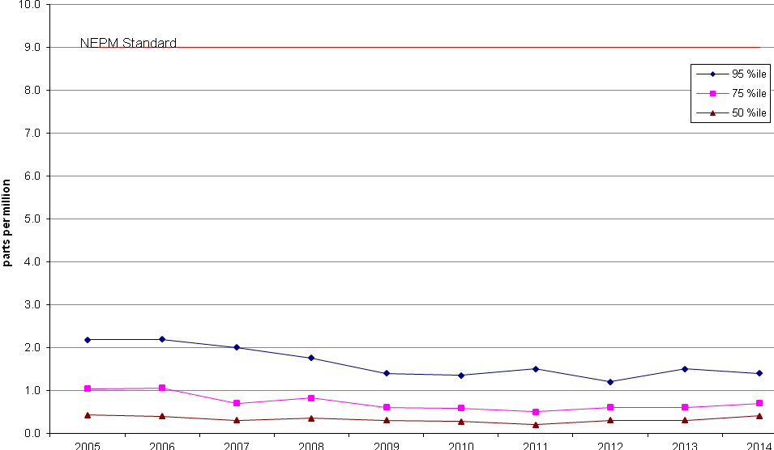
Figure 16: Statistical summary for daily maximum 8-hour CO Monash 2005 – 2014

Nitrogen dioxide
Table 16: Statistical summary for daily maximum 1-hour NO₂ Monash 2005 – 2014
Year | Data  Recovery  (%) | No. of  Exceedences  (days) | Max  conc.  (ppm) | 99th  percentile  (ppm) | 98th  percentile  (ppm) | 95th  percentile  (ppm) | 90th  percentile  (ppm) | 75th  percentile  (ppm) | 50th  percentile  (ppm)
2005 | 97.8 | 0 | 0.041 | 0.034 | 0.031 | 0.028 | 0.027 | 0.024 | 0.018
2006 | 98.4 | 0 | 0.044 | 0.036 | 0.033 | 0.031 | 0.029 | 0.024 | 0.019
2007 | 97.0 | 0 | 0.039 | 0.037 | 0.035 | 0.030 | 0.028 | 0.023 | 0.018
2008 | 86.5 | 0 | 0.103 | 0.040 | 0.032 | 0.031 | 0.028 | 0.025 | 0.019
2009 | 92.6 | 0 | 0.041 | 0.034 | 0.033 | 0.029 | 0.027 | 0.023 | 0.019
2010 | 89.1 | 0 | 0.037 | 0.029 | 0.028 | 0.025 | 0.023 | 0.021 | 0.017
2011 | 96.7 | 0 | 0.043 | 0.031 | 0.030 | 0.029 | 0.026 | 0.022 | 0.015
2012 | 97.5 | 0 | 0.033 | 0.030 | 0.029 | 0.026 | 0.025 | 0.021 | 0.014
2013 | 97.5 | 0 | 0.037 | 0.031 | 0.030 | 0.027 | 0.025 | 0.021 | 0.014
2014 | 94.1 | 0 | 0.036 | 0.030 | 0.029 | 0.027 | 0.025 | 0.020 | 0.015

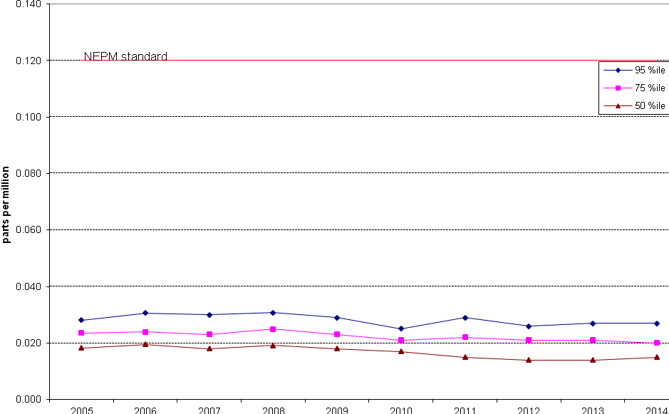
Figure 17: Statistical summary for daily maximum 1-hour NO₂ Monash 2005 – 2014

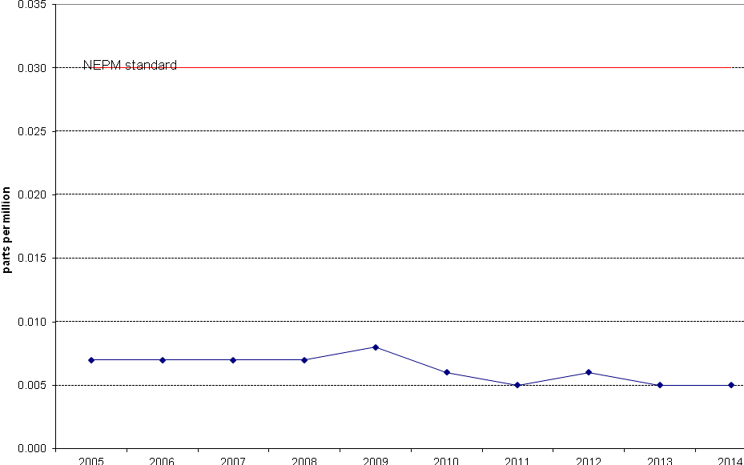
Figure 18: Annual average 1-hour NO₂ Monash 2005 – 2014

Ozone
Table 17: Statistical summary for daily maximum 1-hour O₃ Monash 2005 – 2014
Year | Data  Recovery  (%) | No. of  Exceedences  (days) | Max  conc.  (ppm) | 99th  percentile  (ppm) | 98th  percentile  (ppm) | 95th  percentile  (ppm) | 90th  percentile  (ppm) | 75th  percentile  (ppm) | 50th  percentile  (ppm)
2005 | 97.8 | 0 | 0.065 | 0.058 | 0.053 | 0.045 | 0.041 | 0.034 | 0.030
2006 | 99.7 | 0 | 0.067 | 0.060 | 0.057 | 0.052 | 0.049 | 0.040 | 0.032
2007 | 95.4 | 0 | 0.075 | 0.064 | 0.062 | 0.057 | 0.052 | 0.043 | 0.032
2008 | 84.2 | 0 | 0.065 | 0.055 | 0.053 | 0.047 | 0.040 | 0.031 | 0.026
2009 | 96.4 | 0 | 0.073 | 0.063 | 0.059 | 0.052 | 0.045 | 0.038 | 0.030
2010 | 86.6 | 0 | 0.051 | 0.048 | 0.046 | 0.042 | 0.037 | 0.033 | 0.030
2011 | 99.2 | 0 | 0.056 | 0.052 | 0.047 | 0.044 | 0.040 | 0.033 | 0.028
2012 | 100 | 0 | 0.055 | 0.048 | 0.046 | 0.043 | 0.040 | 0.034 | 0.029
2013 | 97.8 | 0 | 0.062 | 0.051 | 0.049 | 0.045 | 0.041 | 0.035 | 0.029
2014 | 94.8 | 0 | 0.087 | 0.060 | 0.057 | 0.050 | 0.044 | 0.036 | 0.030

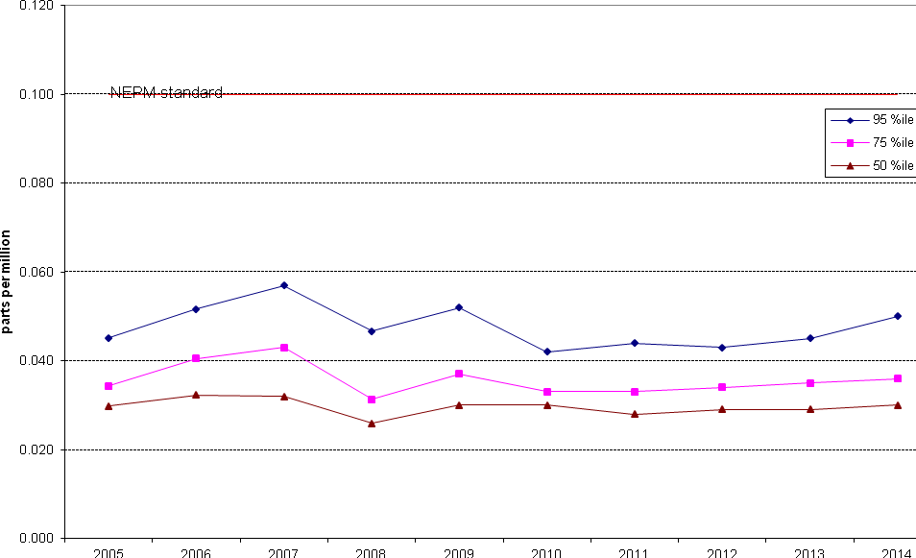
Figure 19: Statistical summary for daily maximum 1-hour O₃ Monash 2005 – 2014

Table 18: Statistical summary for daily maximum 1-hour O₃ Civic 2005 – 2014
Year | Data  Recovery  (%) | No. of  Exceedences  (days) | Max  conc.  (ppm) | 99th  percentile  (ppm) | 98th  percentile  (ppm) | 95th  percentile  (ppm) | 90th  percentile  (ppm) | 75th  percentile  (ppm) | 50th  percentile  (ppm)
2005 | 85.5 | 0 | 0.070 | 0.061 | 0.051 | 0.042 | 0.038 | 0.032 | 0.028
2006 | 95.5 | 3 | 0.252 | 0.084 | 0.060 | 0.049 | 0.043 | 0.034 | 0.027
2007 | 91.5 | 1 | 0.112 | 0.057 | 0.050 | 0.044 | 0.040 | 0.032 | 0.026
2008 | 91.4 | 0 | 0.052 | 0.050 | 0.044 | 0.039 | 0.034 | 0.028 | 0.023
2009 | 97.8 | 0 | 0.060 | 0.055 | 0.052 | 0.044 | 0.040 | 0.031 | 0.024
2010 | 99.2 | 0 | 0.058 | 0.050 | 0.048 | 0.040 | 0.036 | 0.029 | 0.025
2011 | 96.4 | 0 | 0.052 | 0.046 | 0.045 | 0.041 | 0.036 | 0.030 | 0.026
2012 | 100 | 0 | 0.053 | 0.041 | 0.038 | 0.034 | 0.030 | 0.024 | 0.020
2013 | 92.1 | 0 | 0.060 | 0.043 | 0.041 | 0.036 | 0.032 | 0.028 | 0.024
2014 | 94.0 | 0 | 0.060 | 0.050 | 0.046 | 0.039 | 0.036 | 0.028 | 0.022

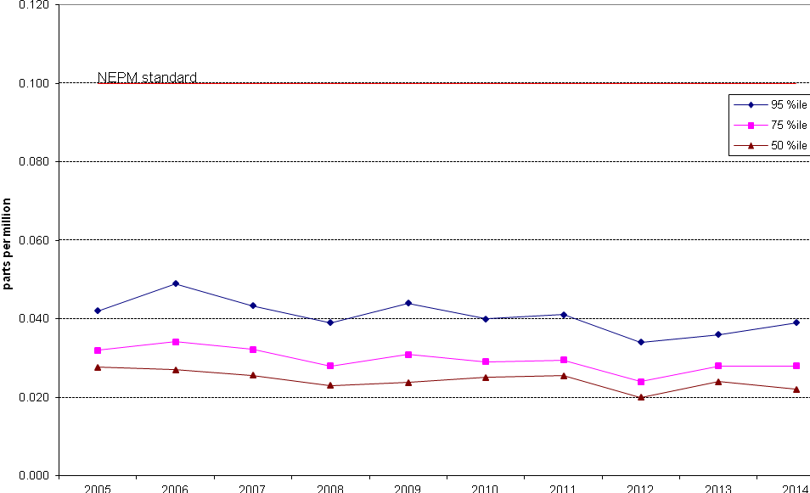
Figure 20: Statistical summary for daily maximum 1-hour O₃ Civic 2005 – 2014

Table 19: Statistical summary for daily maximum 4-hour O₃ Monash 2005 – 2014
Year | Data  Recovery  (%) | No. of  Exceedences  (days) | Max  conc.  (ppm) | 99th  percentile  (ppm) | 98th  percentile  (ppm) | 95th  percentile  (ppm) | 90th  percentile  (ppm) | 75th  percentile  (ppm) | 50th  percentile  (ppm)
2005 | 97.5 | 0 | 0.062 | 0.054 | 0.049 | 0.044 | 0.039 | 0.033 | 0.029
2006 | 99.7 | 0 | 0.061 | 0.056 | 0.055 | 0.050 | 0.046 | 0.038 | 0.031
2007 | 100 | 0 | 0.072 | 0.061 | 0.059 | 0.054 | 0.050 | 0.040 | 0.032
2008 | 84.2 | 0 | 0.061 | 0.052 | 0.049 | 0.045 | 0.038 | 0.030 | 0.025
2009 | 96.2 | 0 | 0.068 | 0.058 | 0.056 | 0.048 | 0.044 | 0.036 | 0.029
2010 | 86.6 | 0 | 0.049 | 0.046 | 0.043 | 0.040 | 0.037 | 0.032 | 0.029
2011 | 98.9 | 0 | 0.054 | 0.048 | 0.044 | 0.041 | 0.038 | 0.032 | 0.027
2012 | 99.7 | 0 | 0.052 | 0.048 | 0.046 | 0.043 | 0.040 | 0.034 | 0.029
2013 | 97.8 | 0 | 0.059 | 0.048 | 0.047 | 0.042 | 0.039 | 0.033 | 0.028
2014 | 94.8 | 0 | 0.060 | 0.055 | 0.052 | 0.046 | 0.042 | 0.034 | 0.029

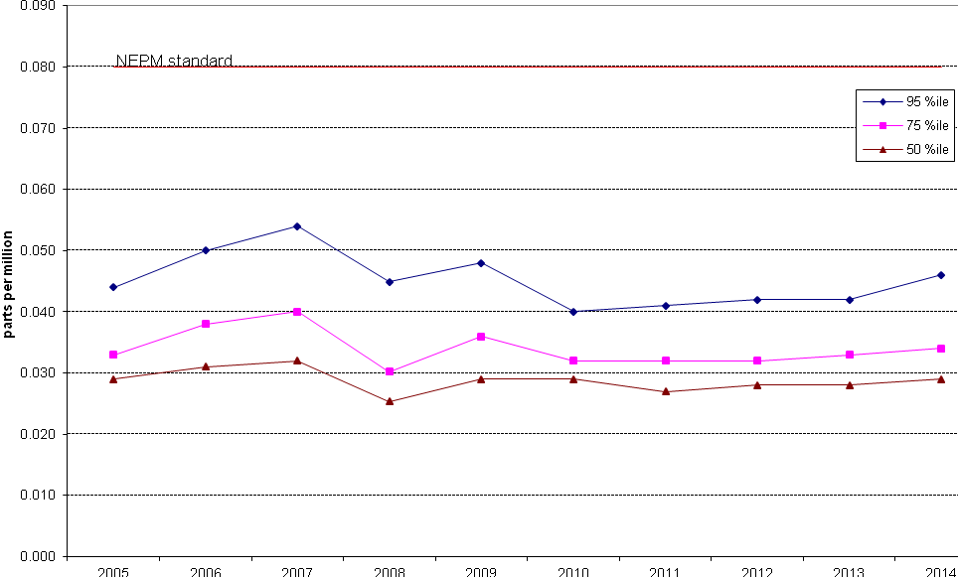
Figure 21: Statistical summary for daily maximum 4-hour O₃ Monash 2005 – 2014

Table 20: Statistical summary for daily maximum 4-hour O₃ Civic 2005 – 2014
Year | Data  Recovery  (%) | No. of  Exceedences  (days) | Max  conc.  (ppm) | 99th  percentile  (ppm) | 98th  percentile  (ppm) | 95th  percentile  (ppm) | 90th  percentile  (ppm) | 75th  percentile  (ppm) | 50th  percentile  (ppm)
2005 | 85.5 | 0 | 0.061 | 0.054 | 0.047 | 0.040 | 0.036 | 0.031 | 0.026
2006 | 95.5 | 1 | 0.145 | 0.066 | 0.053 | 0.045 | 0.040 | 0.032 | 0.026
2007 | 91.5 | 1 | 0.097 | 0.052 | 0.046 | 0.040 | 0.037 | 0.030 | 0.025
2008 | 91.4 | 0 | 0.051 | 0.047 | 0.039 | 0.036 | 0.033 | 0.027 | 0.022
2009 | 97.8 | 0 | 0.059 | 0.049 | 0.047 | 0.041 | 0.037 | 0.030 | 0.023
2010 | 99.2 | 0 | 0.056 | 0.047 | 0.044 | 0.037 | 0.034 | 0.028 | 0.024
2011 | 96.4 | 0 | 0.050 | 0.044 | 0.041 | 0.038 | 0.035 | 0.029 | 0.025
2012 | 100 | 0 | 0.042 | 0.037 | 0.036 | 0.032 | 0.028 | 0.023 | 0.019
2013 | 91.8 | 0 | 0.057 | 0.040 | 0.038 | 0.034 | 0.030 | 0.027 | 0.023
2014 | 94.0 | 0 | 0.047 | 0.045 | 0.040 | 0.036 | 0.034 | 0.026 | 0.020

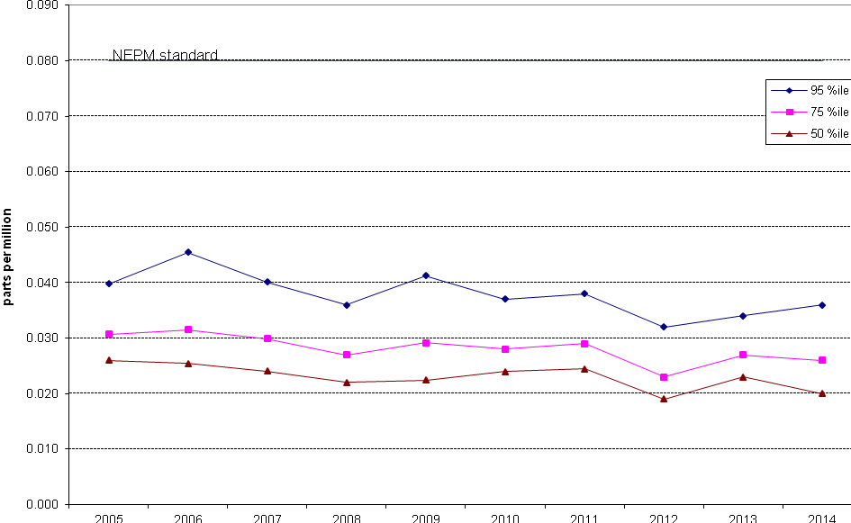
Figure 22: Statistical summary for daily maximum 4-hour O₃ Civic 2005 – 2014

PM₁₀
Table 21: Statistical summary for daily maximum 24-hour PM₁₀ Monash 2005 – 2014
Year | Data  Recovery  (%) | No. of  Exceedences  (days) | Max  conc.  (ppm) | 99th  percentile  (ppm) | 98th  percentile  (ppm) | 95th  percentile  (ppm) | 90th  percentile  (ppm) | 75th  percentile  (ppm) | 50th  percentile  (ppm)
2005 | 99.7 | 3 | 52.0 | 48.2 | 46.0 | 33.8 | 28.5 | 20.7 | 14.7
2005 | 97.5 | 10 | 98.8 | 57.6 | 52.7 | 37.3 | 31.0 | 21.2 | 14.5
2006 | 83.8 | 4 | 55.2 | 51.0 | 44.9 | 33.9 | 28.3 | 22.7 | 16.9
2007 | 99.7 | 5 | 117.7 | 61.8 | 42.5 | 35.3 | 28.0 | 21.0 | 14.9
2008 | 82 | 3 | 96.6 | 45.8 | 35.7 | 29.9 | 26.6 | 20.1 | 14.8
2009 | 42.3 | 9 | 210.0 | 116.0 | 62.4 | 50.5 | 37.7 | 25.5 | 15.2
2010 | 95.4 | 0 | 48.4 | 35.6 | 27.4 | 23.5 | 20.2 | 14.7 | 10.0
2011 | 99.2 | 0 | 40.0 | 33.7 | 30.3 | 22.8 | 18.6 | 13.2 | 8.7
2012 | 98.6 | 0 | 41.0 | 24.2 | 21.8 | 19.7 | 17.4 | 13.7 | 9.7
2013 | 95.6 | 0 | 43.5 | 29.1 | 25.1 | 20.2 | 16.8 | 13.1 | 8.9
2014 | 97.8 | 0 | 39.3 | 27.1 | 23.1 | 19.1 | 16.4 | 12.9 | 9.6

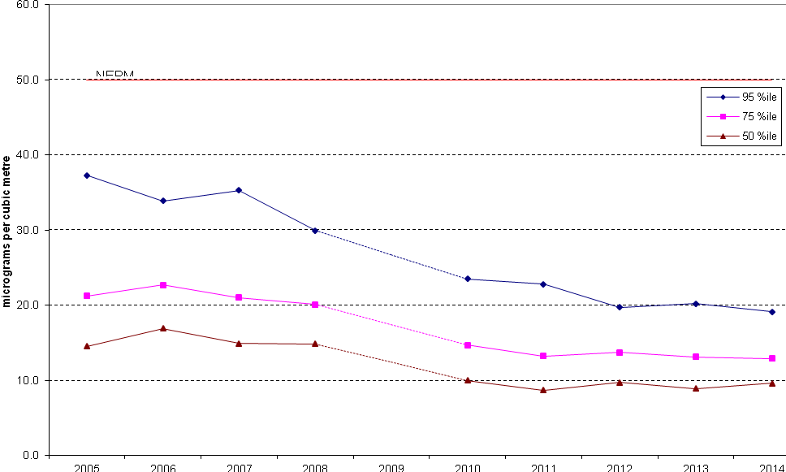
Figure 23: Statistical summary for daily maximum 24-hour PM₁₀ Monash 2005 – 2014
Note: 2009 data has not been included in Figure 23 as the percentile data has been skewed because of insufficient data in Q1 and Q2 (zero and twenty five percent respectively) and the extreme readings associated with the dust storm which affected most of eastern Australia on 22 and 23 September, 2009.

Table 22: Statistical summary for daily maximum 24-hour PM₁₀ Civic 2005 – 2014
Year | Data  Recovery  (%) | No. of  Exceedences  (days) | Max  conc.  (ppm) | 99th  percentile  (ppm) | 98th  percentile  (ppm) | 95th  percentile  (ppm) | 90th  percentile  (ppm) | 75th  percentile  (ppm) | 50th  percentile  (ppm)
2005 | 9.6 | 1 | 50.64 | 47.2 | 43.8 | 34.8 | 27.5 | 19.5 | 12.7
2006 | 13.2 | 2 | 70.8 | 61.2 | 51.5 | 46.5 | 35.1 | 26.0 | 17.6
2007 | 13.2 | 1 | 50.9 | 48.7 | 46.5 | 42.7 | 31.4 | 20.1 | 13.8
2008 | 12.0 | 1 | 53.3 | 42.5 | 31.7 | 26.1 | 24.2 | 17.3 | 11.9
2009 | n/a | n/a | n/a | n/a | n/a | n/a | n/a | n/a | n/a
2010 | 57.6 | 0 | 23.8 | 19.7 | 17.1 | 14.7 | 13.7 | 11.1 | 8.4
2011 | 97.0 | 0 | 29.2 | 22.3 | 20.9 | 16.9 | 14.4 | 11.0 | 7.9
2012 | 95.1 | 0 | 49.5 | 22.8 | 20.2 | 17.0 | 14.9 | 12.1 | 8.7
2013 | 92.9 | 1 | 57.8 | 26.5 | 24.4 | 19.9 | 15.8 | 12.0 | 8.6
2014 | 95.1 | 0 | 31.4 | 24.2 | 22.1 | 17.7 | 15.1 | 12.6 | 9.3

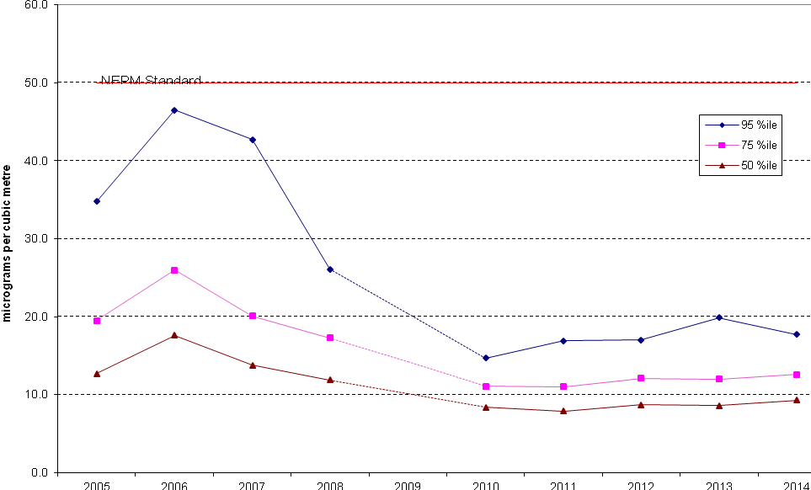
Figure 24: Statistical summary for daily maximum 24-hour PM₁₀ Civic 2005 – 2014
Note: No PM₁₀ monitoring was conducted at Civic in 2009.

PM_{2.5}
Table 23: Statistical summary for daily maximum 24-hour PM_{2.5} Monash 2005 – 2014
Year | Data  Recovery  (%) | No. of  Exceedences  (days) | Max  conc.  (ppm) | 99th  percentile  (ppm) | 98th  percentile  (ppm) | 95th  percentile  (ppm) | 90th  percentile  (ppm) | 75th  percentile  (ppm) | 50th  percentile  (ppm)
2005 | 73.6 | 14 | 38.6 | 31.4 | 29.3 | 25.0 | 20.7 | 9.0 | 4.9
2006 | 83.3 | 20 | 46.9 | 35.6 | 33.3 | 27.8 | 15.6 | 8.7 | 5.8
2007 | 58.1 | 8 | 45.7 | 27.8 | 27.6 | 20.9 | 15.7 | 8.8 | 5.4
2008 | 45.4 | 6 | 30.7 | 28.0 | 25.7 | 23.5 | 19.7 | 12.4 | 6.3
2009 | 64.5 | 2 | 33.5 | 23.0 | 20.0 | 14.6 | 12.2 | 7.6 | 5.0
2010 | 95.1 | 2 | 52.4 | 22.1 | 20.9 | 17.4 | 14.3 | 7.8 | 4.4
2011 | 92.1 | 4 | 32.8 | 25.6 | 22.9 | 20.0 | 12.5 | 7.0 | 4.5
2012 | 95.1 | 3 | 29.2 | 23.8 | 19.8 | 16.5 | 13.2 | 8.3 | 5.0
2013 | 98.6 | 6 | 38.4 | 30.5 | 22.7 | 19.2 | 12.9 | 8.1 | 5.2
2014 | 87.7 | 4 | 31.5 | 25.7 | 21.6 | 18.7 | 14.4 | 8.6 | 5.6
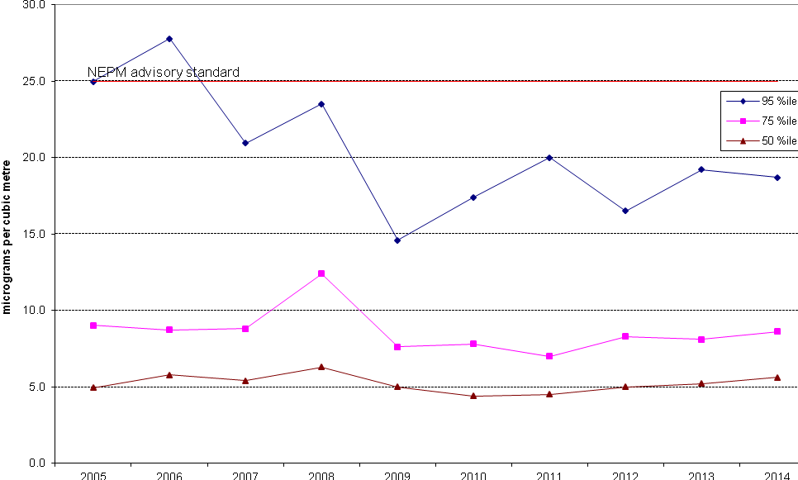
Figure 25: Statistical summary for daily maximum 24-hour PM_{2.5} Monash 2005 – 2014
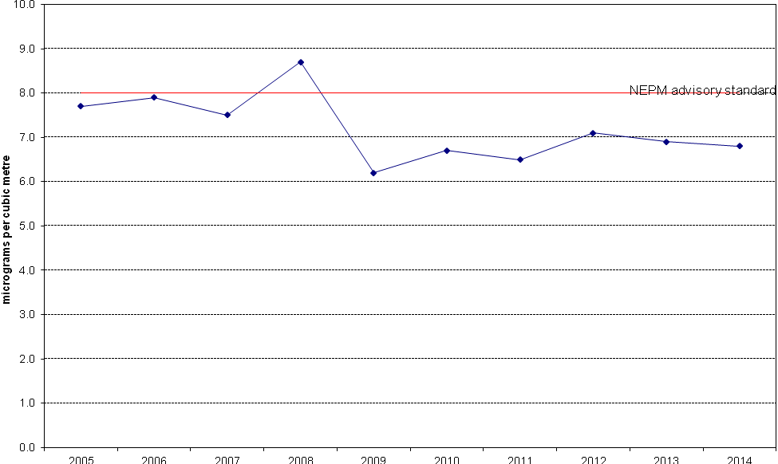
Figure 26: Annual average 24-hour PM_{2.5} Monash 2005 - 2014

