TABLE OF CONTENTS
TABLE OF CONTENTS i
LIST OF TABLES ii
LIST OF FIGURES iii
LIST OF DEFINITIONS AND ABBREVIATIONS v
OVERVIEW 6
MONITORING SUMMARY 8
Performance Monitoring Stations 8
Monitoring Methods 8
NATA Accreditation Status 9
ASSESSMENT OF COMPLIANCE WITH STANDARDS AND GOALS 10
Carbon monoxide 12
Nitrogen dioxide 13
Ozone 15
PM₁₀ 18
PM_{2.5} 22
ANALYSIS OF AIR QUALITY MONITORING 26
Carbon monoxide 26
Nitrogen dioxide 26
Ozone 27
PM₁₀ 27
PM_{2.5} 28
ASSESSMENT OF PROGRESS TOWARDS ACHIEVING THE GOAL 29
APPENDIX A: STATISTICAL SUMMARY AND TRENDS 30
Carbon monoxide 30
Nitrogen dioxide 32
Ozone 35
PM₁₀ 41
PM_{2.5} 45
APPENDIX A Exceedance Summary 50

LIST OF TABLES
Table 1: Summary of stations’ siting compliance with AS 3580.1.1:2008 8
Table 2: Methods used for monitoring AAQ NEPM pollutants 9
Table 3: AAQ NEPM standards and ACT policy position 10
Table 4: 2020 compliance summary for CO 12
Table 5: 2020 compliance summary for NO₂ 13
Table 6: 2020 compliance summary for O₃ 15
Table 7: 2020 compliance summary for PM₁₀ 18
Table 8: 2020 compliance summary for PM_{2.5} 22
Table 9: 2020 summary statistics for daily peak 8-hour CO 26
Table 10: 2020 summary statistics for daily peak 1-hour NO₂ 26
Table 11: 2020 summary statistics for daily peak 1-hour O₃ 27
Table 12: 2020 summary statistics for daily peak 4-hour O₃ 27
Table 13: 2020 summary statistics for daily PM₁₀ 28
Table 14: 2020 summary statistics for daily PM_{2.5} 28
Table 15: Statistical summary for daily maximum 8-hour CO Monash 2011 – 2020 30
Table 16: Statistical summary for daily maximum 8-hour CO Florey 2014 – 2020 31
Table 17: Statistical summary for daily maximum 1-hour NO₂ Monash 2011 – 2020 32
Table 18: Statistical summary for daily maximum 1-hour NO₂ Florey 2014 – 2020 33
Table 19: Statistical summary for daily maximum 1-hour O₃ Monash 2011 – 2020 35
Table 20: Statistical summary for daily maximum 1-hour O₃ Civic 2011 – 2020 36
Table 21: Statistical summary for daily maximum 1-hour O₃ Florey 2014 – 2020 37
Table 22: Statistical summary for daily maximum 4-hour O₃ Monash 2011 – 2020 38
Table 23: Statistical summary for daily maximum 4-hour O₃ Civic 2011 – 2020 39
Table 24: Statistical summary for daily maximum 4-hour O₃ Florey 2014 – 2020 40
Table 25: Statistical summary for daily maximum daily PM₁₀ Monash 2011 – 2020 41
Table 26: Statistical summary for daily maximum daily PM₁₀ Civic 2011 – 2020 42
Table 27: Statistical summary for daily maximum daily PM₁₀ Florey 2014 – 2020 44
Table 28: Statistical summary for daily maximum daily PM_{2.5} Monash 2011 – 2020 45
Table 29: Statistical summary for daily maximum daily PM_{2.5} Civic 2016 – 2020 47
Table 30: Statistical summary for daily maximum daily PM_{2.5} Florey 2014 – 2020 48
Table 31: PM₁₀ Daily Exceedances in 2020 51
Table 32: PM_{2.5} Daily Exceedances in 2020 52
Table 33: Carbon Monoxide 8-hour Exceedances in 2020 53
Table 34: Nitrogen Dioxide 1-hour Exceedances in 2020 53
Table 35: Ozone 1-hour and 4-hour Exceedances in 2020 53

LIST OF FIGURES
Figure 1: Daily maximum for CO 8-hour average – Monash 12
Figure 2: Daily maximum for CO 8-hour average – Florey 13
Figure 3: Daily maximum for NO₂ 1-hour average – Monash 14
Figure 4: Daily maximum for NO₂ 1-hour average – Florey 14
Figure 5: Daily maximum for O₃ 1-hour average – Monash 15
Figure 6: Daily maximum for O₃ 1-hour average – Civic 16
Figure 7: Daily maximum for O₃ 1-hour average – Florey 16
Figure 8: Daily maximum for O₃ 4-hour average – Monash 17
Figure 9: Daily maximum for O₃ 4-hour average – Civic 17
Figure 10: Daily maximum for O₃ 4-hour average – Florey 18
Figure 11: Daily maximum for PM₁₀ – Monash 19
Figure 12: Daily maximum for PM₁₀ – Monash (Excluding Bushfire Period) 19
Figure 13: Daily maximum for PM₁₀ – Civic 20
Figure 14: Daily maximum for PM₁₀ – Civic (Excluding Bushfire Period) 20
Figure 15: Daily maximum for PM₁₀ – Florey 21
Figure 16: Daily maximum for PM₁₀ – Florey (Excluding Bushfire Period) 21
Figure 17: Daily maximum for PM_{2.5} – Monash 23
Figure 18: Daily maximum for PM_{2.5} – Monash (Excluding Bushfire Period) 23
Figure 19: Daily maximum for PM_{2.5} – Civic 24
Figure 20: Daily maximum for PM_{2.5} – Civic (Excluding Bushfire Period) 24
Figure 21: Daily maximum for PM_{2.5} – Florey 25
Figure 22: Daily maximum for PM_{2.5} – Florey (Excluding Bushfire Period) 25
Figure 23: Statistical summary for daily maximum 8-hour CO Monash 2011 – 2020 30
Figure 24: Statistical summary for daily maximum 8-hour CO Florey 2014 – 2020 31
Figure 25: Statistical summary for daily maximum 1-hour NO₂ Monash 2011 – 2020 32
Figure 26: Annual average 1-hour NO₂ Monash 2011 – 2020 33
Figure 27: Statistical summary for daily maximum 1-hour NO₂ Florey 2014 – 2020 34
Figure 28: Annual average 1-hour NO₂ Florey 2014 – 2020 34
Figure 29: Statistical summary for daily maximum 1-hour O₃ Monash 2011 – 2020 35
Figure 30: Statistical summary for daily maximum 1-hour O₃ Civic 2011 – 2020 36
Figure 31: Statistical summary for daily maximum 1-hour O₃ Florey 2014 – 2020 37
Figure 32: Statistical summary for daily maximum 4-hour O₃ Monash 2011 – 2020 38
Figure 33: Statistical summary for daily maximum 4-hour O₃ Civic 2011 – 2020 39
Figure 34: Statistical summary for daily maximum 4-hour O₃ Florey 2014 – 2020 40
Figure 35: Statistical summary for daily PM₁₀ Monash 2011 – 2020 41
Figure 36: Annual average daily PM₁₀ Monash 2011 – 2020 42
Figure 37: Statistical summary for daily PM₁₀ Civic 2011 – 2020 43
Figure 38: Annual average daily PM₁₀ Civic 2011 – 2020 43
Figure 39: Statistical summary for daily PM₁₀ Florey 2014 – 2020 44
Figure 40: Annual average daily PM₁₀ Florey 2014 – 2020 45
Figure 41: Statistical summary for daily PM_{2.5} Monash 2011 – 2020 46
Figure 42: Annual average daily PM_{2.5} Monash 2011 – 2020 46
Figure 43: Statistical summary for daily PM_{2.5} Civic 2016 – 2020 47
Figure 44: Annual average daily PM_{2.5} Civic 2016 – 2020 48
Figure 45: Statistical summary for daily PM_{2.5} Florey 2014 – 2020 49
Figure 46: Annual average daily PM_{2.5} Florey 2014 – 2020 49

LIST OF DEFINITIONS AND ABBREVIATIONS
Term | Definition
AAQ NEPM | National Environment Protection (Ambient Air Quality) Measure
ACT | Australian Capital Territory
CO | Carbon Monoxide
BAM | Beta Attenuation Monitor
Exceptional event | Exceptional event means a fire or dust occurrence that adversely affects air quality at a particular location and causes an exceedance of one (1) day average standards in excess of normal historical fluctuations and background levels and is directly related to: bushfire; jurisdiction authorised hazard reduction burning; or continental scale windblown dust
NATA | National Association of Testing Authorities
ND | Not Demonstrated
NO₂ | Nitrogen Dioxide
O₃ | Ozone
PMS | Performance Monitoring Station
PM_{2.5} | Particles with an equivalent aerodynamic diameter less than or equal to 2.5 micrometres
PM₁₀ | Particles with an equivalent aerodynamic diameter less than or equal to 10 micrometres
ppm | Parts per million by volume – parts of pollutant per million parts of air
Q | Quarter (e.g. Q1 means the first quarter of the year)
SO₂ | Sulfur Dioxide
µg/m³ | micrograms per cubic metre

OVERVIEW
The ACT Air Quality Report 2020 (‘the Report’) presents the results of ambient air quality monitoring in the ACT for 2020 and assesses the results in accordance with the requirements of the National Environment Protection (Ambient Air Quality) Measure (AAQ NEPM) made by the National Environment Protection Council on 26 June 1998.
Air quality in this Report is assessed against the AAQ NEPM standards shown in Table 3. In accordance with its agreed policy position, the ACT assesses its compliance for the annual average for particulate matter less than 10 microns (PM₁₀) against a lower standard of 20 μg/m³ rather than the 25 μg/m³ standard introduced in 2016.
The ACT monitors four of the six NEPM pollutants:
- carbon monoxide (CO)
- nitrogen dioxide (NO₂)
- photochemical oxidants as ozone (O₃)
- particulate matter (as PM₁₀, particles less than or equal to 10 microns in diameter and PM_{2.5}, particles less than or equal to 2.5 microns in diameter).
The ACT does not monitor sulfur dioxide (SO₂) as it is primarily an industrial pollutant and the ACT does not have much heavy industry. In 2002, lead monitoring ceased with the phase out of leaded petrol.
A summary of the 2020 Report is:
- the major air quality issue in 2020 was particle pollution (both PM₁₀ and PM_{2.5}) between January to early February, primarily associated with the continued impact of the 2019–2020 summer bushfires
- while concentrations of carbon monoxide and nitrogen dioxide increased during the bushfire period, the associated AAQ NEPM standards were met on 99.5% of days during the year;
- ozone remained at relatively high levels in January 2020 compared with the rest of the year, meeting the AAQ NEPM standards on 99% of days throughout the year
- though more nitrogen dioxide and ozone exceedances were recorded in the ACT, the overall levels for those two pollutants in 2020 decreased compared with 2019. This is possibly due to less vehicle traffic and other human activities as a result of the COVID-19 pandemic restrictions and the cooler temperatures in the second half of 2020
- the daily PM₁₀ standard was exceeded on 27 days at one or more monitoring stations, compared to 29 days in 2019 and 6 days in 2018. All of the PM₁₀ exceedances occurred outside the winter season and were due to bushfires or dust storms
- the daily PM_{2.5} standard was exceeded on 39 days at one or more monitoring stations, compared to 32 days in 2019 and 5 days in 2018. Excluding the 26 exceedance days directly associated with bushfires, there were only 13 exceedance days related to wood heater emissions which occurred between mid-May and early August; and
- a possible cause of this increase in PM_{2.5} may be due to people staying at home more during the COVID-19 pandemic. As a comparison, there were only 2 days in 2019 and 1 day in 2018 that exceeded the national standard in winter months.

MONITORING SUMMARY

Performance Monitoring Stations
The ACT Government has been undertaking ambient air quality monitoring in Canberra since the early 1990’s. The Health Directorate is responsible for the Government’s ambient air quality monitoring network. The Environment Protection Authority (EPA) within the Chief Minister, Treasury and Economic Development Directorate is responsible for annual reporting under the AAQ NEPM.
The ACT monitoring network consists of three monitoring stations located at:
- Monash – approximately 300 metres west of Cockcroft Avenue in open urban space area
- Civic – at the northern end of the carpark on the western side of the Olympic swimming pool adjacent to Allara Street
- Florey – at the end of Neumann Place, on public land.
The compliance and non-compliance criteria for the monitoring stations against the siting standard AS/NZS 3580.1.1:2008 are listed in Table 1 below.
Table 1: Summary of stations’ siting compliance with AS 3580.1.1:2008
Station | Height above ground | Minimum distance to support structure | Clear sky angle of 120° | Unrestricted airflow of 270°/360° | 20m from trees | No boilers or incinerators nearby | Minimum distance from road or traffic
Monash
Civic
Florey

Monash and Florey stations are the ACT’s two performance monitoring stations as per the requirements under Section 14 of the AAQ NEPM. In addition, the ACT Government carries out key pollutants monitoring at Civic station to better inform the community concerning ambient air quality and support formation of government policy.
The Monash and Florey stations contain instrumentation that continuously monitors carbon monoxide, nitrogen dioxide, ozone and particles as PM₁₀ and PM_{2.5}. Following the establishment of the Florey station on 28 February 2014, the Civic station only monitors key pollutants, including ozone and particles as PM₁₀ and PM_{2.5}.

Monitoring Methods
The ACT monitoring is conducted in accordance with the relevant Australian Standards as shown in Table 2. Data not meeting the requirements of these Standards are identified as invalid and not included in this report.

Table 2: Methods used for monitoring AAQ NEPM pollutants
Pollutant | Standard | Title | Method Used
Carbon monoxide | AS 3580.7.1-2011 | Methods for sampling and analysis of ambient air - Determination of carbon monoxide - Direct-reading instrumental method | Gas filter correlation/  Infrared
Nitrogen dioxide | AS 3580.5.1-2011 | Methods for sampling and analysis of ambient air - Determination of oxides of nitrogen - Direct-reading instrumental method | Gas phase  chemiluminescence
Photochemical  oxidant (ozone) | AS 3580.6.1-2016 | Methods for sampling and analysis of ambient air - Determination of ozone - Direct-reading instrumental method | Non-dispersive ultraviolet
PM₁₀ | AS/NZS 3580.9.11-2016 | Method for sampling and analysis of ambient air Method – Determination of suspended particles matter – PM₁₀ beta attenuation monitors | Beta Attenuation Monitor
PM_{2.5} | AS/NZS 3580.9.12:2013 | Methods for sampling and analysis of ambient air - Method 9.12: Determination of suspended particulate matter - PM2.5 beta attenuation monitors | Beta Attenuation Monitor

NATA Accreditation Status
The ACT Government monitoring network is accredited by NATA for the measurement of all AAQ NEPM pollutants except sulfur dioxide and lead as required under Clause 12 of the AAQ NEPM.

ASSESSMENT OF COMPLIANCE WITH STANDARDS AND GOALS
For the purpose of this Report, air quality is assessed against the AAQ NEPM standards as specified in Schedule 2 of the AAQ NEPM and ACT policy position. The standards against which air quality is assessed are concentrations in parts per million (ppm) or micrograms per cubic metre (µg/m³) (refer to Table 3, column 3).
The goal of the AAQ NEPM is to achieve the NEPM standards as assessed in accordance with the monitoring protocol to the extent specified in Schedule 2 of the AAQ NEPM. The extent is expressed as a maximum allowable number of exceedances for each standard (shown in Table 3 column 4).
In accordance with its agreed policy position, the ACT assesses its compliance for the annual average for PM₁₀ against a lower standard of 20 μg/m³ rather than the AAQ NEPM standard of 25 μg/m³. There is an additional goal to further reduce PM_{2.5} concentrations to below a daily concentration of 20 μg/m³ and an annual concentration of 7 μg/m³ by 2025.
Table 3: AAQ NEPM standards and ACT policy position
Pollutant | Averaging Period | Maximum concentration | Maximum allowable exceedances
Carbon monoxide | 8 hours | 9.0 ppm | 1 day a year
Nitrogen dioxide | 1 hour  1 year | 0.12 ppm  0.03 ppm | 1 day a year  None
Photochemical oxidants | 1 hour  4 hours | 0.10 ppm  0.08 ppm | 1 day a year  1 day a year
Sulfur dioxide | 1 hour  1 day  1 year | 0.20 ppm  0.08 ppm  0.02 ppm | 1 day a year  1 day a year  None
Lead | 1 year | 0.50 μg/m³ | None
Particles as PM₁₀ | 1 day  1 year | 50 μg/m³  20 μg/m³ | None  None
Particles as PM_{2.5} | 1 day  1 year | 25 μg/m³  8 μg/m³ | None  None

Table 4 to Table 8 summarise compliance with the standards of the AAQ NEPM and ACT policy position. For each pollutant, the data availability (quarterly and annual), the number of days when standards were exceeded, the annual average (where an annual standard exists) and an assessment of compliance, are given for each monitoring station. Although Civic station is not a NEPM performance monitoring station, measured data from this station is included in this report to better understand ambient air quality in the ACT, especially in the city area.
Air quality is assessed as complying with the AAQ NEPM (ie ‘MET’) if the number of exceedances is no more than the number specified in Table 3 and data availability was at least 75 percent in each quarter of the year.
Air quality is assessed as not complying with the AAQ NEPM (ie ‘NOT MET’) if there is more than the number of exceedances specified in Table 3. For the purpose of reporting compliance against PM₁₀ and PM_{2.5} daily average standards, monitoring data that has been determined as being directly associated with an exceptional event has been excluded.
Please refer to Appendix A for detailed information regarding pollutants exceedance in 2020.
Air quality is assessed as ‘NOT DEMONSTRATED’ (ie ‘ND’) if there has been insufficient data collected to demonstrate that the standards and goal have been met or not met.
These categories (ie MET, NOT MET and ND) are used in Tables 4 to 8 on the following pages.

Carbon monoxide
During 2020, there were two exceedances of the carbon monoxide standard at Monash and Florey due to bushfire smoke. As a result, compliance was not met at both stations.
Table 4: 2020 compliance summary for CO
AAQ NEPM standard - 9.0 ppm (8-hour average)
Monitoring station | Data availability rates  (% of hours) |  |  |  |  | Number of exceedances  (days) | NEPM goal compliance
 | Q1 | Q2 | Q3 | Q4 | Annual
Monash  Florey | 95.8  95.8 | 95.8  94.3 | 92.4  95.0 | 95.7  93.6 | 94.9  94.7 | 2  2 | NOT MET  NOT MET

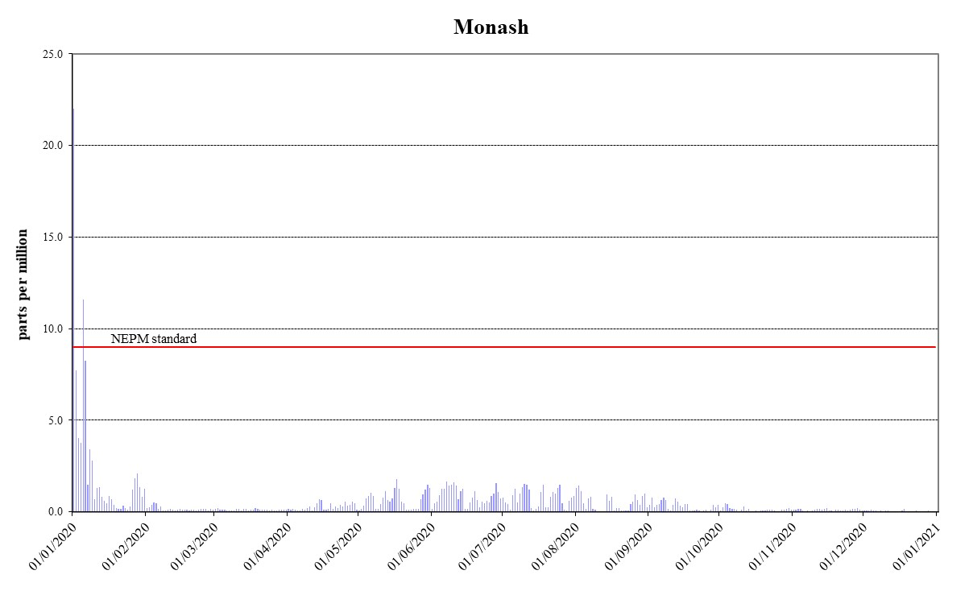

Figure 1: Daily maximum for CO 8-hour average – Monash
`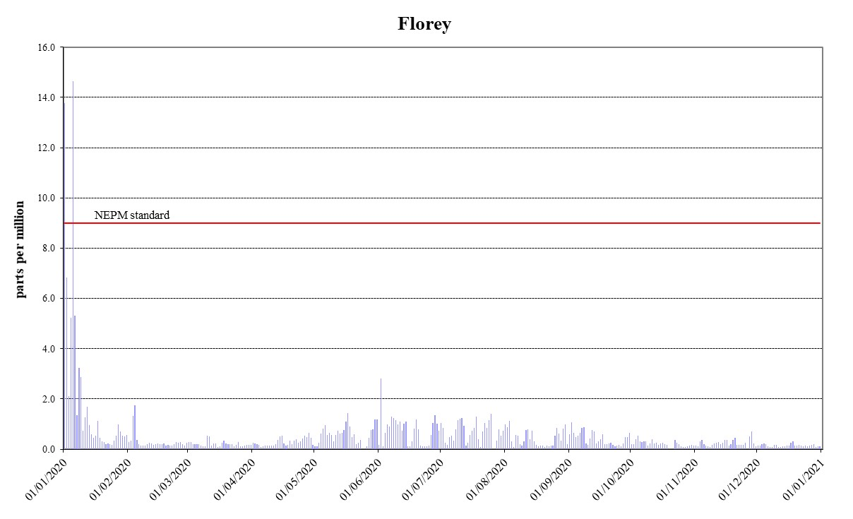
Figure 2: Daily maximum for CO 8-hour average – Florey

Nitrogen dioxide
During 2020, there were two exceedances of the nitrogen dioxide standard at Florey due to bushfire smoke. As a result, compliance was not met at Florey. No exceedances were recorded at Monash and compliance was demonstrated. The 1-year average levels remained low and met the standard at both stations.
Table 5: 2020 compliance summary for NO₂
AAQ NEPM standard – 0.12 ppm (1-hour average), 0.03 ppm (1-year average)
Monitoring station | Data availability rates  (% of hours) |  |  |  |  | 1 Hour |  | 1 Year
 | Q1 | Q2 | Q3 | Q4 | Annual | Number of exceedances | NEPM goal compliance | Annual average  (ppm) | NEPM goal compliance
Monash  Florey | 95.8  94.3 | 95.8  94.3 | 95.7  94.2 | 95.7  93.6 | 95.7  94.1 | 0  2 | MET  NOT MET | 0.004  0.004 | MET  MET

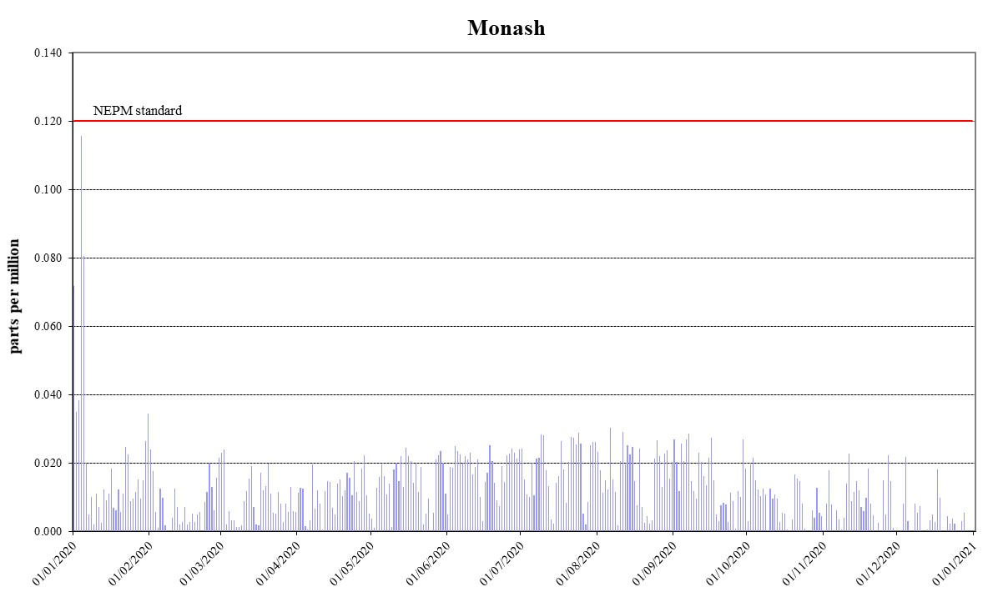
Figure 3: Daily maximum for NO₂ 1-hour average – Monash
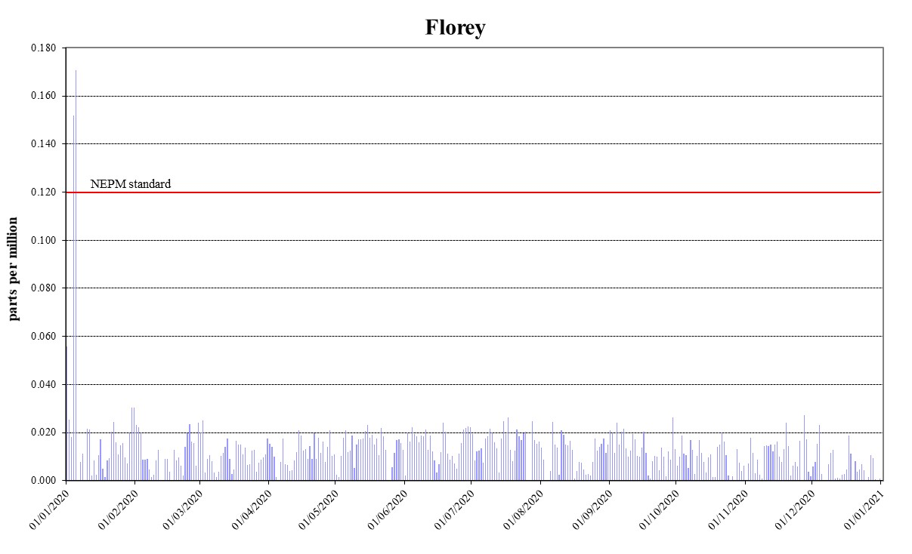
Figure 4: Daily maximum for NO₂ 1-hour average – Florey

Ozone
During 2020, compliance for 1-hour ozone standard was demonstrated at Civic with no exceedances. However, compliance for 4-hour ozone standard was not met at Civic as the standard was exceeded two times due to bushfire smoke. Ozone levels above the 1-hour and 4-hour standards were recorded four times and three times at Monash and Florey respectively, due to the same reason. As a result, compliance was not met at Monash and Florey.
Table 6: 2020 compliance summary for O₃
AAQ NEPM standard – 0.10 ppm (1-hour average), 0.08 ppm (4-hour average)
Monitoring station | Data availability rates  (% of days) |  |  |  |  | 1 Hour |  | 4 Hour
 | Q1 | Q2 | Q3 | Q4 | Annual | Number of exceedances | NEPM goal compliance | Number of exceedances | NEPM goal compliance
Monash  Civic  Florey | 95.8  95.8  95.8 | 95.8  95.8  80.7 | 95.7  95.7  95.7 | 95.8  95.8  95.7 | 95.8  95.8  92.0 | 2  0  2 | NOT MET  MET  NOT MET | 4  2  3 | NOT MET  NOT MET  NOT MET

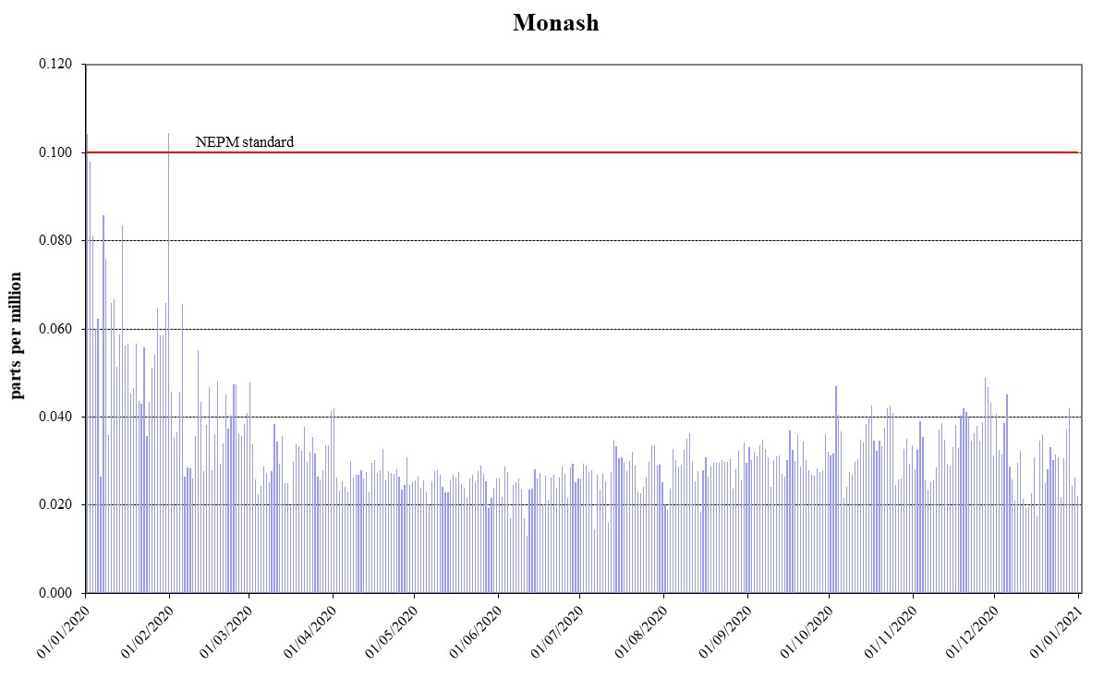
Figure 5: Daily maximum for O₃ 1-hour average – Monash

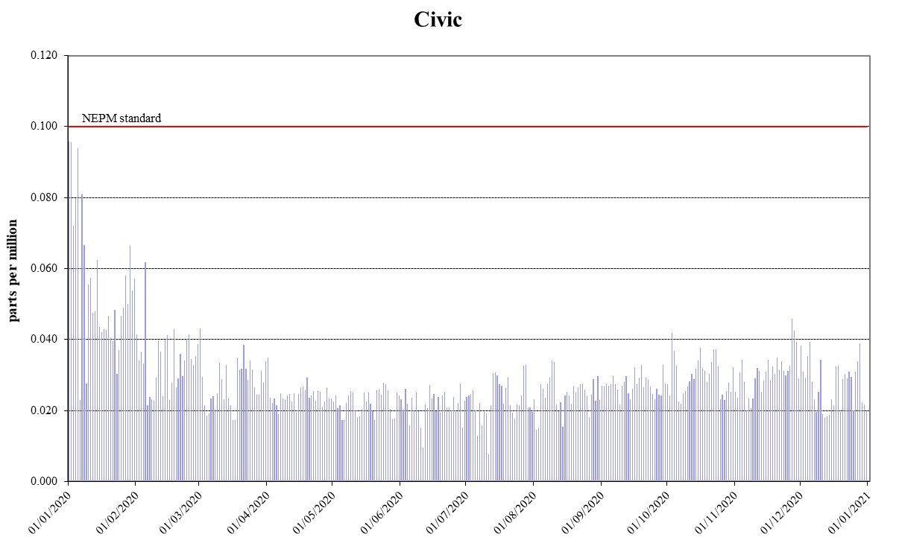
Figure 6: Daily maximum for O₃ 1-hour average – Civic
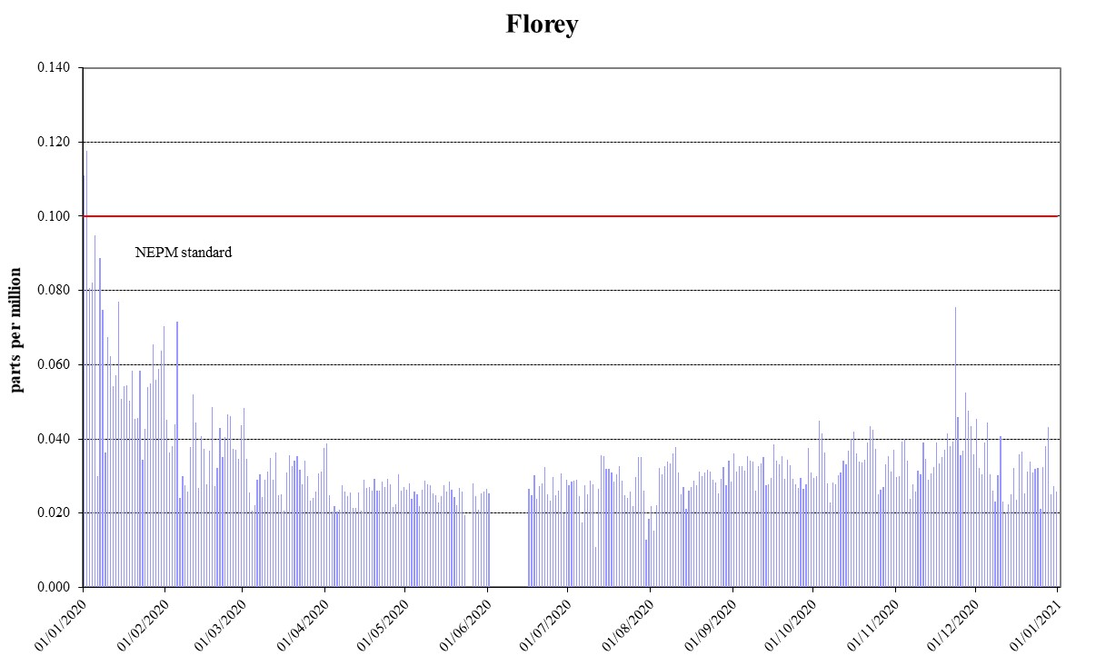
Figure 7: Daily maximum for O₃ 1-hour average – Florey
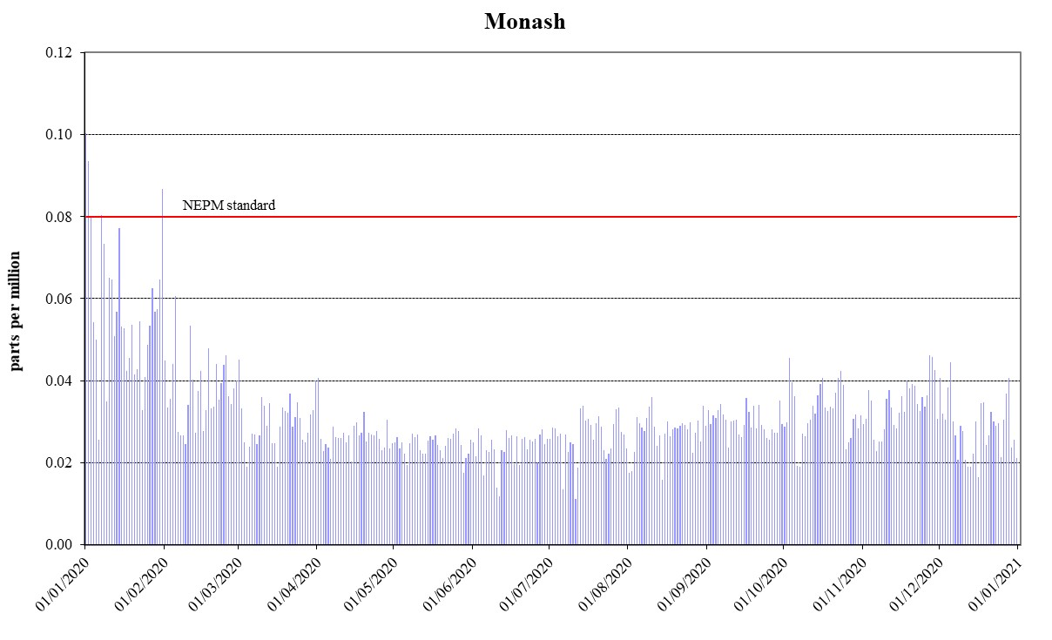
Figure 8: Daily maximum for O₃ 4-hour average – Monash
©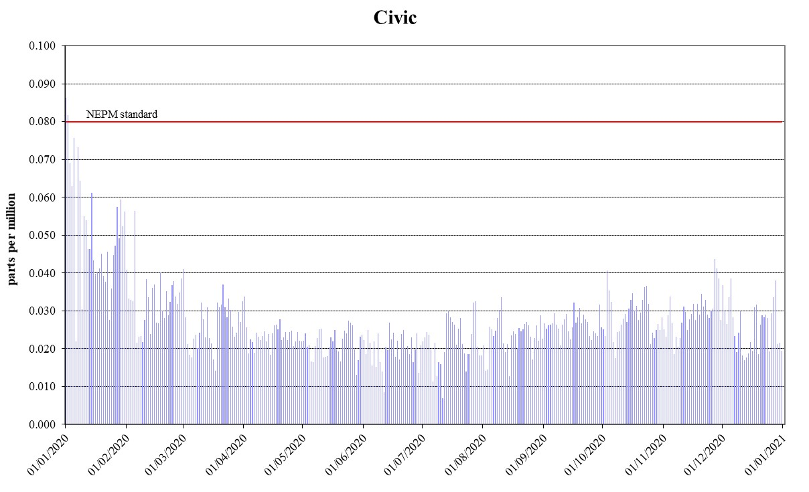
Figure 9: Daily maximum for O₃ 4-hour average – Civic
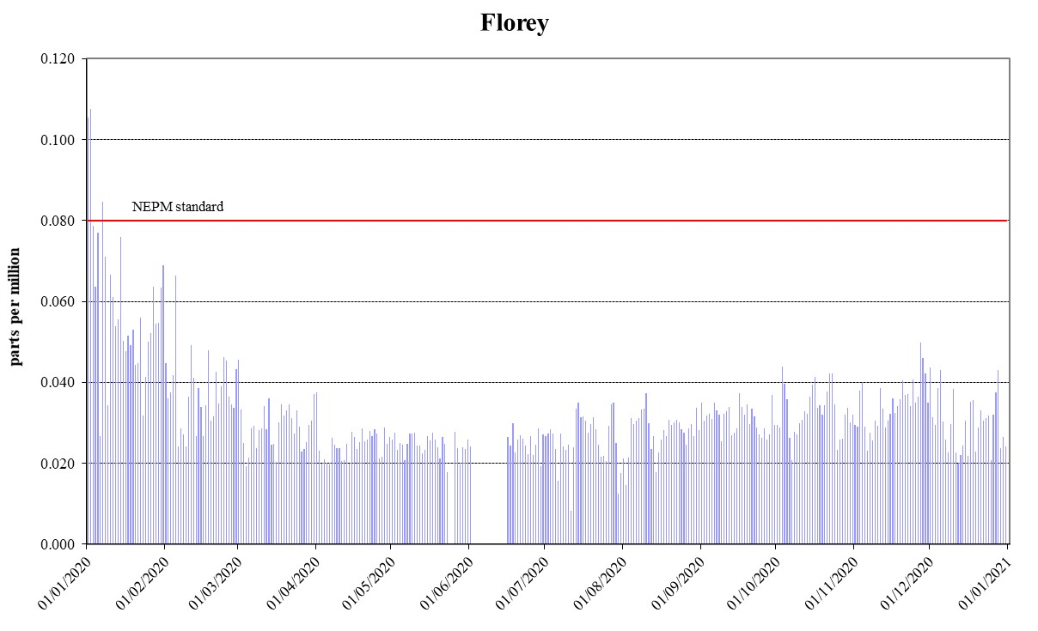
Figure 10: Daily maximum for O₃ 4-hour average – Florey

PM₁₀
During 2020, unprecedently high PM₁₀ levels were recorded in the ACT. There were exceedances of daily PM₁₀ standard on 27 days due to bushfires (24 days) and dust storms (3 days). Compliance against the daily PM₁₀ standard was demonstrated at all stations as theses exceedances being exceptional events are removed. While annual average PM₁₀ data at all stations met the 25 μg/m³ standard, annual average levels at all stations slightly exceeded the 20 μg/m³ ACT policy position.
Table 7: 2020 compliance summary for PM₁₀
AAQ NEPM standard 50 μg/m³ 1-day average, 20 μg/m³ (1-year average)*
Monitoring station | Data availability rates  (% of days) |  |  |  |  | 1 Day |  | 1 Year
 | Q1 | Q2 | Q3 | Q4 | Annual | Number of exceedances** | NEPM goal compliance | Annual average  (μg/m³) | ACT goal compliance
Monash  Civic  Florey | 100  100  100 | 100  95.6  97.8 | 95.2  98.4  100 | 100  98.4  100 | 99.2  98.4  99.5 | 0  0  0 | MET  MET  MET | 22.4  21.7  22.8 | NOT MET  NOT MET  NOT MET

* ACT policy position 20 µg/m³ not AAQ NEPM standard of 25 µg/m³ .
** the number excludes exceptional events.
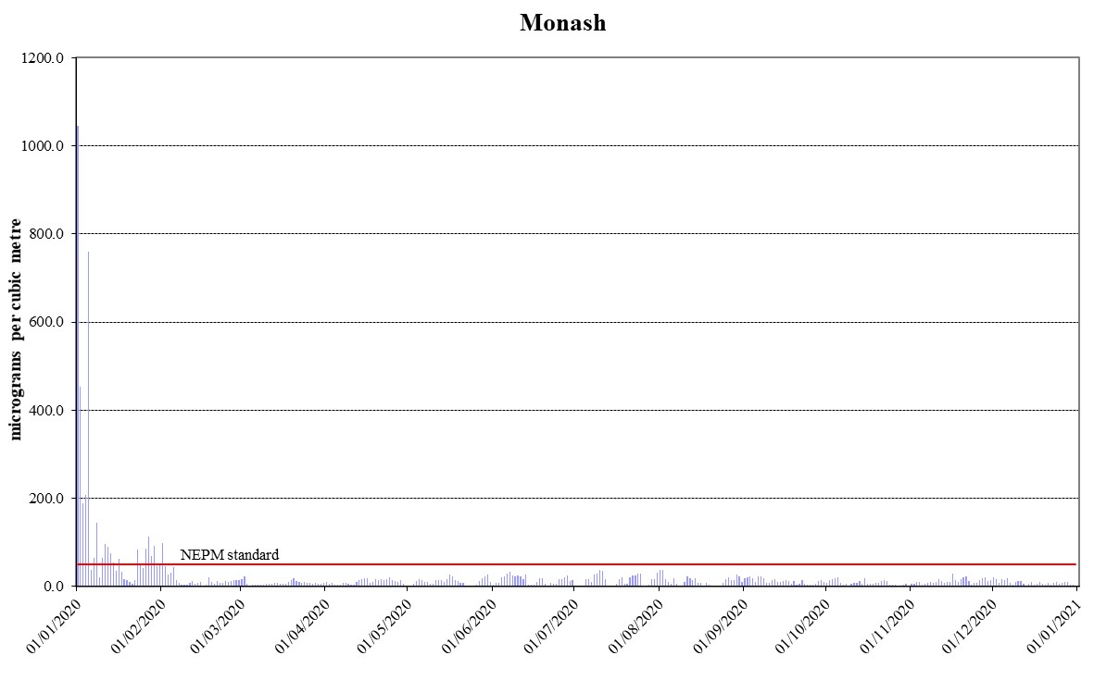

Figure 11: Daily maximum for PM₁₀ – Monash
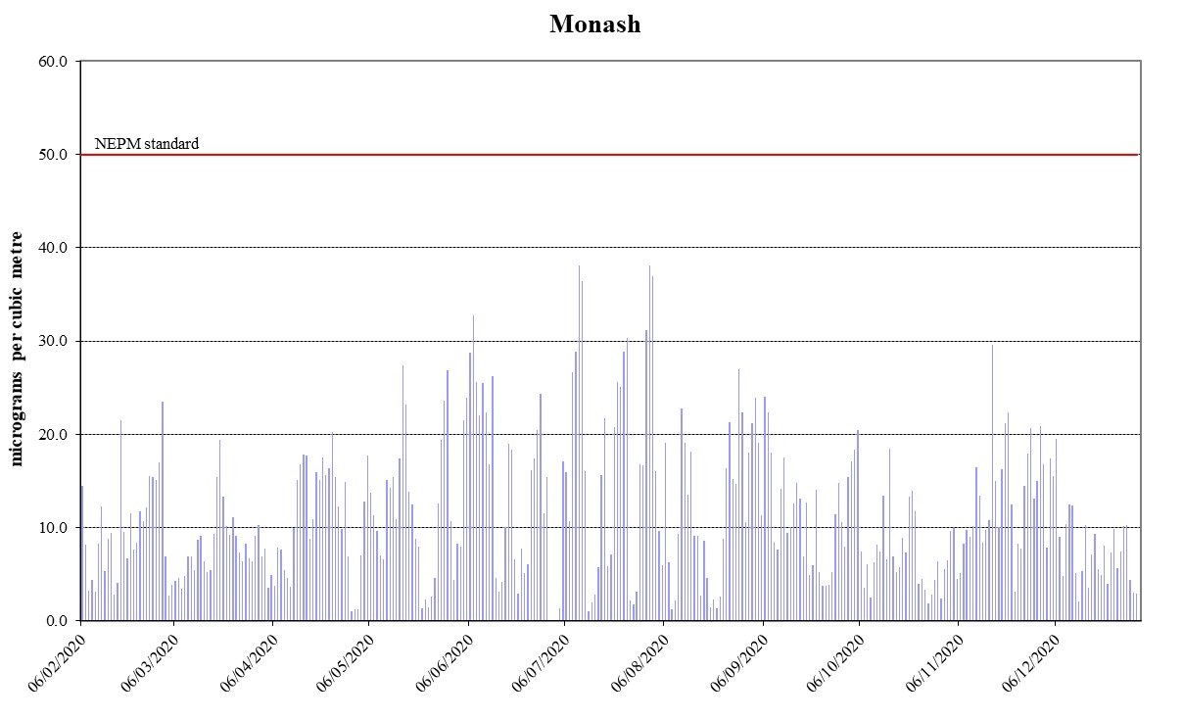
Figure 12: Daily maximum for PM₁₀ – Monash (Excluding Bushfire Period)
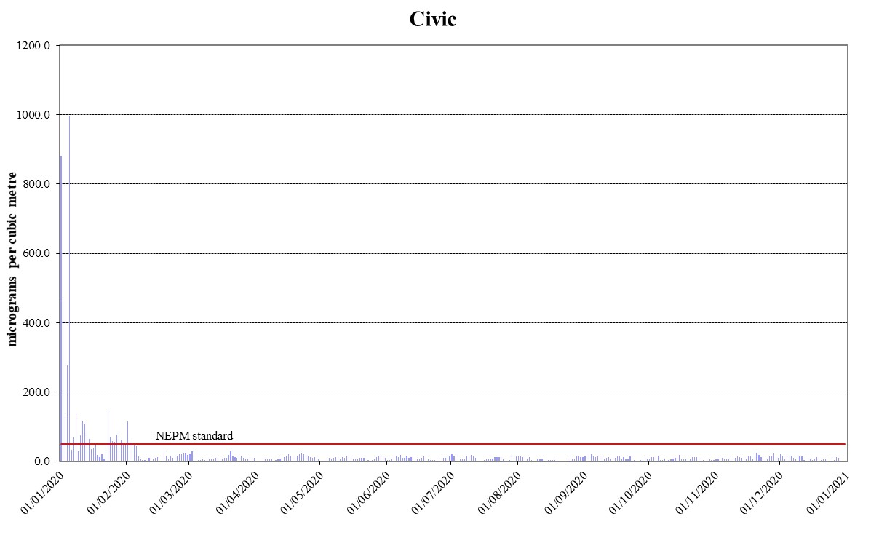
Figure 13: Daily maximum for PM₁₀ – Civic
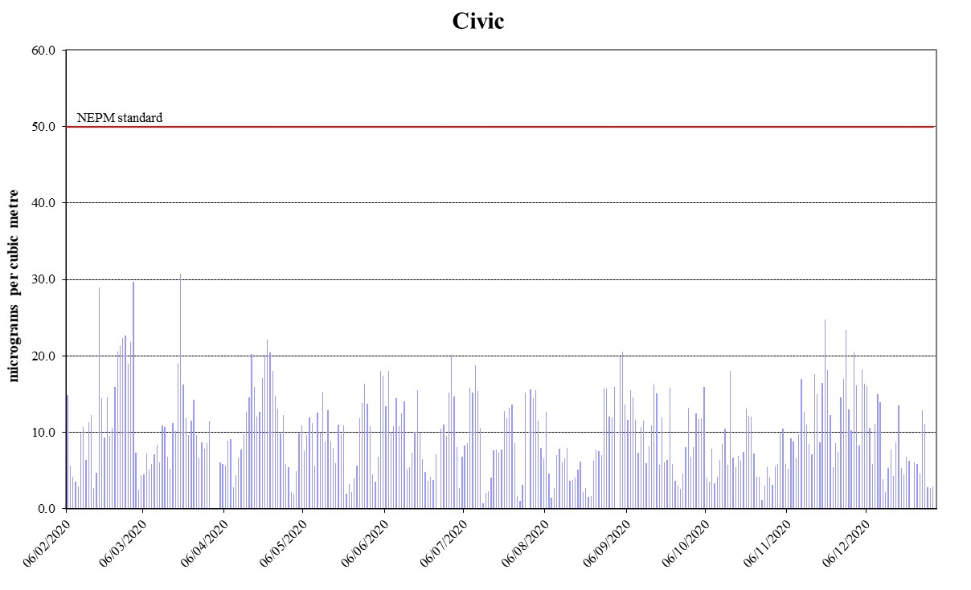
Figure 14: Daily maximum for PM₁₀ – Civic (Excluding Bushfire Period)
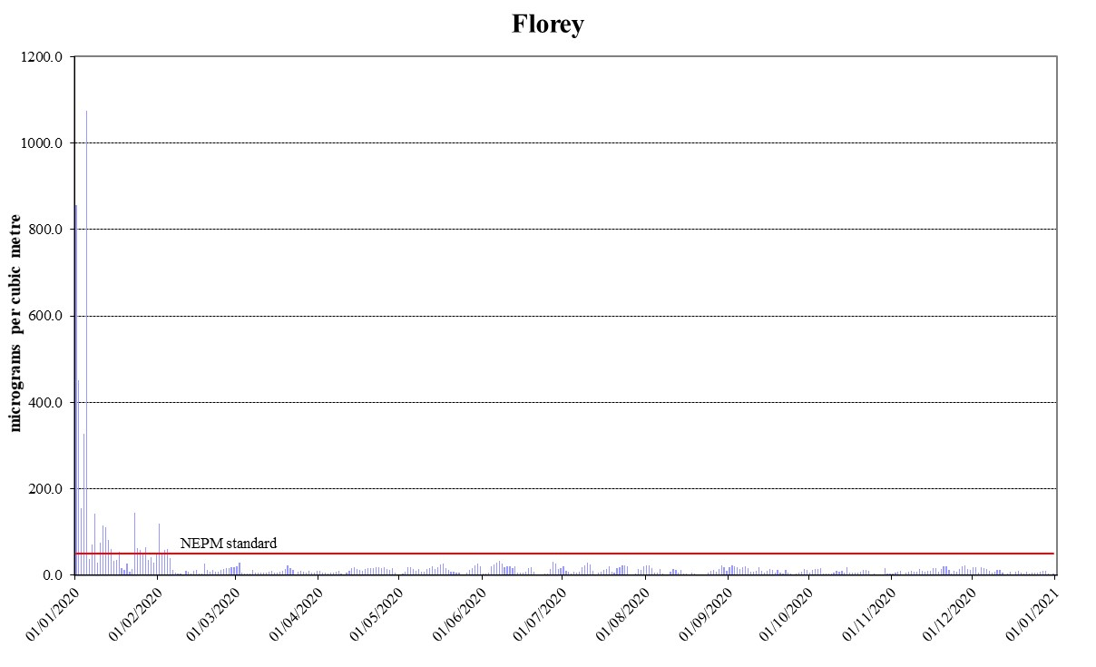
Figure 15: Daily maximum for PM₁₀ – Florey
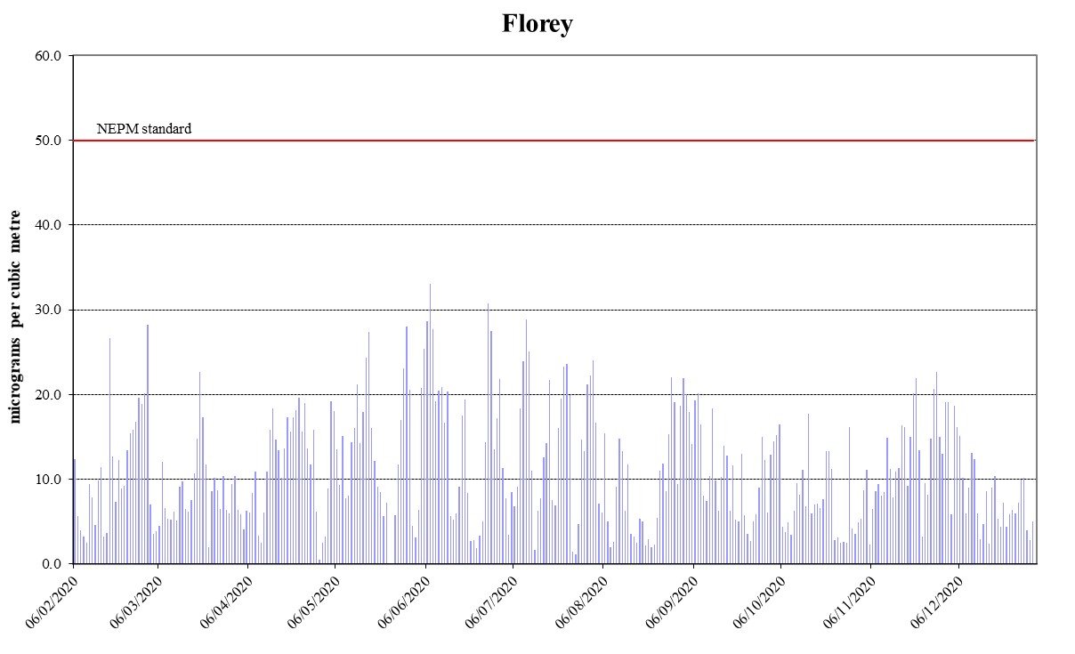
Figure 16: Daily maximum for PM₁₀ – Florey (Excluding Bushfire Period)

PM_{2.5}
During 2020, there were exceedances of daily PM_{2.5} standard on 39 days due to bushfires and wood heater emissions. Two thirds of exceedance days (26 days) occurred outside the winter season and were due to bushfires. Compliance against the daily PM_{2.5} standard was demonstrated at Civic when the exceptional events were removed. There were 13 exceedance days between mid-May and early August related to wood heater emissions at Monash and Florey. As a result, compliance against the daily PM_{2.5} standard was not met at Monash and Florey. Annual average PM_{2.5} data at all stations did not meet the 8 μg/m³ AAQ NEPM standard.
Table 8: 2020 compliance summary for PM_{2.5}
AAQ NEPM standard – 25 μg/m³ (1-day), 8 μg/m³ (1-year)
Monitoring station | Data availability rates  (% of days) |  |  |  |  | 1 Day |  | 1 Year
 | Q1 | Q2 | Q3 | Q4 | Annual | Number of exceedances* | NEPM goal compliance | Annual average  (μg/m³) | NEPM goal compliance
Monash  Civic  Florey | 98.9  97.8  98.9 | 100  97.8  95.6 | 96.8  100  97.8 | 98.4  100  100 | 98.6  98.9  98.1 | 12  0  6 | NOT MET  MET  NOT MET | 17.8  12.8  16.9 | NOT MET  NOT MET  NOT MET

* the number excludes exceptional events.

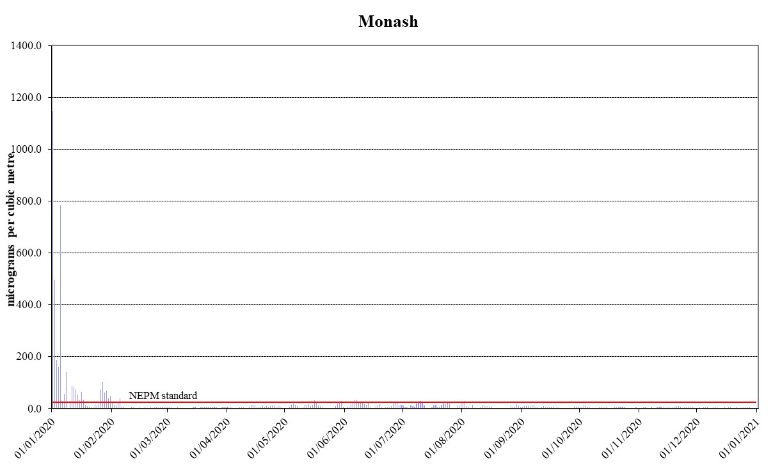
Figure 17: Daily maximum for PM_{2.5} – Monash
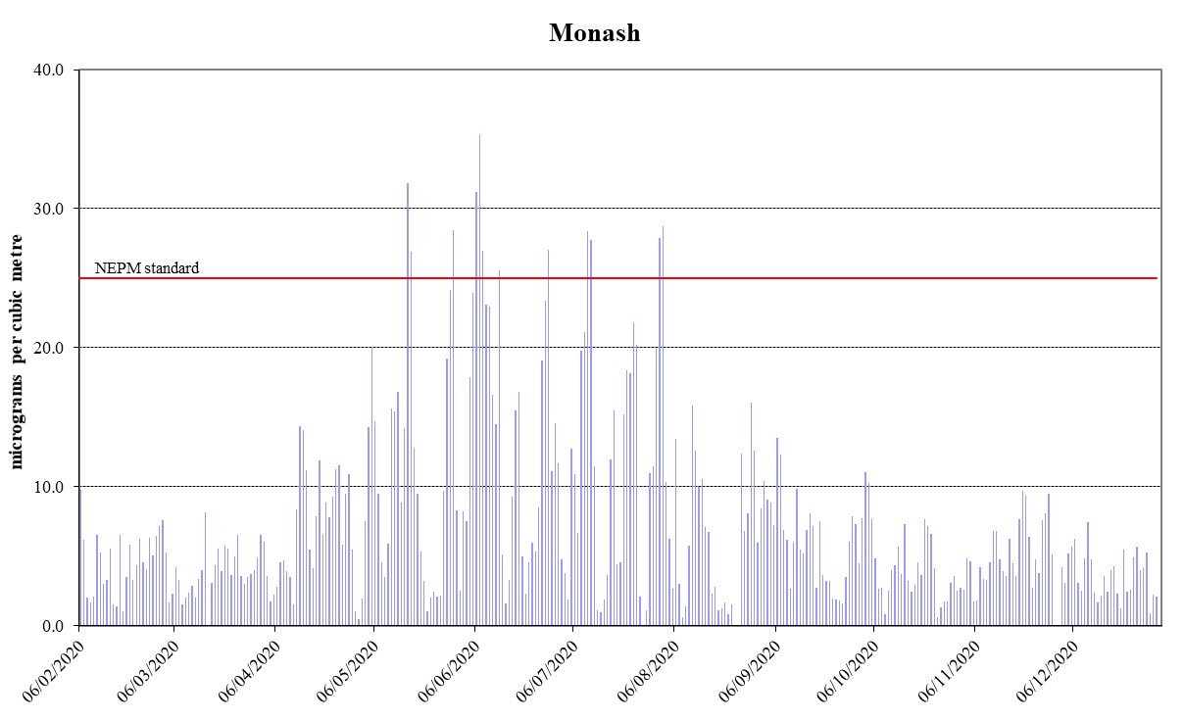
Figure 18: Daily maximum for PM_{2.5} – Monash (Excluding Bushfire Period)
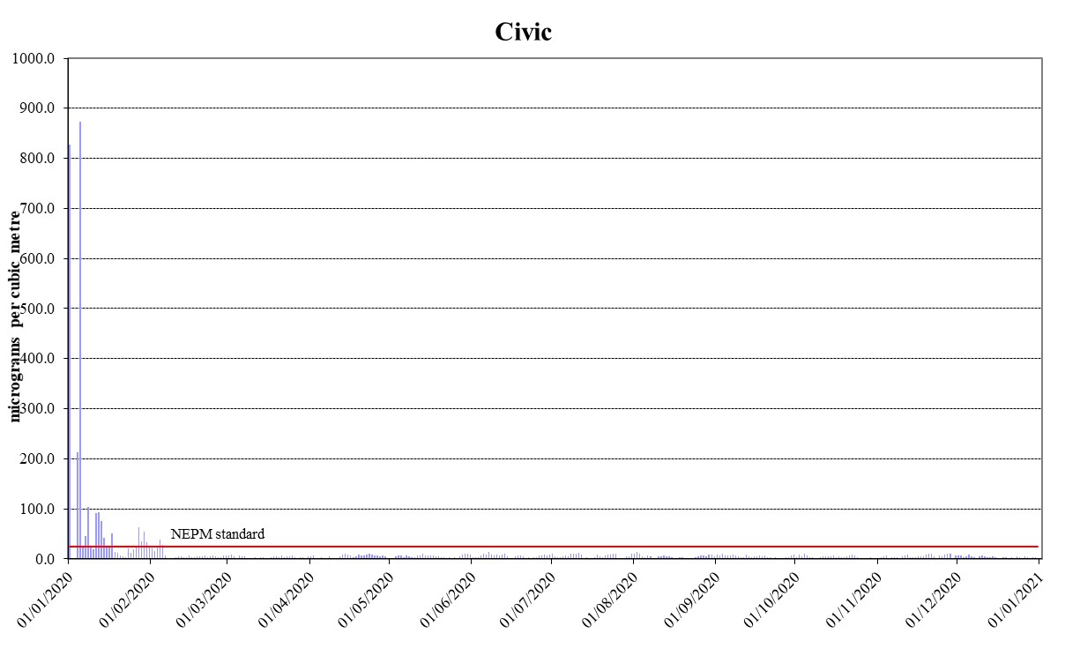
Figure 19: Daily maximum for PM_{2.5} – Civic
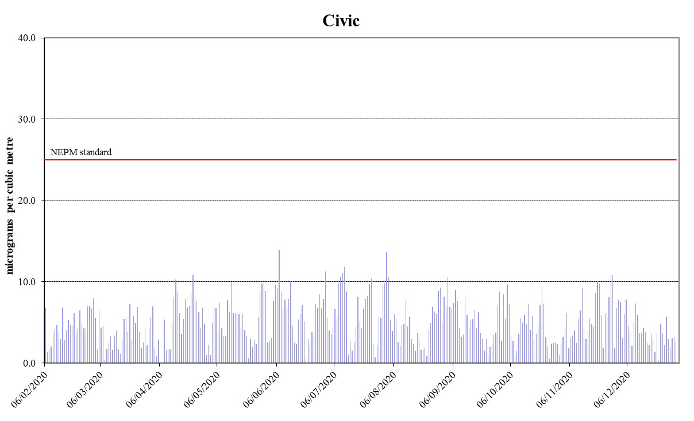
Figure 20: Daily maximum for PM_{2.5} – Civic (Excluding Bushfire Period)
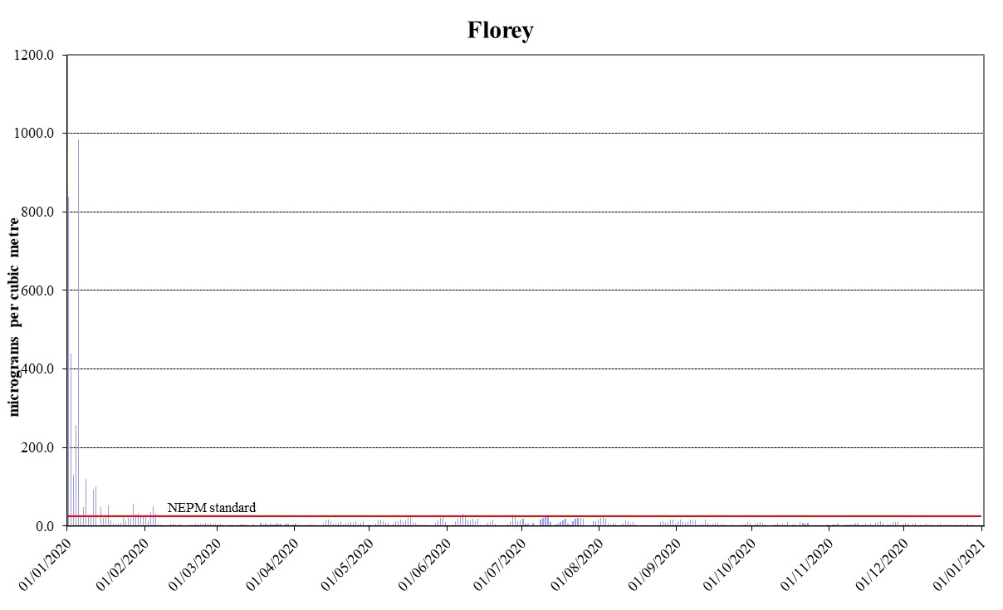
Figure 21: Daily maximum for PM_{2.5} – Florey
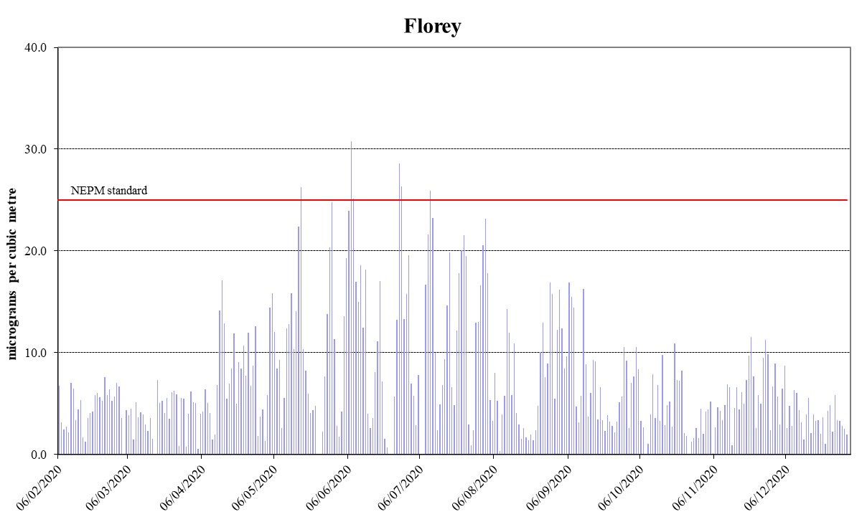
Figure 22: Daily maximum for PM_{2.5} – Florey (Excluding Bushfire Period)

ANALYSIS OF AIR QUALITY MONITORING
Annual summary statistics contained in Carbon monoxide levels remained relatively high across the ACT in January 2020 due to bushfires. Two exceedances were measured in January at both Monash and Florey, with a new record of 22.0 ppm at Monash on 1 January 2020.
Table 9 to Table 14 below assess air quality against the standards and the extent of compliance with the goal. Instances where the standard has been exceeded are highlighted in bold.

Carbon monoxide
Carbon monoxide levels remained relatively high across the ACT in January 2020 due to bushfires. Two exceedances were measured in January at both Monash and Florey, with a new record of 22.0 ppm at Monash on 1 January 2020.
Table 9: 2020 summary statistics for daily peak 8-hour CO
AAQ NEPM standard - 9.0 ppm (8-hour average)
Monitoring station | Number of valid days | Highest  (ppm) | Highest  (date/time) | 2nd Highest  (ppm) | 2nd Highest  (date/time)
Monash  Florey | 362  359 | 22.0  14.6 | 01 Jan 05:00  05 Jan 06:00 | 11.6  13.8 | 05 Jan 22:00  01 Jan 07:00

Nitrogen dioxide
The bushfire smoke adversely impacted the nitrogen dioxide levels in January 2020. Two exceedances were recorded at Florey, which was the first time since the commencement of air quality monitoring in the ACT. The highest recorded 1-hour value during 2020 was 0.171 ppm at Florey. The overall nitrogen dioxide levels decreased compared with the previous year. This may be attributed to less traffic and other human activities during the COVID-19 pandemic. Annual average remained well below the standard in 2020. The annual average in 2020 was 0.004ppm at both Monash and Florey. This is 13% of the annual standard 0.03ppm.
Table 10: 2020 summary statistics for daily peak 1-hour NO₂
AAQ NEPM standard 0.12 ppm (1-hour average)
Monitoring station | Number of valid days | Highest  (ppm) | Highest  (date/time) | 2nd Highest  (ppm) | 2nd Highest  (date/time)
Monash  Florey | 366  354 | 0.116  0.171 | 04 Jan 22:00  05 Jan 01:00 | 0.081  0.152 | 05 Jan 20:00  04 Jan 00:00

Ozone
Due to bushfires impacts, there were four days in 2020 when ozone levels were above the standards. On 1 and 2 January 2020, the most extensive ozone event for 2020 occurred. All monitoring stations recorded ozone levels over the 4-hour standard on those two days. Ozone levels above the 4-hour standard were recorded one more time at Monash and Florey on 7 January 2020. The 1-hour standard was also exceeded at Monash and Florey on 1 and 2 January 2020. Bushfires continued impacting the Canberra region till early February, which resulted in another exceedance day for both 1-hour and 4-hour standards on 31 January 2020 at Monash.
The highest recorded 1-hour value in the ACT during 2020 was 0.118 ppm at Florey. The highest recorded 4-hour value in the ACT during 2020 was 0.108 ppm at Florey.
Table 11: 2020 summary statistics for daily peak 1-hour O₃
AAQ NEPM standard 0.10 ppm (1-hour average)
Monitoring station | Number of valid days | Highest  (ppm) | Highest  (date/time) | 2nd Highest  (ppm) | 2nd Highest  (date/time)
Monash  Civic  Florey | 366  366  350 | 0.104  0.096  0.118 | 31 Jan 10:00  01 Jan 15:00  02 Jan 17:00 | 0.104  0.095  0.111 | 01 Jan 14:00  02 Jan 17:00  01 Jan 15:00

Table 12: 2020 summary statistics for daily peak 4-hour O₃
AAQ NEPM standard 0.08 ppm (4-hour average)
Monitoring station | Number of valid days | Highest  (ppm) | Highest  (date/time) | 2nd Highest  (ppm) | 2nd Highest  (date/time)
Monash  Civic  Florey | 366  366  350 | 0.100  0.086  0.108 | 01 Jan 16:00  01 Jan 16:00  02 Jan 18:00 | 0.093  0.082  0.105 | 02 Jan 17:00  02 Jan 17:00  01 Jan 16:00

PM₁₀
There were 27 days when daily PM₁₀ standard was exceeded at different stations from January till early February 2020. The daily PM₁₀ reached unprecedented high levels across the ACT.
The high number of daily PM₁₀ exceedances was attributed to the extensive bushfires throughout NSW (24 days) impacting the ACT and the increasing frequency of widespread dust storms (3 days). Under the exceptional event rule they have been excluded when assessing compliance against the daily standard.
Whilst monitoring data from exceptional events is excluded for reporting compliance for daily averaging standards it is still included for one-year averaging standards.
The highest recorded annual average in 2020 was 22.8μg/m³ at Florey (refer to Table 7) slightly less than the maximum annual average of 23.8μg/m³ (Florey) in 2019. This is below the national annual standard of 25μg/m³, but slightly over the ACT annual standard of 20μg/m³.
Table 13: 2020 summary statistics for daily PM₁₀
AAQ NEPM daily standard 50 μg/m³
Monitoring station | Number of valid days | Highest  (μg/m³) | Highest  (date)
Monash  Civic  Florey | 363  359  364 | 1046.1  994.9  1075.5 | 01 January  05 January  05 January

PM_{2.5}
The daily standard for PM_{2.5} was exceeded on 39 days in 2020 at one or more of the monitoring stations. 13 exceedance days, which occurred between May and August 2020, were primarily a result of domestic wood heater emissions in winter. The other exceedances were attributed to bushfire smoke (26 days). The highest daily PM_{2.5} level was 1146.5μg/m³ which was recorded at Monash on 1 January 2020.
Whilst monitoring data from exceptional events is excluded for reporting compliance for daily averaging standards it is still included for one year averaging standards. Given the length of time the Canberra airshed was affected by bushfire smoke the annual average PM_{2.5} levels remained relatively high in 2020. All monitoring stations recorded annual average PM_{2.5} concentrations above the national standard 8μg/m³. The highest recorded annual average in 2020 was 17.8μg/m³ at Monash (refer to Table 8).
Table 14: 2020 summary statistics for daily PM_{2.5}
AAQ NEPM daily standard 25 μg/m³
Monitoring station | Number of valid days | Highest  (μg/m³) | Highest  (date)
Monash  Civic  Florey | 361  362  359 | 1146.5  872.6  983.4 | 01 January  05 January  05 January

ASSESSMENT OF PROGRESS TOWARDS ACHIEVING THE GOAL
Historical monitoring results indicate that the only AAQ NEPM pollutant of concern in the ACT air shed is particulate matter, which increases significantly during winter because of emissions from domestic wood heaters. In more recent years, especially 2018 and 2019, exceedances of the particulate matter standards have also been attributed to smoke from hazard reduction burns, bushfires and dust storms.
While carbon monoxide and nitrogen dioxide concentrations increased during bushfire period, the AAQ NEPM standards were met on 99.5% of days during the year.
Ozone levels were relatively high in January 2020 compared with other months of the year, meeting the AAQ NEPM standards on 99% of all days during the year.
Canberra experienced days with extreme air pollution in early 2020 due to smoke from bushfires, dust storms or a combination of both. In early January, the particle pollution was at levels more than 20 times (PM₁₀) or 45 times (PM_{2.5}) the national standards. In addition, there was an increase of PM_{2.5} exceedances in winter months. The COVID-19 pandemic restrictions may be a possible cause of this increase, with people staying at home more.
The ACT Government acknowledges that wood heater emissions reduce air quality during winter, and continue to implement an integrated program to address this including:
- provides public information on air quality levels in the ACT through the online Air Quality Index and AirRater App;
- the annual 'Burn Right Tonight' community education campaign which reminds ACT residents how to use wood heaters correctly to minimise air pollution;
- the regulation of firewood merchants to ensure only seasoned wood is sold;
- the regulation of wood heaters sold in the ACT to ensure they meet the current Australian Standards for emissions and efficiency;
- the prohibition of wood heaters in new developments where planning studies show that they would have an adverse impact on air quality. The ACT Government has taken this approach for the development of the Molonglo Valley (except Wright), and previously with the suburbs of Dunlop and East O'Malley;
- compliance and enforcement activities for wood heater emissions; and
- administering the Wood Heater Replacement Program to replace old inefficient wood heaters with high efficiency alternatives.
Bushfire smoke and dust storms continue to present a threat to future air quality in the ACT, particularly as climate change is set to exacerbate the frequency and intensity of bushfire events, coupled with rising temperatures and prolonged dry weather.

APPENDIX A: STATISTICAL SUMMARY AND TRENDS
The following section provides a basic statistical summary, using percentiles, for Monash, Civic and Florey stations and for each standard in the past ten years. Daily maximum values are also presented in the following tables.

Carbon monoxide
Table 15: Statistical summary for daily maximum 8-hour CO Monash 2011 – 2020
Year | Data  Availability  (%) | No. of  Exceedances  (days) | Max  conc.  (ppm) | 95th  percentile  (ppm) | 75th  percentile  (ppm) | 50th  percentile  (ppm)
2011 | 98.6 | 0 | 2.2 | 1.5 | 0.5 | 0.2
2012 | 99.7 | 0 | 1.8 | 1.2 | 0.6 | 0.3
2013 | 95.9 | 0 | 2.1 | 1.5 | 0.6 | 0.3
2014 | 94.0 | 0 | 1.8 | 1.4 | 0.7 | 0.4
2015 | 94.8 | 0 | 1.9 | 1.4 | 0.6 | 0.3
2016 | 95.8 | 0 | 1.7 | 1.0 | 0.4 | 0.2
2017 | 95.4 | 0 | 1.6 | 1.2 | 0.6 | 0.2
2018 | 92.3 | 0 | 1.5 | 1.2 | 0.5 | 0.2
2019 | 72.1 | 1 | 12.4 | 1.1 | 0.4 | 0.1
2020 | 94.9 | 2 | 22.0 | 1.5 | 0.6 | 0.2

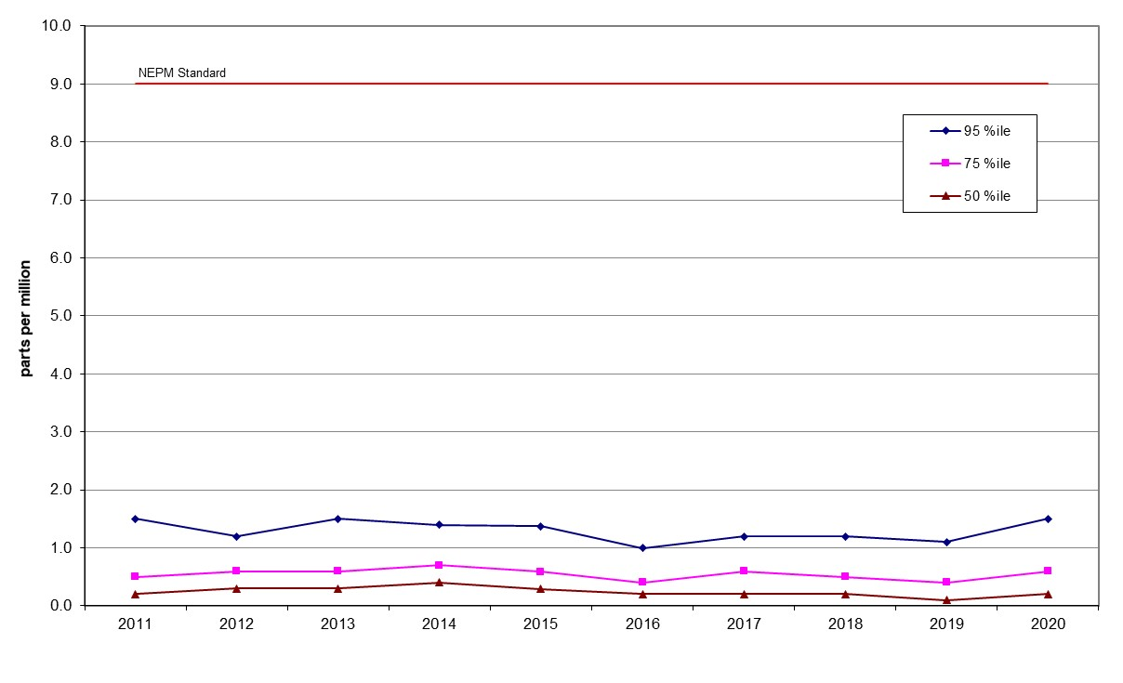
Figure 23: Statistical summary for daily maximum 8-hour CO Monash 2011 – 2020
Table 16: Statistical summary for daily maximum 8-hour CO Florey 2014 – 2020
Year | Data  Availability  (%) | No. of  Exceedances  (days) | Max  conc.  (ppm) | 95th  percentile  (ppm) | 75th  percentile  (ppm) | 50th  percentile  (ppm)
2014 | 79.2 | 0 | 2.2 | 1.4 | 0.7 | 0.3
2015 | 94.9 | 0 | 2.0 | 1.5 | 0.6 | 0.3
2016 | 95.5 | 0 | 1.9 | 1.2 | 0.5 | 0.3
2017 | 94.7 | 0 | 1.8 | 1.4 | 0.5 | 0.2
2018 | 94.7 | 0 | 1.5 | 1.1 | 0.5 | 0.3
2019 | 95.3 | 0 | 8.6 | 1.2 | 0.6 | 0.3
2020 | 94.7 | 2 | 14.6 | 1.3 | 0.6 | 0.3

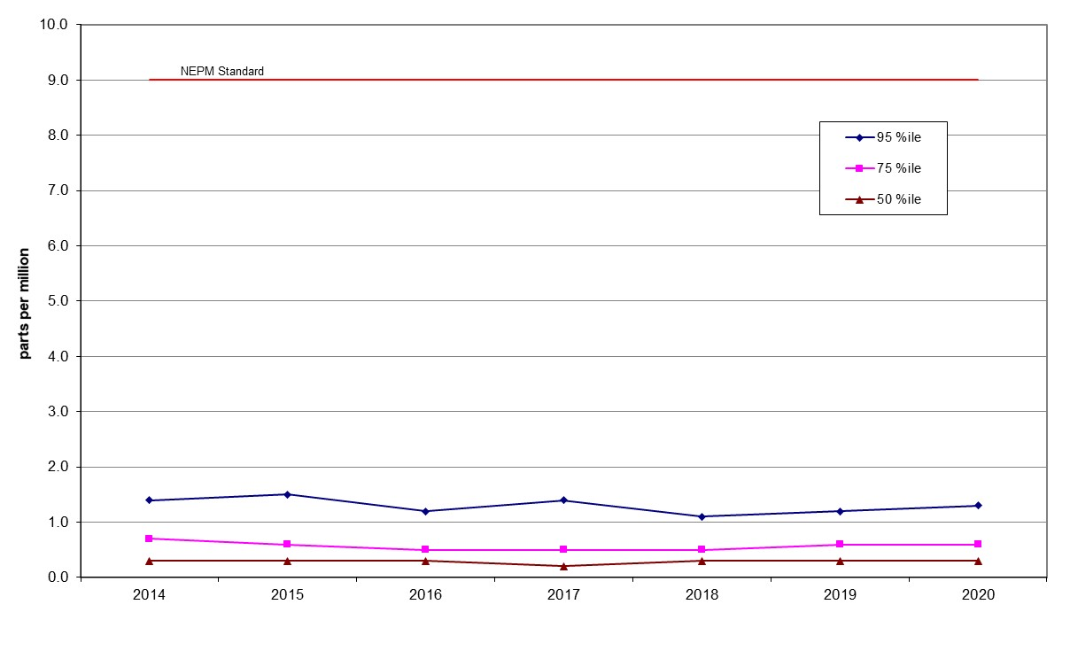
Figure 24: Statistical summary for daily maximum 8-hour CO Florey 2014 – 2020

Nitrogen dioxide
Table 17: Statistical summary for daily maximum 1-hour NO₂ Monash 2011 – 2020
Year | Data  Availability  (%) | No. of  Exceedances  (days) | Max  conc.  (ppm) | Annual average  (ppm) | 95th  percentile  (ppm) | 75th  percentile  (ppm) | 50th  percentile  (ppm)
2011 | 96.7 | 0 | 0.043 | 0.005 | 0.029 | 0.022 | 0.015
2012 | 97.5 | 0 | 0.033 | 0.006 | 0.026 | 0.021 | 0.014
2013 | 97.5 | 0 | 0.037 | 0.005 | 0.027 | 0.021 | 0.014
2014 | 94.1 | 0 | 0.036 | 0.005 | 0.027 | 0.020 | 0.015
2015 | 94.8 | 0 | 0.032 | 0.004 | 0.026 | 0.020 | 0.014
2016 | 95.6 | 0 | 0.036 | 0.004 | 0.027 | 0.019 | 0.012
2017 | 95.6 | 0 | 0.031 | 0.004 | 0.027 | 0.021 | 0.013
20208 | 95.5 | 0 | 0.039 | 0.004 | 0.028 | 0.020 | 0.014
2019 | 94.9 | 0 | 0.084 | 0.005 | 0.027 | 0.021 | 0.014
2020 | 95.7 | 0 | 0.116 | 0.004 | 0.027 | 0.019 | 0.011

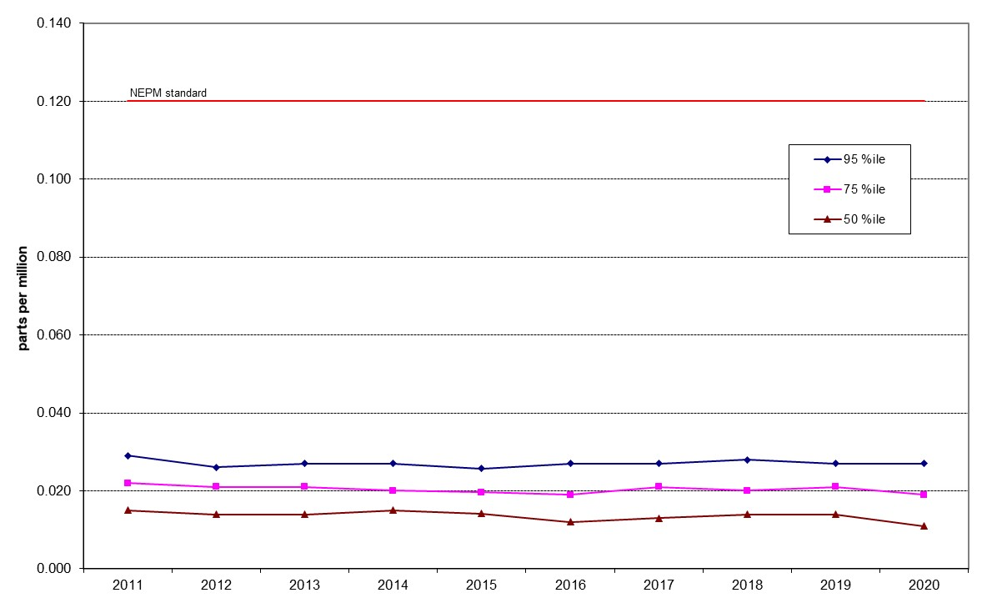

Figure 25: Statistical summary for daily maximum 1-hour NO₂ Monash 2011 – 2020

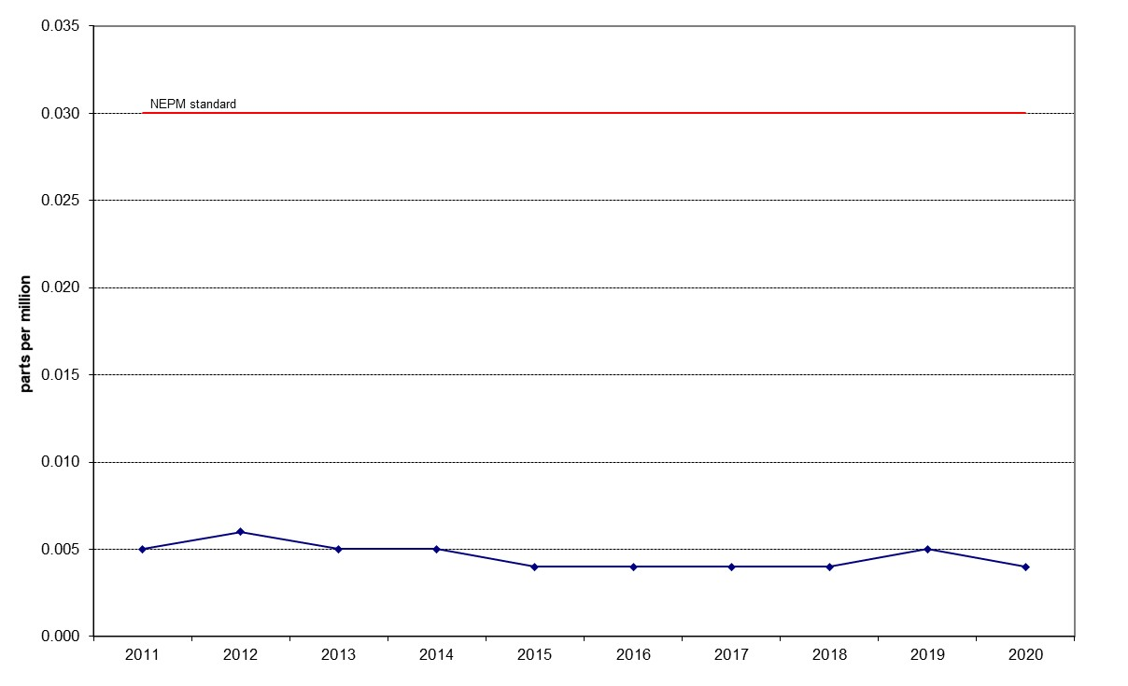

Figure 26: Annual average 1-hour NO₂ Monash 2011 – 2020

Table 18: Statistical summary for daily maximum 1-hour NO₂ Florey 2014 – 2020
Year | Data  Availability  (%) | No. of  Exceedances  (days) | Max  conc.  (ppm) | Annual average  (ppm) | 95th  percentile  (ppm) | 75th  percentile  (ppm) | 50th  percentile  (ppm)
2014 | 78.3 | 0 | 0.045 | 0.006 | 0.027 | 0.020 | 0.015
2015 | 91.5 | 0 | 0.033 | 0.005 | 0.027 | 0.020 | 0.014
2016 | 94.7 | 0 | 0.034 | 0.004 | 0.027 | 0.019 | 0.013
2017 | 93.7 | 0 | 0.033 | 0.005 | 0.025 | 0.020 | 0.015
2018 | 93.3 | 0 | 0.039 | 0.005 | 0.028 | 0.022 | 0.015
2019 | 92.4 | 0 | 0.062 | 0.005 | 0.027 | 0.020 | 0.014
2020 | 94.1 | 2 | 0.171 | 0.004 | 0.024 | 0.017 | 0.011

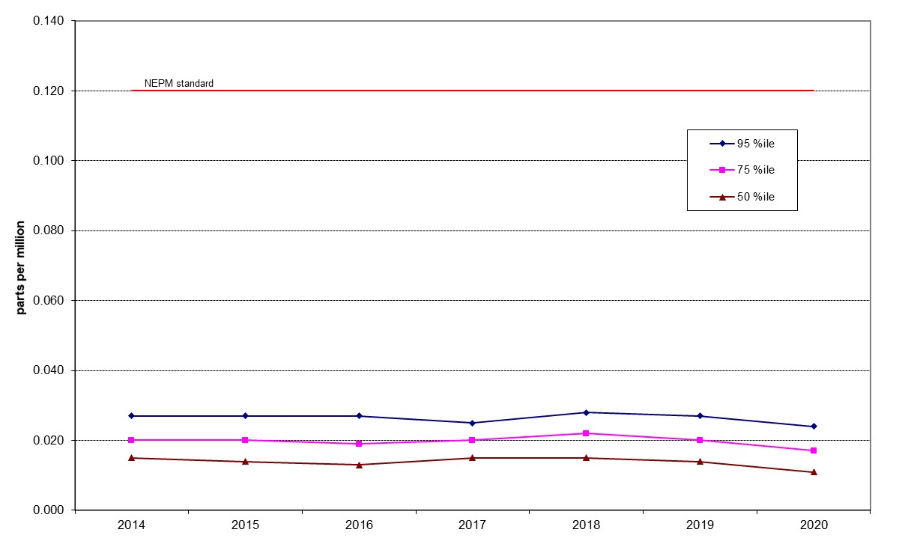
Figure 27: Statistical summary for daily maximum 1-hour NO₂ Florey 2014 – 2020
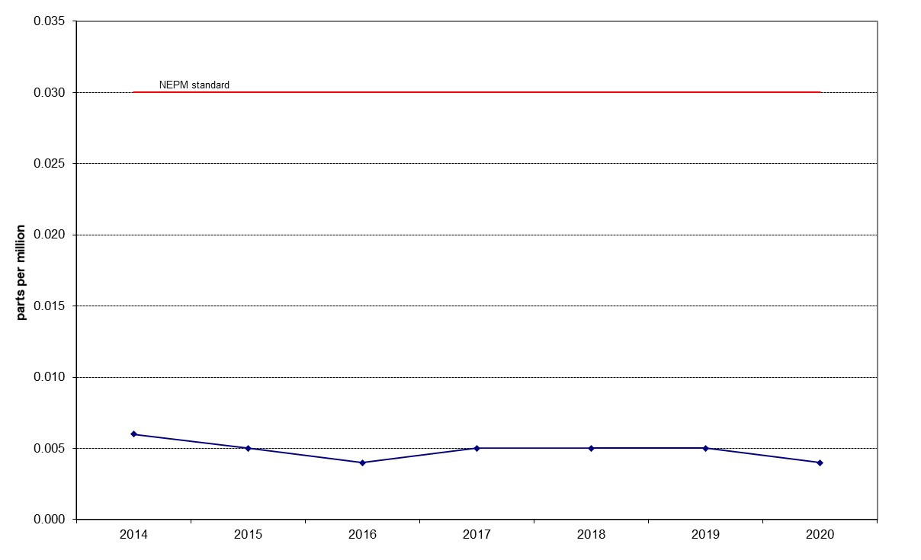
Figure 28: Annual average 1-hour NO₂ Florey 2014 – 2020

Ozone
Table 19: Statistical summary for daily maximum 1-hour O₃ Monash 2011 – 2020
Year | Data  Availability  (%) | No. of  Exceedances  (days) | Max  conc.  (ppm) | 95th  percentile  (ppm) | 75th  percentile  (ppm) | 50th  percentile  (ppm)
2011 | 99.2 | 0 | 0.056 | 0.044 | 0.033 | 0.028
2012 | 100 | 0 | 0.055 | 0.043 | 0.034 | 0.029
2013 | 97.8 | 0 | 0.062 | 0.045 | 0.035 | 0.029
2014 | 94.8 | 0 | 0.087 | 0.050 | 0.036 | 0.030
2015 | 92.8 | 0 | 0.065 | 0.044 | 0.034 | 0.026
2016 | 95.2 | 0 | 0.057 | 0.044 | 0.032 | 0.026
2017 | 95.5 | 0 | 0.060 | 0.049 | 0.038 | 0.032
2018 | 95.8 | 0 | 0.062 | 0.050 | 0.039 | 0.032
2019 | 95.8 | 1 | 0.127 | 0.066 | 0.040 | 0.033
2020 | 95.8 | 2 | 0.104 | 0.056 | 0.035 | 0.030

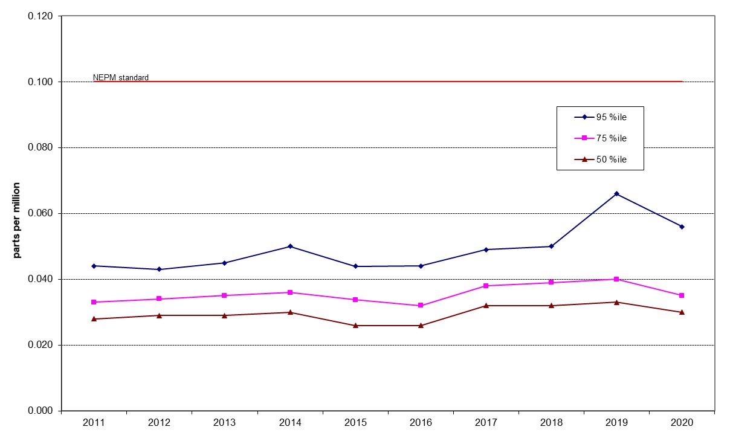

Figure 29: Statistical summary for daily maximum 1-hour O₃ Monash 2011 – 2020

Table 20: Statistical summary for daily maximum 1-hour O₃ Civic 2011 – 2020
Year | Data  Availability  (%) | No. of  Exceedances  (days) | Max  conc.  (ppm) | 95th  percentile  (ppm) | 75th  percentile  (ppm) | 50th  percentile  (ppm)
2011 | 96.4 | 0 | 0.052 | 0.041 | 0.030 | 0.026
2012 | 100 | 0 | 0.053 | 0.034 | 0.024 | 0.020
2013 | 92.1 | 0 | 0.060 | 0.036 | 0.028 | 0.024
2014 | 94.0 | 0 | 0.060 | 0.039 | 0.028 | 0.022
2015 | 89.0 | 0 | 0.042 | 0.034 | 0.026 | 0.022
2016 | 95.8 | 0 | 0.047 | 0.036 | 0.028 | 0.024
2017 | 95.8 | 0 | 0.053 | 0.045 | 0.034 | 0.028
2018 | 95.2 | 0 | 0.056 | 0.046 | 0.032 | 0.028
2019 | 95.8 | 4 | 0.169 | 0.065 | 0.037 | 0.029
2020 | 95.8 | 0 | 0.096 | 0.048 | 0.032 | 0.026

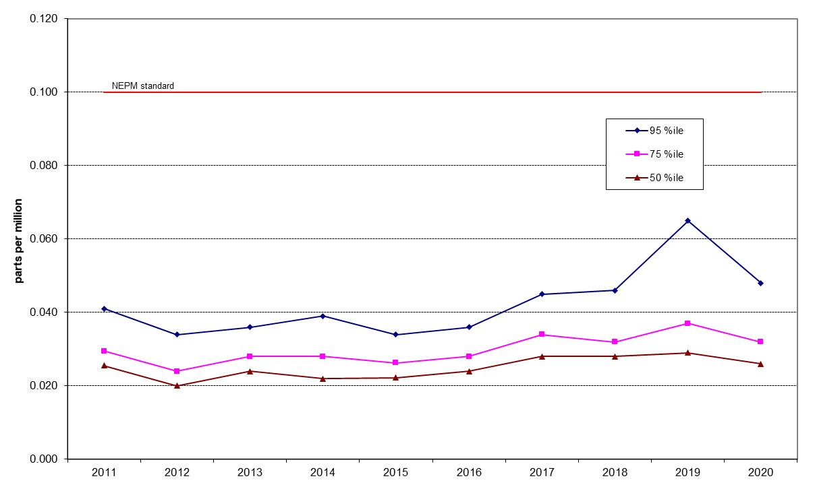

Figure 30: Statistical summary for daily maximum 1-hour O₃ Civic 2011 – 2020

Table 21: Statistical summary for daily maximum 1-hour O₃ Florey 2014 – 2020
Year | Data  Availability  (%) | No. of  Exceedances  (days) | Max  conc.  (ppm) | 95th  percentile  (ppm) | 75th  percentile  (ppm) | 50th  percentile  (ppm)
2014 | 79.4 | 0 | 0.074 | 0.034 | 0.027 | 0.023
2015 | 94.2 | 0 | 0.040 | 0.032 | 0.025 | 0.021
2016 | 95.8 | 0 | 0.050 | 0.040 | 0.031 | 0.027
2017 | 95.5 | 0 | 0.057 | 0.048 | 0.038 | 0.032
2018 | 95.2 | 0 | 0.059 | 0.050 | 0.038 | 0.032
2019 | 95.3 | 1 | 0.118 | 0.067 | 0.039 | 0.032
2020 | 92.0 | 2 | 0.118 | 0.058 | 0.036 | 0.030

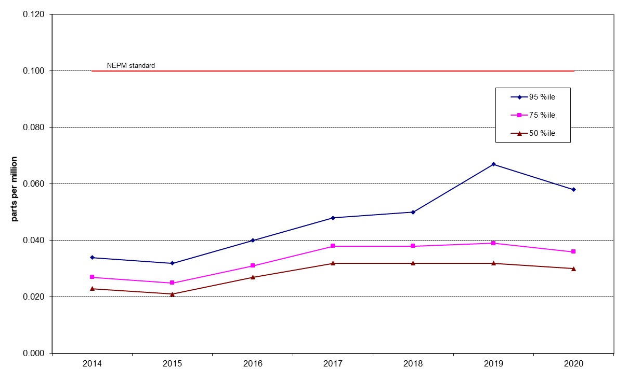

Figure 31: Statistical summary for daily maximum 1-hour O₃ Florey 2014 – 2020

Table 22: Statistical summary for daily maximum 4-hour O₃ Monash 2011 – 2020
Year | Data  Availability  (%) | No. of  Exceedances  (days) | Max  conc.  (ppm) | 95th  percentile  (ppm) | 75th  percentile  (ppm) | 50th  percentile  (ppm)
2011 | 98.9 | 0 | 0.054 | 0.041 | 0.032 | 0.027
2012 | 99.7 | 0 | 0.052 | 0.043 | 0.034 | 0.029
2013 | 97.8 | 0 | 0.059 | 0.042 | 0.033 | 0.028
2014 | 94.8 | 0 | 0.060 | 0.046 | 0.034 | 0.029
2015 | 92.8 | 0 | 0.050 | 0.041 | 0.033 | 0.025
2016 | 95.2 | 0 | 0.055 | 0.042 | 0.030 | 0.025
2017 | 95.5 | 0 | 0.055 | 0.047 | 0.036 | 0.031
2018 | 95.8 | 0 | 0.057 | 0.049 | 0.038 | 0.032
2019 | 95.8 | 1 | 0.118 | 0.061 | 0.039 | 0.032
2020 | 95.8 | 4 | 0.100 | 0.053 | 0.034 | 0.029

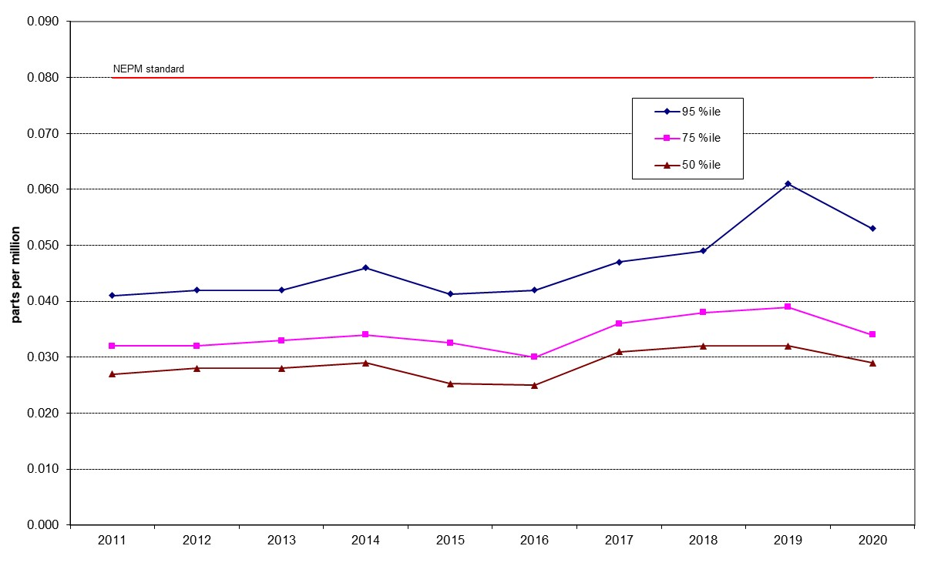

Figure 32: Statistical summary for daily maximum 4-hour O₃ Monash 2011 – 2020

Table 23: Statistical summary for daily maximum 4-hour O₃ Civic 2011 – 2020
Year | Data  Availability  (%) | No. of  Exceedances  (days) | Max  conc.  (ppm) | 95th  percentile  (ppm) | 75th  percentile  (ppm) | 50th  percentile  (ppm)
2011 | 96.4 | 0 | 0.050 | 0.038 | 0.029 | 0.025
2012 | 100 | 0 | 0.042 | 0.032 | 0.023 | 0.019
2013 | 91.8 | 0 | 0.057 | 0.034 | 0.027 | 0.023
2014 | 94.0 | 0 | 0.047 | 0.036 | 0.026 | 0.020
2015 | 89.0 | 0 | 0.041 | 0.031 | 0.025 | 0.021
2016 | 95.8 | 0 | 0.045 | 0.035 | 0.027 | 0.023
2017 | 95.8 | 0 | 0.049 | 0.042 | 0.033 | 0.027
2018 | 95.2 | 0 | 0.053 | 0.044 | 0.031 | 0.026
2019 | 95.8 | 1 | 0.098 | 0.060 | 0.036 | 0.029
2020 | 95.8 | 2 | 0.086 | 0.046 | 0.031 | 0.025

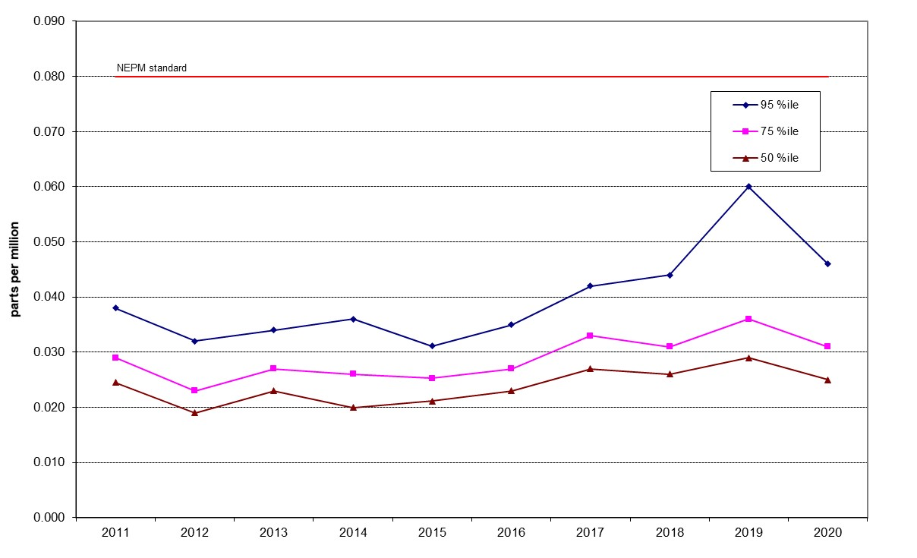

Figure 33: Statistical summary for daily maximum 4-hour O₃ Civic 2011 – 2020

Table 24: Statistical summary for daily maximum 4-hour O₃ Florey 2014 – 2020
Year | Data  Availability  (%) | No. of  Exceedances  (days) | Max  conc.  (ppm) | 95th  percentile  (ppm) | 75th  percentile  (ppm) | 50th  percentile  (ppm)
2014 | 79.4 | 0 | 0.040 | 0.031 | 0.026 | 0.022
2015 | 94.2 | 0 | 0.037 | 0.031 | 0.025 | 0.020
2016 | 95.8 | 0 | 0.050 | 0.038 | 0.029 | 0.026
2017 | 95.5 | 0 | 0.054 | 0.046 | 0.037 | 0.031
2018 | 95.2 | 0 | 0.057 | 0.048 | 0.037 | 0.031
2019 | 95.3 | 3 | 0.109 | 0.064 | 0.038 | 0.031
2020 | 92.0 | 3 | 0.108 | 0.054 | 0.035 | 0.029

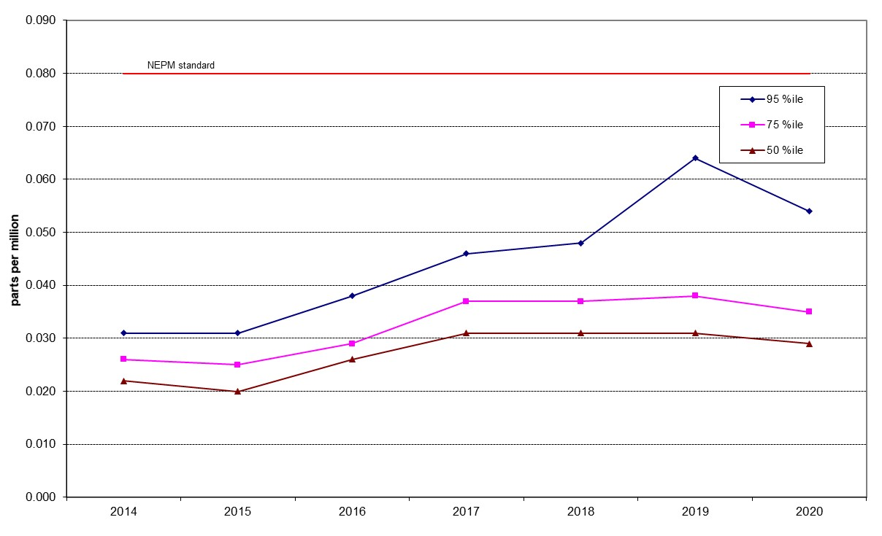

Figure 34: Statistical summary for daily maximum 4-hour O₃ Florey 2014 – 2020

PM₁₀
Table 25: Statistical summary for daily maximum daily PM₁₀ Monash 2011 – 2020
Year | Data  Availability  (%) | No. of  Exceedances  (days) | Max  conc.  (μg/m³) | Annual average  (μg/m³) | 95th  percentile  (μg/m³) | 75th  percentile  (μg/m³) | 50th  percentile  (μg/m³)
2011 | 99.2 | 0 | 40.0 | 10.4 | 22.8 | 13.2 | 8.7
2012 | 98.6 | 0 | 41.0 | 10.4 | 19.7 | 13.7 | 9.7
2013 | 95.6 | 0 | 43.5 | 9.8 | 20.2 | 13.1 | 8.9
2014 | 97.8 | 0 | 39.3 | 10 | 19.1 | 12.9 | 9.6
2015 | 98.4 | 0 | 49.4 | 9.9 | 19.5 | 13.1 | 9.5
2016 | 99.5 | 0 | 31.9 | 9.7 | 21.5 | 12.7 | 9.0
2017 | 98.9 | 0 | 28.3 | 9.8 | 20.5 | 12.3 | 9.0
2018 | 99.2 | 4 | 139.2 | 11.8 | 23.0 | 14.8 | 10.4
2019 | 98.4 | 22 | 385.7 | 19.1 | 61.1 | 17.8 | 11.4
2020 | 99.2 | 21 | 1046.1 | 22.4 | 54.3 | 17.8 | 10.4

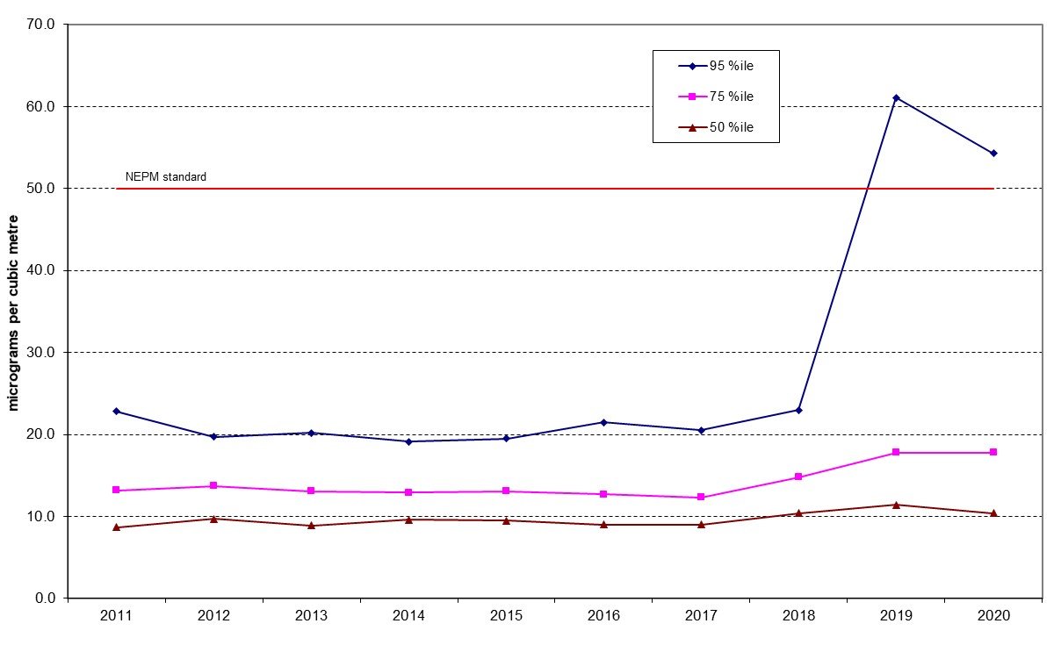
Figure 35: Statistical summary for daily PM₁₀ Monash 2011 – 2020
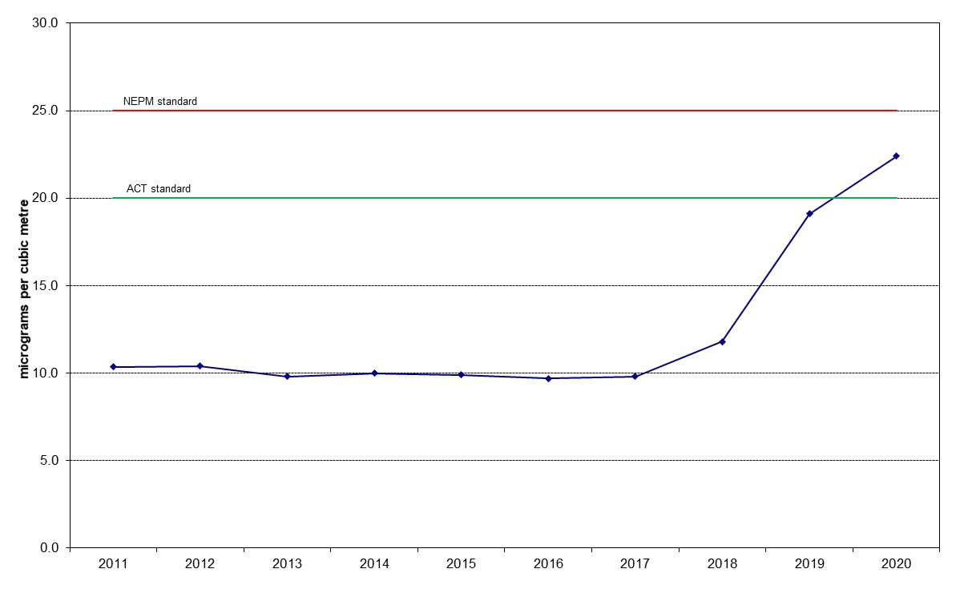

Figure 36: Annual average daily PM₁₀ Monash 2011 – 2020

Table 26: Statistical summary for daily maximum daily PM₁₀ Civic 2011 – 2020
Year | Data  Availability  (%) | No. of  Exceedances  (days) | Max  conc.  (μg/m³) | Annual average  (μg/m³) | 95th  percentile  (μg/m³) | 75th  percentile  (μg/m³) | 50th  percentile  (μg/m³)
2011 | 97.0 | 0 | 29.2 | 8.7 | 16.9 | 11.0 | 7.9
2012 | 95.1 | 0 | 49.5 | 9.4 | 17.0 | 12.1 | 8.7
2013 | 92.9 | 1 | 57.8 | 9.7 | 19.9 | 12.0 | 8.6
2014 | 95.1 | 0 | 31.4 | 9.8 | 17.7 | 12.6 | 9.3
2015 | 97.5 | 1 | 64.3 | 11.1 | 20.9 | 14.1 | 10.4
2016 | 100 | 0 | 36.6 | 10.7 | 20.6 | 14.3 | 9.7
2017 | 83.6 | 1 | 53.0 | 9.68 | 10.8 | 7.1 | 5.2
2018 | 97.8 | 1 | 179.8 | 13.5 | 24.1 | 16.1 | 11.3
2019 | 97.3 | 29 | 390.2 | 22.9 | 82.5 | 19.5 | 12.7
2020 | 98.4 | 24 | 994.9 | 21.7 | 56.7 | 15.2 | 10.0
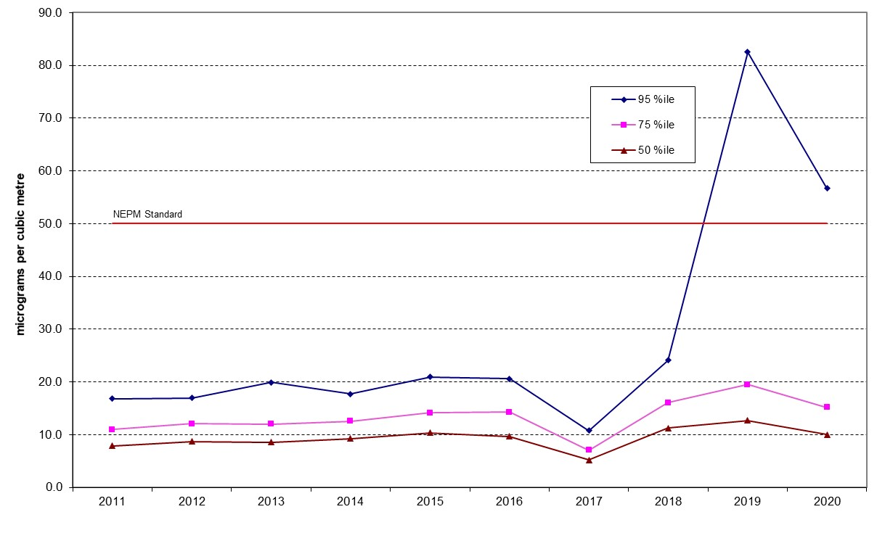
Figure 37: Statistical summary for daily PM₁₀ Civic 2011 – 2020
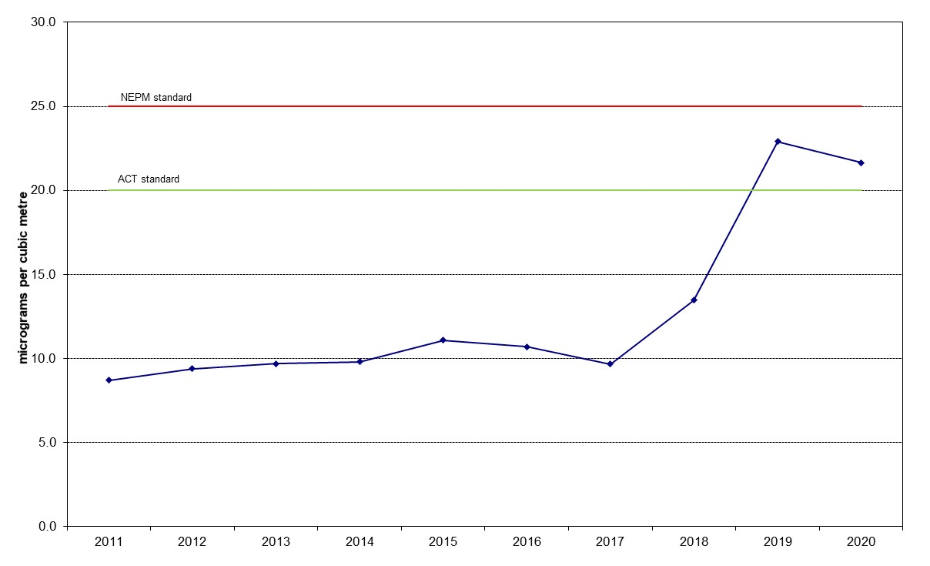

Figure 38: Annual average daily PM₁₀ Civic 2011 – 2020
Table 27: Statistical summary for daily maximum daily PM₁₀ Florey 2014 – 2020
Year | Data  Availability  (%) | No. of  Exceedances  (days) | Max  conc.  (μg/m³) | Annual average  (μg/m³) | 95th  percentile  (μg/m³) | 75th  percentile  (μg/m³) | 50th  percentile  (μg/m³)
2014 | 83.3 | 0 | 30.2 | 10.4 | 21.5 | 13.0 | 9.4
2015 | 95.6 | 0 | 70.8 | 10.7 | 21.8 | 13.7 | 9.4
2016 | 98.9 | 0 | 28.8 | 10.1 | 20.6 | 13.1 | 9.2
2017 | 98.4 | 0 | 28.1 | 9.84 | 21.8 | 12.8 | 8.5
2018 | 89.9 | 3 | 158.6 | 12.0 | 23.8 | 15.3 | 10.1
2019 | 98.1 | 28 | 379.7 | 23.8 | 96.8 | 20.6 | 13.4
2020 | 99.5 | 21 | 1075.5 | 22.8 | 57.5 | 17.9 | 10.9

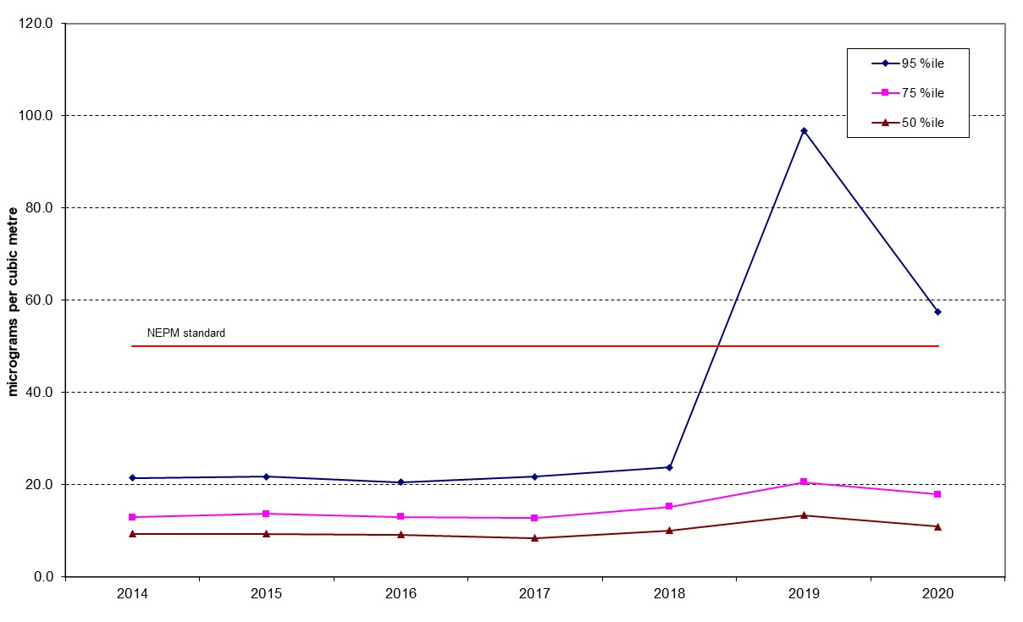

Figure 39: Statistical summary for daily PM₁₀ Florey 2014 – 2020

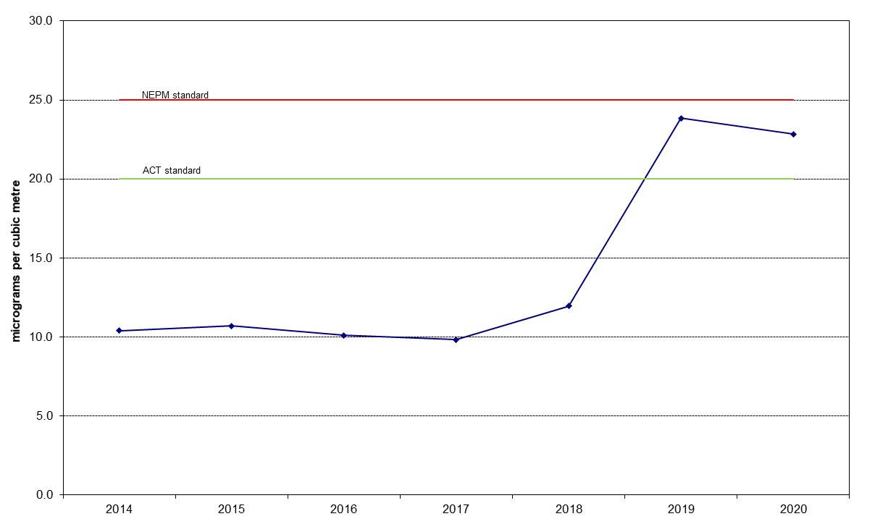

Figure 40: Annual average daily PM₁₀ Florey 2014 – 2020

PM_{2.5}
Table 28: Statistical summary for daily maximum daily PM_{2.5} Monash 2011 – 2020
Year | Data  Availability  (%) | No. of  Exceedances  (days) | Max  conc.  (μg/m³) | Annual average  (μg/m³) | 95th  percentile  (μg/m³) | 75th  percentile  (μg/m³) | 50th  percentile  (μg/m³)
2011 | 92.1 | 4 | 32.8 | 6.5 | 20.0 | 7.0 | 4.5
2012 | 95.1 | 3 | 29.2 | 7.1 | 16.5 | 8.3 | 5.0
2013 | 98.6 | 6 | 38.4 | 6.9 | 19.2 | 8.1 | 5.2
2014 | 87.7 | 4 | 31.5 | 6.8 | 18.7 | 8.6 | 5.6
2015 | 96.4 | 6 | 33.8 | 7.4 | 19.0 | 8.2 | 5.6
2016 | 98.1 | 8 | 32.7 | 7.4 | 20.7 | 8.2 | 5.4
2017 | 98.6 | 12 | 35.2 | 7.7 | 22.5 | 9.3 | 5.3
2018 | 99.2 | 2 | 32.0 | 6.8 | 19.2 | 8.6 | 5.3
2019 | 98.9 | 28 | 307.9 | 14.1 | 42.7 | 12.5 | 7.2
2020 | 98.6 | 37 | 1146.5 | 17.9 | 38.4 | 11.3 | 5.7
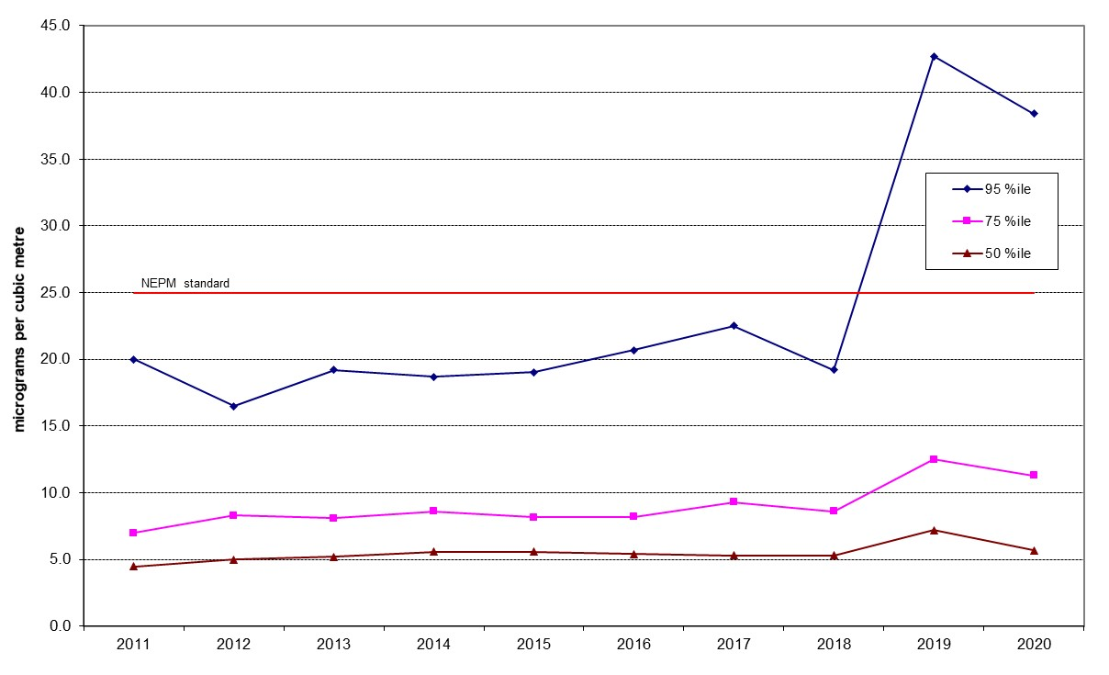
Figure 41: Statistical summary for daily PM_{2.5} Monash 2011 – 2020
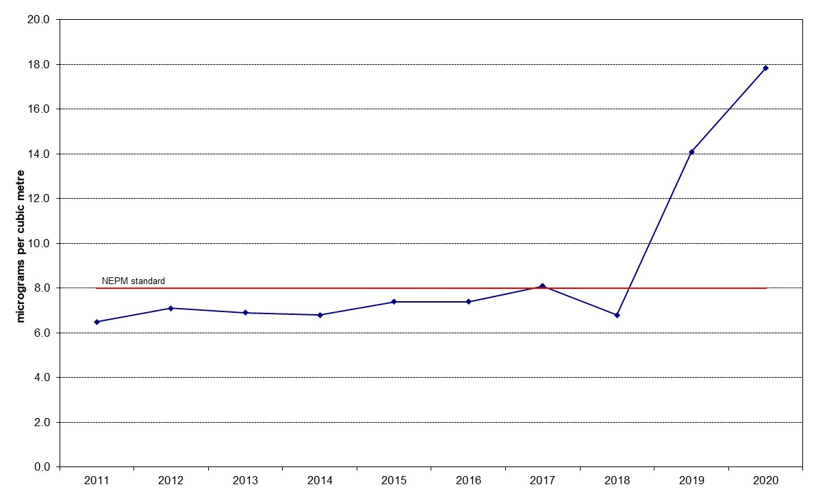
Figure 42: Annual average daily PM_{2.5} Monash 2011 – 2020

Table 29: Statistical summary for daily maximum daily PM_{2.5} Civic 2016 – 2020
Year | Data  Availability  (%) | No. of  Exceedances  (days) | Max  conc.  (μg/m³) | Annual average  (μg/m³) | 95th  percentile  (μg/m³) | 75th  percentile  (μg/m³) | 50th  percentile  (μg/m³)
2016 | 98.6 | 0 | 22.1 | 5.5 | 11.0 | 7.1 | 4.8
2017 | 94.2 | 1 | 53.8 | 5.9 | 10.8 | 7.1 | 5.2
2018 | 98.6 | 1 | 36.1 | 6.5 | 12.1 | 8.1 | 6.1
2019 | 96.4 | 29 | 390.2 | 22.9 | 82.5 | 19.5 | 12.7
2020 | 99.2 | 18 | 872.6 | 12.9 | 24.8 | 7.6 | 5.1

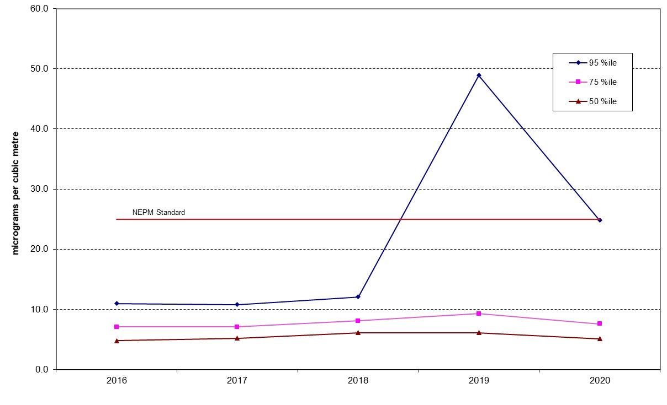

Figure 43: Statistical summary for daily PM_{2.5} Civic 2016 – 2020
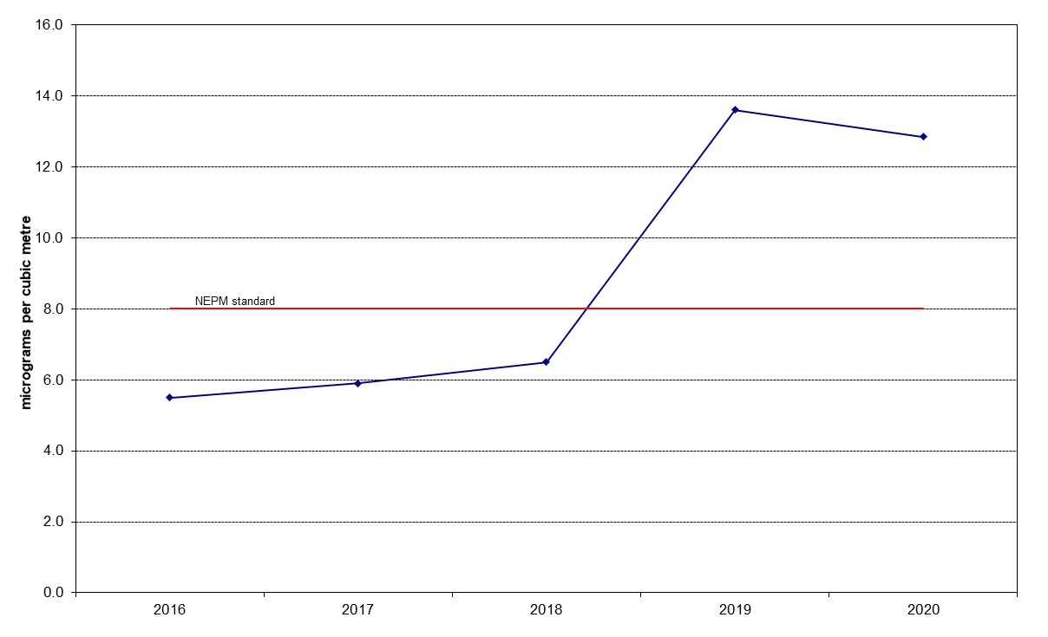

Figure 44: Annual average daily PM_{2.5} Civic 2016 – 2020

Table 30: Statistical summary for daily maximum daily PM_{2.5} Florey 2014 – 2020
Year | Data  Availability  (%) | No. of  Exceedances  (days) | Max  conc.  (μg/m³) | Annual average  (μg/m³) | 95th  percentile  (μg/m³) | 75th  percentile  (μg/m³) | 50th  percentile  (μg/m³)
2014 | 74.2 | 0 | 22.8 | 5.8 | 15.0 | 7.1 | 4.9
2015 | 96.2 | 0 | 24.3 | 6.5 | 17.1 | 7.4 | 4.8
2016 | 98.6 | 1 | 27.2 | 7.3 | 17.4 | 8.6 | 5.8
2017 | 94.2 | 0 | 23.8 | 7.2 | 17.9 | 8.7 | 5.6
2018 | 97.3 | 2 | 26.4 | 7.4 | 17.0 | 8.7 | 5.9
2019 | 98.4 | 29 | 319.6 | 14.8 | 46.9 | 12.3 | 7.2
2020 | 97.3 | 25 | 983.4 | 16.9 | 28.8 | 12.2 | 5.9

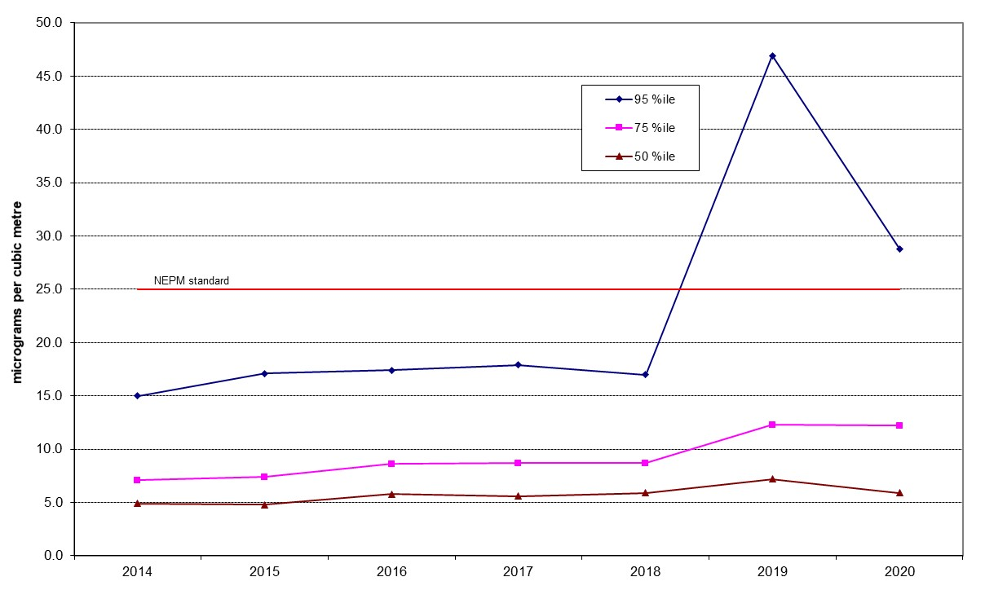
Figure 45: Statistical summary for daily PM_{2.5} Florey 2014 – 2020
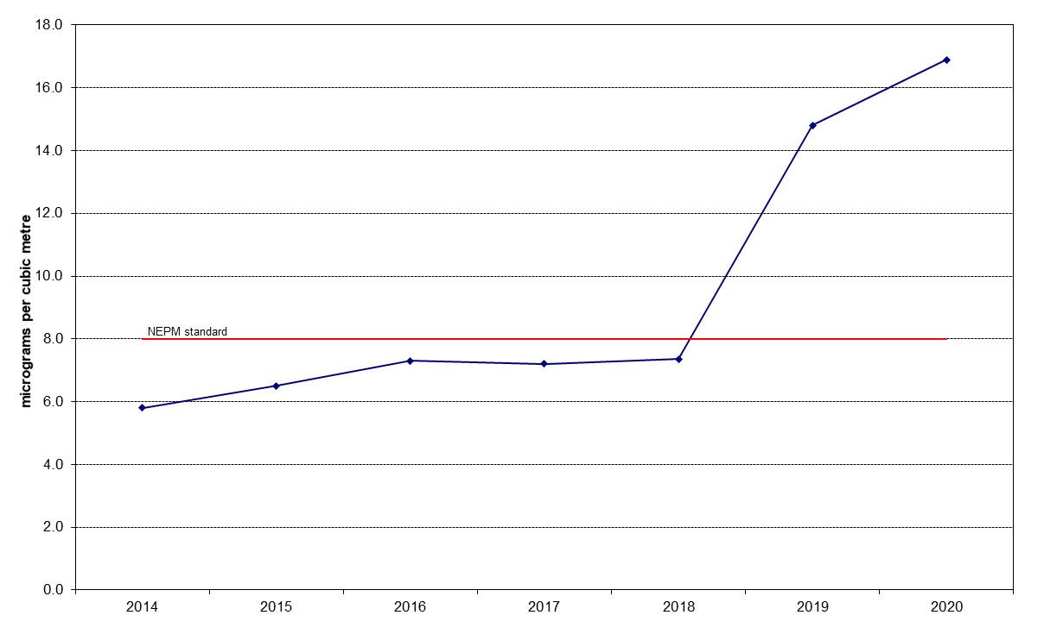
Figure 46: Annual average daily PM_{2.5} Florey 2014 – 2020

APPENDIX A Exceedance Summary

Table 31: PM₁₀ Daily Exceedances in 2020

Date | Monitoring Station |  |  | Inferred Cause | Exceptional Event
 | Monash  (μg/m³) | Civic  (μg/m³) | Florey  (μg/m³)
01/01/2020 | 1046.1 | 881.8 | 857.3 | Bushfire | Yes
02/01/2020 | 453.6 | 462.8 | 451.9 | Bushfire | Yes
03/01/2020 | 188.3 | 127.6 | 156.1 | Bushfire | Yes
04/01/2020 | 206.7 | 277.5 | 328.1 | Bushfire | Yes
05/01/2020 | 759.0 | 994.9 | 1075.5 | Bushfire | Yes
07/01/2020 | 65.7 | 68.5 | 71.3 | Bushfire | Yes
08/01/2020 | 145.2 | 137.3 | 142.7 | Bushfire | Yes
10/01/2020 | 65.6 | 76.4 | 75.0 | Bushfire | Yes
11/01/2020 | 96.2 | 115.7 | 115.6 | Bushfire | Yes
12/01/2020 | 89.6 | 109.6 | 110.7 | Bushfire | Yes
13/01/2020 | 74.8 | 85 | 82.7 | Bushfire | Yes
14/01/2020 | 54.5 | 64.4 | 61.3 | Bushfire | Yes
16/01/2020 | 62.6 |  |  | Bushfire | Yes
17/01/2020 |  | 51.3 | 53.7 | Bushfire | Yes
23/01/2020 | 84.8 | 150 | 144.4 | Dust Storm | Yes
24/01/2020 | 52.6 | 70.9 | 63.5 | Dust Storm | Yes
25/01/2020 |  | 59.4 | 58.2 | Dust Storm | Yes
26/01/2020 | 86.5 | 56.4 |  | Bushfire | Yes
27/01/2020 | 112.4 | 77.8 | 64.6 | Bushfire | Yes
28/01/2020 | 69.3 |  |  | Bushfire | Yes
29/01/2020 | 92.8 | 63 |  | Bushfire | Yes
30/01/2020 |  | 54.4 |  | Bushfire | Yes
31/01/2020 | 51.9 | 51.5 | 52.0 | Bushfire | Yes
01/02/2020 | 98.7 | 114.8 | 119.5 | Bushfire | Yes
02/02/2020 |  | 54 |  | Bushfire  Dust Storm | Yes
03/02/2020 |  | 56 | 58.8 | Bushfire  Dust Storm | Yes
04/02/2020 |  |  | 60.2 | Bushfire  Dust Storm | Yes

Table 32: PM_{2.5} Daily Exceedances in 2020

Date | Monitoring Station |  |  | Inferred Cause | Exceptional Event
 | Monash  (μg/m³) | Civic  (μg/m³) | Florey  (μg/m³)
01/01/2020 | 1146.5 | 827.1 | 839.1 | Bushfire | Yes
02/01/2020 | 495.0 |  | 439.4 | Bushfire | Yes
03/01/2020 | 188.2 |  | 130.2 | Bushfire | Yes
04/01/2020 | 159.3 | 213.8 | 258.5 | Bushfire | Yes
05/01/2020 | 783.6 | 872.6 | 983.4 | Bushfire | Yes
06/01/2020 | 29.8 |  | 27.1 | Bushfire | Yes
07/01/2020 | 56.7 | 46.4 | 48.5 | Bushfire | Yes
08/01/2020 | 140.5 | 103.8 | 121.0 | Bushfire | Yes
10/01/2020 | 28.6 |  |  | Bushfire | Yes
11/01/2020 | 88.6 | 91.3 | 92.4 | Bushfire | Yes
12/01/2020 | 82.2 | 92.6 | 102.2 | Bushfire | Yes
13/01/2020 | 74.5 | 76.1 |  | Bushfire | Yes
14/01/2020 | 54.7 | 42.4 | 48.1 | Bushfire | Yes
15/01/2020 | 31.8 |  |  | Bushfire | Yes
16/01/2020 | 64.0 |  |  | Bushfire | Yes
17/01/2020 | 35.2 | 50.2 | 52.4 | Bushfire | Yes
26/01/2020 | 74.8 | 26.0 |  | Bushfire | Yes
27/01/2020 | 104.4 | 64.0 | 57.5 | Bushfire | Yes
28/01/2020 | 61.5 | 34.8 | 30.5 | Bushfire | Yes
29/01/2020 | 68.9 | 54.1 | 33.7 | Bushfire | Yes
30/01/2020 | 39.9 | 34.1 |  | Bushfire | Yes
31/01/2020 | 46.1 |  | 26.7 | Bushfire | Yes
01/02/2020 | 27.2 |  |  | Bushfire | Yes
03/02/2020 |  | 26.9 | 36.5 | Bushfire | Yes
04/02/2020 | 27.9 | 38.2 | 50.1 | Bushfire | Yes
05/20/2020 | 38.4 | 27.4 | 31.9 | Bushfire | Yes
16/05/2020 | 31.83 |  |  | Wood Heater | No
17/05/2020 | 26.93 |  | 26.3 | Wood Heater | No
30/05/2020 | 28.5 |  |  | Wood Heater | No
06/06/2020 | 31.2 |  |  | Wood Heater | No
07/06/2020 | 35.3 |  | 30.8 | Wood Heater | No
08/06/2020 | 27.0 |  | 25.1 | Wood Heater | No
13/06/2020 | 25.6 |  |  | Wood Heater | No
27/06/2020 |  |  | 28.6 | Wood Heater | No
28/06/2020 | 27.0 |  | 26.3 | Wood Heater | No
10/07/2020 | 28.4 |  | 25.9 | Wood Heater | No
11/07/2020 | 27.8 |  |  | Wood Heater | No
01/08/2020 | 27.9 |  |  | Wood Heater | No
02/08/2020 | 28.8 |  |  | Wood Heater | No

Table 33: Carbon Monoxide 8-hour Exceedances in 2020
Date | Monitoring Station |  | Inferred Cause
 | Monash  (ppm) | Florey  (ppm)
01/01/2020 | 22.00 | 13.76 | Bushfire
05/01/2020 | 11.58 | 14.64 | Bushfire

Table 34: Nitrogen Dioxide 1-hour Exceedances in 2020
Date | Monitoring Station | Inferred Cause
Florey
(ppm)
04/01/2020 | 0.152 | Bushfire
05/01/2020 | 0.171 | Bushfire

Table 35: Ozone 1-hour and 4-hour Exceedances in 2020
Date | Monitoring Station |  |  |  |  |  | Inferred Cause
 | Monash  (ppm) |  | Civic  (ppm) |  | Florey  (ppm)
 | 1 Hour | 4 Hour | 1 Hour | 4 Hour | 1 Hour | 4 Hour
01/01/2020 | 0.104 | 0.100 |  | 0.086 | 0.111 | 0.105 | Bushfire
02/01/2020 |  | 0.093 |  | 0.082 | 0.118 | 0.108 | Bushfire
07/01/2020 |  | 0.080 |  |  |  | 0.085 | Bushfire
31/01/2020 | 0.104 | 0.087 |  |  |  |  | Bushfire

