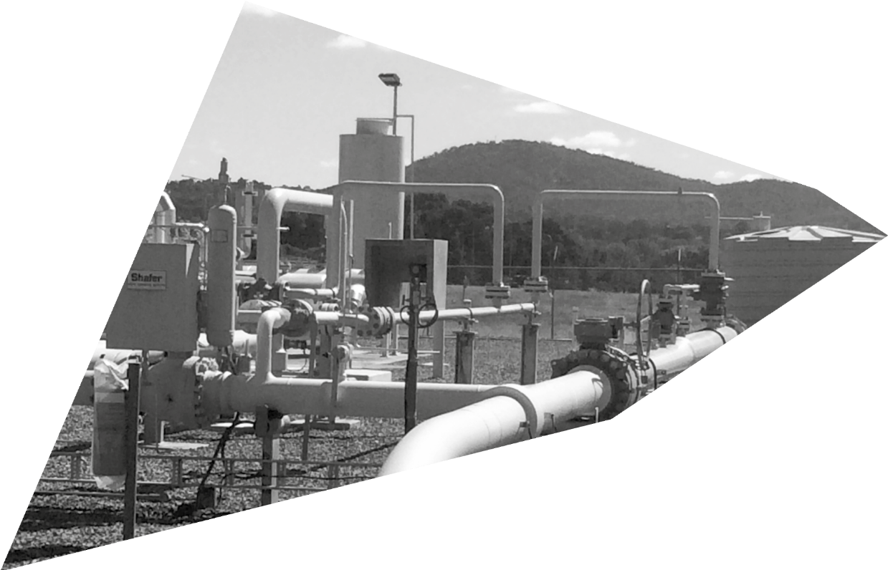

OPERATING CERTIFICATES –
A GUIDE FOR PROVIDERS
OF UNLICENSED REGULATED UTILITY SERVICES
OCTOBER 2020

Produced by the Environment, Planning and Sustainable Development
© Australian Capital Territory, Canberra 2020
This work is copyright. Apart from any use as permitted under the Copyright Act 1968, no part may be reproduced by any process without written permission from:
Director-General, Environment, Planning and Sustainable Development Directorate, ACT Government, GPO Box 158, Canberra ACT 2601.
Telephone: 02 6207 1923
Website: www.planning.act.gov.au

Acknowledgment to Country
We wish to acknowledge the traditional custodians of the land we are meeting on, the Ngunnawal people. We wish to acknowledge and respect their continuing culture and the contribution they make to the life of this city and this region.
Accessibility
The ACT Government is committed to making its information, services, events and venues as accessible as possible.
If you have difficulty reading a standard printed document and would like to receive this publication in an alternative format, such as large print, please phone Access Canberra on 13 22 81 or email the Environment, Planning and Sustainable Development Directorate at EPSDDComms@act.gov.au

If English is not your first language and you require a translating and interpreting service, please phone 13 14 50.
If you are deaf, or have a speech or hearing impairment, and need the teletypewriter service, please phone 13 36 77 and ask for Access Canberra on 13 22 81.
For speak and listen users, please phone 1300 555 727 and ask for Canberra Connect on 13 22 81.
For more information on these services visit http://www.relayservice.com.au

INTRODUCTION 1
CONTENTS
PURPOSE OF THE GUIDE 1
KEY TERMS 2
INDEPENDENT COMPETITION AND REGULATORY COMMISSION (ICRC) 3
OPERATING CERTIFICATES 4
Types of operating certificates 4
Operating certificate conditions 5
Revocation of an operating certificate 5
Regulatory Plan 5
Independent Certification 5
Applying for an operating certificate 6
FEES 9
Audits/compliance activities 9
Renewals/amending an Operating Certificate 9
OBLIGATIONS 9
RELEVANT LEGISLATION AND TECHNICAL CODES 10
Legislation 10
Technical Codes 10
Contact 10

The Technical Regulator is responsible for the regulation of licensed and unlicensed regulated utility services. This guidance provides a responsive regulatory framework to the varied needs of constructors and operators of these unlicensed regulated utility services, which include generators and large batteries of 200kW export capacity; larger dams; large water reuse schemes and the light rail.

This guide is also required for operators of utilities that would require a licence from the ICRC under the Utilities Act 2000 who have received an exemption from holding this licence by the relevant Minister. These exempted utilities require an operating certificate from the Technical Regulator.

INTRODUCTION

The Utilities Technical Regulation team within Access Canberra supports the Technical Regulator in the administration of the Utilities Act 2000 and Utilities (Technical Regulation) Act 2014 through the regulation of regulated utility services, which includes the issuing of operating certificates.
Regulated utility services include:
→ the transmission, distribution, connection, or generation of electricity;
→ the transmission, distribution, or connection of gas;
→ the collection and/or treatment of water for distribution through a water network and the distribution of water through the network;
→ the conveyance, collection, treatment and disposal of sewage;
→ making a water or sewerage network available for connection services;
→ a water or sewerage connection service; and
→ prescribed unlicensed regulated utilities, including the light rail network.
Regulated utility services must be designed, constructed, maintained and operated to meet the minimum safety, reliability and functional requirements of the installation. If you propose to provide or provide a regulated utility service under the Utilities (Technical Regulation) Act 2014, but are not required to be licensed under the Utilities
Act 2000 (or are exempt), you will require an operating certificate. The operating certificate is issued by the Technical Regulator to ensure the safe and reliable supply of a regulated utility service in relation to technical regulation.

PURPOSE OF THE GUIDE
This guide aims to support applicants through the process of applying for an operating certificate. The guide outlines who requires an operating certificate, eligibility criteria for obtaining an operating certificate and the associated fees.

KEY TERMS

TERM | DESCRIPTION
Applicant | An applicant may be the owner, an operator or an agent acting on behalf of a regulated utility.
Discrete District Network | Discrete district network means infrastructure that is not connected to a network and issued for 1 or more of the following:  - providing a form of energy to more than 1 building or premises;  - converting a form of energy to another form of energy and providing that energy to more than 1 building or premises;  - providing reticulated gas, water or another fluid to more than 1building or premises;  - storing a form of energy, gas, water or another fluid for provision to more than 1 building or premises
District energy service | District energy systems generate power locally and capture waste heat from power generation to provide heating and cooling services to buildings in the ACT.
Electricity generation | Electricity generation is the process of generating electric power from sources of primary energy.
Energy Storage System | Energy Storage Systems refer to equipment that can store electrical energy in a safe and efficient manner so that it can be used at a later time. Lithium ion batteries and pumped hydro are most commonly used technologies for energy storage
Independent Competition and Regulatory Commission | The Independent Competition and Regulatory Commission (ICRC) is responsible for administering the licensing framework, which includes the granting, varying, transferring and revoking of licenses.
Kilowatt | A measure of one thousand watts of electrical power.
Licensed Utility | A licensed utility is a regulated utility that holds a licence under the Utilities Act 2000.
Light rail | A light rail network and the infrastructure it consists of is a regulated utility service.
Registrable Dam | A dam which is greater than 5 metres in height and/or has a water storage capacity of more than 250 mega-litres.
Regulated Utility | A person who provides a service that is a regulated utility service under the Utilities (Technical Regulation) Act 2014.
Regulated utility services | Each of the following is a regulated utility service as defined by section 9 and 10 of the Utilities (Technical Regulation) Act 2014:  - a utility service under the Utilities Act 2000, part 2;  - a regulated utility service prescribed under section 10 of the Utilities (Technical Regulation) Act 2014;  - in relation to electricity—small (<200kW) or medium (200kW – 1MW) scale electrical generation;  - in relation to electricity—the supply of electricity from an electricity network to premises;  - in relation to gas—the supply of gas from a gas network to premises;  - in relation to water—owning, leasing or subleasing a registrable dam;  - the provision of a district energy service.

TERM | DESCRIPTION
Technical Regulator | The Director-General of the Environment, Planning and Sustainable Development Directorate is the Technical Regulator of utility services in the Australian Capital Territory (ACT). The role of the Technical Regulator is to ensure safe, reliable and efficient delivery of gas, electricity and water services to the ACT community.
Unlicensed Utility | A person who provides, or proposes to provide a regulated utility service under the Utilities (Technical Regulation) Act 2014, but is not required to be licensed under the Utilities Act 2000 or is exempt from the requirements to be licensed under that Act.
Utility Service | The distribution or transmission of gas, water or electricity through a network. Please refer to the Utilities Act 2000 for specific definitions

INDEPENDENT COMPETITION AND REGULATORY COMMISSION (ICRC)

The ICRC is the economic regulator responsible for licensing utilities in the ACT under the Utilities Act 2000, which includes the granting, varying, transferring and revoking of licences.
Regulated utility service providers, who do not hold a license under the Utilities Act 2000, may apply for an exemption. An exemption is a Ministerial decision, typically based on policy consideration of economic, social, environmental and technical factors relating to the service. Essential Energy is a NSW Electricity Distributor and the Inner North Reticulation Network is a stormwater reuse system that are both regulated utility services which currently hold a licence exemption under the Utilities Act 2000 and an operating certificate issued by the Technical Regulator.
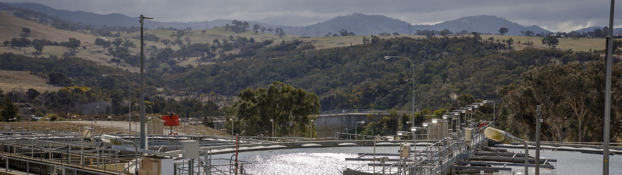
The operator of an exempted utility must hold an operating certificate issued by the Technical Regulator. For more information about obtaining a utility licence visit the ICRC website.

OPERATING CERTIFICATES

Operating certificates were introduced under the Utilities (Technical Regulation) Act 2014, to regulate unlicensed utilities. Operating certificates are issued to the entity providing unlicensed regulated services. This may be the owner, operations manager or an agent acting as owner’s representative. Operating Certificates serve to address the following objectives:
→ Safe, reliable and efficient delivery of regulated utility services
→ Promotion of long term serviceability of the network
→ Promotion of network’s design integrity and functionality; and
→ Safe and reliable operation of a regulated utility service.
Regulated utility services that require an operating certificate are outlined as follows and as introduced at the beginning of this guide:
SERVICES DESCRIPTION

TYPES OF OPERATING CERTIFICATES
Design and Construct
The purpose of a design and construct operating certificate for regulated utility infrastructure is to demonstrate to the Technical Regulator that the unlicensed regulated utility service can be provided in a safe, reliable and efficient manner when the infrastructure is used to deliver a regulated utility service.
The design and construct operating certificate is issued to an owner or owner’s agent before the design and construction of the infrastructure required to provide a regulated utility service. An application should be made prior to commencing detailed design of the infrastructure that will provide the regulated utility service and must
be accompanied by a regulatory plan and other supporting documents.

Potential Regulated Utility

Infrastructure, Activities and Services requiring an Operating Certificate
The design and construct operating certificate will normally be conditioned to end upon completion and commissioning of the regulated utility infrastructure and prior to regular operation of the facility to deliver

Dams A registrable dam is a regulated utility and
will require an operating certificate.
the regulated utility service.

District energy services
Light Rail network

Electrical Generation

Licence exempt regulated utilities
A district energy service is a regulated utility and will require an operating certificate.
A light rail network and the infrastructure it consists of is a regulated utility service and required an operating certificate.
Small, medium or large scale electricity generation system are regulated utilities and will require an operating certificate if capable of generating between 200kW and 30 MW. This includes solar farms, rooftop PV solar installations, mini hydro generating systems, micro wind turbines and Biogas genrators.
An exempt regulated utility providing a utility service will require an operating certificate. For example the Inner North Reticulation Network has licence
exemption and an operating certificate.
Provision of Service
The purpose of a provision of service operating certificate for regulated utility infrastructure is to provide confidence to the Technical Regulator that the unlicensed regulated utility service will be provided in a safe, reliable and efficient manner for the period of the operating certificate.
The Provision of Service operating certificate is issued to an unlicensed regulated utility that is ready to commence providing the regulated utility service. An application should be made to the Technical Regulator at least two months prior to commencing regular operation of the infrastructure that will provide the regulated utility service and will need to be accompanied by a regulatory plan and other supporting documentation (if applicable).
Provision of service operating certificates are issued for a five year period unless an alternate period is deemed appropriate by the Technical Regulator.

OPERATING CERTIFICATE CONDITIONS
Operating certificates may contain two kinds of conditions.
→ ‘General’ conditions – This type of condition relates to the general administration of the operating certificate, such as the requirement to notify the Technical Regulator if there is a change of ownership. General conditions appear on all operating certificates.
→ ‘Special’ conditions - These types of conditions are more specific to each utility service being provided and usually relate to operational/maintenance requirements of the facility.
All conditions of an operating certificate must be complied with. Where a utility fails to comply with conditions of
an operating certificate, the Technical Regulator may revoke the operating certificate suspending all delivery of utility services, in accordance with the Utilities (Technical Regulation) Act 2014.

REVOCATION OF AN OPERATING CERTIFICATE
The Technical Regulator holds the power to revoke an operating certificate if satisfied on reasonable grounds that an unlicensed regulated utility does not comply with the Utilities (Technical Regulation) Act 2014 or a condition of the operating certificate under section 48. Before revocation, the Technical Regulator must give the unlicensed regulated utility a written notice of the proposed revocation, the reasons for the revocation and allow 20 days for the written submission period. The Technical Regulator must consider the submission given by the unlicensed regulated utility.

REGULATORY PLAN
A regulatory plan is required with an application for a Design and Construct operating certificate and a Provision of Service operating certificate. A Design and Construct operating certificate regulatory plan should outline design and construction specifications to a degree that provides the Technical Regulator confidence the utility will be designed and constructed in a safe, reliable and efficient manner. In the same way, a Provision of Service operating certificate regulatory plan should outline operational and maintenance standards, again providing the Technical Regulator confidence the utility will be operated and maintained in a safe, reliable and efficient manner.
The regulatory plan is essential to support an operating certificate application. A regulatory plan is a document that describes the specific steps and action required to successfully meet the regulatory objectives. The regulatory plan should consider the design, construction, testing and commissioning, augmentation, extension, operation and
maintenance of the regulated utility service, and identify key milestones and supporting documentation/management systems within this process. The plan should identify the entities involved with the service and demonstrate the suitability of any key staff for their identified role. The plan should also consider and address regulatory requirements of relevant legislation, technical codes and standards, including environmental considerations.
Details of engineering design, safe work method systems, maintenance schedules, inspection/testing plans and environmental control plans, among other documents may support the regulatory plan.
The regulatory plan should state the length of time for which the operating certificate is sought. You will need to justify this timeframe and include time appropriate operation and maintenance considerations within the regulatory plan. The regulatory plan would ideally cover the utility for the life of the service, however as operating certificates are normally issued for a 5 year period, you may consider the length of time the regulatory plan is covering, noting that this may require a new regulatory plan to be produced prior to renewal of an operating certificate. In addition, if you are submitting a design and construct operating certificate regulatory plan, this should only be for the period in which the utility will
be designed and constructed, prior to operation.

INDEPENDENT CERTIFICATION
The independent certifier is an individual or entity with relevant qualifications and experience in certification specific to the regulated utility service intended to be provided.
Complete independence must be maintained, meaning the independent certifier cannot hold any personal or professional interest in the regulated utility service.
The engagement of the independent certifier is subject to the agreement of Utilities Technical Regulation and therefore it is necessary to engage with Utilities Technical Regulation prior to contracting an Independent Certifier. The independent certifier will work directly with Utilities Technical Regulation at times without the utility’s involvement to ensure the safe, reliable and efficient delivery of regulated utility services in the ACT.

It is at the discretion of the utility service provider as to whether they engage an independent certifier or not, however it is recommended by Utilities Technical Regulation. Engagement of an independent certifier often streamlines the application process, assisting with the formation of a suitable regulatory plan and associated documents. The independent certifier can
help demonstrate that you meet each of the criteria for issuing an operating certificate, and provide a signed certificate of compliance to support a regulatory plan. The independent certifier’s role is to certify the Regulatory plan and associated documents in compliance with relevant Australian Standards, Legislation, Technical Codes and any other regulatory framework relevant to the specific service. This reduces the risk associated with a more complex proposal for the Technical Regulator,
and significantly reduces the level of assessment required, with a corresponding reduction in fees payable to the Technical Regulator.

APPLYING FOR AN OPERATING CERTIFICATE
Applications for an operating certificate should be made to Utilities Technical Regulation within Access Canberra.
Prior to making an application, all applicants may prefer to contact Utilities Technical Regulation to discuss the proposal. Fees associated with operating certificates are dependent on the regulated utility service you propose
to provide, along with the accuracy of documents accompanying your application. Fees can be located on the Access Canberra Website.
Whether you require a Design and Construct operating certificate or a Provision of Service operating certificate, or both, will be project specific. Please refer to the earlier section relating to types of operating certificates for more information.

Dams
The Utilities (Technical Regulation) Act 2014 defines a dam as an artificial barrier, and incidental or related works, constructed for the storage or control of water, other liquids, or other material within a liquid but does not include a concrete and steel ring tank that is reliant
on hoop stress for structural stability.
Registrable dams are greater than 5 metres in height and/ or have a water storage capacity of more than 250 mega litres. Registrable dams require an operating certificate.
The Utilities (Dam Safety Code) Determination 2014 applies to the operation of dams. It ensures the proper management of dams to prevent unsafe operation and/or failure.
To gain an operating certificate you will need to undertake the following steps:
- Contact Utilities Technical Regulation to discuss your proposal. You may be asked to supply evidence of this interaction. After speaking with Utilities Technical
Regulation there may be additional documents that you are required to supply specific to your project.
- Prepare the regulatory plan. It is highly recommended that you share a copy of the draft regulatory plan with Utilities Technical Regulation for feedback. This is not mandatory however this will give you an opportunity to received feedback and ensure the final regulatory plan does not require amendments.
- Download Application for an Operating Certificate Form (Available on the Access Canberra Website)
- Submit final regulatory plan and application form to Utilities Technical Regulation for assessment.
- Pay applicable fees
Utilities Technical Regulation have established a Dam Safety Checklist for Dam Owners to assist applicants through to process of applying for an operating certificate in relation to a dam. The checklist can be located here:
District energy services and District water services
A district energy service is a discrete district network operating either electricity to another form of energy; or reticulated gas, water, water vapour or other fluid and is not connected to an electricity, gas, sewerage, and water or prescribed utility service network.
A district energy services that is a discrete district network includes electricity generators without an electricity network connection, connected to multiple buildings.
A district water service is tank or bore water connected to multiple buildings without a water network connection.
To gain an operating certificate you will need to undertake the following steps:
- Contact Utilities Technical Regulation to discuss your proposal. You may be asked to supply evidence of this interaction. After speaking with Utilities Technical
Regulation there may be additional documents that you are required to supply specific to your project.

- Prepare the regulatory plan. It is highly recommended that you share a copy of the draft regulatory plan with Utilities Technical Regulation for feedback. This is not mandatory however this will give you an opportunity to received feedback and ensure the final regulatory plan does not require amendments.
- Download Application for an Operating Certificate Form (Available on the Access Canberra Website)
- Submit final regulatory plan and application form to Utilities Technical Regulation for assessment.
- Pay applicable fees

Electrical Generation
Medium and Large scale (200kW to 30MW) electrical generation systems require an operating certificate. The form of the operating certificate will vary based on the size of the generator and are detailed below.

200kW to 1MW:
A 200kW to 1MW Operating Certificate is required if you intend to operate a generator between 200kW and 1MW. Your system should be installed in accordance with the Electricity Safety Act 1971, with electrical work completed by ACT licensed electricians who are Clean Energy Council accredited, or that has been certified by a Clean Energy Council accredited member. Copies of your certificates will be required with the application.
To gain an operating certificate for an electrical generation system of 200kW to 1MW:
- Contact Utilities Technical Regulation to discuss your proposal. You may be asked to supply evidence of this interaction. After speaking with Utilities Technical Regulation there may be additional documents that you are required to supply specific to your project.
- Prepare a basic maintenance schedule, inverter testing program, emergency plan and single line diagram.
- Apply for and obtain a connection agreement.
- Apply for and obtain a Certificate of Electrical Safety, from the Electrical inspectorate of Access Canberra.
- Submit an Operating Certificate Form and supporting documents to Utilities Technical Regulation for assessment.
- Pay applicable fees.
* If the system has already been installed, please contact the Utilities Technical Regulation Team to discuss options for gaining an operating certificate and coming back into compliance.
Fees associated with the issuing and regulating of an electrical generation system of 200kW to 1MW vary from all other regulated utility services, in that fees are charged as one fee, rather than on an hourly basis. These systems require an inspection by an Access Canberra electrical inspector and application assessment by Utilities Technical Regulation.

1MW to 30MW:
To gain an operating certificate for an electrical generation system of 1MW to 30MW:
- Contact Utilities Technical Regulation to discuss your proposal. You may be asked to supply evidence of this interaction. After speaking with Utilities Technical Regulation there may be additional documents that you are required to supply specific to your project.
- Prepare a Regulatory Plan. It is highly recommended that you share a copy of the draft regulatory plan with Utilities Technical Regulation for feedback. This is not mandatory however this will give you an opportunity to received feedback and ensure the final regulatory plan does not require amendments.
- Apply for and obtain a connection agreement.
- Apply for and obtain a Certificate of Electrical Safety, from the Electrical inspectorate of Access Canberra.
*please note these systems require certification by an independent certifier prior to issuing of a certificate of Electrical Safety. For more information please contact Utilities Technical Regulation.
- Submit an Operating Certificate Form and supporting documents to Utilities Technical Regulation for assessment.
- Pay applicable fees.
Further information on utility connection requirements for micro, small, medium and larger scale generation is available in the Electrical note – Installing grid connected photovoltaic systems in the ACT or through Evoenergy, the ACT’s Electricity Distributor. Your connection agreement with Evoenergy will vary based on the size
of your generator.

Licence exempt regulated utilities
The Minister for the Environment and Heritage can exempt an entity from requiring a licence for electricity distribution and transmission; gas distribution and transmission; or water and sewerage collection, treatment, distribution and conveyance.
Any exemption would be based on consideration of economic, social, environmental and technical factors relating to the service.
There is still a requirement for an operator of an exempted utility to hold an operating certificate issued by the Technical Regulator.
To gain an operating certificate for an exempt regulated utility:
  - Contact Utilities Technical Regulation to discuss your proposal. You may be asked to supply evidence of this interaction. After speaking with Utilities Technical Regulation there may be additional documents that you are required to supply specific to your project.
  - Prepare a Regulatory Plan. It is highly recommended that you share a copy of the draft regulatory plan with Utilities Technical Regulation for feedback. This is not mandatory however this will give you an opportunity to received feedback and ensure the final regulatory plan does not require amendments.
  - Submit an Operating Certificate Form and supporting documents to Utilities Technical Regulation for assessment.
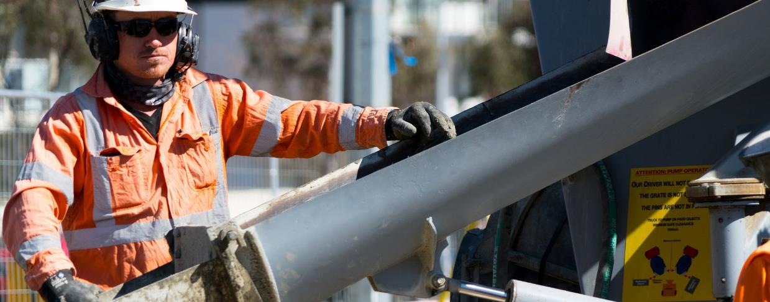
  - Pay applicable fees.
Light Rail
A light rail utility infrastructure network is a regulated utility service and requires an operating certificate.
To gain an operating certificate for a light rail utility infrastructure:
- Contact Utilities Technical Regulation to discuss your proposal. You may be asked to supply evidence of this interaction. After speaking with Utilities Technical Regulation there may be additional documents that you are required to supply specific to your project.
- Prepare a Regulatory Plan. It is highly recommended that you share a copy of the draft regulatory plan with Utilities Technical Regulation for feedback. This is not mandatory however this will give you an opportunity to received feedback and ensure the final regulatory plan does not require amendments.
- Submit an Operating Certificate Form and supporting documents to Utilities Technical Regulation for assessment.
- Pay applicable fees.

FEES
The Utilities (Technical Regulation) Operating Certificate Fees Determination 2019 (the Instrument) is a disallowable instrument under the Utilities (Technical Regulation) Act 2014 which sets out the fees payable by unlicensed regulated utilities for grant of an operating certificate and ongoing regulatory activities.
Fees are determined on a cost recovery basis, meaning the number of staff and hours required to determine eligibility for an operating certificate will determine the final amount due. This fee structure commences from the date of application.
Where possible, Utilities Technical Regulation aims to advise estimated costs as early as possible. UTR will provide regular estimates of associated cost throughout the application process.
There are things you can do to reduce the overall costs associated with gaining an operating certificate:
→ Early transparent engagement with Utilities Technical Regulation. By engaging early, Utilities Technical Regulation will be able to guide you through the process, reducing the need to repeat steps once an application has been received for clarity.
→ Identify and engage (Once agreed by Utilities Technical Regulation) an independent certifier.
→ Where additional information has been requested, be sure to ask any clarifying question you may have. If Utilities Technical Regulation has to review documents and request additional information multiple times, it will increase your overall fees.

AUDITS/COMPLIANCE ACTIVITIES
Audits and compliance activities are carried out in accordance with the operating certificate conditions and the Technical Regulator’s legislated obligations. Fees associated in undertaking audits and compliance activities are charged on a cost recovery basis. The fee
determination outlines the hourly rate for these activities.
Collaboration between Utilities Technical Regulation and the Regulated Utility service will streamline the
process, reducing the need for duplication and the overall associated costs.

RENEWALS/AMENDING AN OPERATING CERTIFICATE
Fees associated with renewing or amending an operating certificate are charged on a cost recovery basis. Depending on the complexity of the renewal or amendment, the amount of time and resources required may vary greatly. For example, for renewal of an existing operating certificate where there has been no change to the operation and maintenance, the process is fairly simple and therefore does not require an extended amount of time to assess.

OBLIGATIONS
There are offences related to non-compliance with operating certificates and the conditions of an operating certificate.
These are listed here for your convenience, as prescribed by part 6 of the Utilities (Technical Regulation) Act 2014.
Offence—providing regulated utility service without operating certificate
→ An unlicensed regulated utility commits an offence if
  - the unlicensed regulated utility provides a regulated utility service; and (b) an operating certificate is not in force in relation to the unlicensed regulated utility.
→ Maximum penalty: 3 000 penalty units.
Offence—constructing regulated utility service without operating certificate
→ An unlicensed regulated utility commits an offence if (a) the unlicensed regulated utility constructs infrastructure for the provision of a regulated utility service; and (b)
an operating certificate is not in force in relation to the unlicensed regulated utility.
→ Maximum penalty: 3 000 penalty units.
The Legislation Act 2001 defines a penalty unit as:
- For an offence committed by an individual—$160; or
- For an offence committed by a corporation—$810.

RELEVANT LEGISLATION AND TECHNICAL CODES

LEGISLATION
Construction Occupations (Licensing) Act 2004 Electricity Safety Act 1971
Gas Safety Act 2000
Utilities (Technical Regulation) Act 2014
Utilities (Technical Regulation) Listed Dams Determination 2019
Utilities (Technical Regulation) Operating Certificate Fees Determination 2019
Utilities (Technical Regulation) Regulation 2017 Utilities Act 2000
Water and Sewerage Act 2000

TECHNICAL CODES
Light rail codes
Light Rail Regulated Utility (Electrical) Network Boundary Code 2016
Light Rail Regulated Utility (Electrical) Network Code 2016

Electricity codes
Electricity Distribution Supply Standards Code 2013 Electricity Metering Code 2015
Electricity Service and Installation Rules Code 2013 Management of Electricity Network Assets Code 2013 Electricity Network Boundary Code 2017
Electricity Powerline Vegetation Management Code 2018 Electricity Transmission Supply Code 2016
Gas codes
Gas Service and Installation Rules Code 2013 Gas Network Boundary Code 2018
Water codes
Non-drinking Water Supply Code 2014 ACT Dam Safety Code 2018
Utilities (Technical Codes) Determination 2000 Water Metering Code
Water and Sewerage Service and Installation Code
Water and Sewerage Network (Design and Maintenance) Code
Water supply and Sewerage Service Standards Code Contestable Work Accreditation Code
Utilities (Technical Regulation) Dams Register - Required Information Determination 2015 (No 1)
Water and Sewerage Network Boundary Code 2018

All sector codes
Emergency Planning Code 2011 Regulated Utility Coordination Code 2016
Utilities (Technical Codes) Determination 2000

CONTACT
If you have any enquiries, please contact Access Canberra at www.accesscanberra.act.gov.au or call Utilities Technical Regulation on 02 6207 0362.

